Coding challenge_Rmarkdown
Gibi Thomas
2026-02-19
Table of Contents

Link to the article:https://doi.org/10.1094/PDIS-06-21-1253-RE

Question 1
Question 1.Explain the following
- YAML header
A YAML header contains YAML arguments, such as “title”, “author”, and “output”, demarcated by three dashes (—) on either end.
- Literate programming
Literate programming is in essence to treat programming as writing human readable literature. The litr R package lets you write a complete R package in a single R markdown document. This enables a workflow for writing R packages that is probably very different from what you are used to.

Question 2
Question 2. Take the code you wrote for coding challenge 3, question 5, and incorporate it into your R markdown file. Some of you have already been doing this, which is great! Your final R markdown file should have the following elements. a. At the top of the document, make a clickable link to the manuscript where these data are published. The link is here:
Noel, Z.A., Roze, L.V., Breunig, M., Trail, F. 2022. Endophytic fungi as promising biocontrol agent to protect wheat from Fusarium graminearum head blight. Plant Disease. https://doi.org/10.1094/PDIS-06-21-1253-RE
#install.packages("ggpubr")
library(ggpubr)
## Warning: package 'ggpubr' was built under R version 4.5.2
## Loading required package: ggplot2
## Warning: package 'ggplot2' was built under R version 4.5.2
#install.packages("ggplot2")
library(ggplot2)

Plot_DON
cbbPalette <- c("#000000", "#E69F00", "#56B4E9", "#009E73", "#F0E442", "#0072B2" , "#D55E00", "#CC79A7")
toxin.data <- read.csv("MycotoxinData.csv", na.strings = "na")
plot_DON_pwc <- ggplot(toxin.data, aes(x = Treatment, y = DON, fill = Cultivar)) +
geom_boxplot(position = position_dodge(width = 0.8)) +
geom_jitter(shape = 21, color = "black", size = 1.5, stroke = 0.3,
position = position_jitterdodge(jitter.width = 0.2), alpha = 0.7) +
geom_pwc(aes(group = Treatment), method = "t.test",
label = "{p.adj.format}{p.adj.signif}") +
ylab("DON (ppm)") + xlab("") +
theme_classic() +
facet_wrap(~Cultivar)
plot_DON_pwc
## Warning: Removed 8 rows containing non-finite outside the scale range
## (`stat_boxplot()`).
## Warning: Removed 8 rows containing non-finite outside the scale range
## (`stat_pwc()`).
## Warning: Removed 8 rows containing missing values or values outside the scale range
## (`geom_point()`).
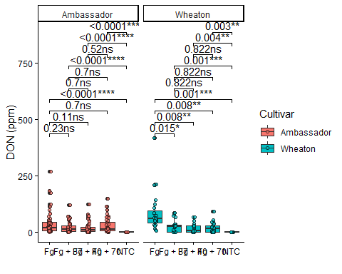

Plot 15ADON
plot_15ADON_pwc <- ggplot(toxin.data, aes(x = Treatment, y = X15ADON, fill = Cultivar)) +
geom_boxplot(position = position_dodge(width = 0.8)) +
geom_jitter(shape = 21, color = "black", size = 1.5, stroke = 0.3,
position = position_jitterdodge(jitter.width = 0.2), alpha = 0.7) +
geom_pwc(aes(group = Treatment), method = "t.test",
label = "{p.adj.format}{p.adj.signif}") +
ylab("15ADON") + xlab("") +
theme_classic() +
facet_wrap(~Cultivar)
plot_15ADON_pwc
## Warning: Removed 10 rows containing non-finite outside the scale range
## (`stat_boxplot()`).
## Warning: Removed 10 rows containing non-finite outside the scale range
## (`stat_pwc()`).
## Warning: Removed 10 rows containing missing values or values outside the scale range
## (`geom_point()`).
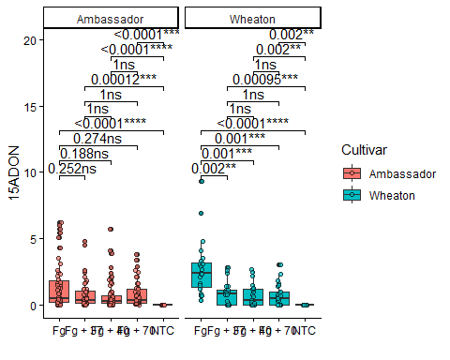

Plot_Seedmass
plot_SeedMass_pwc <- ggplot(toxin.data, aes(x = Treatment, y = MassperSeed_mg, fill = Cultivar)) +
geom_boxplot(position = position_dodge(width = 0.8)) +
geom_jitter(shape = 21, color = "black", size = 1.5, stroke = 0.3,
position = position_jitterdodge(jitter.width = 0.2), alpha = 0.7) +
geom_pwc(aes(group= Treatment), method = "t.test",
label = "{p.adj.format}{p.adj.signif}") +
ylab("Seed Mass (mg)") + xlab("") +
theme_classic() +
facet_wrap(~Cultivar)
plot_SeedMass_pwc
## Warning: Removed 2 rows containing non-finite outside the scale range
## (`stat_boxplot()`).
## Warning: Removed 2 rows containing non-finite outside the scale range
## (`stat_pwc()`).
## Warning: Removed 2 rows containing missing values or values outside the scale range
## (`geom_point()`).
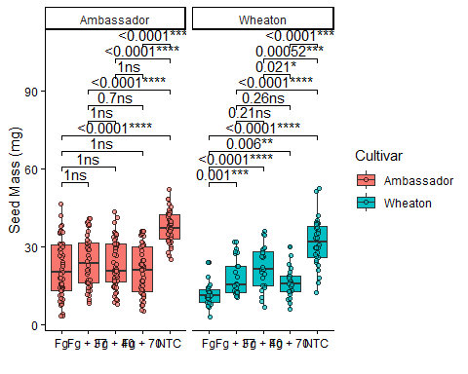

PlotCombined
combined_pwc <- ggarrange(plot_DON_pwc, plot_15ADON_pwc, plot_SeedMass_pwc,
ncol = 3, nrow = 1,
labels = c("a", "b", "c"),
common.legend = TRUE,
legend = "top")
## Warning: Removed 8 rows containing non-finite outside the scale range
## (`stat_boxplot()`).
## Warning: Removed 8 rows containing non-finite outside the scale range
## (`stat_pwc()`).
## Warning: Removed 8 rows containing missing values or values outside the scale range
## (`geom_point()`).
## Warning: Removed 8 rows containing non-finite outside the scale range
## (`stat_boxplot()`).
## Warning: Removed 8 rows containing non-finite outside the scale range
## (`stat_pwc()`).
## Warning: Removed 8 rows containing missing values or values outside the scale range
## (`geom_point()`).
## Warning: Removed 10 rows containing non-finite outside the scale range
## (`stat_boxplot()`).
## Warning: Removed 10 rows containing non-finite outside the scale range
## (`stat_pwc()`).
## Warning: Removed 10 rows containing missing values or values outside the scale range
## (`geom_point()`).
## Warning: Removed 2 rows containing non-finite outside the scale range
## (`stat_boxplot()`).
## Warning: Removed 2 rows containing non-finite outside the scale range
## (`stat_pwc()`).
## Warning: Removed 2 rows containing missing values or values outside the scale range
## (`geom_point()`).
combined_pwc
