Untitled
Gibi Thomas
2026-03-26
install.packages(“multcompView”, repos = “https://cloud.r-project.org”) install.packages(“emmeans”, repos = “https://cloud.r-project.org”) install.packages(“lme4”, repos = “https://cloud.r-project.org”) install.packages(“dplyr”, repos = “https://cloud.r-project.org”) # if using %>%
``` r
library(tidyverse)
## Warning: package 'tidyverse' was built under R version 4.5.2
## Warning: package 'ggplot2' was built under R version 4.5.2
## Warning: package 'tidyr' was built under R version 4.5.2
## Warning: package 'purrr' was built under R version 4.5.2
## Warning: package 'dplyr' was built under R version 4.5.2
## Warning: package 'stringr' was built under R version 4.5.2
## Warning: package 'forcats' was built under R version 4.5.2
## ── Attaching core tidyverse packages ──────────────────────── tidyverse 2.0.0 ──
## ✔ dplyr 1.1.4 ✔ readr 2.1.5
## ✔ forcats 1.0.1 ✔ stringr 1.6.0
## ✔ ggplot2 4.0.2 ✔ tibble 3.2.1
## ✔ lubridate 1.9.4 ✔ tidyr 1.3.2
## ✔ purrr 1.2.1
## ── Conflicts ────────────────────────────────────────── tidyverse_conflicts() ──
## ✖ dplyr::filter() masks stats::filter()
## ✖ dplyr::lag() masks stats::lag()
## ℹ Use the conflicted package (<http://conflicted.r-lib.org/>) to force all conflicts to become errors
library(lme4)
## Warning: package 'lme4' was built under R version 4.5.2
## Loading required package: Matrix
##
## Attaching package: 'Matrix'
##
## The following objects are masked from 'package:tidyr':
##
## expand, pack, unpack
library(emmeans)
## Warning: package 'emmeans' was built under R version 4.5.3
## Welcome to emmeans.
## Caution: You lose important information if you filter this package's results.
## See '? untidy'
library(multcomp)
## Warning: package 'multcomp' was built under R version 4.5.2
## Loading required package: mvtnorm
## Warning: package 'mvtnorm' was built under R version 4.5.3
## Loading required package: survival
## Loading required package: TH.data
## Warning: package 'TH.data' was built under R version 4.5.2
## Loading required package: MASS
##
## Attaching package: 'MASS'
##
## The following object is masked from 'package:dplyr':
##
## select
##
##
## Attaching package: 'TH.data'
##
## The following object is masked from 'package:MASS':
##
## geyser
data("mtcars")
library(ggplot2)
ggplot(mtcars, aes(x = wt, y = mpg)) +
geom_smooth(method = lm, se = FALSE, color = "grey") +
geom_point(aes(color = wt)) +
xlab("Weight") +
ylab("Miles per gallon") +
scale_colour_gradient(low = "forestgreen", high = "black") +
theme_classic()
## `geom_smooth()` using formula = 'y ~ x'
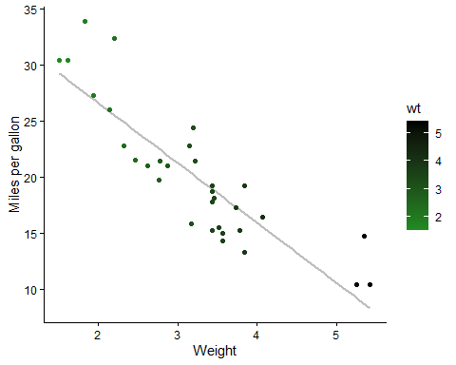
lm(mpg~wt, data = mtcars)
##
## Call:
## lm(formula = mpg ~ wt, data = mtcars)
##
## Coefficients:
## (Intercept) wt
## 37.285 -5.344
summary(lm(mpg~wt, data = mtcars))
##
## Call:
## lm(formula = mpg ~ wt, data = mtcars)
##
## Residuals:
## Min 1Q Median 3Q Max
## -4.5432 -2.3647 -0.1252 1.4096 6.8727
##
## Coefficients:
## Estimate Std. Error t value Pr(>|t|)
## (Intercept) 37.2851 1.8776 19.858 < 2e-16 ***
## wt -5.3445 0.5591 -9.559 1.29e-10 ***
## ---
## Signif. codes: 0 '***' 0.001 '**' 0.01 '*' 0.05 '.' 0.1 ' ' 1
##
## Residual standard error: 3.046 on 30 degrees of freedom
## Multiple R-squared: 0.7528, Adjusted R-squared: 0.7446
## F-statistic: 91.38 on 1 and 30 DF, p-value: 1.294e-10
anova(lm(mpg~wt, data = mtcars))
## Analysis of Variance Table
##
## Response: mpg
## Df Sum Sq Mean Sq F value Pr(>F)
## wt 1 847.73 847.73 91.375 1.294e-10 ***
## Residuals 30 278.32 9.28
## ---
## Signif. codes: 0 '***' 0.001 '**' 0.01 '*' 0.05 '.' 0.1 ' ' 1
cor.test(mtcars$wt, mtcars$mpg)
##
## Pearson's product-moment correlation
##
## data: mtcars$wt and mtcars$mpg
## t = -9.559, df = 30, p-value = 1.294e-10
## alternative hypothesis: true correlation is not equal to 0
## 95 percent confidence interval:
## -0.9338264 -0.7440872
## sample estimates:
## cor
## -0.8676594
model <- lm(mpg~wt, data = mtcars)
ggplot(model, aes(y = .resid, x = .fitted)) +
geom_point() +
geom_hline(yintercept = 0)
## Warning: `fortify(<lm>)` was deprecated in ggplot2 4.0.0.
## ℹ Please use `broom::augment(<lm>)` instead.
## ℹ The deprecated feature was likely used in the ggplot2 package.
## Please report the issue at <https://github.com/tidyverse/ggplot2/issues>.
## This warning is displayed once per session.
## Call `lifecycle::last_lifecycle_warnings()` to see where this warning was
## generated.
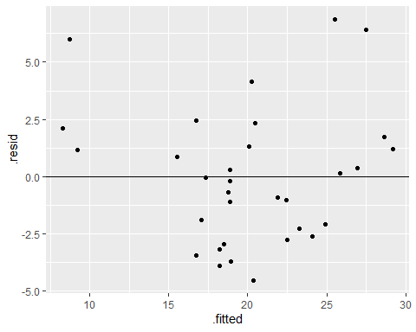
library(dplyr)
bull.rich <- read.csv("Bull_richness.csv")
bull.rich %>%
filter(GrowthStage == "V8" & Treatment == "Conv.") %>%
ggplot(aes(x = Fungicide, y = richness)) +
geom_boxplot()
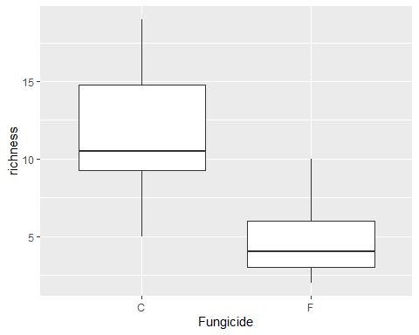
bull.rich.sub <- bull.rich %>%
filter(GrowthStage == "V8" & Treatment == "Conv.")
t.test(richness~Fungicide, data = bull.rich.sub)
##
## Welch Two Sample t-test
##
## data: richness by Fungicide
## t = 4.8759, df = 17.166, p-value = 0.0001384
## alternative hypothesis: true difference in means between group C and group F is not equal to 0
## 95 percent confidence interval:
## 4.067909 10.265425
## sample estimates:
## mean in group C mean in group F
## 11.750000 4.583333
t.test(richness~Fungicide, data = bull.rich.sub, var.equal = TRUE)
##
## Two Sample t-test
##
## data: richness by Fungicide
## t = 4.8759, df = 22, p-value = 7.118e-05
## alternative hypothesis: true difference in means between group C and group F is not equal to 0
## 95 percent confidence interval:
## 4.118459 10.214875
## sample estimates:
## mean in group C mean in group F
## 11.750000 4.583333
summary(lm(richness~Fungicide, data = bull.rich.sub))
##
## Call:
## lm(formula = richness ~ Fungicide, data = bull.rich.sub)
##
## Residuals:
## Min 1Q Median 3Q Max
## -6.7500 -1.7500 -0.6667 2.2500 7.2500
##
## Coefficients:
## Estimate Std. Error t value Pr(>|t|)
## (Intercept) 11.750 1.039 11.306 1.24e-10 ***
## FungicideF -7.167 1.470 -4.876 7.12e-05 ***
## ---
## Signif. codes: 0 '***' 0.001 '**' 0.01 '*' 0.05 '.' 0.1 ' ' 1
##
## Residual standard error: 3.6 on 22 degrees of freedom
## Multiple R-squared: 0.5194, Adjusted R-squared: 0.4975
## F-statistic: 23.77 on 1 and 22 DF, p-value: 7.118e-05
anova(lm(richness~Fungicide, data = bull.rich.sub))
## Analysis of Variance Table
##
## Response: richness
## Df Sum Sq Mean Sq F value Pr(>F)
## Fungicide 1 308.17 308.167 23.774 7.118e-05 ***
## Residuals 22 285.17 12.962
## ---
## Signif. codes: 0 '***' 0.001 '**' 0.01 '*' 0.05 '.' 0.1 ' ' 1
bull.rich.sub2 <- bull.rich %>%
filter(Fungicide == "C" & Treatment == "Conv." & Crop == "Corn")
bull.rich.sub2$GrowthStage <- factor(bull.rich.sub2$GrowthStage, levels = c("V6", "V8", "V15"))
ggplot(bull.rich.sub2, aes(x = GrowthStage, y = richness)) +
geom_boxplot()
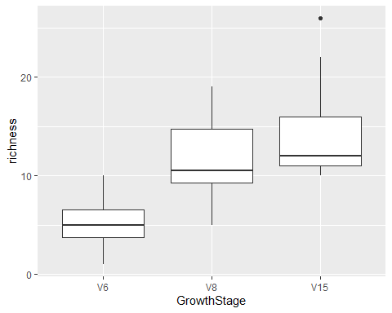
lm.growth <- lm(richness ~ GrowthStage, data = bull.rich.sub2)
summary(lm.growth)
##
## Call:
## lm(formula = richness ~ GrowthStage, data = bull.rich.sub2)
##
## Residuals:
## Min 1Q Median 3Q Max
## -6.750 -2.625 -1.000 2.250 11.583
##
## Coefficients:
## Estimate Std. Error t value Pr(>|t|)
## (Intercept) 5.250 1.208 4.348 0.000124 ***
## GrowthStageV8 6.500 1.708 3.806 0.000581 ***
## GrowthStageV15 9.167 1.708 5.368 6.23e-06 ***
## ---
## Signif. codes: 0 '***' 0.001 '**' 0.01 '*' 0.05 '.' 0.1 ' ' 1
##
## Residual standard error: 4.183 on 33 degrees of freedom
## Multiple R-squared: 0.4803, Adjusted R-squared: 0.4488
## F-statistic: 15.25 on 2 and 33 DF, p-value: 2.044e-05
anova(lm.growth)
## Analysis of Variance Table
##
## Response: richness
## Df Sum Sq Mean Sq F value Pr(>F)
## GrowthStage 2 533.56 266.778 15.247 2.044e-05 ***
## Residuals 33 577.42 17.497
## ---
## Signif. codes: 0 '***' 0.001 '**' 0.01 '*' 0.05 '.' 0.1 ' ' 1
summary(aov(richness ~ GrowthStage, data = bull.rich.sub2))
## Df Sum Sq Mean Sq F value Pr(>F)
## GrowthStage 2 533.6 266.8 15.25 2.04e-05 ***
## Residuals 33 577.4 17.5
## ---
## Signif. codes: 0 '***' 0.001 '**' 0.01 '*' 0.05 '.' 0.1 ' ' 1
``` r
library(dplyr)
bull.rich.sub3 <- bull.rich %>%
filter(Treatment == "Conv." & Crop == "Corn")
bull.rich.sub3$GrowthStage <- factor(bull.rich.sub3$GrowthStage, levels = c("V6", "V8", "V15"))
lm.inter <- lm(richness ~ GrowthStage + Fungicide + GrowthStage:Fungicide, data = bull.rich.sub3)
summary(lm.inter)
##
## Call:
## lm(formula = richness ~ GrowthStage + Fungicide + GrowthStage:Fungicide,
## data = bull.rich.sub3)
##
## Residuals:
## Min 1Q Median 3Q Max
## -8.5000 -2.4167 -0.4167 2.0625 11.5833
##
## Coefficients:
## Estimate Std. Error t value Pr(>|t|)
## (Intercept) 5.2500 1.1029 4.760 1.10e-05 ***
## GrowthStageV8 6.5000 1.5597 4.167 9.15e-05 ***
## GrowthStageV15 9.1667 1.5597 5.877 1.51e-07 ***
## FungicideF -1.2500 1.5597 -0.801 0.42575
## GrowthStageV8:FungicideF -5.9167 2.2057 -2.682 0.00923 **
## GrowthStageV15:FungicideF 0.3333 2.2057 0.151 0.88034
## ---
## Signif. codes: 0 '***' 0.001 '**' 0.01 '*' 0.05 '.' 0.1 ' ' 1
##
## Residual standard error: 3.82 on 66 degrees of freedom
## Multiple R-squared: 0.5903, Adjusted R-squared: 0.5593
## F-statistic: 19.02 on 5 and 66 DF, p-value: 1.144e-11
anova(lm.inter)
## Analysis of Variance Table
##
## Response: richness
## Df Sum Sq Mean Sq F value Pr(>F)
## GrowthStage 2 1065.58 532.79 36.5027 2.113e-11 ***
## Fungicide 1 174.22 174.22 11.9363 0.0009668 ***
## GrowthStage:Fungicide 2 148.36 74.18 5.0823 0.0088534 **
## Residuals 66 963.33 14.60
## ---
## Signif. codes: 0 '***' 0.001 '**' 0.01 '*' 0.05 '.' 0.1 ' ' 1
library(dplyr)
library(ggplot2)
bull.rich.sub3 %>%
ggplot(aes(x = GrowthStage, y = richness, fill = Fungicide)) +
geom_boxplot()
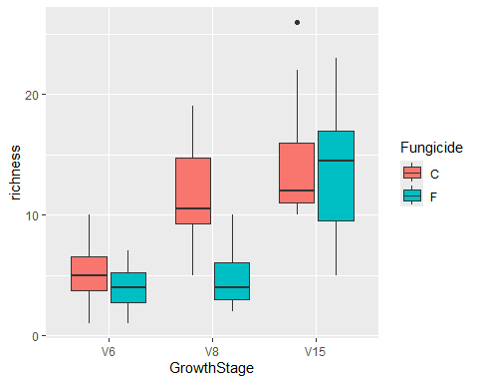
library(emmeans)
library(multcompView)
## Warning: package 'multcompView' was built under R version 4.5.3
lsmeans <- emmeans(lm.inter, ~Fungicide|GrowthStage)
Results_lsmeans <- cld(lsmeans, alpha = 0.05, reversed = TRUE, details = TRUE)
Results_lsmeans
## $emmeans
## GrowthStage = V6:
## Fungicide emmean SE df lower.CL upper.CL .group
## C 5.25 1.1 66 3.05 7.45 1
## F 4.00 1.1 66 1.80 6.20 1
##
## GrowthStage = V8:
## Fungicide emmean SE df lower.CL upper.CL .group
## C 11.75 1.1 66 9.55 13.95 1
## F 4.58 1.1 66 2.38 6.79 2
##
## GrowthStage = V15:
## Fungicide emmean SE df lower.CL upper.CL .group
## C 14.42 1.1 66 12.21 16.62 1
## F 13.50 1.1 66 11.30 15.70 1
##
## Confidence level used: 0.95
## significance level used: alpha = 0.05
## NOTE: If two or more means share the same grouping symbol,
## then we cannot show them to be different.
## But we also did not show them to be the same.
##
## $comparisons
## GrowthStage = V6:
## contrast estimate SE df t.ratio p.value
## C - F 1.250 1.56 66 0.801 0.4258
##
## GrowthStage = V8:
## contrast estimate SE df t.ratio p.value
## C - F 7.167 1.56 66 4.595 <0.0001
##
## GrowthStage = V15:
## contrast estimate SE df t.ratio p.value
## C - F 0.917 1.56 66 0.588 0.5587
library(lme4)
lme0 <- lm(richness ~ GrowthStage*Fungicide, data = bull.rich.sub3)
lme1 <- lmer(richness ~ GrowthStage*Fungicide + (1|Rep), data = bull.rich.sub3)
summary(lme1)
## Linear mixed model fit by REML ['lmerMod']
## Formula: richness ~ GrowthStage * Fungicide + (1 | Rep)
## Data: bull.rich.sub3
##
## REML criterion at convergence: 378.3
##
## Scaled residuals:
## Min 1Q Median 3Q Max
## -2.4664 -0.5966 -0.1788 0.6257 2.9101
##
## Random effects:
## Groups Name Variance Std.Dev.
## Rep (Intercept) 0.7855 0.8863
## Residual 13.9533 3.7354
## Number of obs: 72, groups: Rep, 4
##
## Fixed effects:
## Estimate Std. Error t value
## (Intercept) 5.2500 1.1658 4.503
## GrowthStageV8 6.5000 1.5250 4.262
## GrowthStageV15 9.1667 1.5250 6.011
## FungicideF -1.2500 1.5250 -0.820
## GrowthStageV8:FungicideF -5.9167 2.1566 -2.743
## GrowthStageV15:FungicideF 0.3333 2.1566 0.155
##
## Correlation of Fixed Effects:
## (Intr) GrwSV8 GrSV15 FngcdF GSV8:F
## GrowthStgV8 -0.654
## GrwthStgV15 -0.654 0.500
## FungicideF -0.654 0.500 0.500
## GrwthSV8:FF 0.462 -0.707 -0.354 -0.707
## GrwtSV15:FF 0.462 -0.354 -0.707 -0.707 0.500
summary(lme0)
##
## Call:
## lm(formula = richness ~ GrowthStage * Fungicide, data = bull.rich.sub3)
##
## Residuals:
## Min 1Q Median 3Q Max
## -8.5000 -2.4167 -0.4167 2.0625 11.5833
##
## Coefficients:
## Estimate Std. Error t value Pr(>|t|)
## (Intercept) 5.2500 1.1029 4.760 1.10e-05 ***
## GrowthStageV8 6.5000 1.5597 4.167 9.15e-05 ***
## GrowthStageV15 9.1667 1.5597 5.877 1.51e-07 ***
## FungicideF -1.2500 1.5597 -0.801 0.42575
## GrowthStageV8:FungicideF -5.9167 2.2057 -2.682 0.00923 **
## GrowthStageV15:FungicideF 0.3333 2.2057 0.151 0.88034
## ---
## Signif. codes: 0 '***' 0.001 '**' 0.01 '*' 0.05 '.' 0.1 ' ' 1
##
## Residual standard error: 3.82 on 66 degrees of freedom
## Multiple R-squared: 0.5903, Adjusted R-squared: 0.5593
## F-statistic: 19.02 on 5 and 66 DF, p-value: 1.144e-11
summary(lme1)
## Linear mixed model fit by REML ['lmerMod']
## Formula: richness ~ GrowthStage * Fungicide + (1 | Rep)
## Data: bull.rich.sub3
##
## REML criterion at convergence: 378.3
##
## Scaled residuals:
## Min 1Q Median 3Q Max
## -2.4664 -0.5966 -0.1788 0.6257 2.9101
##
## Random effects:
## Groups Name Variance Std.Dev.
## Rep (Intercept) 0.7855 0.8863
## Residual 13.9533 3.7354
## Number of obs: 72, groups: Rep, 4
##
## Fixed effects:
## Estimate Std. Error t value
## (Intercept) 5.2500 1.1658 4.503
## GrowthStageV8 6.5000 1.5250 4.262
## GrowthStageV15 9.1667 1.5250 6.011
## FungicideF -1.2500 1.5250 -0.820
## GrowthStageV8:FungicideF -5.9167 2.1566 -2.743
## GrowthStageV15:FungicideF 0.3333 2.1566 0.155
##
## Correlation of Fixed Effects:
## (Intr) GrwSV8 GrSV15 FngcdF GSV8:F
## GrowthStgV8 -0.654
## GrwthStgV15 -0.654 0.500
## FungicideF -0.654 0.500 0.500
## GrwthSV8:FF 0.462 -0.707 -0.354 -0.707
## GrwtSV15:FF 0.462 -0.354 -0.707 -0.707 0.500
```

