Coding challenge_Rmarkdown
Gibi Thomas
2026-02-19
Table of Contents

Question 1.Explain the following a. YAML header A YAML header contains YAML arguments, such as “title”, “author”, and “output”, demarcated by three dashes (—) on either end. b. Literate programming Literate programming is in essence to treat programming as writing human readable literature. The litr R package lets you write a complete R package in a single R markdown document. This enables a workflow for writing R packages that is probably very different from what you are used to.
Question 2. Take the code you wrote for coding challenge 3, question 5, and incorporate it into your R markdown file. Some of you have already been doing this, which is great! Your final R markdown file should have the following elements. a. At the top of the document, make a clickable link to the manuscript where these data are published. The link is here:
Noel, Z.A., Roze, L.V., Breunig, M., Trail, F. 2022. Endophytic fungi as promising biocontrol agent to protect wheat from Fusarium graminearum head blight. Plant Disease. https://doi.org/10.1094/PDIS-06-21-1253-RE
#install.packages("ggpubr")
library(ggpubr)
## Warning: package 'ggpubr' was built under R version 4.5.2
## Loading required package: ggplot2
## Warning: package 'ggplot2' was built under R version 4.5.2
#install.packages("ggplot2")
library(ggplot2)
cbbPalette <- c("#000000", "#E69F00", "#56B4E9", "#009E73", "#F0E442", "#0072B2" , "#D55E00", "#CC79A7")
toxin.data <- read.csv("MycotoxinData.csv", na.strings = "na")
plot_DON_pwc <- ggplot(toxin.data, aes(x = Treatment, y = DON, fill = Cultivar)) +
geom_boxplot(position = position_dodge(width = 0.8)) +
geom_jitter(shape = 21, color = "black", size = 1.5, stroke = 0.3,
position = position_jitterdodge(jitter.width = 0.2), alpha = 0.7) +
geom_pwc(aes(group = Treatment), method = "t.test",
label = "{p.adj.format}{p.adj.signif}") +
ylab("DON (ppm)") + xlab("") +
theme_classic() +
facet_wrap(~Cultivar)
plot_DON_pwc
## Warning: Removed 8 rows containing non-finite outside the scale range
## (`stat_boxplot()`).
## Warning: Removed 8 rows containing non-finite outside the scale range
## (`stat_pwc()`).
## Warning: Removed 8 rows containing missing values or values outside the scale range
## (`geom_point()`).
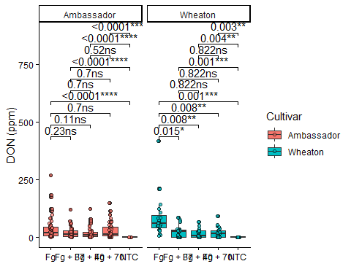
plot_15ADON_pwc <- ggplot(toxin.data, aes(x = Treatment, y = X15ADON, fill = Cultivar)) +
geom_boxplot(position = position_dodge(width = 0.8)) +
geom_jitter(shape = 21, color = "black", size = 1.5, stroke = 0.3,
position = position_jitterdodge(jitter.width = 0.2), alpha = 0.7) +
geom_pwc(aes(group = Treatment), method = "t.test",
label = "{p.adj.format}{p.adj.signif}") +
ylab("15ADON") + xlab("") +
theme_classic() +
facet_wrap(~Cultivar)
plot_15ADON_pwc
## Warning: Removed 10 rows containing non-finite outside the scale range
## (`stat_boxplot()`).
## Warning: Removed 10 rows containing non-finite outside the scale range
## (`stat_pwc()`).
## Warning: Removed 10 rows containing missing values or values outside the scale range
## (`geom_point()`).
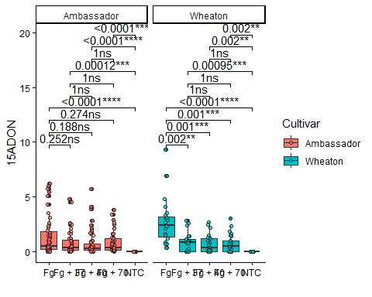
plot_SeedMass_pwc <- ggplot(toxin.data, aes(x = Treatment, y = MassperSeed_mg, fill = Cultivar)) +
geom_boxplot(position = position_dodge(width = 0.8)) +
geom_jitter(shape = 21, color = "black", size = 1.5, stroke = 0.3,
position = position_jitterdodge(jitter.width = 0.2), alpha = 0.7) +
geom_pwc(aes(group= Treatment), method = "t.test",
label = "{p.adj.format}{p.adj.signif}") +
ylab("Seed Mass (mg)") + xlab("") +
theme_classic() +
facet_wrap(~Cultivar)
plot_SeedMass_pwc
## Warning: Removed 2 rows containing non-finite outside the scale range
## (`stat_boxplot()`).
## Warning: Removed 2 rows containing non-finite outside the scale range
## (`stat_pwc()`).
## Warning: Removed 2 rows containing missing values or values outside the scale range
## (`geom_point()`).
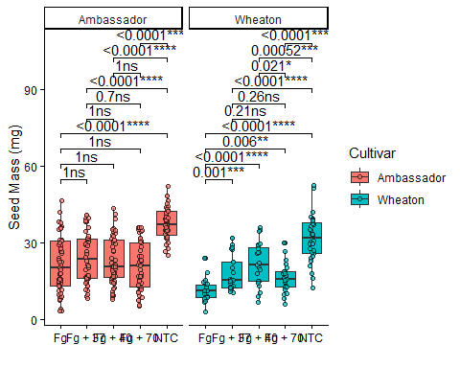
combined_pwc <- ggarrange(plot_DON_pwc, plot_15ADON_pwc, plot_SeedMass_pwc,
ncol = 3, nrow = 1,
labels = c("a", "b", "c"),
common.legend = TRUE,
legend = "top")
## Warning: Removed 8 rows containing non-finite outside the scale range
## (`stat_boxplot()`).
## Warning: Removed 8 rows containing non-finite outside the scale range
## (`stat_pwc()`).
## Warning: Removed 8 rows containing missing values or values outside the scale range
## (`geom_point()`).
## Warning: Removed 8 rows containing non-finite outside the scale range
## (`stat_boxplot()`).
## Warning: Removed 8 rows containing non-finite outside the scale range
## (`stat_pwc()`).
## Warning: Removed 8 rows containing missing values or values outside the scale range
## (`geom_point()`).
## Warning: Removed 10 rows containing non-finite outside the scale range
## (`stat_boxplot()`).
## Warning: Removed 10 rows containing non-finite outside the scale range
## (`stat_pwc()`).
## Warning: Removed 10 rows containing missing values or values outside the scale range
## (`geom_point()`).
## Warning: Removed 2 rows containing non-finite outside the scale range
## (`stat_boxplot()`).
## Warning: Removed 2 rows containing non-finite outside the scale range
## (`stat_pwc()`).
## Warning: Removed 2 rows containing missing values or values outside the scale range
## (`geom_point()`).
combined_pwc
