After docker compose up …

* Access DRUPAL CMS

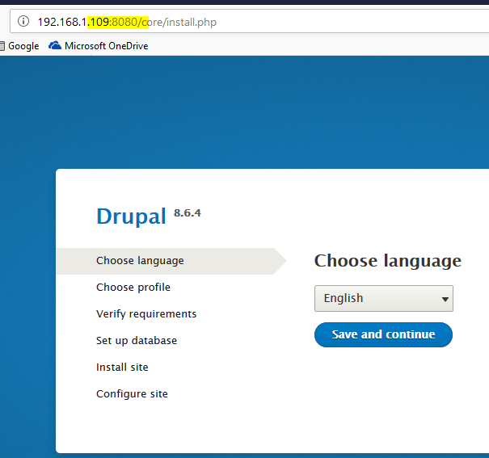

Configure postgres database connectivity:

* Hostname changed from localhost to postgres as shown in compose file

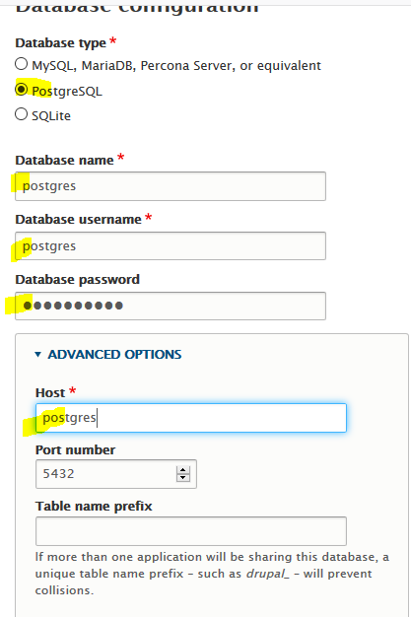

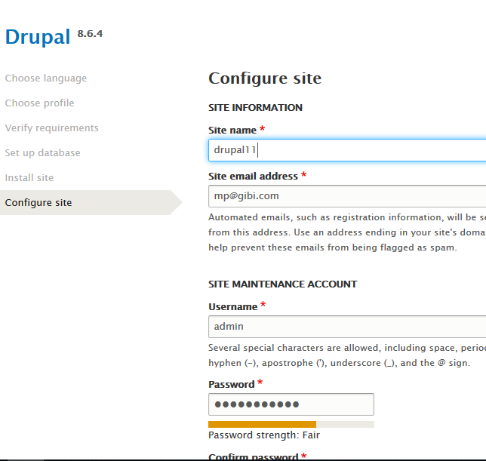

DRUPAL SITE setup …

