API TEST

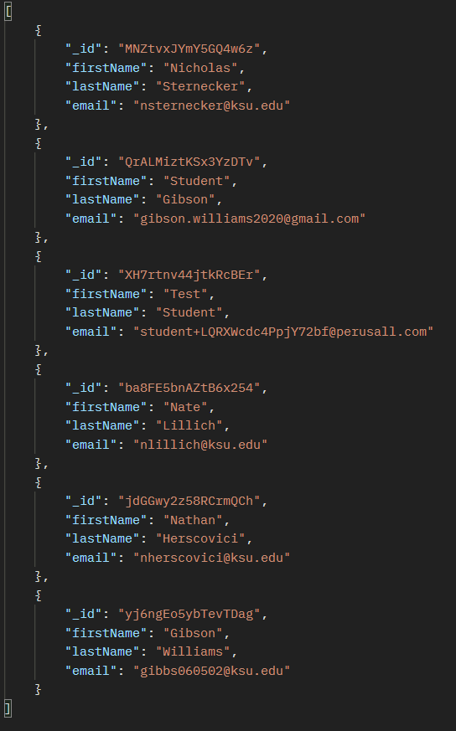The expected API request return:

When you open localhost and it brings you to the CAS login verification system:

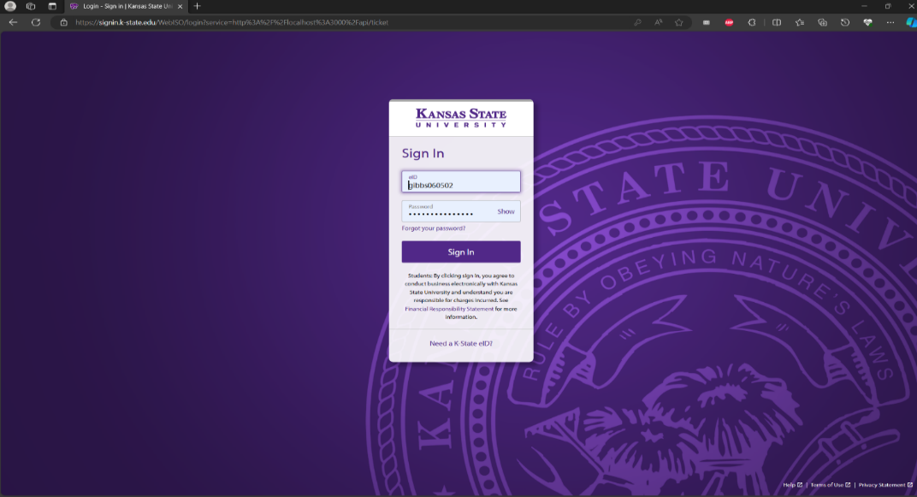

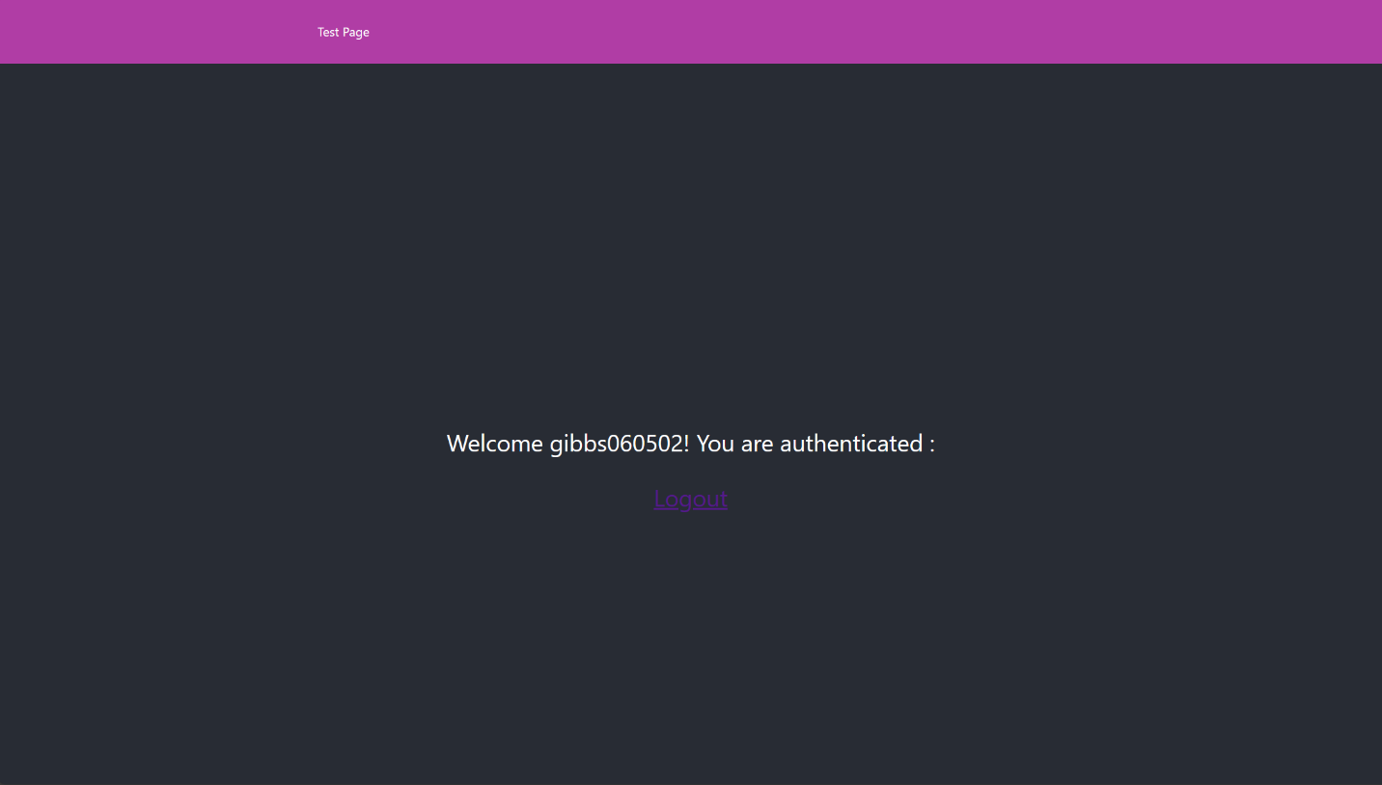Upon successful login:

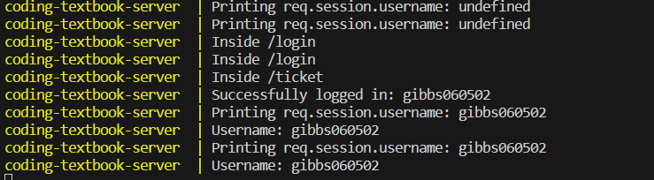Shows the communication between server and CAS system:

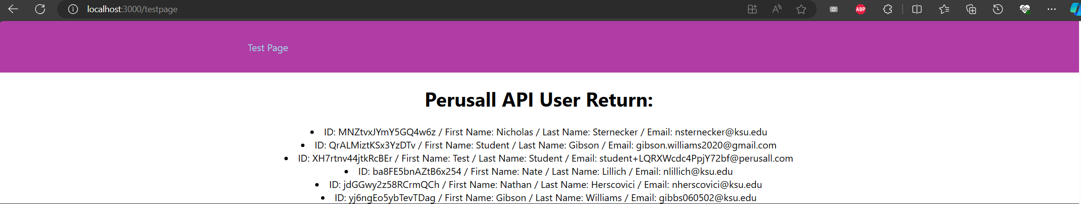Content from Perusall API call for users displayed within the client test page:

