GULZAR GROUP OF INSTITUTIONS
KHANNA, PUNJAB
DEPARTMENT OF COMPUTER APPLICATIONS (BCA)

INTERNSHIP TRAINING REPORT
on
WEB DEVELOPMENT
Internship Undertaken at Viro Web Solution

Submitted in partial fulfilment of the requirements for the award of the degree of
BACHELOR OF COMPUTER APPLICATIONS (BCA)

Submitted by:
[Student Name]
University Roll No.: 2433548
BCA — [Semester / Year]

Under the guidance of:
[Faculty Guide Name]
[Designation, Department of Computer Applications]
Industry Guide: [Industry Guide Name & Designation]

Session: [20XX – 20XX]

INTERNSHIP COMPLETION CERTIFICATE
(Issued by the Viro Web Solution)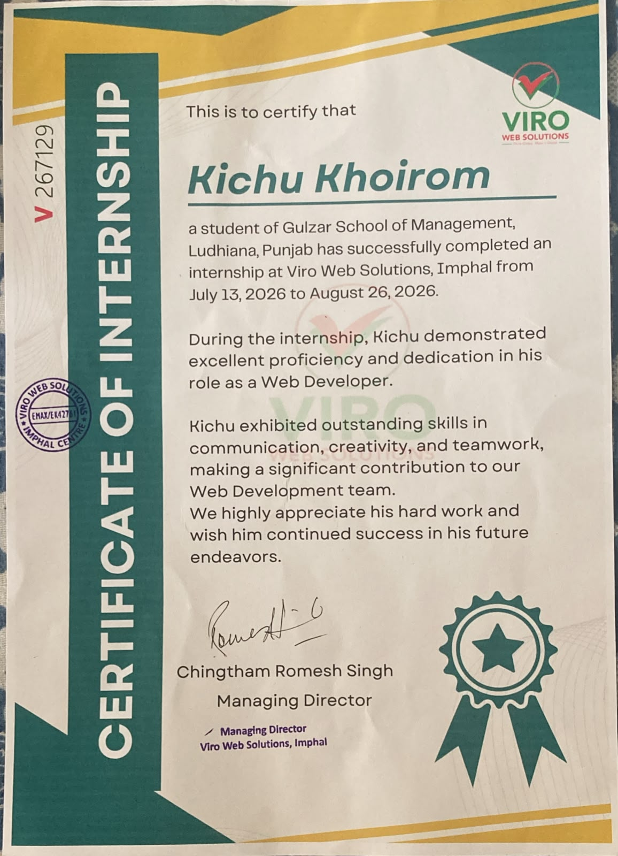
STUDENT DECLARATION
I, Kichu Khoirom, University Roll No. 2433548, hereby declare that the Internship Training Report entitled “Web Development Internship at Viro Web Solution”, submitted to the Department of Computer Applications, Gulzar Group of Institutions, Khanna, Punjab, in partial fulfilment of the requirements for the award of the degree of Bachelor of Computer Applications, is an original record of work carried out by me during my internship at Viro Web Solution under the guidance of the concerned faculty and industry guide.
I further declare that this report has not been submitted, in part or in full, to any other university or institute for the award of any degree or diploma, and that all sources of information used have been duly acknowledged.

Kichu Khoirom
[Date & Place]

ACKNOWLEDGEMENT
I would like to express my sincere gratitude to Viro Web Solution for providing me with the opportunity to undergo internship training as a Web Developer and gain valuable practical exposure to the professional software and web development environment.
I am thankful to my industry guide and the team at Viro Web Solution for their guidance, support, feedback, and encouragement throughout the training period. Their practical suggestions helped me understand how web development concepts are applied in real-world projects.
I would also like to thank my faculty guide and the Department of Computer Applications, Gulzar Group of Institutions, Khanna, Punjab, for their valuable guidance and continuous support during the internship and preparation of this report.
Finally, I extend my gratitude to the Head of Department, faculty members, family, and friends for their constant motivation and support.

Kichu Khoirom

TABLE OF CONTENTS
Chapter 1: Introduction
1.1 About the Internship Training
1.2 Objectives of the Training
1.3 Scope of the Training
Chapter 2: Organization Profile
2.1 About the Organization
2.2 Vision & Mission
2.3 Products / Services Offered
2.4 Organizational Structure
Chapter 3: Project Undertaken
3.1 Introduction to the Project
3.2 Problem Definition
3.3 Objectives of the Project
3.4 Tools & Technologies Used
Chapter 4: System Analysis & Design
4.1 Requirement Analysis
4.2 Feasibility Study
4.3 System Design
4.4 Database Design
Chapter 5: Implementation
5.1 Modules Description
5.2 Coding Standards Followed
5.3 Sample Code Snippets
Chapter 6: Testing
6.1 Testing Objectives
6.2 Testing Methods Used
6.3 Test Cases
Chapter 7: Screenshots / Output
Chapter 8: Conclusion & Future Scope
8.1 Conclusion
8.2 Limitations
8.3 Future Enhancements
References / Bibliography
Appendix (Optional)
Note: In Microsoft Word, page numbers can be updated after final editing by updating the Table of Contents field.

Chapter 1: Introduction

1.1 About the Internship Training
Internship training is an important part of professional education because it provides students with an opportunity to apply classroom knowledge in a practical working environment. The internship at Viro Web Solution was undertaken in the role of Web Developer. The training focused on understanding the web development workflow, developing and improving web pages, working with front-end technologies, testing interfaces, identifying errors, and following professional development practices.
During the internship, the main emphasis was on practical web development activities. The training helped bridge the gap between academic concepts and their application in real projects. It also provided experience in understanding requirements, planning page structure, writing and organizing code, checking responsiveness, debugging, and improving the overall user experience.
Internship Duration: 13th July to 26th August
Organization: Viro Web Solution
Role: Web Developer

1.2 Objectives of the Training
- To gain practical exposure to real-world web development practices.
- To apply classroom knowledge of programming and web technologies to practical tasks.
- To understand the development life cycle of a web-based project.
- To improve skills in designing responsive, user-friendly web interfaces.
- To learn effective coding, debugging, testing, and documentation practices.
- To understand professional communication, teamwork, task management, and deadline-based work.

1.3 Scope of the Training
The scope of the internship covered practical web development activities performed within the responsibilities assigned to the trainee. The work included understanding requirements, creating or modifying web pages, structuring content, styling interfaces, implementing client-side interactions, testing pages on different screen sizes, debugging issues, and improving usability.
The internship scope was primarily related to web development. Advanced production responsibilities such as large-scale server administration, enterprise deployment, or unrestricted access to confidential organizational systems were outside the scope unless specifically assigned by the organization.

Chapter 2: Organization Profile

2.1 About the Organization
Viro Web Solution was the host organization for the internship training. The internship was completed in the Web Development domain, where the trainee worked on practical activities related to the design, development, improvement, and testing of websites and web-based interfaces.
Organization Name: Viro Web Solution
Internship Domain: Web Development
Role: Web Developer Intern
Location: [Organization Location]
Year of Establishment: [Year, if provided by organization]
Note: Organization-specific historical details should be completed from the official company profile or information supplied by Viro Web Solution.

2.2 Vision & Mission
The official vision and mission statements of Viro Web Solution should be inserted here from the organization’s official material or internship documentation. For report purposes, the internship work can be described as being focused on delivering practical, functional, user-friendly, and maintainable web solutions.

2.3 Products / Services Offered
Based on the internship role, the relevant service area was web development. The organization-specific list below should be finalized using the company’s official service profile:
- Website design and development
- Responsive web interface development
- Web application development
- Website maintenance and improvement

2.4 Organizational Structure
A simple structure relevant to the internship can be represented as follows:
- Management / Founder
- Project or Team Lead
- Web Development Team
- Web Developer Intern

Chapter 3: Project Undertaken

3.1 Introduction to the Project
During the internship at Viro Web Solution, the trainee worked as a Web Developer and participated in practical web development tasks. The project work involved understanding the required interface and functionality, planning web pages, implementing front-end components, improving the visual presentation, and testing the resulting pages.
The project undertaken during the internship is detailed below:
Project Title: Design and Development of Responsive Business Website for Client
Project Type: Web-based Application / Website
Project Description: The project assigned was to develop a fully responsive business website for a client of Viro Web Solutions. The website includes Home, About Us, Services, Portfolio and Contact Us pages. My role w to convert the Figma design into HTML/CSS using Bootstrap 5, make it responsive for mobile and tablet, add interactivity using JavaScript/jQuery, and integrate the contact form with PHP & database. The website was tested on different browsers and deployed MySQL on live server via cPanel.

3.2 Problem Definition
The project addressed the need for a web interface that presents information in a clear and accessible manner while providing a consistent user experience across devices. The development work focused on organizing content, implementing an appropriate page structure, providing interactive elements where required, and ensuring that the interface works correctly.

3.3 Objectives of the Project
- To design and develop a functional web-based interface according to the assigned requirements.
- To create a clear and user-friendly page structure.
- To implement responsive layouts suitable for desktop and mobile screens.
- To use appropriate front-end technologies for structure, styling, and interaction.
- To test the website and identify interface or functional issues.
- To improve the quality, usability, and maintainability of the developed pages.

3.4 Technologies Used:

A. Frontend Technologies (For User Interface)

1. HTML5 - For Structure

2. CSS3 - For Styling

3. Bootstrap 5 - For Responsive Layout

4. JavaScript & jQuery - For Interactivity

B. Backend Technologies (For Data Handling)

1. PHP - For Server-Side Logic

2. MySQL - For Database

Frontend + Backend Connection:

The contact form in HTML sends data to a PHP file ‘contact.php’, which then inserts the data into the MySQL database.

C. Tools and Platforms Used

1. VS Code: Main code editor for writing all code

2. XAMPP / Local Server: For testing PHP and MySQL on local computer before uploading

3. GitHub: For saving code version and sharing with mentor at Viro Web Solutions

4. cPanel: For deploying/hosting the final website on live server

5. Figma: For referring to the design layout given by the company

6. Chrome DevTools: For testing responsiveness and debugging

Chapter 4: System Analysis & Design

4.1 Requirement Analysis
Requirement analysis was used to identify what the web project needed to provide and the quality characteristics expected from the final interface.
Functional Requirements:
- Display website content and navigation elements correctly.
- Allow users to move between required pages or sections.
- Provide forms or interactive components where specified.
- Validate user input on the client side where applicable.
- Respond appropriately to user actions such as button clicks or menu selections.
Non-Functional Requirements:
- Responsive design for different screen sizes.
- Readable and consistent user interface.
- Reasonable loading performance.
- Maintainable and well-structured code.
- Compatibility with commonly used modern browsers.
- Basic usability and accessibility considerations.

4.2 Feasibility Study
Technical Feasibility: The project was technically feasible because standard web development technologies and commonly available development tools can be used to create, test, and maintain the required interface.
Economic Feasibility: A web project based on commonly available development tools can be developed with comparatively low software cost, especially when open-source technologies are used. Actual organizational costs should be inserted if they were provided.
Operational Feasibility: The proposed web interface is operationally feasible because users can access it through standard web browsers and interact with the provided navigation, content, and forms.

4.3 System Design
The system design describes the major flow of interaction between the user and the web application. A typical flow for the internship project is:
- User opens the website.
- User views the home page and available navigation options.
- User selects a required page or feature.
- The browser loads the requested content and executes client-side scripts where applicable.
- The user submits information through a form if provided.
- The system validates the input and displays an appropriate response.

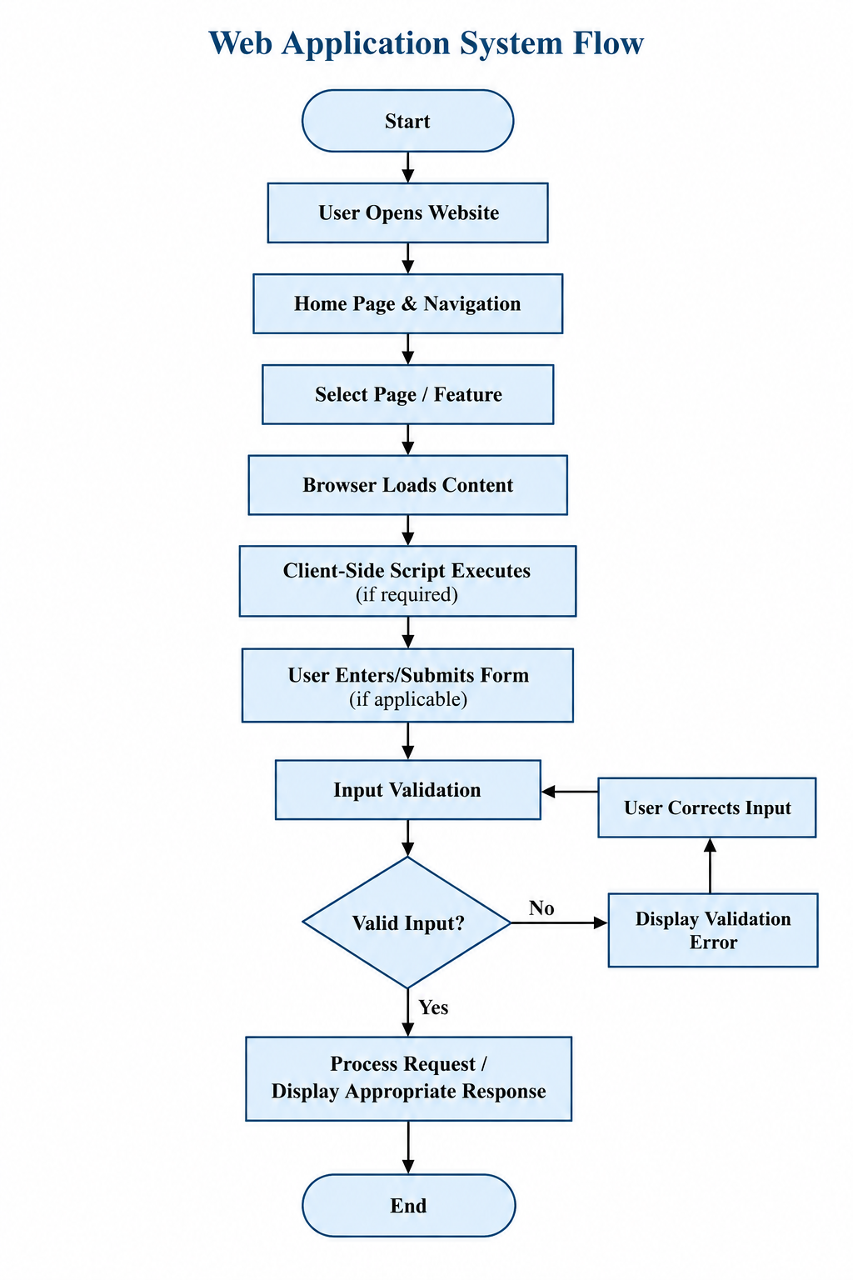

Fig: Web Application System Flow

4.4 Database Design
If the assigned project did not use a database, this section should state: “The project was primarily front-end based and did not require a dedicated database.” If a database was used, insert the actual database name, tables, fields, primary keys, relationships, and schema here.
Database Status: [Not Used / Used — provide actual schema if applicable]

Chapter 5: Implementation

5.1 Modules Description
Module | Description
Home / Landing Module | Presents the main introduction, important content, and primary navigation.
Navigation Module | Provides links or menu controls for moving between website sections or pages.
Content Module | Displays the main information, services, features, or other project-specific content.
Responsive UI Module | Adapts page layout and components for different screen sizes.
Form Module | Provides required input fields and client-side validation where applicable.
Interaction Module | Handles JavaScript-based interactions and dynamic interface behavior where required.

5.2 Coding Standards Followed
- Used meaningful names for files, variables, classes, IDs, and functions.
- Maintained consistent indentation and formatting.
- Kept HTML structure organized and semantic where applicable.
- Separated styling from HTML by using CSS files where appropriate.
- Used comments for important or non-obvious sections of code.
- Avoided unnecessary repetition and kept code readable.
- Tested changes after implementation to identify and correct errors.

5.3 Sample Code Snippets
The final report should include short, representative snippets from the actual project rather than the complete source code. Suitable examples include a responsive navigation section, a CSS media query, a JavaScript validation function, or another important feature.
Sample Snippet 1 — HTML Structure:
<header>
<nav>
<a href="index.html">Home</a>
<a href="about.html">About</a>
<a href="contact.html">Contact</a>
</nav>
</header>
Explanation: This demonstrates a simple semantic navigation structure. Replace this example with code from the actual internship project.
Sample Snippet 2 — Responsive CSS:
@media (max-width: 768px) {
.container {
width: 100%;
padding: 15px;
}
}
Explanation: A media query can be used to adjust the layout for smaller screens. Replace with the actual project code where appropriate.

Chapter 6: Testing

6.1 Testing Objectives
Testing was performed to verify that the developed web pages and interactive features behaved as expected. The main objectives were to identify errors, verify navigation and form behavior, check responsive layouts, and ensure that the final interface met the assigned requirements.

6.2 Testing Methods Used
- Unit Testing — individual functions or small components were checked independently where applicable.
- Integration Testing — interactions between page components, scripts, forms, and other connected features were checked.
- System Testing — the complete website or assigned module was tested as a whole.
- User Acceptance Testing (UAT) — the final result was reviewed against the expected requirements and feedback was incorporated where applicable.

6.3 Test Cases
Test Case ID | Description | Input | Expected Output | Actual Output | Status
TC-01 | Open home page | Website URL | Home page loads correctly | [Enter actual result] | [Pass/Fail]
TC-02 | Check navigation | Click navigation link | Correct page/section opens | [Enter actual result] | [Pass/Fail]
TC-03 | Check responsive layout | Resize browser / mobile view | Layout adjusts without major overlap | [Enter actual result] | [Pass/Fail]
TC-04 | Form validation | Invalid/empty form input | Validation message is displayed | [Enter actual result] | [Pass/Fail]
TC-05 | Form submission | Valid input | Form processes input as designed | [Enter actual result] | [Pass/Fail]
TC-06 | Interactive element | Click required button/control | Expected interaction occurs | [Enter actual result] | [Pass/Fail]

Chapter 7: Screenshots / Output
Insert screenshots from the actual internship project in this chapter. Each screenshot should have a figure number and short caption.
Fig 7.1: Home / Landing Page
[Insert actual screenshot here]

Fig 7.2: About / Information Page
[Insert actual screenshot here]

Fig 7.3: Services / Features Page
[Insert actual screenshot here]

Fig 7.4: Contact / Registration / Enquiry Page
[Insert actual screenshot here]

Fig 7.5: Responsive Mobile View
[Insert actual screenshot here]

Fig 7.6: Form Validation / Interactive Feature
[Insert actual screenshot here]

Fig 7.7: Final Project Output
[Insert actual screenshot here]

Chapter 8: Conclusion & Future Scope

8.1 Conclusion
The internship at Viro Web Solution provided valuable practical exposure to the field of web development. It helped in understanding how web development concepts learned during the BCA course can be applied to practical tasks. The training strengthened skills related to webpage structure, styling, client-side scripting, responsive design, debugging, testing, and documentation.
The internship also provided an opportunity to understand professional working practices such as requirement understanding, task completion, feedback, communication, time management, and quality checking. Overall, the training contributed to improving both technical and professional skills required for a career in web development.

8.2 Limitations
- The internship project scope was limited to the tasks and responsibilities assigned during the training period.
- Some advanced back-end, database, deployment, or production activities may not have been part of the assigned work.
- Testing may have been limited to the devices, browsers, and environments available during the internship.
- Further project-specific limitations should be added based on the actual system developed.

8.3 Future Enhancements
- Improve accessibility and usability based on user feedback.
- Add additional responsive improvements for a wider range of devices.
- Introduce stronger form validation and error handling.
- Add back-end functionality and database integration if required.
- Improve performance, security, and deployment practices.
- Add additional features based on future project requirements.

References / Bibliography
The final report should list only the resources actually used during the internship. Suitable categories include:
- HTML and CSS documentation used during development.
- JavaScript documentation used for client-side scripting.
- Official documentation of any framework or library actually used.
- Visual Studio Code or other development-tool documentation, if consulted.
- Viro Web Solution project requirements, instructions, or internal documentation, where permitted.
[1] Resource / Documentation Name, Page or Topic, Publisher/Organization, Year.
[2] Website / Documentation Name, Page Title, URL, Accessed on [date].
[3] Viro Web Solution, Project / Internship Documentation, [date if applicable].

Appendix (Optional)
The appendix may contain supplementary material that supports the internship report without interrupting the main discussion.
- Appendix A — Internship Completion Certificate
- Appendix B — Additional Screenshots
- Appendix C — Additional Diagrams
- Appendix D — Selected Source Code Snippets
- Appendix E — Internship Offer / Joining Letter, if applicable

