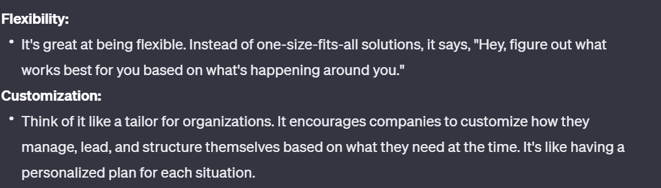v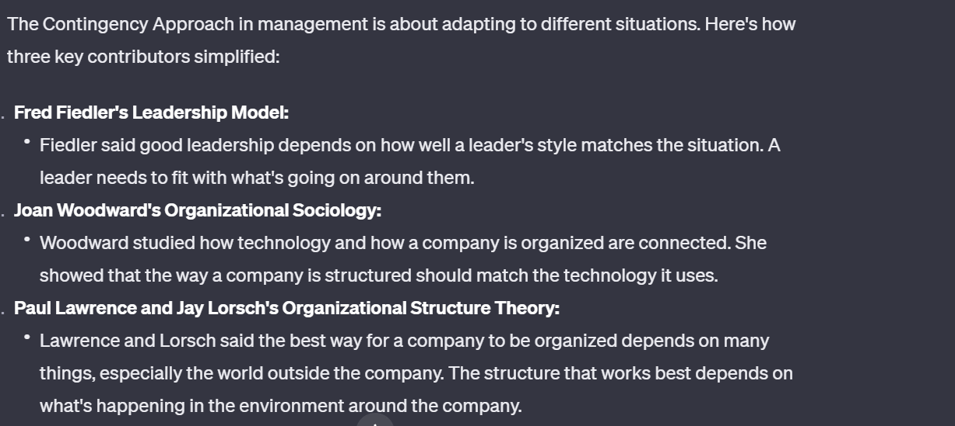he Contingency Approach in management is about adapting to different situations.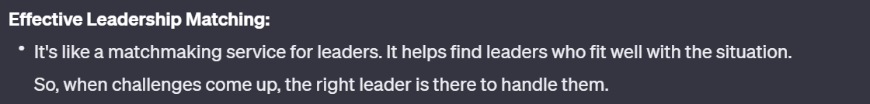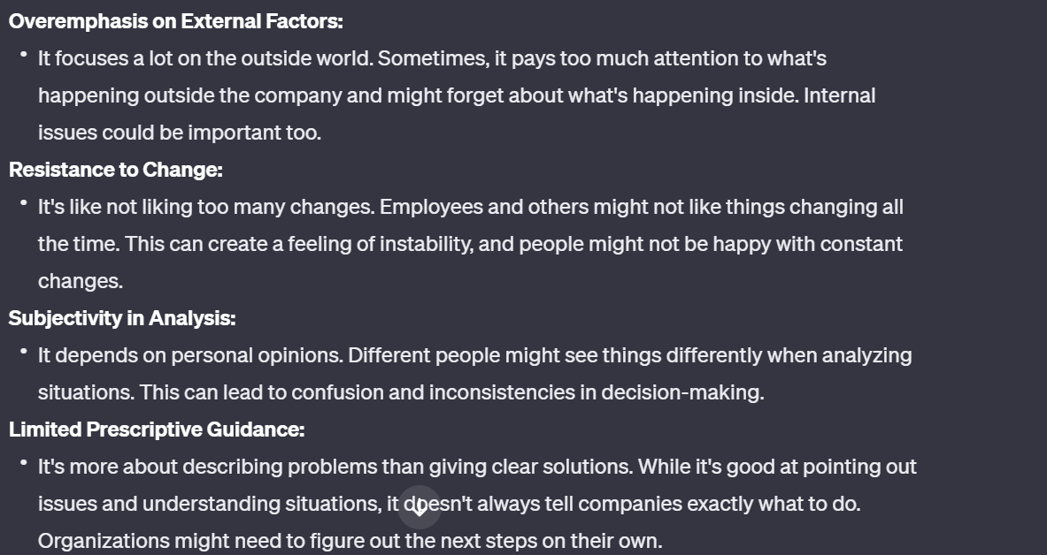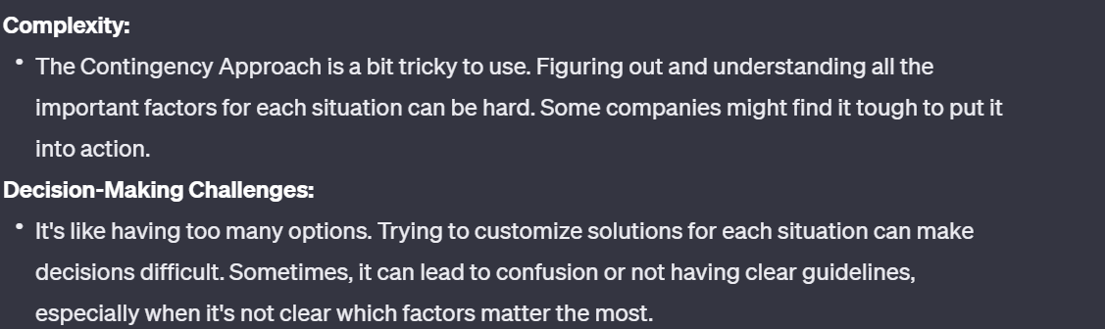 oughere's how three key contributors simplified:

1. **Fred Fiedler's Leadership Model:**
   * Fiedler said good leadership depends on how well a leader's style matches the situation. A leader needs to fit with what's going on around them.
2. **Joan Woodward's Organizational Sociology:**
   * Woodward studied how technology and how a company is organized are connected. She showed that the way a company is structured should match the technology it uses.
3. **Paul Lawrence and Jay Lorsch's Organizational Structure Theory:**
   * Lawrence and Lorsch said the best way for a company to be organized depends on many things, especially the world outside the company. The structure that works best depends on what's happening in the environment around the company.

Top of Form

e Contingency Approach in management is about adapting to different situations. Here's how three key contributors simplified:

1. **Fred Fiedler's Leadership Model:**
   * Fiedler said good leadership depends on how well a leader's style matches the situation. A leader needs to fit with what's going on around them.
2. **Joan Woodward's Organizational Sociology:**
   * Woodward studied how technology and how a company is organized are connected. She showed that the way a company is structured should match the technology it uses.
3. **Paul Lawrence and Jay Lorsch's Organizational Structure Theory:**
   * Lawrence and Lorsch said the best way for a company to be organized depends on many things, especially the world outside the company. The structure that works best depends on what's happening in the environment around the company.

Top of Form