**NAME: BONFACE KURIA**

**REG: C025-02-0935/2015**

**COURSE: BSc INFORMATION TECHNOLOGY**

**UNIT: HUMAN COMPUTER INTERACTION**

**TASK: ASSIGNMENT 3**

**LECTURER: MR IRAYA**

***1.Chose a Software interface and conduct an evaluation using Norman’s seven principles.***

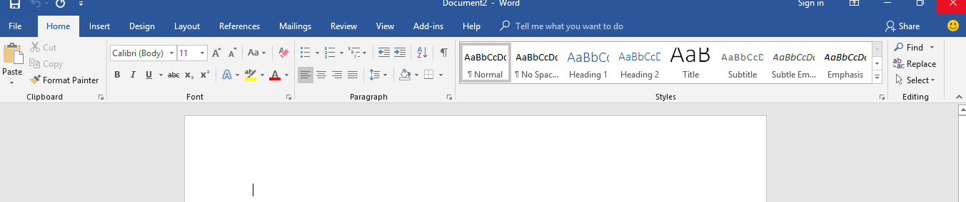

|  |  |
| --- | --- |
| **Principle** | **Evaluation** |
| knowledge in world &  knowledge in the head | Ms. Word Office 2016 is a document editing software which is geared towards the manipulation of word text documents. The interface has well been designed to achieve the goal of manipulation of the documents.  At the Syntactic level describes the conceptual entities and operations are provided in the toolbar whereby the user can perform various operations which include markup operations, save and deletion of content in the documents |
| Simplify task structures. | Ms. Word has a user-friendly interface structure too suit all type of users including a first-time user given that it uses iconic  entities to represent operations that can be done towards a given task. |
| Make things visible | Ms. Word has used visual elements for dropdown arrows at the at the Semantic level which are mapped to the objects at Syntactic level, for the user |
| Get the mapping right | At the top left corner of the Ms. Word application, there exists an icon of a floppy disk which symbolizes storing of data. This performs the function of saving the content modified by the user. |

|  |  |
| --- | --- |
| Convert constrains into advantages | Ms. Word in regards to constrains has been able to group related functionalities as a set which enables the user to easily use these operations. Eg the bold, italic and underline functions have been grouped under one set and placed adjacent to each other |
| Design for Error | Ms. Word has been designed to cater for user errors in that it automatically corrects common mistakes that cannot be blamed on the users for instance, ‘sAMPLE’ is automatically corrected to ‘Sample’. It also uses a red line to enable user identify grammatical and spelling errors. |
| When all else fails –  Standardize | Standardization in Ms. Word has been achieved by setting default constraints for instance the use of default margins to specify the start and the end of the margins where the content  lays. |

***2. Draw an’ interaction model’ based on Norman’s model for the following Interface: Assume all data. An interface for checking number of Leaves (absence with permission) availed off by a student and their type (Medical, Vacation; Conference visits . Refer to the student leave rules of your institution for necessary constraints and other relevant data.***

