Top of Form



Bottom of Form

* [UML diagrams](https://www.uml-diagrams.org/)
* [Class diagrams overview](https://www.uml-diagrams.org/class-diagrams-overview.html)
* [Class](https://www.uml-diagrams.org/class.html)
* [Interface](https://www.uml-diagrams.org/interface.html)
* [Data type](https://www.uml-diagrams.org/data-type.html)
* [Property](https://www.uml-diagrams.org/property.html?context=class-diagrams)
* [Operation](https://www.uml-diagrams.org/operation.html)
* [Multiplicity](https://www.uml-diagrams.org/multiplicity.html?context=class-diagrams)
* [Visibility](https://www.uml-diagrams.org/visibility.html?context=class-diagrams)
* [Constraint](https://www.uml-diagrams.org/constraint.html?context=class-diagrams)
* [Object](https://www.uml-diagrams.org/object.html)
* [Association](https://www.uml-diagrams.org/association.html?context=class-diagrams)
* [Aggregation](https://www.uml-diagrams.org/aggregation.html?context=class-diagrams)
* [Composition](https://www.uml-diagrams.org/composition.html?context=class-diagrams)
* [Generalization](https://www.uml-diagrams.org/generalization.html?context=class-diagrams)
* [Dependency](https://www.uml-diagrams.org/dependency.html?context=class-diagrams)
* [Abstraction](https://www.uml-diagrams.org/abstraction.html?context=class-diagrams)
* [Nested classifiers](https://www.uml-diagrams.org/nested-classifier.html)
* [Reference](https://www.uml-diagrams.org/class-reference.html)
* [Examples](https://www.uml-diagrams.org/class-diagrams-examples.html)
* [UML index](https://www.uml-diagrams.org/index-references.html)

**UML Class and Object Diagrams Overview**

**Class diagram** is **UML** [structure diagram](https://www.uml-diagrams.org/uml-25-diagrams.html#structure-diagram) which shows structure of the designed system at the level of [classes](https://www.uml-diagrams.org/class.html) and [interfaces](https://www.uml-diagrams.org/interface.html), shows their [features](https://www.uml-diagrams.org/uml-core.html#feature), [constraints](https://www.uml-diagrams.org/constraint.html?context=class-diagrams) and relationships - [associations](https://www.uml-diagrams.org/association.html??context=class-diagrams), [generalizations](https://www.uml-diagrams.org/generalization.html?context=class-diagrams), [dependencies](https://www.uml-diagrams.org/dependency.html), etc.

Some common types of class diagrams are:

* [domain model diagram](https://www.uml-diagrams.org/class-diagrams-overview.html#domain-model-diagram),
* [diagram of implementation classes](https://www.uml-diagrams.org/class-diagrams-overview.html#implementation-classes).

[Object diagram](https://www.uml-diagrams.org/class-diagrams-overview.html#object-diagram) could be considered as instance level class diagram which shows [instance specifications](https://www.uml-diagrams.org/uml-core.html#instance-specification-core) of classes and interfaces ([objects](https://www.uml-diagrams.org/object.html)), [slots](https://www.uml-diagrams.org/property.html#slot) with value specifications, and [links](https://www.uml-diagrams.org/association.html#link) (instances of [association](https://www.uml-diagrams.org/association.html)).

**Domain Model Diagram**

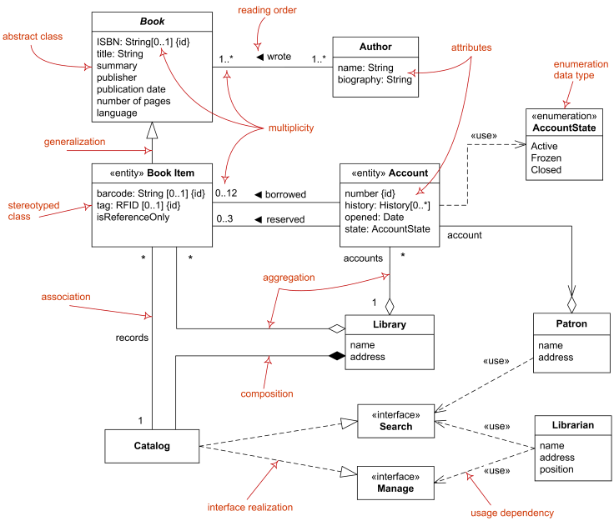

Domain diagram overview - classes, interfaces, associations, usage, realization, multiplicity.

**Diagram of Implementation Classes**

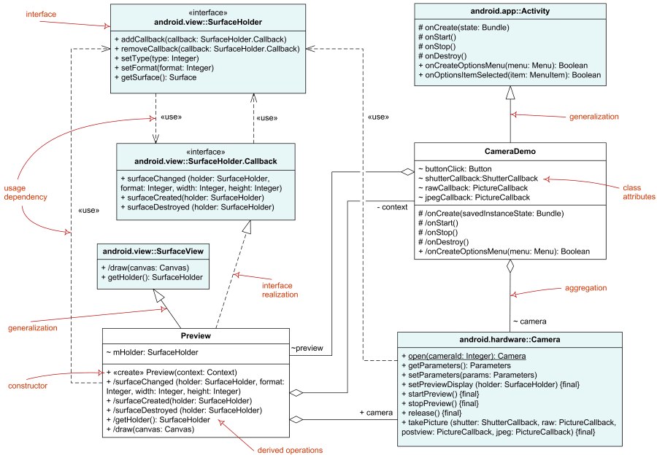

Elements of implementation class diagram - classes, interfaces, associations, usage, realization.

**Object Diagram**

**Object diagram** was defined in now obsolete [UML 1.4.2 Specification](https://www.uml-diagrams.org/references.html#ref-uml-142) as "a graph of instances, including objects and data values. A static object diagram is an instance of a class diagram; it shows a snapshot of the detailed state of a system at a point in time." It also stated that object diagram is "a class diagram with objects and no classes."

**UML 2.4** specification simply provides no definition of **object diagram** except that "the following nodes and edges are typically drawn in an object diagram: Instance Specification and Link (i.e., Association)."

Note, that UML 2.5 standard hierarchy of diagrams (see [UML 2.5 diagrams overview](https://www.uml-diagrams.org/uml-25-diagrams.html)), shows class diagrams and object diagrams as completely unrelated. Some other authoritative UML sources state that [component diagrams](https://www.uml-diagrams.org/component-diagrams.html) and [deployment diagrams](https://www.uml-diagrams.org/deployment-diagrams-overview.html) containing only [instance specifications](https://www.uml-diagrams.org/uml-core.html#instance-specification-core) are also special kinds of object diagrams.

**Object diagram** overview below shows some major elements of object diagram - named and anonymous [instance specifications](https://www.uml-diagrams.org/uml-core.html#instance-specification-core) for [objects](https://www.uml-diagrams.org/object.html), [slots](https://www.uml-diagrams.org/property.html#slot) with value specifications, and [links](https://www.uml-diagrams.org/association.html#link) (instances of [association](https://www.uml-diagrams.org/association.html)).

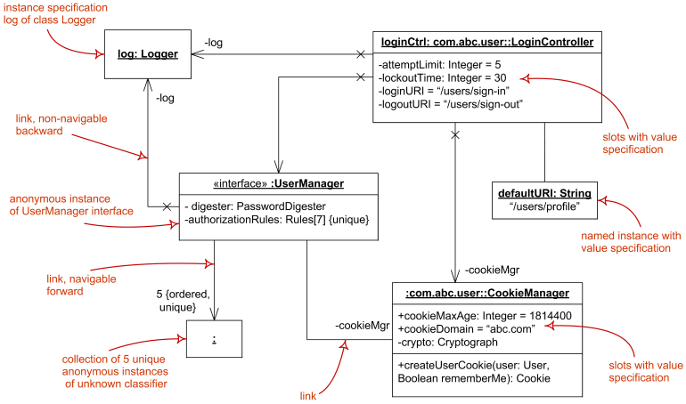

Object diagram overview - instance specifications, value specifications, slots, and links.

Noticed a spelling error? Select the text using the mouse and press Ctrl + Enter.

[https://www.google.com/images/icons/ui/gprofile_button-44.png](https://plus.google.com/u/0/100310735326224144303)

[https://www.google.com/images/icons/ui/gprofile_button-44.png](https://plus.google.com/100310735326224144303)  [Orphus system](http://orphus.ru/)  [Powered by 100% wind energy](https://www.ipage.com/green-certified/)  https://shield.sitelock.com/shield/www.uml-diagrams.org  by [Kirill Fakhroutdinov](https://plus.google.com/100310735326224144303?rel=author)

This document describes UML versions up to [**UML 2.5**](https://www.uml-diagrams.org/references.html#ref-uml-25) and is based on the corresponding **OMG™ Unified Modeling Language™ (OMG UML®)** specifications. UML diagrams were created in **Microsoft® Visio®** 2007-2016 using [**UML 2.x Visio Stencils**](http://softwarestencils.com/uml/index.html). [**Lucidchart**](https://www.lucidchart.com/pages/examples/uml_diagram_tool) is a nice, free UML tool that I recommend for students.

You can send your comments and suggestions to [webmaster](mailto:webmaster@uml-diagrams.org) at **webmaster@uml-diagrams.org**.

*Copyright © 2009-2018 uml-diagrams.org. All rights reserved.*

* [Site License](https://www.smartdraw.com/software/smartdraw-site-license.htm)
* [What's New](https://www.smartdraw.com/whats-new/)
* [Support](https://www.smartdraw.com/support/)
* [Login](https://www.smartdraw.com/myaccount/)

Top of Form



Bottom of Form

[SmartDraw](https://www.smartdraw.com/)

* [Home](https://www.smartdraw.com/)
* [Diagrams](https://www.smartdraw.com/diagrams/)
* [Solutions](https://www.smartdraw.com/solutions/)
* [Templates](https://www.smartdraw.com/templates/)
* [Features](https://www.smartdraw.com/features/)
* [Buy](https://www.smartdraw.com/buy/)
* [Blog](https://www.smartdraw.com/blog/)
* [Try it Now](https://www.smartdraw.com/downloads/)

Top of Form

# Activity Diagram

1. [WHAT IS AN ACTIVITY DIAGRAM?](https://www.smartdraw.com/activity-diagram/#whatisActivityDiagram)
2. [ACTIVITY DIAGRAM SYMBOLS](https://www.smartdraw.com/activity-diagram/#activityDiagramSymbols)
3. [ACTIVITY DIAGRAM EXAMPLES](https://www.smartdraw.com/activity-diagram/#activityDiagramExamples)
4. [HOW TO MAKE AN ACTIVITY DIAGRAM](https://www.smartdraw.com/activity-diagram/#activityDiagramTutorial)
5. [HOW TO MAKE UML DIAGRAMS](https://www.smartdraw.com/uml-diagram/how-to-make-uml-diagrams.htm)
6. [UML DIAGRAM TIPS](https://www.smartdraw.com/uml-diagram/uml-diagram-tips.htm)
7. [OTHER UML DIAGRAMS](https://www.smartdraw.com/uml-diagram/)

With SmartDraw, You Can Create More than 70 Different Types of Diagrams, Charts, and Visuals.

[Learn More](https://www.smartdraw.com/diagrams/?exp=ste)

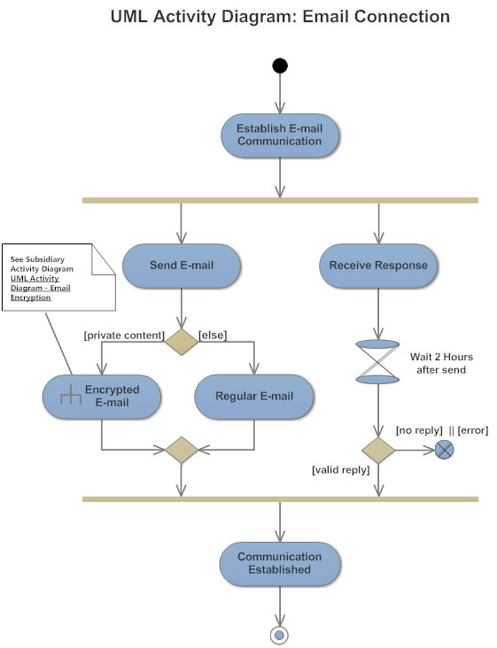

## What is an Activity Diagram?

An activity diagram visually presents a series of actions or flow of control in a system similar to a [flowchart](https://www.smartdraw.com/flowchart/) or a [data flow diagram](https://www.smartdraw.com/data-flow-diagram/). Activity diagrams are often used in business process modeling. They can also describe the steps in a [use case diagram](https://www.smartdraw.com/use-case-diagram/). Activities modeled can be sequential and concurrent. In both cases an activity diagram will have a beginning (an initial state) and an end (a final state). In between there are ways to depict activities, flows, decisions, guards, merge and and time events and more. Learn about activity diagram symbols below:

## Basic Activity Diagram Notations and Symbols

##### Initial State or Start Point

A small filled circle followed by an arrow represents the initial action state or the start point for any activity diagram. For activity diagram using swimlanes, make sure the start point is placed in the top left corner of the first column.

Start point symbol - Activity diagram

##### Activity or Action State

An action state represents the non-interruptible action of objects. You can draw an action state in SmartDraw using a rectangle with rounded corners.

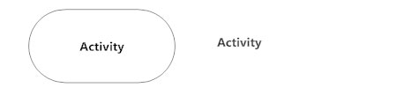

##### Action Flow

Action flows, also called edges and paths, illustrate the transitions from one action state to another. They are usually drawn with an arrowed line.

Action flow - Activity diagram

##### Object Flow

Object flow refers to the creation and modification of objects by activities. An object flow arrow from an action to an object means that the action creates or influences the object. An object flow arrow from an object to an action indicates that the action state uses the object.

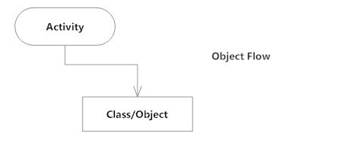

##### Decisions and Branching

A diamond represents a decision with alternate paths. When an activity requires a decision prior to moving on to the next activity, add a diamond between the two activities. The outgoing alternates should be labeled with a condition or guard expression. You can also label one of the paths "else."

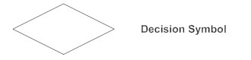

##### Guards

In UML, guards are a statement written next to a decision diamond that must be true before moving next to the next activity. These are not essential, but are useful when a specific answer, such as "Yes, three labels are printed," is needed before moving forward.

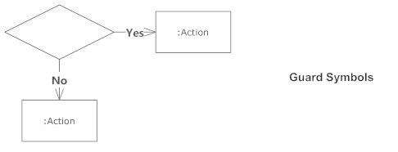

##### Synchronization

A fork node is used to split a single incoming flow into multiple concurrent flows. It is represented as a straight, slightly thicker line in an activity diagram.

A join node joins multiple concurrent flows back into a single outgoing flow.

A fork and join mode used together are often referred to as synchronization.

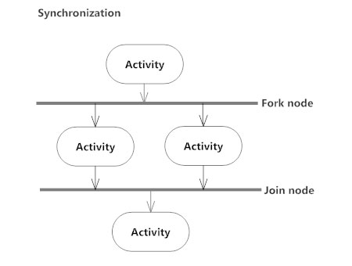

##### Time Event

This refers to an event that stops the flow for a time; an hourglass depicts it.

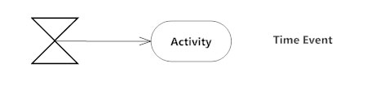

##### Merge Event

A merge event brings together multiple flows that are not concurrent.

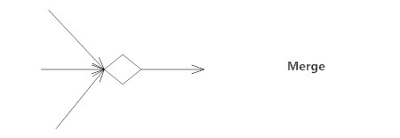

##### Sent and Received Signals

Signals represent how activities can be modified from outside the system. They usually appear in pairs of sent and received signals, because the state can't change until a response is received, much like synchronous messages in a [sequence diagram](https://www.smartdraw.com/sequence-diagram/). For example, an authorization of payment is needed before an order can be completed.

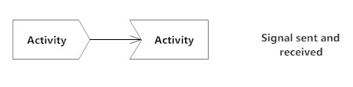

##### Interrupting Edge

An event, such as a cancellation, that interrupts the flow denoted with a lightning bolt.

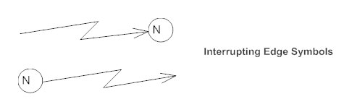

##### Swimlanes

Swimlanes group related activities into one column.

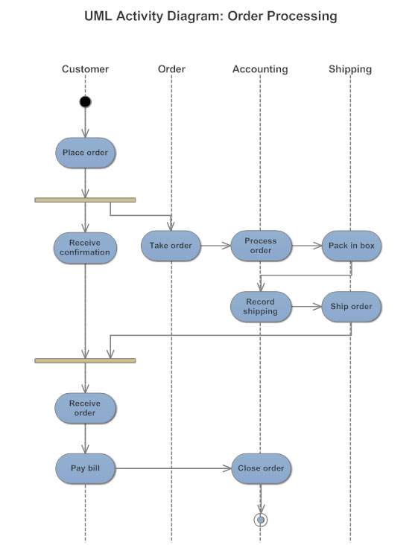

##### Final State or End Point

An arrow pointing to a filled circle nested inside another circle represents the final action state.

End point symbol - Activity diagram

## Activity Diagram Examples

The best way to understand activity diagrams is to look at some examples of activity diagrams.

Click on any of these activity diagrams included in SmartDraw and edit them:

[[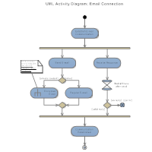](https://cloud.smartdraw.com/?ex=2adbabc7-deab-4a28-a1b4-4a02a63798ac)Activity Diagram - Email Connection](https://cloud.smartdraw.com/?ex=2adbabc7-deab-4a28-a1b4-4a02a63798ac)

[[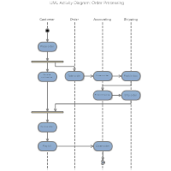](https://cloud.smartdraw.com/?ex=cf65ecf0-649d-412b-bee2-f46b5baeea49)Activity Diagram - Order Processing](https://cloud.smartdraw.com/?ex=cf65ecf0-649d-412b-bee2-f46b5baeea49)

[Browse SmartDraw's entire collection of activity diagram examples and templates](https://www.smartdraw.com/activity-diagram/examples/)

## Activity Diagram Tutorial

You can make an activity diagram by connecting and joining various activity states. The starting point is usually marked with a dark, filled-in circle with an errow pointing to the next state usually a rectangle with rounded corners. All action flows are represented with arrows indicating the transitions from state to state.

SmartDraw makes drawing activity diagrams easy with built-in activity diagram templates that already have all the basic symbols docked and the tools to connect everything at your fingertips.

## Two ways to get started

#### [Use the online edition of SmartDraw on any computer or tablet](https://cloud.smartdraw.com/)

[Start Now](https://cloud.smartdraw.com/)

#### [Download the Windows desktop edition of SmartDraw](https://www.smartdraw.com/downloads/download.htm)

[Download](https://www.smartdraw.com/downloads/download.htm)

#### More info

* [UML Diagram Tool](https://www.smartdraw.com/uml-diagram/uml-diagram-tool.htm)
* [Software design diagram templates](https://www.smartdraw.com/uml-diagram/software-design-diagram-templates.htm)
* [Data flow diagram software](https://www.smartdraw.com/data-flow-diagram/data-flow-diagram-software.htm)

Bottom of Form

* [Home](https://www.smartdraw.com/)
* [Diagrams](https://www.smartdraw.com/diagrams/)
* [Solutions](https://www.smartdraw.com/solutions/)
* [Templates](https://www.smartdraw.com/templates/)
* [Features](https://www.smartdraw.com/features/)
* [Support](https://www.smartdraw.com/support/)
* [Blog](https://www.smartdraw.com/blog/)
* [Buy](https://www.smartdraw.com/buy/)
* [About](https://www.smartdraw.com/about/)
* [Privacy (UPDATED)](https://www.smartdraw.com/about/privacy.htm)
* [Sitemap](https://www.smartdraw.com/sd-sitemap/)
* [Flowchart Maker](https://www.smartdraw.com/flowchart/flowchart-maker.htm)
* [Floor Plan Designer](https://www.smartdraw.com/floor-plan/floor-plan-designer.htm)
* [Diagram Software](https://www.smartdraw.com/software/diagram-software.htm)

©1994-2018 SmartDraw, LLC