

**SCHOOL OF COMPUTER SCIENCE AND INFORMATION TECHNOLOGY**

**DEPARTMENT OF INFORMATION TECHNOLOGY**

**PROJECT TITLE:**

**FRESH FARM PRODUCE MARKET**

**NAME: KURIA BONFACE METHU**

**REGISTRATION NUMBER: C025-01-0935/2015**

**SUPERVISOR: MR JAMES IRAYA**

**DATE OF SUBMISSION: June 8, 2018**

NAME: KURIA BONFACE METHU

REGISTRATION NUMBER: C025-01-0935/2015

SIGNATURE: ……………

DATE: …………………………

SUPERVISOR

NAME: MR JAMES IRAYA

SIGNATURE: ………………………………….

DATE: …………………………...

# ABSTRACT

The proposed system will help solve the problem faced by the agriculturists in Kenya where they lack a better way to link to the customers of the agricultural produce. The system will also help the farmers to get rid of the middlemen who exploits them by buying from them at cheap prices and then selling the produce to customers at high prices and earn more than the farmers despite exploiting the consumers. The system will also help the customers of the agricultural produce to get a reliable supplier and be guaranteed of fresh produce which is not contaminated since its direct from the farmer. The farmer will also get a reliable means of payment from the system upon the delivery of the produce to the customer. The system will include a location feature which will help the customer locate the nearest farmer (producer) of whichever product he/she needs.

Table of Contents

ABSTRACT 3

1 CHAPTER ONE: INTRODUCTION 5

1.1 BACKGROUND OF THE STUDY 5

1.2 PROBLEM STATEMENT 7

1.3 OBJECTIVES 7

1.3.1 general objective 7

1.3.2 specific objectives 7

1.4 SCOPE OF RESEARCH 8

1.5 ASSUMPTIONS MADE 8

1.6 LIMITATIONS OF THE PROJECT 8

1.7 JUSTIFICATION 9

2 CHAPTER TWO: LITERATURE REVIEW 9

2.1 INTRODUCTION 9

2.2 OVERVIEW AND ANALYSIS OF RELATED SYSTEMS 10

2.2.1 Kenya Agricultural Commodity Exchange (KACE) 10

2.2.2 M-farm 10

3 CHAPTER THREE METHODOLOGY 13

3.1.1 Introduction 13

3.2 system development methodology 13

3.3 data collection methods 14

3.4 implementation 14

3.5 Hardware Resources 14

3.6 Software Resources 14

3.7 Appendices 15

3.7.1 Budget 15

3.7.2 Time schedule 15

4 REFERENCES 16

Figure 1 Diagrammatic representation of RAD development 14

Figure 2 gant chat 15

# CHAPTER ONE: INTRODUCTION

## BACKGROUND OF THE STUDY

Agriculture is the mainstay of the Kenyan economy directly contributing 26 per cent of the GDP annually, and another 25 per cent indirectly. The sector accounts for 65 per cent of Kenya’s total exports and provides more than 70 per cent of informal employment in the rural areas (GoK, 2015). This translates how vital agriculture is in Kenya. Too many of the Kenyans depends on agriculture for subsistence and for business purposes, so agriculture is not only driver of Kenya’s economy but also the means of livelihood for the majority of Kenyan people.

The agriculture sector provides more than 18 per cent of formal employment. More than 70 per cent of informal employment is in the rural areas (GoK, 2015). Most of the farmers in Kenya are small scale and produce less quantity at individual levels. Traditionally, most households used to participate in farming for subsistence farming only. Urbanization has rampantly grown in Kenya making many people to move in the urban areas for jobs. This has called a great need for agricultural produce for food for the people living in the urban areas. All this now transformed farming from subsistence to agri-business where even the small scale farmers participate in farming for purposes of business. Most agriculturalists in Kenya suffer from unreliable markets of their produce. Some of the small-scale farmers sell their produce to the brokers (middlemen) who purchase it very cheaply sometimes. The vegetables sometimes go bad at the farms due to lack of buyers and bearing in mind that they are highly perishable. Some farmers are forced to feed their livestock with some of this vegetable i.e. cabbages, carrots, potatoes, tomatoes etc. when their sale becomes unworthy. This has made many farmers to abandon some crops claiming they are unprofitable. When it comes to animal products, there are many products which are so nutritious and very useful but the farmers continue to suffer for their poor prices from the middlemen. The products include cow milk, eggs, meat, mutton, pork, etc. most of the farmers put all the efforts on their livestock but leaps not the fruits of having them in place. The demand of all this farm produce is so high in the urban areas and some rural areas where certain crops do not do well, but the supply is really low which is as a result of farmers unwilling to sell the produce at a throw-away price.The beauty of agriculture can only be found in satisfaction of the farmers and the final consumers. To the farmers, it can be achieved when the farmers receive the correct pay of they produce in a timely manner and in the reliable means of payment. To the final consumers, satisfaction is achieved when they get quality products and very fresh from the farms without too many transitions which brings along contamination. The development of institutional arrangements that are needed to make markets work better for the poor, especially those needed to lower transaction costs, improve market coordination and ensure availability of price information, is needed in order to improve access of the poor to new input technologies and output markets. In this regard, pro-poor market information is the key to making markets work for the poor in Africa. Market information is needed for farmers to choose what commodities to produce, what technologies to apply for production, when to produce, for whom to produce, and when and at what price to sell. Market information also empowers the farmer with bargaining power for a better price in the market place. Without this, the farmers is greatly disadvantaged against middlemen and traders who often have better access to market information. In addition, market information can bring about stability in product supplies and prices in time and space.(Mukhebi, 2004)

The

## PROBLEM STATEMENT

Most farmers in Kenya suffer from exploitation by the middlemen traders who purchase their produce at the farmers gates at very low prices thus making them very poor where in many cases they earn less than 1000 USD per year (Ferreira & Goh, 2015). Most farmers in Kenya decide upon production quantities and harvest their crops before knowing how much their crops can be sold for. This price uncertainty makes it diﬃcult for farmers to make optimal production and harvesting decisions leaving them with little or no choice to sell their produce and end up to selling their produce to traders who stop by their farm gates (Ferreira & Goh, 2015).

Due to the existence of long supply chain, there has been much expenses incurred by these traders including the holding costs in the warehouses (storage cost), transportation costs, preservation costs and the cost of the produce from the farmers, it translates to expensive food produce to the final consumer.

Due to delays of the produce as it exchanges hands in the long supply chain, the freshness of the produce is compromised when it gets to the final consumer in that it less fresh or never fresh at all.

The consumers/customer of the produce has to travel to the market places for him/her to access what he/she needs. This is tiresome and time consuming especially if he/she stays a little bit far from the market.

## OBJECTIVES

### general objective

To come up with a system where farmers in Kenya can link with the customers of their produce in the most convenient manner and in the fastest way in order to do successful business and providence of fresh produce to the customers.

### specific objectives

1. to come with a system where consumers/customers can make order of desired products from the desired producer with the quantities specified
2. to come up with a system where customers/ consumers can locate the nearest producer of the desired product
3. to come up with a system where both farmers(producers) and the consumers /customers can access real time updates on the market prices of the products in the different areas.
4. to come up with a system where the customer/consumer can make payments of the delivered products
5. to come up with a system where the farmers can get news on the current trends and technologies in the farming industry.

## SCOPE OF RESEARCH

The proposed system is meant to help the Kenyan farmers to reach their local customers in the most convenient way. It deals with agricultural produce, both livestock and farm produce. The system will focus on the marketing of the agricultural produce as well as helping improve the agricultural sector by providing the information the farmers needs and also the current trends in the agricultural sector including how to apply the new technology in the Kenyan set up.

The proposed system also will be an e-commerce platform where exchange of agricultural produce from the farmers to the consumers/customers will happen in exchange for money.

## ASSUMPTIONS MADE

It will be assumed that both the farmers and the customers/consumers in the local market has access to the smartphones or computers and has basic skills of operating them. It is also assumed that they have access to the internet so that they can access the system online.

## LIMITATIONS OF THE PROJECT

The limitation of the proposed project is that farmers may not be willing to adopt the new technology due to inadequate information concerning the mobile devices (smartphones)or complete lack of the know how in their operation.

## JUSTIFICATION

The proposed system will help in the improvement in agriculture in Kenya which is the backbone of the economy and part of the big 4 agenda mid-economy proposed by the Kenyan president this year, by providing the current trends in technology and farming methods to the farmers. This will help the farmers work on the quality and quantity of their produce.

Farmers has also been suffering greatly by poor prices of their produce by the middlemen making them abandon cultivation of certain crops which makes these crops so scarce to the customers despite their great demand. Therefore, the proposed system will assure the farmers of good prices of their produce since the channel is greatly reduced.

The proposed system will also greatly help the customers since it will safe them the hustle and the tussle of looking for quality farm produce to buy since they will do so in the convenient of their homes and time. They will also enjoy relatively lower prices of the produce as when the channels are reduced in the supply chain, the expenses are minimal.

The consumers will also enjoy the freshness of the produce as it has minimal exchange of hands from the farmers meaning they will get the produce in the shortest time possible which reduces the chances of the produce getting bad.

# CHAPTER TWO: LITERATURE REVIEW

## INTRODUCTION

Internet has changed the way people used to do things in the olden times .Since its existence, internet has transformed business in almost all aspects and has become an effective business tool(Tsekouropoulos et al., 2011). In agriculture, e-market places have existed in the recent years and making producer and consumer meet and discuss terms of sale without intermediaries. Agricultural marketing plays a pivotal role in promoting and sustaining agricultural production and productivity, leading to food security and inclusive growth of the country(Scenario, n.d.). due to increased demand of the farm produce by people who live in the urban centers, supply of the produce has been performed by the resellers who purchases the produce from the farmers gates at very low prices and sell it to the consumers at higher prices. This has always been the case because the resellers incur holding costs in the inventories, transportation, preservation of the perishable products like the vegetables and their personal profits. All these calls for the need to cub the many channels of trade in the agricultural sector. Internet has eased this and made it possible for the farmers to meet directly with their consumers/customers.

There has been several systems in the industry which already exists which solves related problems in the society. Several cases has been discussed below which includes Kenya Agriculture Commodity Exchange,

## OVERVIEW AND ANALYSIS OF RELATED SYSTEMS

### Kenya Agricultural Commodity Exchange (KACE)

Kenya agriculture commodity Exchange is a private sector firm in Kenya which was established in 1997. Its primary functions are to act as an information service to enhance price discovery as well as a spot exchange(“Kenya Agricultural Commodity Exchange,” 2018). It mainly focused on linking the buyers and the sellers, importers and exporters of the agricultural commodities in business. KACE deals with various commodities  of  which  maize  and  beans  are  the  most heavily  traded (Karugu, 2010).The  main  activities  of  KACE  include  linking  farmers  and  mainstream  buyers  by  collecting  information on the prices in different markets of various commodities on a daily basis from market  vendors then availing them to the farmers in real time. Trades  are  made  through  competitive  bids  and  offers,  once  a  buyer  and  a  seller  agree  to  trade,  KACE  acts  as  a  clearing  house  and  arranges  the  financial  and  logistical  aspects  of  the  sale (Karugu, 2010).  KACE’s  services include: a mobile  phone  short message service  (SMS), interactive  voice response  (IVR)  service, daily radio bulletins, a live  radio auction service and online computer services (Karugu, 2010).

KACE is limited in that the customers cannot make payments on the system but instead acts as a tool to just link the producer to the consumer. It also lacks the location facility where the consumer fails to have a choice on which producer to get in touch with considering the transportation cost where a consumer/customer need to choose the nearest producer

Fresh farm produce market, the proposed system, focuses on all round farm produce inclusive of vegetables, cereals, fruits, and the animal products like eggs, meat, mutton, pork etc. Its main objective is to provide a platform where the producer can meet with the consumer and deal on a one basis through a mobile application, do the trade and payments done through the application. The farmer is the one to provide the market price based on the market prices in different locations. The main focus of the proposed system is the buying and selling aspect and satisfaction of both the farmer and the consumer as opposed to KACE which focuses on providing information.

### M-farm

M-Farm Ltd is a software solution and agribusiness company. It assists the farmers to to get the information pertaining to the retail rice of their products where they simply SMS the number 20255 (Safaricom Users) (“MFARM Ltd, Kenya | FARMD: Forum for Agricultural Risk Management in Development,” n.d.). they also have a web platform where farmers can sell their produce and the customers to buy on the platform. The web platform operates as described below

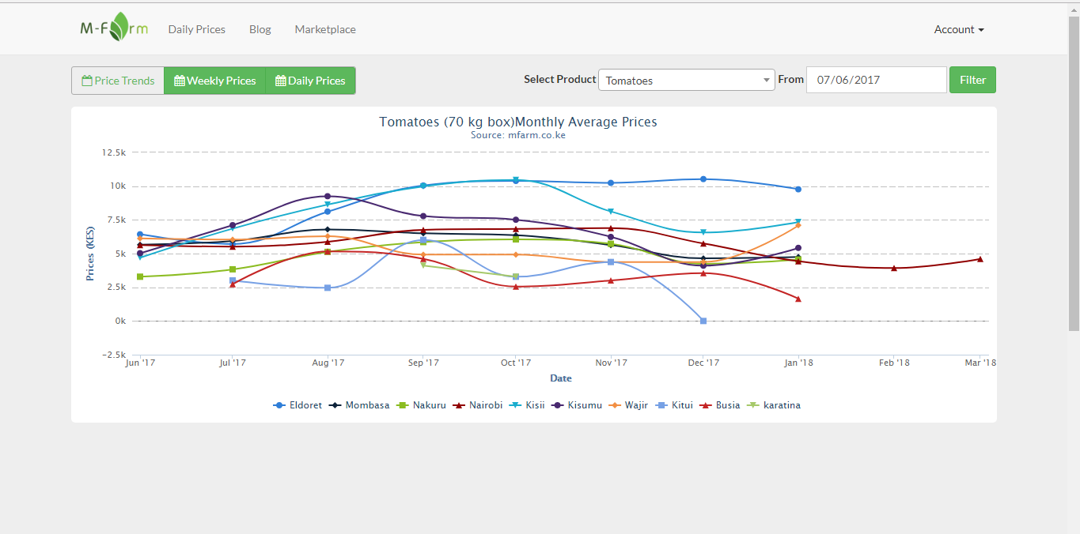

This is the home page where the user is directed after logging in to the system. This page contains the price trends of commodities on a daily basis, weekly basis, and price trends in different places in Kenya.

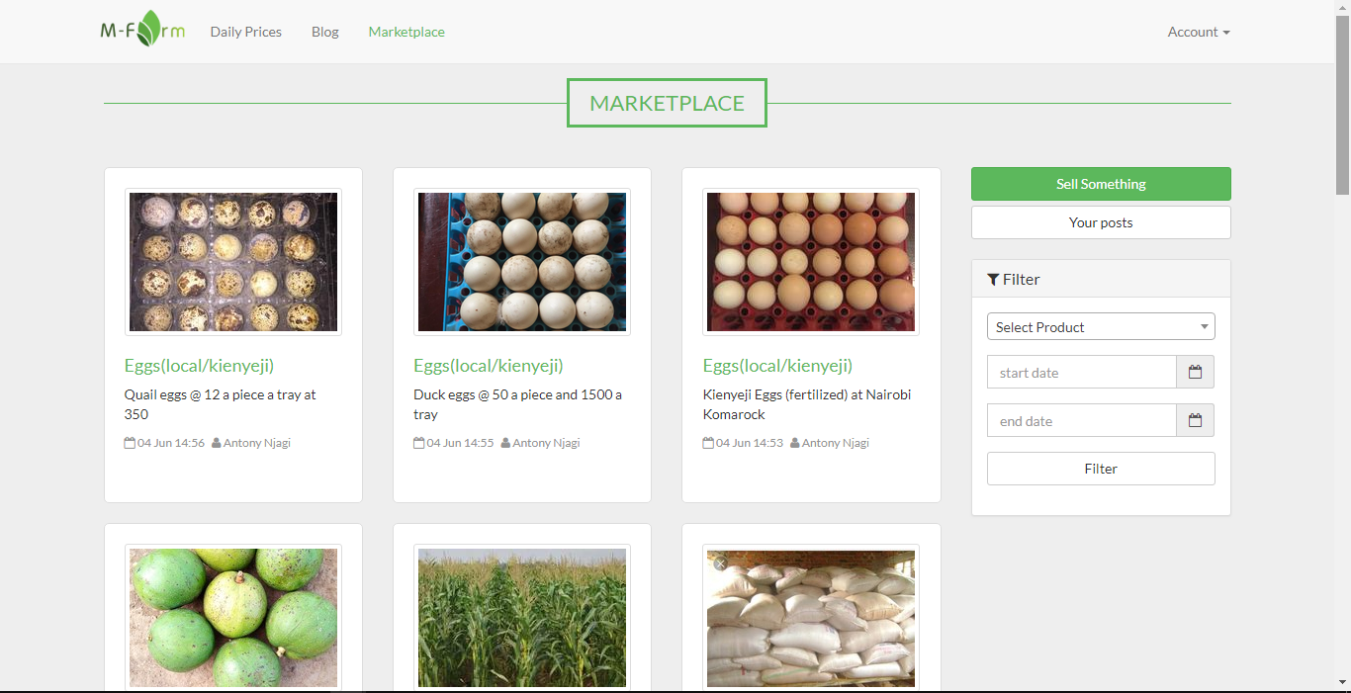

This page contains the market place where sellers posts their produce with images, and basic description. It is also a point where the sellers uploads the commodity they want to sell.

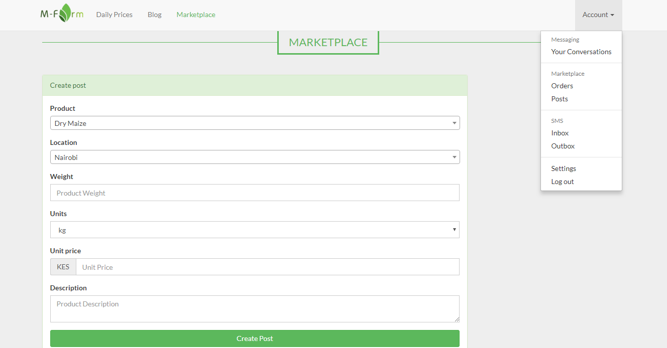

This is where the farmer creates the post of what he/she is selling defining the weighing and units together with the unit price

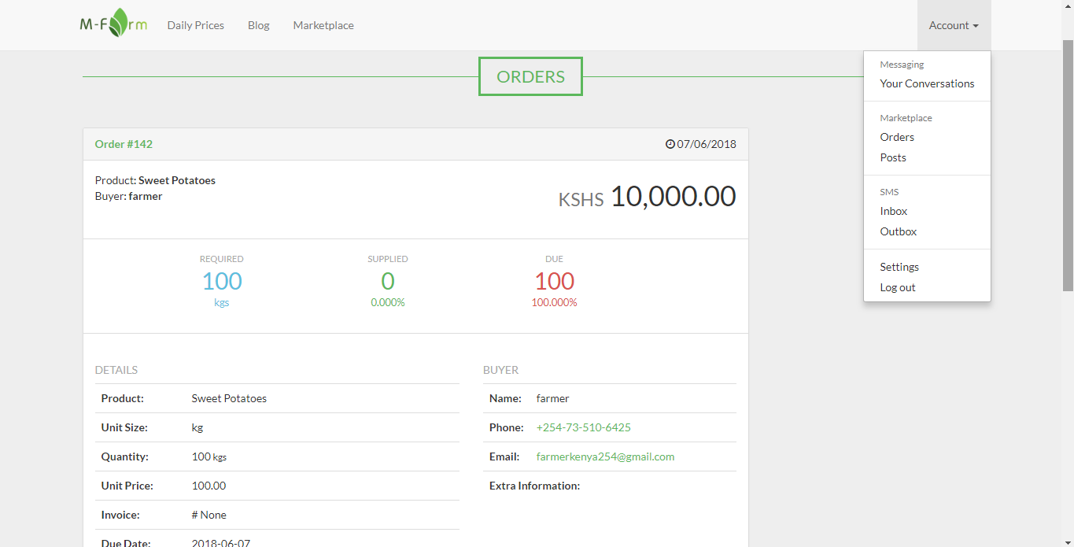

This is where the customer makes the order specifying the product, quantity and the price of the product.

The system also includes a messaging platform where users in the system can chat. The system has some limitations which challenges its well being. It doesn’t have a mechanism to know the genuine sellers of the produce in that anyone can post anything with the name of selling. This makes it possible to have so many jokers in the system which comprises the integrity of the system and its reliance by the genuine customers who need to buy through the system.

Also, the blog of the system is less updated since the latest post was done in the year 2016. The messaging platform of the system is so complex to use as the customer is unable chat the producer direct and instead, selecting the recipient of the message is done manually where the customer selects from a pool of all the users in the system without a search button.

The systems lacks the rating of the farmers/producers /sellers where it is possible to recommend other people to the producers who serves you well as a customer and offers quality products.

The system also, doesn’t include payment options for the customers to make payment through the system when the orders are delivered.

Fresh farm produce market, the proposed system wishes to fix all the above named issues not addressed by the M-Farm. It will provide a platform where there will be approval of the producers to make sure that they are genuine and they have quality products before being allowed to participate in the program to ensure that the systems maintains its integrity and everything in it is trustworthy. Also, the system will include GPRS system where the customer will know the nearest farmer/producer with the products he/she needs with the purposes of saving on the transportation cost of the produce. Fresh farm produce market also wishes to include payment option in the system for the delivered products.

# CHAPTER THREE METHODOLOGY

### Introduction

This section outlines the different methodologies that will be used in developing the proposed system. It will give detail description of the software design methodologies used, data collection methods used, the plan and implementation and the programming languages to be used in development of the proposed system. It also gives rationale behind the choice of the development process and the technologies.

## system development methodology

The proposed system will use Rapid Application development (RAD). RAD puts more emphasis to adaptive process rather than planning. This emphasis works well where short time periods are allocated for a project hence allowing the bulk of work to be done within the stipulated time. Rapid Application Development favors iterative development and the rapid construction of prototypes instead of large amounts of up-front planning. The planning of software developed using RAD is interleaved with writing the software itself. The lack of extensive pre-planning generally allows software to be written much ­­faster and makes it easier to change requirements. The stipulated time to the development of Fresh Farm produce market is limited to eight months, this time is barely enough for the development of a standard system. Hence, for the system in question to be effective enough the system needs increased speed in development. With RAD, high speeds can be achieved while still maintaining the quality of the work.

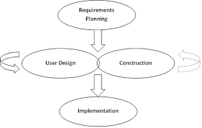

Figure 1 Diagrammatic representation of RAD development

## data collection methods

The intended data collection method in the project implementation includes both primary and the secondary sorces. For the primary sources, Questionnaires, interviews, and observation will be used. For the secondary sources, Journals, Books will be used in the course of the project.

## implementation

The implementation of the project will be done on a UNIX based operating system (ubuntu). The platform of implementation of the proposed project is Nodejs using IONIC framework and Cordova. The intended database to be used is firebase. The reason behind selection of Nodejs platform is because the proposed system is meant to be real time hence highly responsive. Nodejs implements JavaScript on the back end and it runs on googles V8 engine making it highly responsive and interactive. For the database choice, Firebase is a NoSQL database which is quite good with real time systems since it highly responsive.

## Hardware Resources

1. Computer with internet access capability

## Software Resources

1. Operating System – UNIX ubuntu
2. Android studio
3. Web browser – google chrome
4. IDE – Atom
5. Graphics tuning software - Adobe Cs6 Photoshop

## Appendices

### Budget

|  |  |  |
| --- | --- | --- |
|  | **Item** | **Price** |
|  | Computer | 50,000 |
|  | Internet | 10,000 |
|  | Research | 42,000 |
|  | Printing and binding | 5,000 |
|  | Software Licences | 20,000 |
| **Total** | **137,000** |

Table 1 stipulated budget

### Time schedule

#### Gant chat

|  |  |  |  |  |  |  |  |  |
| --- | --- | --- | --- | --- | --- | --- | --- | --- |
| DURATION | May | June | July | August | September | October | November | December |
| TASK |
| FEASIBILITY STUDY |  |  |  |  |  |  |  |  |
| REQUIREMENTS  IDENTIFICATION |  |  |  |  |  |  |  |  |
| RESEARCH |  |  |  |  |  |  |  |  |
| REQUIREMENTS  ANALYSIS |  |  |  |  |  |  |  |  |
| DESIGN |  |  |  |  |  |  |  |  |
| DEVELOPMENT AND CODING |  |  |  |  |  |  |  |  |

Figure 2 gant chat

# REFERENCES

Ferreira, K. J., & Goh, J. (2015). Intermediation in the Supply of Agricultural Products in Developing Economies, (Rapsomanikis), 2.

GoK. (2015). *Agricultural Sector Development Strategy; 2010-2020*. *Government of Kenya Issue*.

Karugu, W. (2010). Kenya Agricultural Commodity Exchange ( KACE ): Linking small ­ scale farmers to markets. *GIM Case Study No. B068*, 1.

Kenya Agricultural Commodity Exchange. (2018, June). In *Wikipedia*.

MFARM Ltd, Kenya | FARMD: Forum for Agricultural Risk Management in Development. (n.d.).

Mukhebi, A. (2004). KENYA AGRICULTURAL COMMODITY EXCHANGE LIMITED ( KACE ) Reaching the Poor in Rural Kenya with Market Information : A Case Study of a Market Information System A Paper for presentation at the CTA Seminar 2004 on the Role of Information Tools in Adrian Mukhe. *A Paper for Presentation at the CTA Seminar 2004 on the Role of Information Tools in Food Security, Maputo, Mozambique*, 1–20.

Scenario, C. (n.d.). 2016-063 Res Rep IDC5 Transforming agr.

Tsekouropoulos, G., Andreopoulou, Z., Koliouska, C., Lefa, S., Koutroumanidis, T., & Batzios, C. (2011). E-marketing and Internet Functions of Agricultural Products in SME in Greece. *CEUR Workshop Proceedings*, *1152*(Haicta 2011), 213–224.