# Chapter three: Methodology

### 3.1.1 Iterative model

Iterative model is will be most preferable model to develop web-based systems. This is because, it focusses on initial, simplified implementation which then progressively gains more complexity and a broader feature set until the final system is complete. And because it’s a cyclic process, after the initial planning stage, a small handful of stages will be repeated over and over, with each completion of the cycle incremented, hence improving the software.

Iteration model consists of the for following stages: initialization, planning and requirement gathering, design and coding, implementation, testing and evaluation.

**Planning and requirement gathering** – in this stage, I will map out the specification of the system. Gather both software and hardware requirement so that to prepare on the upcoming cycles.

**Analysis and design** – after am done with planning, I will have to analyze the requirements so that I come up with the appropriate business logic of the system. Then design the system.

**Implementation** – it is at this stage where I will do coding and implementation into initial iteration of the system.

**Testing** – at this stage, I will perform a series of tests so that to ensure the system works as expected.

**Evaluation** – after completion of the previous stages, I will invite the users of the system to examine the system. If satisfied with it, I deploy it for targeted group to use it.

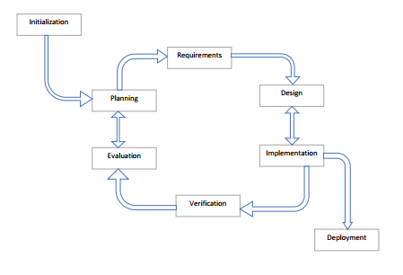

Fig. 3.1 Iteration model

### 3.1.2 Method justification

**Why iterative model?**

There is rapid turnaround meaning that each stage of an iterative process can be slimmed down into smaller and smaller time frames so that to suit the needs of the project.

## 3.3 Resources

* Hardware

1. Computer
2. Modem
3. Hard disk

* Software

1. Xampp server
2. Browser e.g. chrome
3. Editor e.g. atom, sublime etc.
4. Adobe photoshop