**RONGAI LANDSCAPING LIMITED**

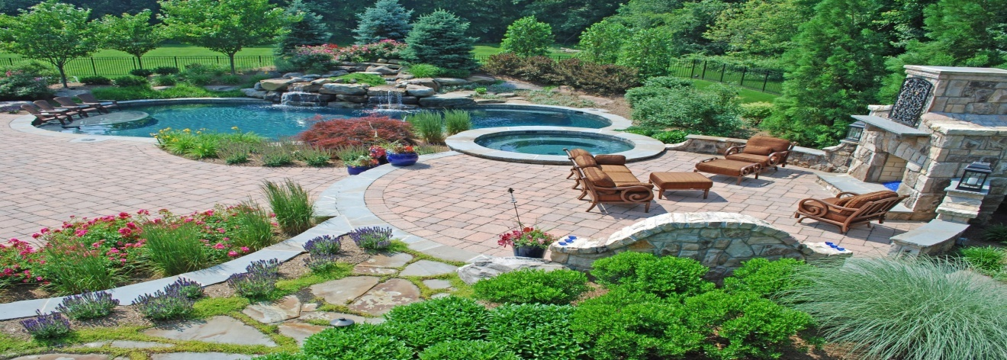

SERVICES WE OFFER

**1. We sell and deliver Flowers to Your Destination**

**2. We Design Layouts For Your Garden**

**3 .We buy Flower’s seeds and young plants**

**4 .We Decorate Your Ceremony Venues**