Technical Story Card

Revision History
Version No. | Date | Prepared by / Modified by | Significant Changes
1 | 22 April 2021 | TEAM 1 | Draft version

Glossary
Abbreviation | Description
BSC | Business Story Card
TSC | Technical Story Card

Table of Contents
1 Introduction 3
2 Scope of Change 3
3 List of impacted modules 3
4 Design and Detailed technical updates 4
4.1 Process model 4
4.1.1 Use case Model 4
4.1.2 Class diagram 5
4.1.3 Sequence diagram 6
4.1.4 Activity diagram 8
4.1.5 DFD diagram 9
4.1.6 Database table 12

4.2 Description 13
4.3 Architecture 17
4.4 Refactoring related changes 18
4.5 Construction strategy and re-use 18
5 Details of Alternative Design Approach 18
6 Other Technical changes 18
6.1 Automation tasks / changes 18
6.2 CI / Build relates tasks / changes 18
6.3 Non-functional related changes 18
7 Additional details 18
7.1 Open Questions / clarifications / Assumptions 18
7.2 Additional notes to technical team 18
8 References 18

Introduction
Online Banking enables customers to easily access banking services without stepping out of their homes. It ensures an increased customer base and has effectively reduced footfalls in the physical bank structure. It also ensures quick and prompt services to the customers.

Under this paradigm, clients are able to register in the app and henceforth login. Clients can deposit money, transfer money, withdraw money 24*7 round the clock. There is also an additional feature of availing loans as well. They can also submit their valuable feedback from time to time.

Secondary utility functions such as changing password and balance enquiries can also be executed.

Scope of Change
Change will not be entertained and whatever specifications mentioned in this document is final.

List of impacted modules
All the functional modules will be created from scratch.

Design and Detailed technical updates

Process model

Use case Model

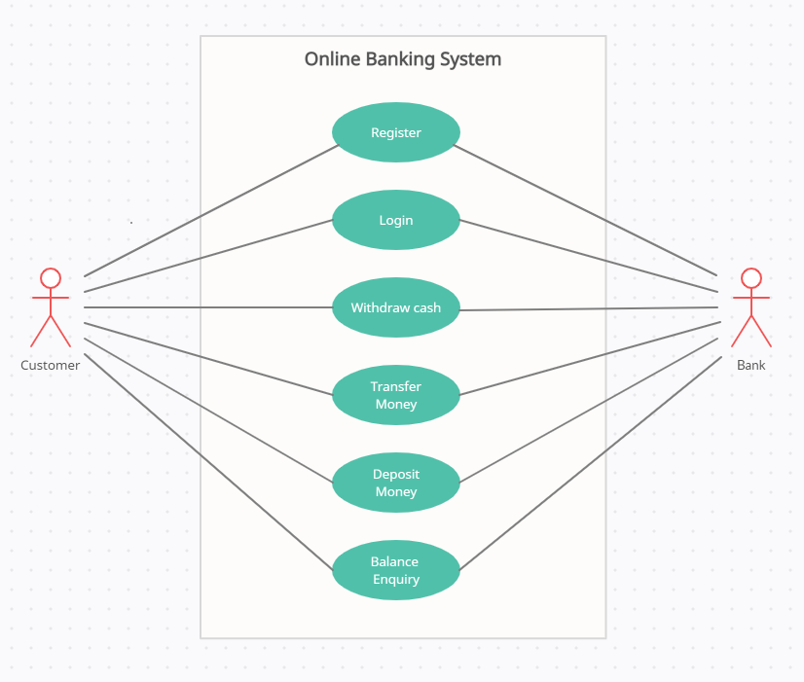

Class diagram

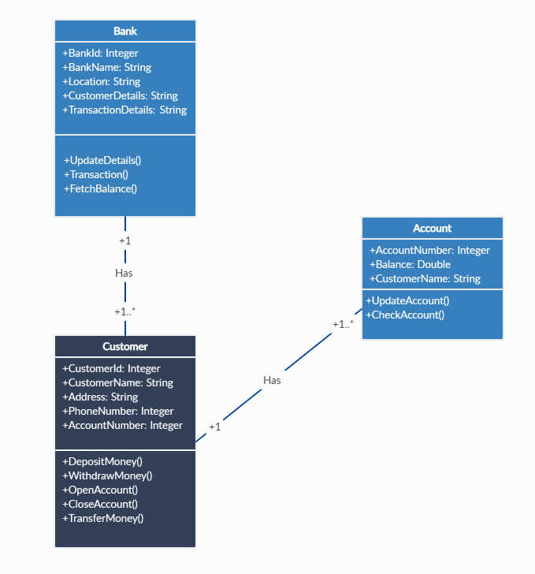

Sequence diagram

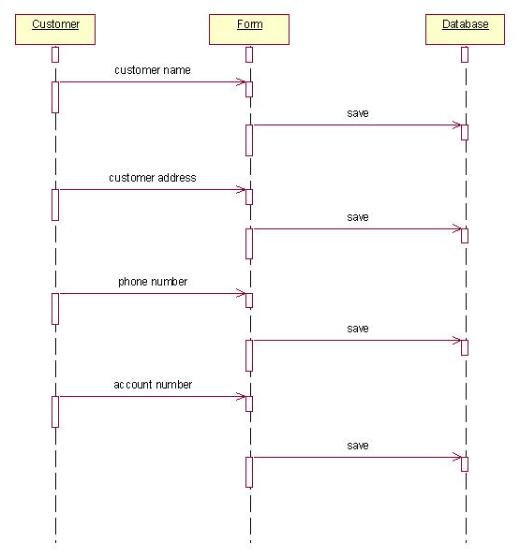

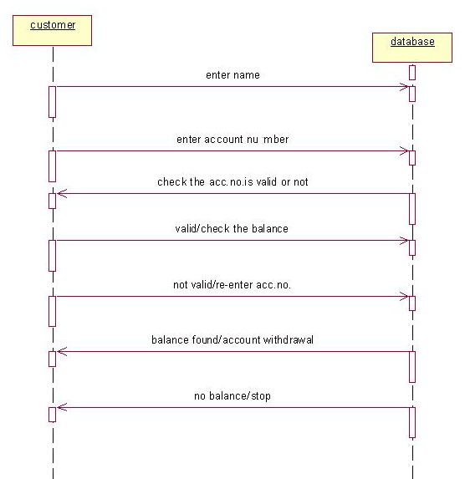
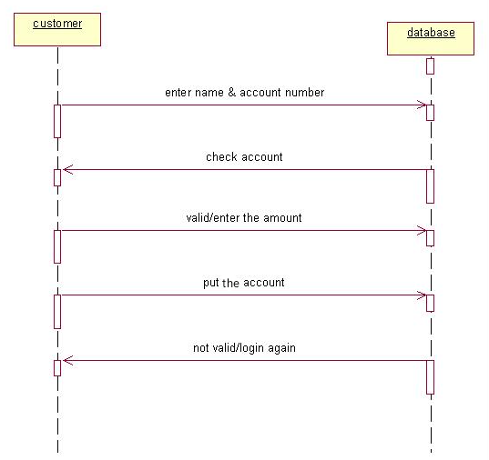

Activity Diagram:

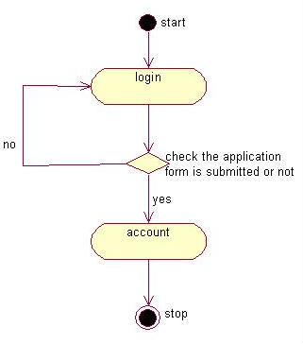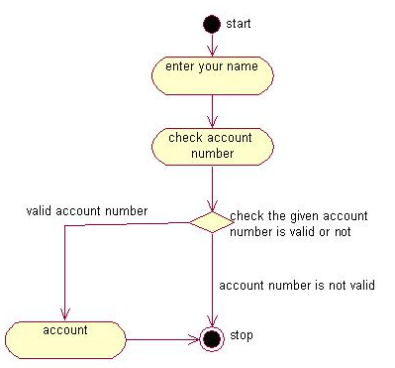

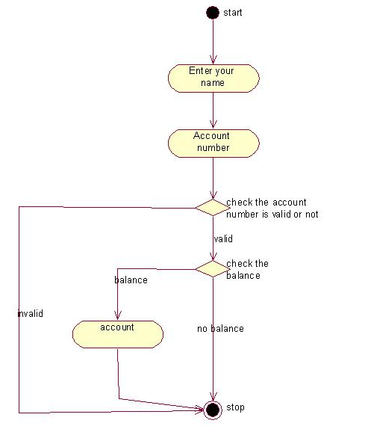

DFD

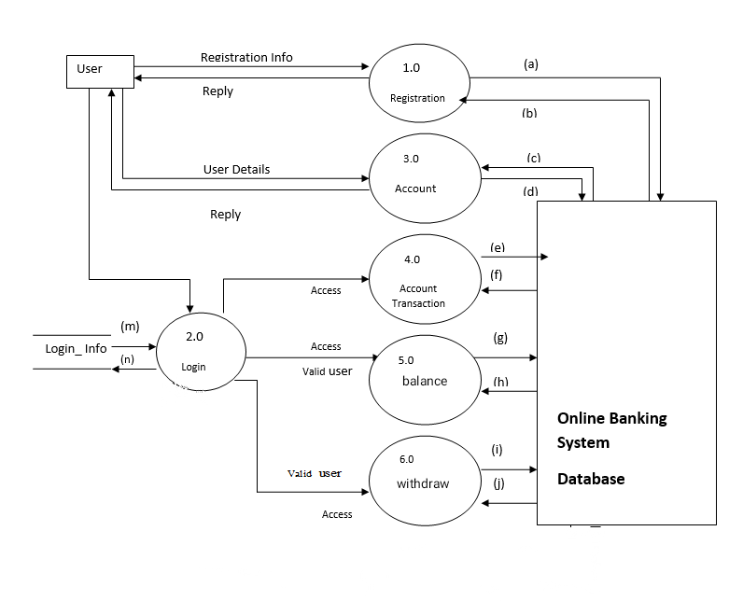

Fig: Level 1 DFD

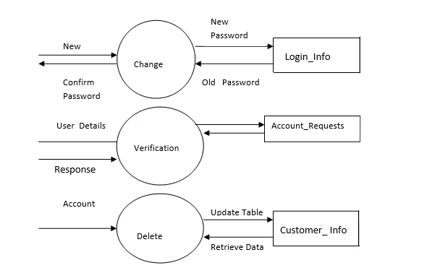

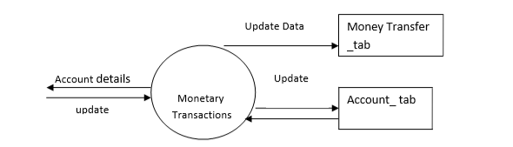

Fig: Level 2 process 1

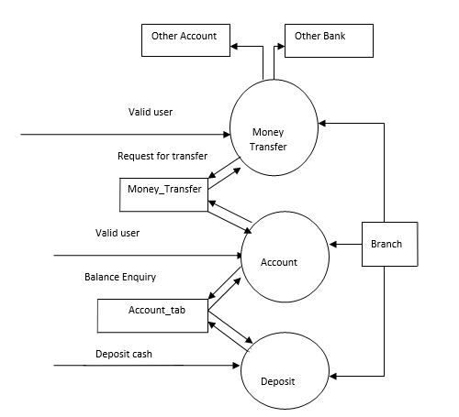

Fig: Level 2 process 2

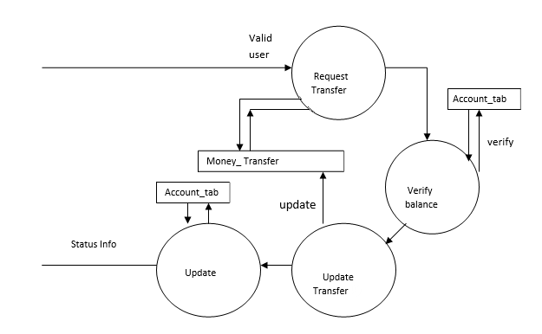

Fig: Level 3

4.1.6 Database Table

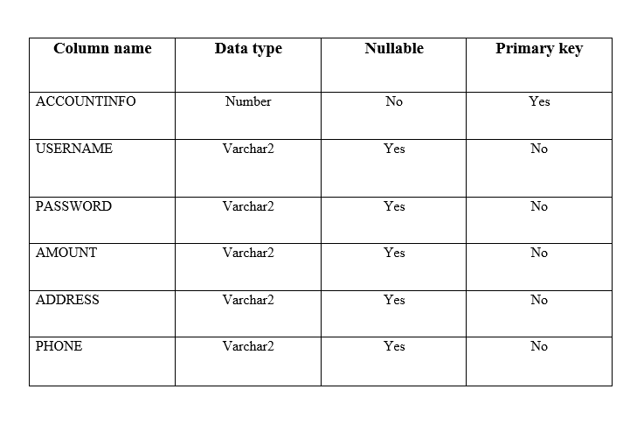

Description

Brief Description | Client Registration
Basic Flow | This use case describes how a client register in to the system  - The client has to register himself into the system.  - After the successful registration, client will get a success message.  - The following information is required during registration.  - Name  - Address  - Email  - Mobile Number  - Account Number
Alternate Flow | - The system will validate the information provided. If any invalid data is found, the input form will be redirected with error message.
Validation | - Name is required and minimum 3 characters and max 30 characters.  - Address can be alphanumeric.  - City/State/Country/Province should be selected from a drop-down.  - The Email should be valid.  - Account details should be valid.
Pre-Conditions | User should have network access and Browser with latest updates.
Post-Conditions | Success message should be shown.

Brief Description | Login
Basic Flow | This use case describes how a client can log-in in to the system  - The client has to enter details and login-in  - After the successful login, user will be taken to the appropriate landing page.  - The following information is required to login.  - Username  - Password
Alternate Flow | - The system will validate the credentials provided. If credentials are invalid, login form will be redirected again with error message.
Validation | - Valid username  - Valid password
Pre-Conditions | User should have network access and Browser with latest updates.
Post-Conditions | Landing page has to be displayed.

Brief Description | Deposit money
Basic Flow | This use case describes how a client can initiate to deposit money in his/her own account.  - The client has to login into the system.  - The following information is required to deposit money.  - Amount to deposit  - Account number  - Username  - Password
Alternate Flow | - The system will validate the information provided. If any invalid data is found, the input form will be redirected with error message.
Validation | - Username should be valid  - Password should be a valid  - Amount should be greater than zero  - Account number should be valid
Pre-Conditions | User should have already logged into the system.
Post-Conditions | Success message should be shown.

Brief Description | Transfer money
Basic Flow | This use case describes how a client can transfer money.  - The client has to login into the system.  - The following information has to be displayed.  - Account number  - Username  - Password  - Target Account Number  - Amount
Alternate Flow | - The system will validate the credentials provided. If credentials are invalid, login form will be redirected again with error message.
Validation | - Valid username  - Valid password  - Valid account number  - Valid account number  - Valid amount greater than current balance
Pre-Conditions | User should have already logged into the system.
Post-Conditions | Landing page should be displayed.

Brief Description | Balance Enquiry
Basic Flow | This use case describes how a client can check balance enquiry.  - The client has to fill the balance enquiry form.  - The following information is required.  - Account number  - Username  - Password
Alternate Flow | - The system will validate the credentials provided. If credentials are invalid, login form will be redirected again with error message.
Validation | - Valid username  - Valid password  - Valid account number
Pre-Conditions | User should have already logged into the system.
Post-Conditions | Landing page has to be displayed.

Brief Description | Withdraw money
Basic Flow | This use case describes how a client can withdraw money from his/her account.  - The client has to login into the system.  - The following information is required.  - Account number  - Username  - Password  - Amount to withdraw
Alternate Flow | - The system will validate the credentials provided. If credentials are invalid, login form will be redirected again with error message.
Validation | - Valid username  - Valid password  - Valid account number
Pre-Conditions | User should have already logged into the system.
Post-Conditions | Landing page should be displayed.

Brief Description | Close Account
Basic Flow | This use case describes how a client can close an account.  - The client has to register himself into the system.  - The following information is required to close account.  - Username  - Password  - Account number
Alternate Flow | - The system will validate the credentials provided. If credentials are invalid, login form will be redirected again with error message.
Validation | - Valid username  - Valid password
Pre-Conditions | User should have already logged into the system.
Post-Conditions | Landing page has to be displayed.

Architecture

Layer
Logical View
Technology/ Framework

UI Components
Presentation Layer
HTML/ CSS/ JavaScript/ AJAX/ Angular
Export (pdf)
Validations
Resources

Report

Web-Server Classes
Java 1.8/ Spring MVC
Application/ Business Layer
Configuration
Controllers

Service
REST Controllers

Entity/ Model Classes

Data Access Layer
Repository classes
Hibernate ORM

Oracle 11g Database

Presentation Layer:
This layer consists of all UI components.
- Export component: The plug-in is used to export the reports in pdf format. It helps to reduce the workload on the web/ application server.
- Validation component: All basic level data validations should be done at UI level.
- Report component: All reports to be generated to the user, will be processed and generated at the browser end.
- Resources: All HTML/CSS/ images, which are required for the page design.
Application Layer:
This layer comprises of all server and business classes.
- Configuration settings (XML or Class based) will define the application and server configuration.
- Spring Controllers defines the server classes, which are required to process the incoming http requests.
- Service classes are required to perform the required business services.
- REST Controllers to process the HTTP AJAX requests.
- Model classes are used the define the functions of the entities present in the system.
Data Layer:
Data layer is implemented through Hibernate ORM. It will contain the repository classes, which provides interface to the table.

<Mention details of code re-factoring requirements; objective and scope of re-factoring and Changes to be done >

Other Technical changes

CI / Build relates tasks
<If the story requirements are about implementation of continuous integration or build, update the details to be done here>

Non-functional related changes
<Non-functional requirements related to response time, System load or Network load>

Additional details

Open Questions / clarifications / Assumptions
<Mention the details of any open technical questions/clarifications or assumptions made, pertaining to story >

Additional notes to technical team
<provide details if any>

References
https://angular.io/start
https://www.javatpoint.com/spring-tutorial
https://www.oracletutorial.com/oracle-basics/
https://www.restapitutorial.com/lessons/httpmethods.html

