Technical Story Card

Revision History
Version No. | Date | Prepared by / Modified by | Significant Changes
1 | 30th May 2022 | TEAM 1 | Draft version

Glossary
Abbreviation | Description
BSC | Business Story Card
TSC | Technical Story Card

Table of Contents
1 Introduction 3
2 Scope of Change 3
3 List of impacted modules 3
4 Design and Detailed technical updates 4
4.1 Process model 4
4.1.1 Use case Model 4
4.1.2 Class diagram 5
4.1.3 ER diagram 6
4.1.4 Database tables 7

4.2 Description 9
4.3 Architecture 12
4.4 Refactoring related changes 13
4.5 Construction strategy and re-use 13
5 Details of Alternative Design Approach 13
6 Other Technical changes 13
6.1 Automation tasks / changes 13
6.2 CI / Build relates tasks / changes 13
6.3 Non-functional related changes 13
7 Additional details 13
7.1 Open Questions / clarifications / Assumptions 13
7.2 Additional notes to technical team 13
8 References 13

Introduction
Online exams are the norm of recent times in this Covid age. Exam portal enables users to take up tests remotely from anywhere. In the Exam portal web app, users can login and attempt MCQ tests and admins can login and upload MCQ tests.

Under this paradigm, users are able to register in the app and henceforth login. Both admins and users can login using the same portal. Admins can upload, modify and delete tests whereas Users can attempt tests. Admins can also check the status of the Users’ attempts.

Scope of Change
Change will not be entertained and whatever specifications mentioned in this document is final.

List of impacted modules
All the functional modules will be created from scratch.

Design and Detailed technical updates

Process model

Use case Model

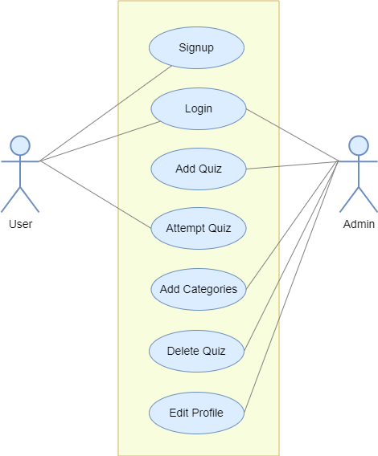

Class diagram

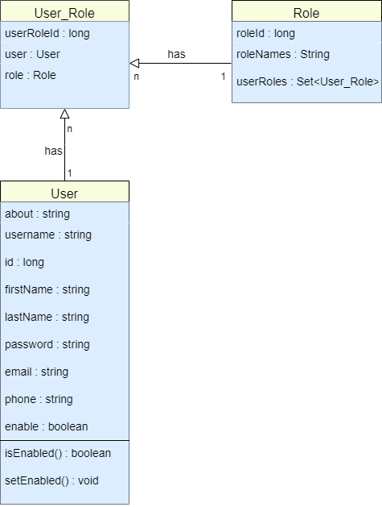

ER diagram

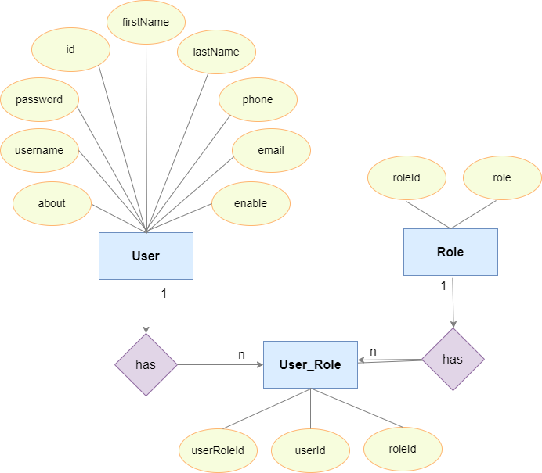

4.1.6 Database Tables

ROLES
COLUMN NAME | COLUMN TYPE | NULLABLE | PRIMARY KEY
role_id | big int | no | yes
role_name | varchar | yes | no

USER_ROLE
COLUMN NAME | COLUMN TYPE | NULLABLE | PRIMARY KEY
user_role_id | big int | no | yes
role_role_id | big int | yes | no
user_id | big int | yes | no

USERS
COLUMN NAME | COLUMN TYPE | NULLABLE | PRIMARY KEY
id | big int | no | yes
email | varchar | yes | no
enabled | bit | no | no
first_name | varchar | yes | no
last_name | varchar | yes | no
password | varchar | yes | no
phone | varchar | yes | no
profile | varchar | yes | no
username | varchar | yes | no

QUESTION
COLUMN NAME | COLUMN TYPE | NULLABLE | PRIMARY KEY
ques_id | big int | no | yes
answer | varchar | yes | no
content | varchar | yes | no
image | varchar | yes | no
option1 | varchar | yes | no
option2 | varchar | yes | no
option3 | varchar | yes | no
option4 | varchar | yes | no
quiz_q_id | big int | yes | no

QUIZ
COLUMN NAME | COLUMN TYPE | NULLABLE | PRIMARY KEY
q_id | big int | no | yes
active_bit | bit | no | no
description | varchar | yes | no
max_marks | varchar | yes | no
number_of_questions | varchar | yes | no
title | varchar | yes | no
category_cid | big int | yes | no

Description

Brief Description | User Signup
Basic Flow | This use case describes how a user registers in to the system  - The user has to register himself into the system.  - After the successful registration, user will get a success message.  - The following information is required during registration.  - Username  - Password  - Email  - Mobile Number  - First Name  - Last Name
Alternate Flow | - The system will validate the information provided. If any invalid data is found, the input form will be redirected with error message.
Validation | - All fields are required.  - The email and phone number should be valid.  - The username must be unique.
Pre-Conditions | User should have network access and Browser with latest updates.
Post-Conditions | Success message should be shown.

Brief Description | Login
Basic Flow | This use case describes how users and admins can log-in in to the system  - The user/admin has to enter details and login-in  - After the successful login, user will be taken to their respective landing page.  - The following information is required to login.  - Username  - Password
Alternate Flow | - The system will validate the credentials provided. If credentials are invalid, login form will be redirected again with error message.
Validation | - Valid username  - Valid password
Pre-Conditions | User should have network access and Browser with latest updates.
Post-Conditions | Landing page has to be displayed.

Brief Description | Admin upload quiz
Basic Flow | This use case describes how a client can upload MCQ tests.  - The admin has to login into the system.  - Click on Add Quiz option  - The following information is required to create new quiz.  - Title  - Description  - Maximum marks  - Number of questions  - Publish status  - Category  - Click on Add button.
Alternate Flow | - The system will validate the information provided. If any invalid data is found, the input form will be redirected with error message.
Validation | - All fields are required.
Pre-Conditions | User should have already logged into the system.
Post-Conditions | Added quiz must be reflected in Quizzes section.

Brief Description | Admin add categories
Basic Flow | This use case describes how an admin can delete quiz.  - The admin has to login into the system.  - Click Add Categories section  - The following information is required.  - Title  - Description
Alternate Flow | - The system will validate the input provided. If inputs are invalid, input form will be redirected again with error message.
Validation | - All fields are required.
Pre-Conditions | User should have already logged into the system.
Post-Conditions | Added category must be reflected in the Categories section.

Brief Description | Admin delete quiz
Basic Flow | This use case describes how an admin can delete quiz.  - The admin has to login into the system.  - Click Quizzes section  - Click Delete button
Pre-Conditions | Admin should have already logged into the system.
Post-Conditions | Quiz must have been deleted from Quizzes section.

Brief Description | Admin update profile
Basic Flow | This use case describes how an admin can update his/her profile.  - The admin has to login into the system.  - Click on Profile section.  - Click on update button.  - The following information is required.  - User id  - Username  - Phone number  - Role  - Status
Alternate Flow | - The system will validate the input provided. If inputs are invalid, input form will be redirected again with error message.
Validation | - All fields are required.
Pre-Conditions | Admin should have already logged into the system.
Post-Conditions | Profile page should be displayed with updated details.

Brief Description | User attempt quiz
Basic Flow | This use case describes how a user can attempt a quiz/MCQ test.  - The user has to register himself into the system.  - The user has to login into the system.  - The user should click on the quiz chosen.  - The user should click on the start button.  - The user should click on submit after giving test.
Pre-Conditions | User should have already logged into the system.
Post-Conditions | Exam page has to be displayed. After submitting result page will be displayed.

Architecture

Layer
Logical View
Technology/ Framework

UI Components
Presentation Layer
HTML/ CSS/ JavaScript/ AJAX/ Angular
Export (pdf)
Validations
Resources

Report

Web-Server Classes
Java 1.8/ Spring MVC
Application/ Business Layer
Configuration
Controllers

Service
REST Controllers

Entity/ Model Classes

Data Access Layer
Repository classes
Hibernate ORM

Oracle 11g Database

Presentation Layer:

This layer consists of all UI components.
- Export component: The plug-in is used to export the reports in pdf format. It helps to reduce the workload on the web/ application server.
- Validation component: All basic level data validations should be done at UI level.
- Report component: All reports to be generated to the user, will be processed and generated at the browser end.
- Resources: All HTML/CSS/ images, which are required for the page design.

Application Layer:

This layer comprises of all server and business classes.
- Configuration settings (XML or Class based) will define the application and server configuration.
- Spring Controllers defines the server classes, which are required to process the incoming http requests.
- Service classes are required to perform the required business services.
- REST Controllers to process the HTTP AJAX requests.
- Model classes are used the define the functions of the entities present in the system.

Data Layer:

Data layer is implemented through Hibernate ORM. It will contain the repository classes, which provides interface to the table.

<Mention details of code re-factoring requirements; objective and scope of re-factoring and Changes to be done >

Other Technical changes

CI / Build relates tasks
<If the story requirements are about implementation of continuous integration or build, update the details to be done here>

Non-functional related changes
<Non-functional requirements related to response time, System load or Network load>

Additional details

Open Questions / clarifications / Assumptions
<Mention the details of any open technical questions/clarifications or assumptions made, pertaining to story >

Additional notes to technical team
<provide details if any>

References
https://angular.io/start
https://www.javatpoint.com/spring-tutorial
https://www.oracletutorial.com/oracle-basics/
https://www.restapitutorial.com/lessons/httpmethods.html

