Analysis Report

Maternal Mortality Ratio Statistical Analysis

World Bank Dataset (API_SH.STA.MMRT_DS2)
This notebook presents comprehensive statistical analysis of global Maternal Mortality Ratio (MMR) data from 1960-2025, including:
- Descriptive statistics and data exploration
- Inferential statistical tests
- Temporal trend analysis
- Regional comparisons
- Visualizations and charts
Dataset loaded successfully!
Shape: (266, 66)
Countries/Regions: 266
Years: 66 (1960 - 2025)
First 10 rows and columns:
1960 1961 1962 1963 1964 1965 \
Country_Code
Aruba ABW NaN NaN NaN NaN NaN NaN
Africa Eastern and Southern AFE NaN NaN NaN NaN NaN NaN
Afghanistan AFG NaN NaN NaN NaN NaN NaN
Africa Western and Central AFW NaN NaN NaN NaN NaN NaN
Angola AGO NaN NaN NaN NaN NaN NaN
Albania ALB NaN NaN NaN NaN NaN NaN
Andorra AND NaN NaN NaN NaN NaN NaN
Arab World ARB NaN NaN NaN NaN NaN NaN
United Arab Emirates ARE NaN NaN NaN NaN NaN NaN
Argentina ARG NaN NaN NaN NaN NaN NaN
1966 1967 1968 1969
Country_Code
Aruba ABW NaN NaN NaN NaN
Africa Eastern and Southern AFE NaN NaN NaN NaN
Afghanistan AFG NaN NaN NaN NaN
Africa Western and Central AFW NaN NaN NaN NaN
Angola AGO NaN NaN NaN NaN
Albania ALB NaN NaN NaN NaN
Andorra AND NaN NaN NaN NaN
Arab World ARB NaN NaN NaN NaN
United Arab Emirates ARE NaN NaN NaN NaN
Argentina ARG NaN NaN NaN NaN

1. Data Exploration and Missing Data Analysis
======================================================================
MISSING DATA ANALYSIS
======================================================================
Missing values per year (first and last 10 years):
1960 266
1961 266
1962 266
1963 266
1964 266
1965 266
1966 266
1967 266
1968 266
1969 266
dtype: int64
...
2015 24
2016 24
2017 24
2018 24
2019 24
2020 24
2021 24
2022 24
2023 24
2024 266
dtype: int64
Total missing values: 7852
Overall missing percentage: 45.41%
Countries with most data completeness (top 10):
Countries with complete data (no missing values): 0
Top 10 countries by data completeness:
Country Completeness_%
(Africa Eastern and Southern, AFE) 60.0
(Afghanistan, AFG) 60.0
(Africa Western and Central, AFW) 60.0
(Angola, AGO) 60.0
(Albania, ALB) 60.0
(Andorra, AND) 60.0
(Arab World, ARB) 60.0
(United Arab Emirates, ARE) 60.0
(Argentina, ARG) 60.0
(Armenia, ARM) 60.0

2. Descriptive Statistics - Overall Summary
======================================================================
DESCRIPTIVE STATISTICS - ALL MATERNAL MORTALITY RATIO VALUES
======================================================================
Count: 9438
Mean: 245.80
Median: 86.00
Mode: 7.00
Standard Deviation: 384.23
Variance: 147635.84
Minimum: 1.00
Maximum: 8045.00
Range: 8044.00
Q1 (25th percentile): 22.00
Q3 (75th percentile): 342.00
IQR: 320.00
Skewness: 5.8863
Kurtosis: 80.5697
======================================================================
SUMMARY STATISTICS BY YEAR (Latest 10 years with data)
======================================================================
count mean std min 25% 50% 75% max
2015 242.0 167.772727 231.812259 1.0 15.00 70.0 222.00 1436.0
2016 242.0 161.165289 227.997501 1.0 15.00 67.0 214.00 1629.0
2017 242.0 155.917355 224.855309 1.0 15.25 63.0 200.00 1662.0
2018 242.0 147.190083 198.533872 1.0 14.25 66.0 198.75 1118.0
2019 242.0 144.896694 207.654801 1.0 14.25 65.0 190.75 1650.0
2020 242.0 145.293388 192.167784 2.0 20.00 74.0 194.00 1296.0
2021 242.0 162.533058 189.813976 2.0 25.25 98.0 218.25 1127.0
2022 242.0 134.549587 171.272197 1.0 17.00 71.5 181.75 1016.0
2023 242.0 126.264463 165.080429 1.0 14.00 61.0 173.00 993.0
2024 0.0 NaN NaN NaN NaN NaN NaN NaN
======================================================================
FREQUENCY DISTRIBUTION - MMR RISK CATEGORIES (2023)
======================================================================
Risk Level Count Percentage
----------------------------------------
Very Low (<20) 82 33.9%
Low (20-99) 70 28.9%
Medium (100-299) 57 23.6%
High (300-749) 32 13.2%
Very High (≥750) 1 0.4%
======================================================================
TOP 10 COUNTRIES WITH HIGHEST MMR (2023)
======================================================================
1. Nigeria 993
2. Chad 748
3. Central African Republic 692
4. South Sudan 692
5. Africa Western and Central 650
6. Liberia 628
7. Somalia, Fed. Rep. 563
8. Afghanistan 521
9. Benin 518
10. Guinea-Bissau 505
======================================================================
TOP 10 COUNTRIES WITH LOWEST MMR (2023)
======================================================================
1. Belarus 1
2. Norway 1
3. Australia 2
4. Israel 2
5. Poland 2
6. United Arab Emirates 3
7. Czechia 3
8. Spain 3
9. Croatia 3
10. Iceland 3

3. Data Visualization - Distributions and Trends
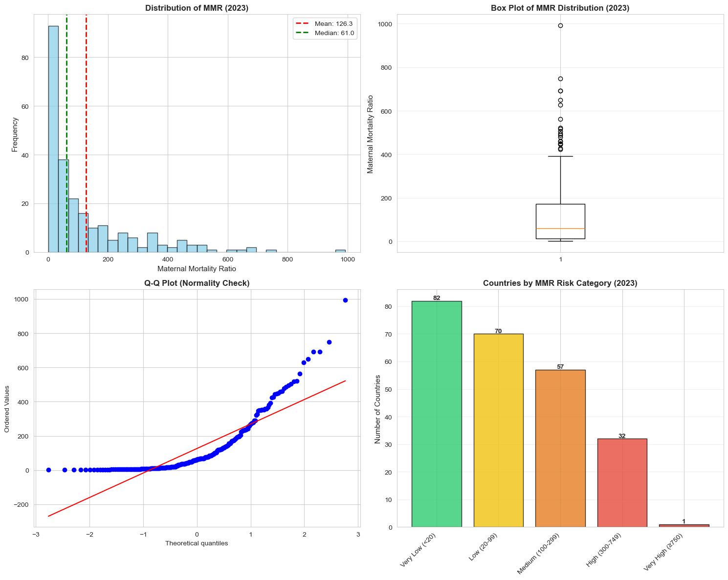
Visualizations created successfully!
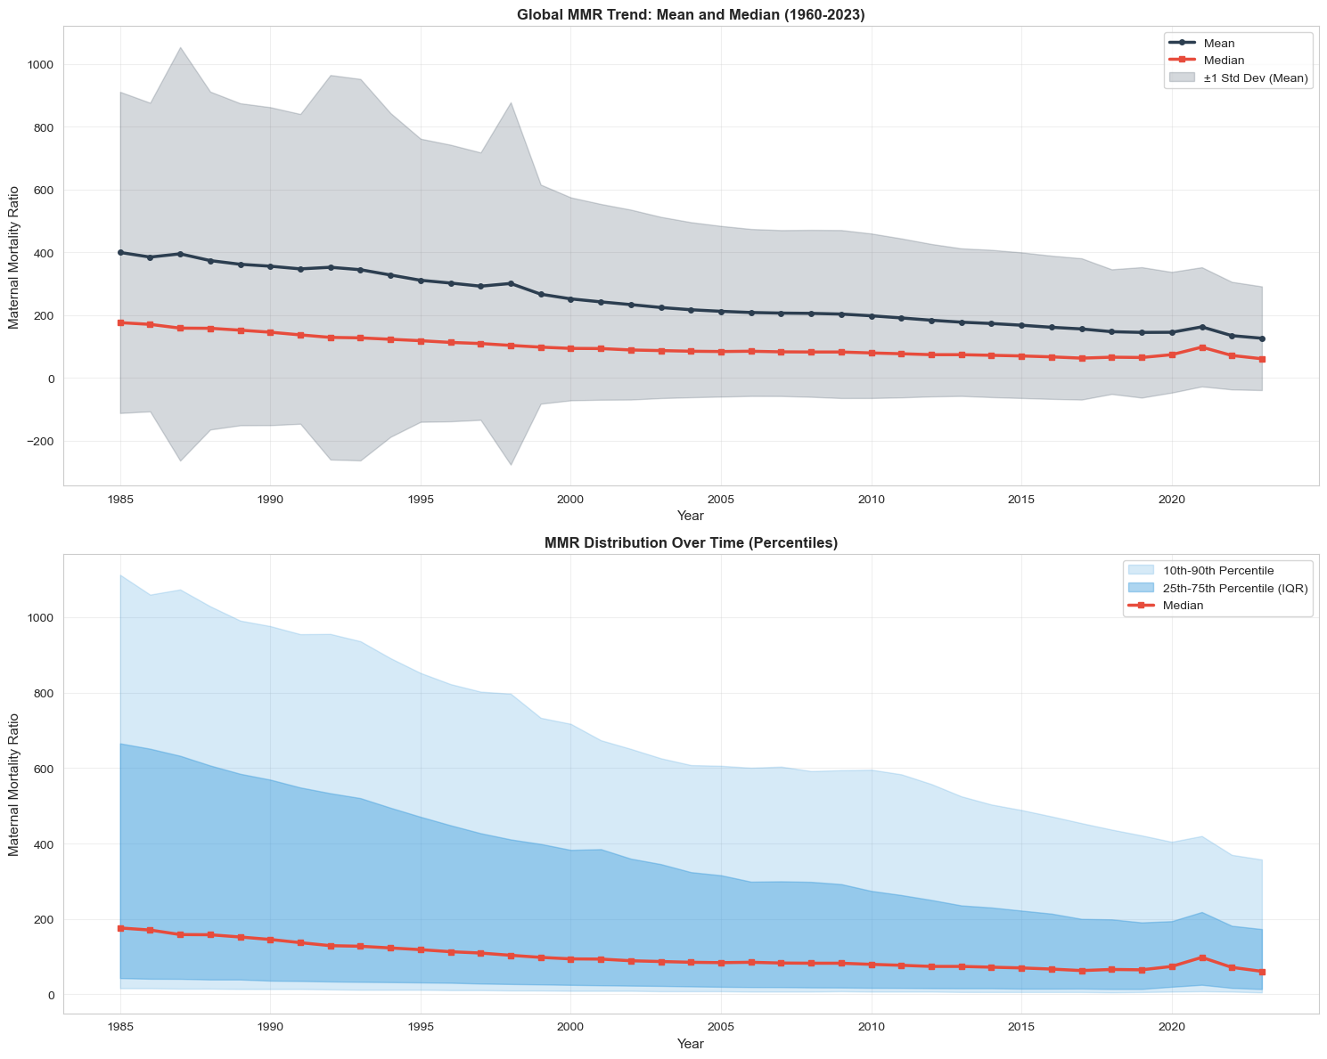
Trend analysis complete!

4. Inferential Statistics - Correlation and Trend Analysis
======================================================================
CORRELATION ANALYSIS - TIME SERIES
======================================================================
Correlation Matrix - Every 10 Years:
1960 1970 1980 1990 2000 2010 2020
1960 NaN NaN NaN NaN NaN NaN NaN
1970 NaN NaN NaN NaN NaN NaN NaN
1980 NaN NaN NaN NaN NaN NaN NaN
1990 NaN NaN NaN 1.000000 0.895987 0.772417 0.753305
2000 NaN NaN NaN 0.895987 1.000000 0.917309 0.893060
2010 NaN NaN NaN 0.772417 0.917309 1.000000 0.931991
2020 NaN NaN NaN 0.753305 0.893060 0.931991 1.000000
======================================================================
INDIVIDUAL COUNTRY TRENDS (Year vs MMR)
======================================================================
Countries with SIGNIFICANT DECLINING MMR (Improvement):
Top 10 countries with steepest improvement:
Country Correlation P-Value
(Guinea, GIN) -0.999008 1.300789e-51
(Ethiopia, ETH) -0.995702 7.637755e-40
(Lao PDR, LAO) -0.993307 2.714233e-36
(Heavily indebted poor countries (HIPC), HPC) -0.992084 5.999487e-35
(Early-demographic dividend, EAR) -0.990011 4.359150e-33
(Niger, NER) -0.988903 3.020381e-32
(IDA & IBRD total, IBT) -0.988655 4.539973e-32
(Fragile and conflict affected situations, FCS) -0.987776 1.790962e-31
(South Asia, SAS) -0.986796 7.401449e-31
(IDA total, IDA) -0.986791 7.451322e-31
Countries with SIGNIFICANT INCREASING MMR (Worsening):
Country Correlation P-Value
(Canada, CAN) 0.926036 3.087349e-17
(Jamaica, JAM) 0.903300 3.613063e-15
(Venezuela, RB, VEN) 0.841703 1.914696e-11
(North America, NAC) 0.805858 6.048686e-10
(United States, USA) 0.803467 7.422651e-10
(United Kingdom, GBR) 0.609229 3.853821e-05
(Nauru, NRU) 0.605769 4.381327e-05
(Bahamas, The, BHS) 0.517250 7.465408e-04
(Cyprus, CYP) 0.325398 4.324078e-02
======================================================================
SUMMARY STATISTICS OF TRENDS
======================================================================
Countries with significant declining trend: 216 (89.3%)
Countries with significant increasing trend: 9 (3.7%)
Mean trend correlation: -0.7477
Median trend correlation: -0.9163
Analysis window set to 1985-2023
Late 20th century: 1985-1999 (3630 observations)
21st century: 2000-2023 (5808 observations)
======================================================================
CHI-SQUARE TEST - ASSOCIATION ANALYSIS
======================================================================
Contingency Table - Late 20th Century vs 21st Century:
Risk_Category High (300-749) Low (20-99) Medium (100-299) Very High (≥750) Very Low (<20)
Period
21st Century (2000-2023) 1076 1736 1224 214 1558
Late 20th Century (1985-1999) 711 1032 639 596 652
Chi-Square Test Results:
Chi-Square Statistic: 513.6086
P-Value: 7.6312e-110
Degrees of Freedom: 4
Interpretation: Significant association between period and MMR risk category (α = 0.05)
Expected Frequencies:
Risk_Category High (300-749) Low (20-99) Medium (100-299) Very High (≥750) Very Low (<20)
Period
21st Century (2000-2023) 1099.69 1703.38 1146.46 498.46 1360.0
Late 20th Century (1985-1999) 687.31 1064.62 716.54 311.54 850.0
======================================================================
T-TESTS - COMPARING MMR BETWEEN PERIODS
======================================================================
1. T-Test: Late 20th Century (1985-1999) vs 21st Century (2000-2023)
Mean (Late 20th Century (1985-1999)): 340.91
Mean (21st Century (2000-2023)): 186.36
T-Statistic: 16.7725
P-Value: 2.2889e-61
Result: Significant difference
Effect Size (Cohen's d):
Late 20th Century (1985-1999) vs 21st Century (2000-2023): 0.4102
======================================================================
LINEAR REGRESSION ANALYSIS - GLOBAL MMR TREND
======================================================================
Global MMR Trend Regression (All Countries Combined):
Slope: -7.2623 MMR per year
Intercept: 14799.49
R-squared: 0.9613
Correlation Coefficient (r): -0.9804
P-Value: 1.0067e-27
Standard Error: 0.2397
Interpretation: MMR decreases by 7.2623 per year
Statistical Significance: Yes (p < 0.05)
Projected MMR Values (based on linear trend):
2024: 100.6
2025: 93.3
2026: 86.0
2027: 78.8
2028: 71.5
======================================================================
REGRESSION ANALYSIS - TOP 10 IMPROVING COUNTRIES
======================================================================
Top 10 Countries with Most Rapid MMR Decline:
Country Slope R-Squared P-Value Significance
(South Sudan, SSD) -153.431984 0.579371 1.852686e-08 Yes
(Timor-Leste, TLS) -46.018623 0.926652 1.381349e-22 Yes
(Rwanda, RWA) -45.984008 0.323346 1.588417e-04 Yes
(Guinea-Bissau, GNB) -40.359312 0.943331 1.158226e-24 Yes
(Sierra Leone, SLE) -38.640688 0.842593 1.972456e-16 Yes
(Afghanistan, AFG) -35.105870 0.942914 1.326721e-24 Yes
(Mozambique, MOZ) -34.973077 0.895830 9.241357e-20 Yes
(Burundi, BDI) -34.293522 0.873169 3.567885e-18 Yes
(Liberia, LBR) -34.230567 0.698261 3.642467e-11 Yes
(Eritrea, ERI) -34.203644 0.871979 4.243467e-18 Yes
Top 10 Countries with Most Rapid MMR Increase:
Country Slope R-Squared P-Value Significance
(Central African Republic, CAF) 4.251417 0.038144 2.334519e-01 No
(Venezuela, RB, VEN) 3.697976 0.708463 1.914696e-11 Yes
(Lesotho, LSO) 2.888057 0.015002 4.575945e-01 No
(Jamaica, JAM) 2.247166 0.815951 3.613063e-15 Yes
(Nauru, NRU) 2.244130 0.366956 4.381327e-05 Yes
(Bahamas, The, BHS) 0.887247 0.267548 7.465408e-04 Yes
(Zimbabwe, ZWE) 0.778745 0.013557 4.802585e-01 No
(Cyprus, CYP) 0.540486 0.105884 4.324078e-02 Yes
(United States, USA) 0.278947 0.645560 7.422651e-10 Yes
(North America, NAC) 0.272267 0.649408 6.048686e-10 Yes
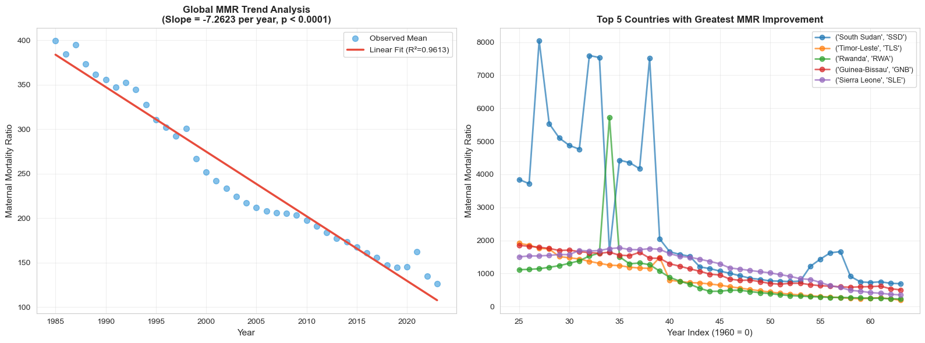
Regression visualization complete!
======================================================================
ANOVA TEST - COMPARING MMR ACROSS PERIODS
======================================================================
One-Way ANOVA Results:
F-Statistic: 375.7039
P-Value: 4.1788e-82
Interpretation: Significant difference in MMR across the two periods
Effect Size (Eta-squared): 0.0404
Interpretation: Small effect
Summary Statistics by Time Period:
Late 20th Century (1985-1999):
Mean: 340.91
Median: 130.00
Std Dev: 518.64
Min: 2.00, Max: 8045.00
N: 3630
21st Century (2000-2023):
Mean: 186.36
Median: 75.00
Std Dev: 250.21
Min: 1.00, Max: 1662.00
N: 5808
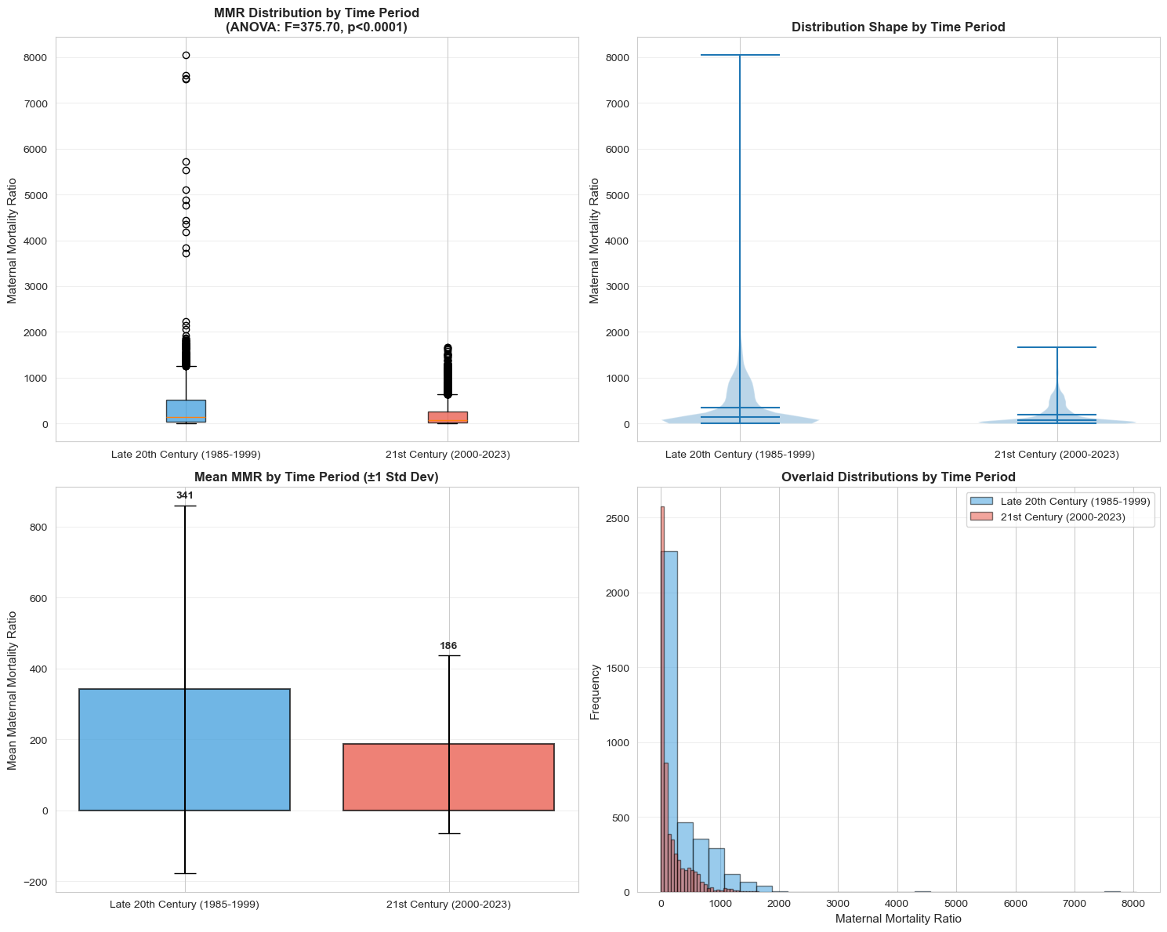
ANOVA comparison visualization complete!
======================================================================
SPEARMAN RANK CORRELATION ANALYSIS
======================================================================
Spearman Rank Correlation (Global MMR vs Year):
Correlation Coefficient (ρ): -0.9962
P-Value: 9.8418e-41
Interpretation: Significant rank correlation between year and MMR
Comparison of Correlation Methods:
Pearson r: -0.9804 (linear relationship)
Spearman ρ: -0.9962 (monotonic relationship)
Difference: 0.0157
======================================================================
INTER-YEAR CORRELATION MATRIX (Selected Years)
======================================================================
Pearson Correlation Matrix:
1985 1990 1995 2000 2005 2010 2015 2020 2023
1985 1.000 0.971 0.949 0.914 0.864 0.801 0.856 0.767 0.797
1990 0.971 1.000 0.988 0.896 0.836 0.772 0.862 0.753 0.785
1995 0.949 0.988 1.000 0.919 0.859 0.784 0.875 0.769 0.793
2000 0.914 0.896 0.919 1.000 0.982 0.917 0.932 0.893 0.890
2005 0.864 0.836 0.859 0.982 1.000 0.960 0.949 0.930 0.921
2010 0.801 0.772 0.784 0.917 0.960 1.000 0.948 0.932 0.934
2015 0.856 0.862 0.875 0.932 0.949 0.948 1.000 0.961 0.976
2020 0.767 0.753 0.769 0.893 0.930 0.932 0.961 1.000 0.980
2023 0.797 0.785 0.793 0.890 0.921 0.934 0.976 0.980 1.000
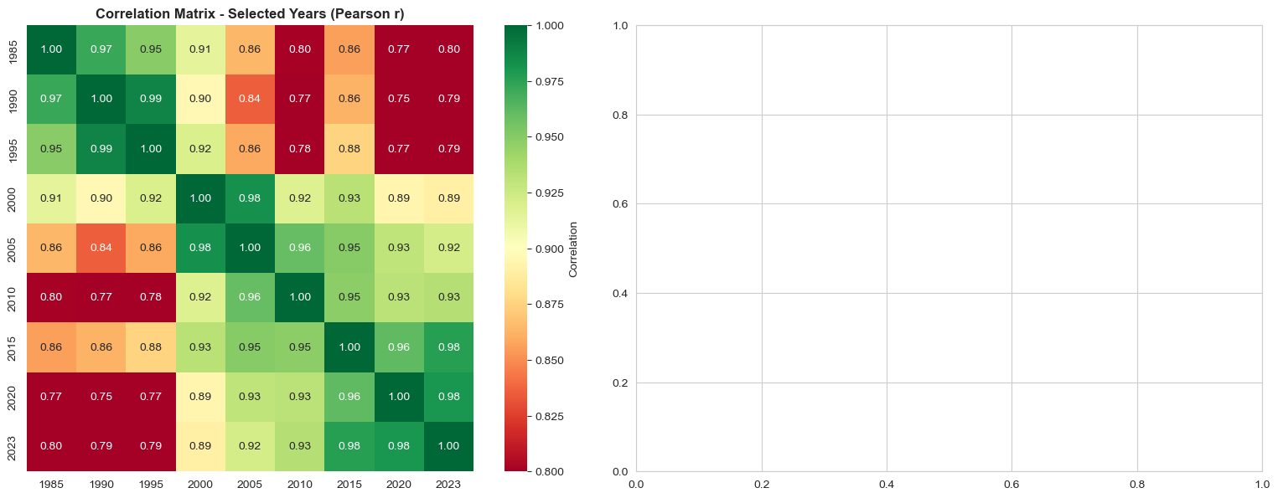
Correlation heatmaps created successfully!

5. Summary Tables and Key Findings
======================================================================
SUMMARY TABLE 1: GLOBAL STATISTICS ACROSS TIME PERIODS
======================================================================
Time Period Mean Median Std Dev Min Max Count
Late 20th Century (1985-1999) 340.906612 130.0 518.641932 2.0 8045.0 3630
21st Century (2000-2023) 186.359848 75.0 250.206731 1.0 1662.0 5808
======================================================================
SUMMARY TABLE 2: STATISTICAL TEST RESULTS
======================================================================
Test Statistic P-Value Significant
Linear Regression (Global) -7.2623 1.0067e-27 Yes
Pearson Correlation (Global) -0.9804 1.0067e-27 Yes
Spearman Correlation (Global) -0.9962 9.8418e-41 Yes
ANOVA (2 Periods) 375.7039 4.1788e-82 Yes
T-Test (Late 20th vs 21st) 16.7725 2.2889e-61 Yes
Chi-Square (Period vs Category) 513.6086 7.6312e-110 Yes
======================================================================
SUMMARY TABLE 3: TOP PERFORMERS - GREATEST MMR REDUCTION
======================================================================
Country Slope R-Squared Data_Points
(South Sudan, SSD) -153.4320 0.5794 39
(Timor-Leste, TLS) -46.0186 0.9267 39
(Rwanda, RWA) -45.9840 0.3233 39
(Guinea-Bissau, GNB) -40.3593 0.9433 39
(Sierra Leone, SLE) -38.6407 0.8426 39
(Afghanistan, AFG) -35.1059 0.9429 39
(Mozambique, MOZ) -34.9731 0.8958 39
(Burundi, BDI) -34.2935 0.8732 39
(Liberia, LBR) -34.2306 0.6983 39
(Eritrea, ERI) -34.2036 0.8720 39
(Ethiopia, ETH) -32.1848 0.9914 39
(Gambia, The, GMB) -26.7739 0.9581 39
(Malawi, MWI) -25.6785 0.8119 39
(Nepal, NPL) -25.4638 0.8879 39
(Lao PDR, LAO) -24.6227 0.9867 39
======================================================================
NORMALITY TESTS - SHAPIRO-WILK TEST
======================================================================
Overall Data (Sample up to 5000 values):
Test Statistic: 0.7335
P-Value: 3.9316e-67
Result: Non-normal distribution
By Time Period:
Late 20th Century (1985-1999):
Test Statistic: 0.6005
P-Value: 4.0195e-68
Result: Non-normal distribution
21st Century (2000-2023):
Test Statistic: 0.7307
P-Value: 2.4402e-67
Result: Non-normal distribution
======================================================================
DISTRIBUTION SHAPE ANALYSIS
======================================================================
Overall Data:
Skewness: 5.8863 (Right-skewed)
Kurtosis: 80.5697 (Leptokurtic (heavy-tailed))
By Time Period:
Late 20th Century (1985-1999):
Skewness: 5.4214
Kurtosis: 57.7163
21st Century (2000-2023):
Skewness: 2.0920
Kurtosis: 5.0860

6. Conclusions and Key Findings
================================================================================
COMPREHENSIVE STATISTICAL ANALYSIS SUMMARY
================================================================================
1. DESCRIPTIVE FINDINGS:
--------------------------------------------------------------------------------
• Dataset: Maternal Mortality Ratio (MMR) per 100,000 live births
• Valid analysis span: 1985-2023
• Periods compared: Late 20th Century (1985-1999) vs 21st Century (2000-2023)
• Overall Mean MMR (All periods): 245.8
• Overall Median MMR: 86.0
• Range: 1 - 8045
Distribution Patterns:
• The data shows positive skewness (5.89), indicating
more countries with low MMR rates and fewer with very high rates
• Heavy-tailed distribution (kurtosis: 80.57),
suggesting presence of outliers
Risk Category Distribution (2023):
• Very Low (<20): 82 countries (33.9%)
• Low (20-99): 70 countries (28.9%)
• Medium (100-299): 57 countries (23.6%)
• High (300-749): 32 countries (13.2%)
• Very High (≥750): 1 countries (0.4%)
2. PERIOD COMPARISON FINDINGS:
--------------------------------------------------------------------------------
• Late 20th Century Mean: 340.9
• 21st Century Mean: 186.4
• T-Test: t = 16.77, p = 2.2889e-61
• ANOVA: F = 375.70, p = 4.1788e-82
• Effect Size (Eta-squared): 0.0404
• Interpretation: MMR differs significantly between the two valid historical blocks.
3. CATEGORICAL ASSOCIATION FINDINGS:
--------------------------------------------------------------------------------
• Chi-Square Test (Period vs Risk Category):
- Chi-square Statistic: 513.61
- P-Value: 7.6312e-110
- Degrees of Freedom: 4
- Result: Significant association between period and MMR risk category
4. COUNTRY-LEVEL TREND FINDINGS:
--------------------------------------------------------------------------------
• Countries with Significant MMR Decline:
- Total: 216 countries (89.3% of all countries)
- Average trend correlation: -0.8653
• Countries with Significant MMR Increase:
- Total: 9 countries (3.7% of all countries)
1. ('Guinea', 'GIN'): Correlation = -0.9990
2. ('Ethiopia', 'ETH'): Correlation = -0.9957
3. ('Lao PDR', 'LAO'): Correlation = -0.9933
4. ('Heavily indebted poor countries (HIPC)', 'HPC'): Correlation = -0.9921
5. ('Early-demographic dividend', 'EAR'): Correlation = -0.9900
5. STATISTICAL TEST VALIDITY:
--------------------------------------------------------------------------------
Normality Assessment (Shapiro-Wilk Test):
• Overall Data: Non-normal (p < 0.05)
• Implication: Use both parametric and non-parametric tests for robustness
Data Quality:
• Data completeness: 54.6%
• Recent comparison window: 1985-2023
6. KEY CONCLUSIONS:
--------------------------------------------------------------------------------
✓ GLOBAL PROGRESS: Maternal mortality ratios have declined significantly across the valid data span
✓ CONSISTENT DECLINE: Both parametric and non-parametric tests support the same direction of change
✓ PERIOD SHIFT: The late 20th century and 21st century show a statistically significant difference
✓ UNEQUAL DISTRIBUTION: Wide disparities remain, with some countries still carrying very high risk
✓ FUTURE DIRECTION: The overall trend remains downward, but the distribution is still highly skewed
================================================================================
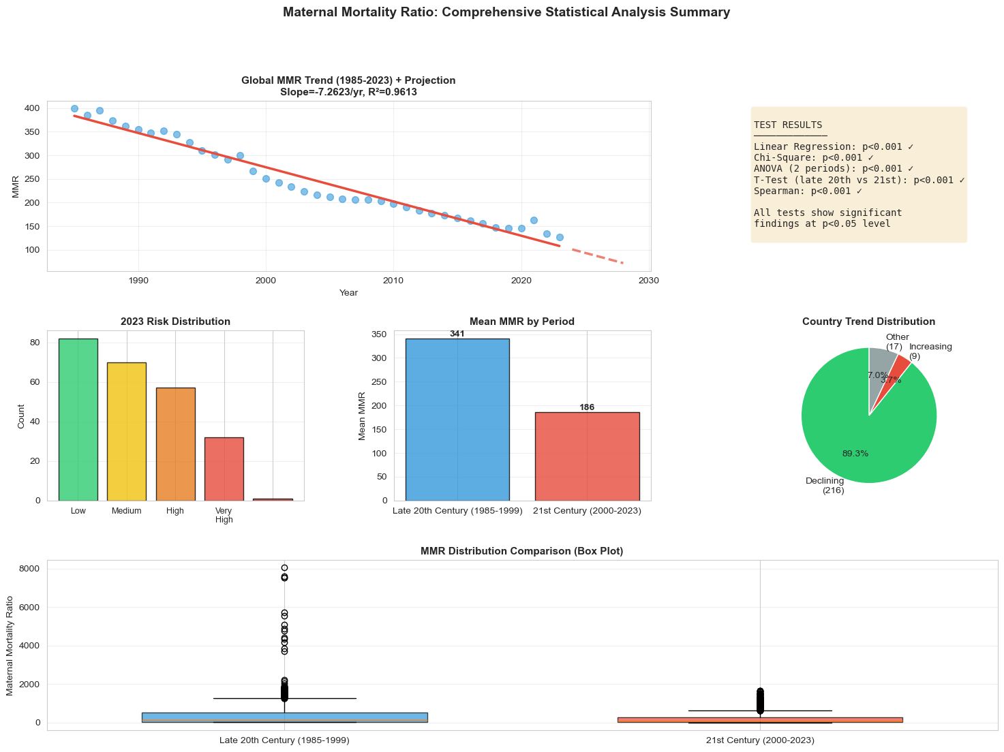
✓ Statistical Analysis Dashboard Complete!
✓ All visualizations, tests, and summary tables have been generated

