4.emf



ChestOMX

Report

**„{{case}}”**

**Case**

{% if lungs %}

Lungs

|  |  |
| --- | --- |
| {%tr for v in lungs_volumes:%} | |
| {{v['Label']}} | {{'{:02.2f}'.format(v['Volume'])}} cm3 |
| {%tr endfor %} | |

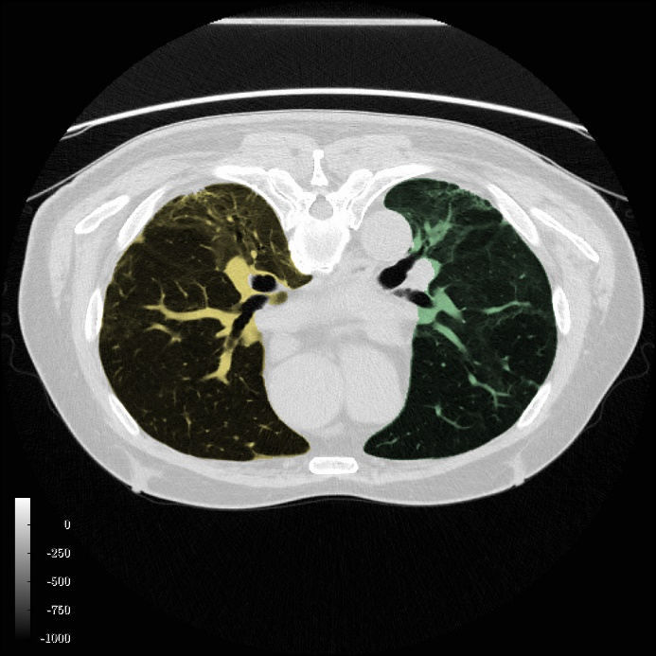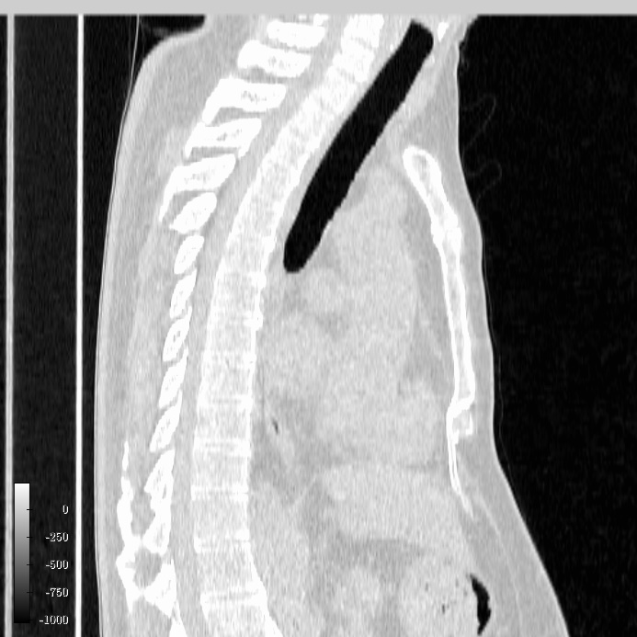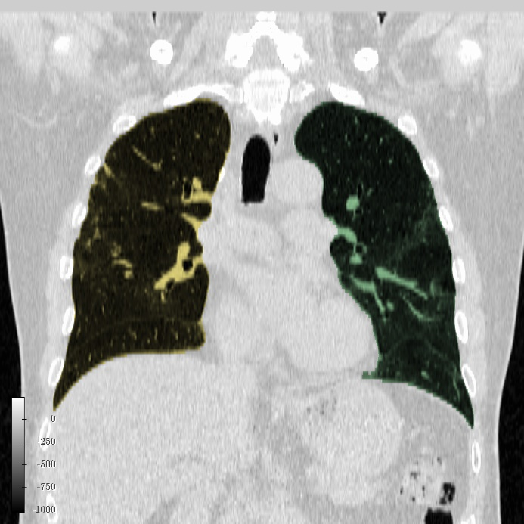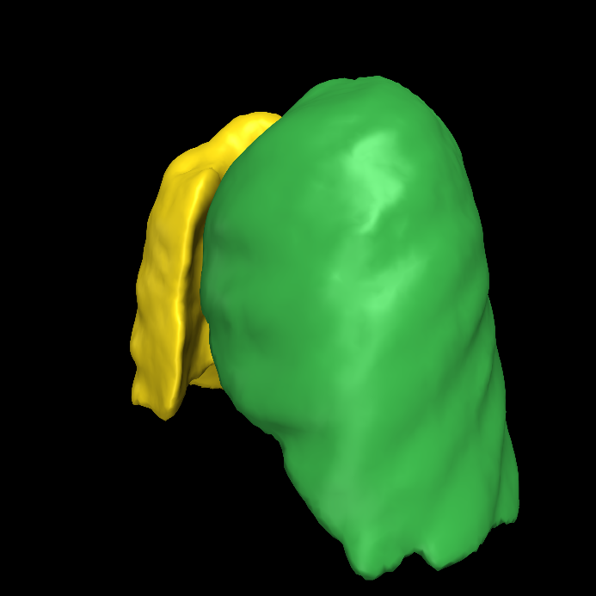

{% endif %}{% if lobes %}

Lobes

|  |  |
| --- | --- |
| {%tr for v in lobes_volumes:%} | |
| {{v['Label']}} | {{'{:02.2f}'.format(v['Volume'])}} cm3 |
| {%tr endfor %} | |

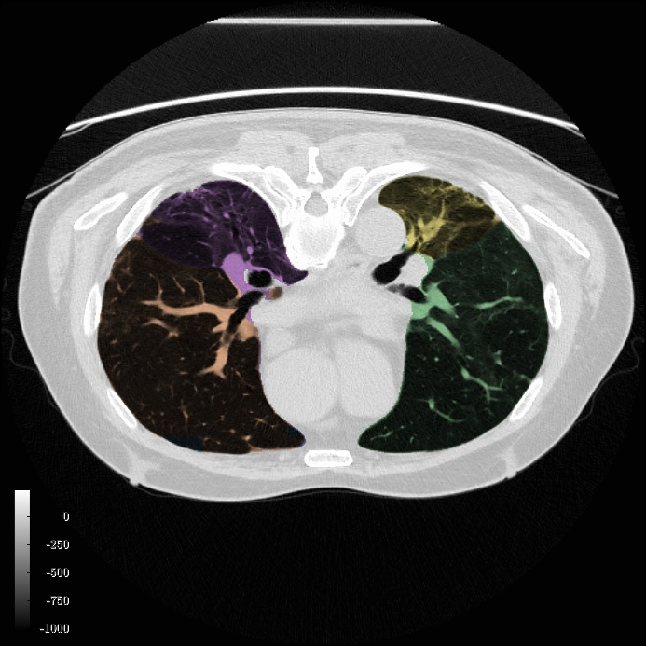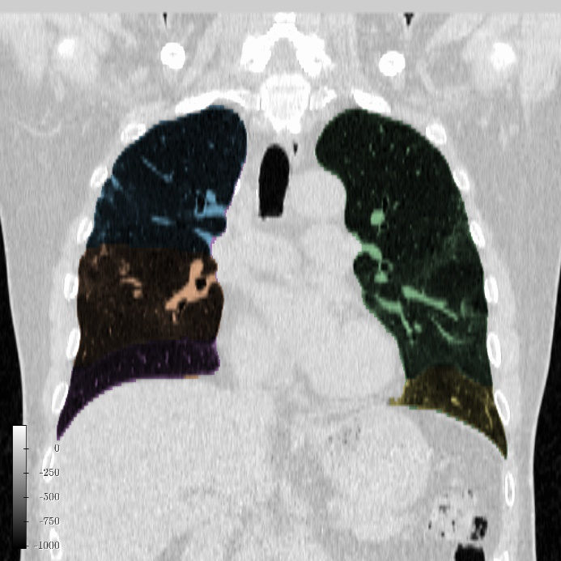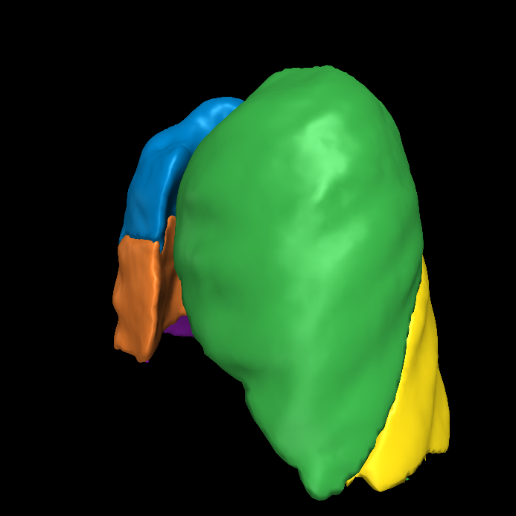

{% endif %}{% if ipf %}

IPF

|  |  |
| --- | --- |
| {%tr for v in IPF_volumes:%} | |
| {{v['Label']}} | {{'{:02.2f}'.format(v['Volume'])}} cm3 |
| {%tr endfor %} | |

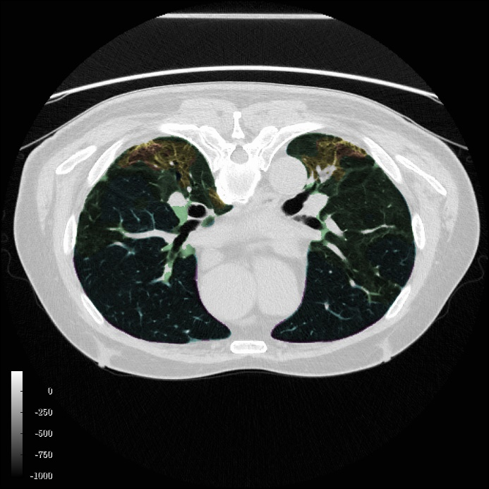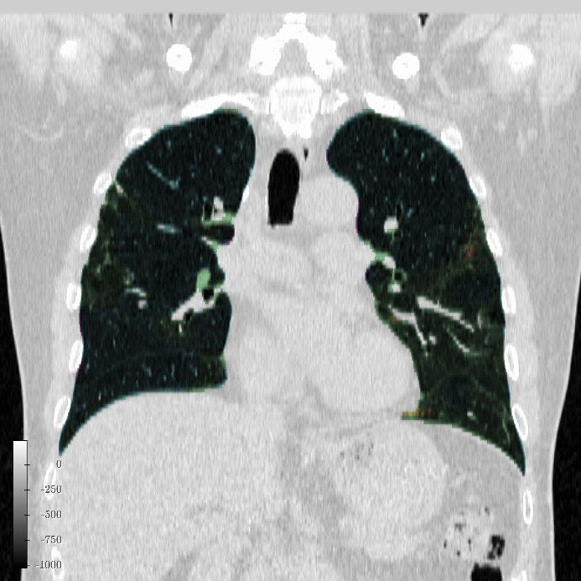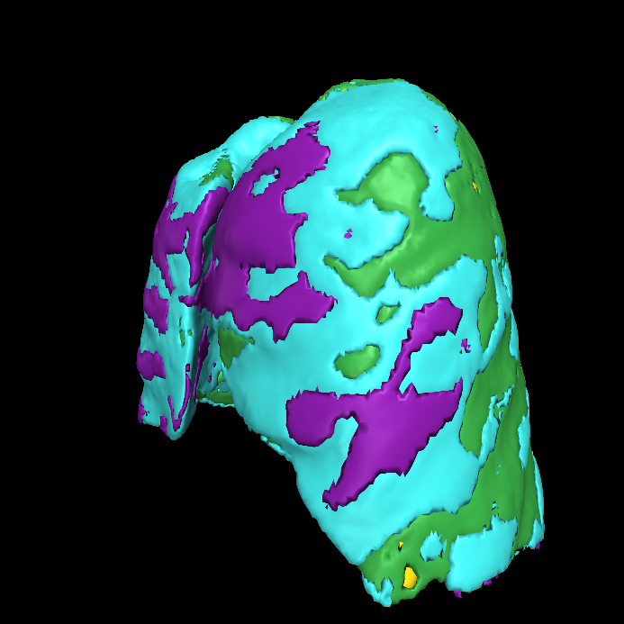

{% endif %}{% if summary %}

Summary

|  |  |  |  |  |
| --- | --- | --- | --- | --- |
|  | | {%tc for g in summary: %} | {{g['Label']}} | {%tc endfor %} |
| {%tr for i in summary[0]['volumes'].keys():%} | | | | |
| {{i}} | Volume | {%tc for l in summary: %} | {{'{:02.2f}'.format(l['volumes'][i])}} cm3 | {%tc endfor %} |
| Percentage | {%tc for l in summary: %} | {{'{:02.2f}'.format(l['volumes'][i] / l['Volume'] * 100.0)}}% | {%tc endfor %} |
| {%tr endfor %} | | | | |

{% endif %}