Python Session 2 – Practice Questions
QUESTION 1: Age Group Classifier
Write a program that:
- Asks the user for their age (convert to int)
- Classifies them into:
  - "Child" (0-12)
  - "Teenager" (13-19)
  - "Adult" (20-64)
  - "Senior" (65+)
- Prints: "You are a [category]."

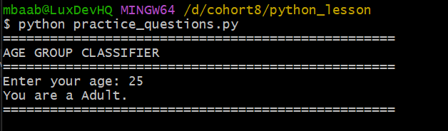

QUESTION 2: Even or Odd Checker
Write a program that:
- Asks the user for a number (convert to int)
- Checks if the number is even or odd
- Prints: "[number] is an even number" or "[number] is an odd number"
- Hint: Use the modulo operator % (number % 2 == 0 means even)
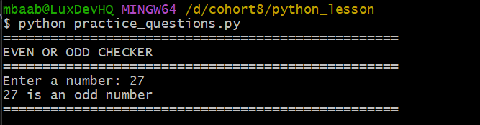

QUESTION 3: Pass/Fail with Subject Details
Write a program that:
- Asks for 3 subject scores (Math, English, Science)
- Calculates the average
- If average >= 50, prints "PASS"
- If average < 50, prints "FAIL"
- Also prints the highest score among the 3 subjects
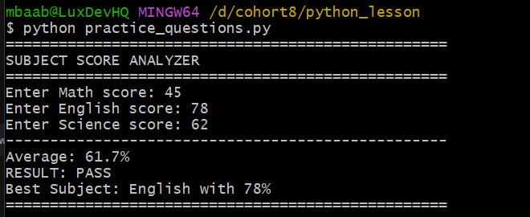

QUESTION 4: Discount Calculator
Write a program that:
- Asks for the total purchase amount (int)
- Asks if the user is a member (yes/no)
- If member AND amount >= 1000: 20% discount
- If member AND amount < 1000: 10% discount
- If not member AND amount >= 1000: 5% discount
- If not member AND amount < 1000: no discount
- Prints the final amount payable with 2 decimal places
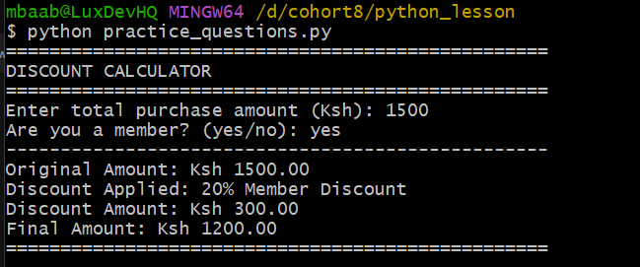

QUESTION 5: Temperature Advice
Write a program that:
- Asks for today's temperature in Celsius (int)
- Asks if it's raining (yes/no)
- Gives advice:
  - If temperature > 30: "It's hot! Wear light clothes."
  - If temperature between 20-30 AND raining: "Carry an umbrella."
  - If temperature between 20-30 AND not raining: "Perfect weather!"
  - If temperature < 20: "It's cold. Wear a jacket."
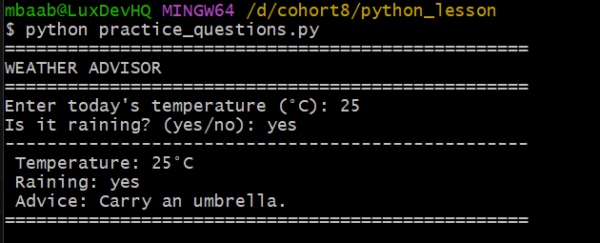

QUESTION 6: Voting Eligibility
Write a program that:
- Asks for age (int)
- Asks for citizenship (Kenyan/Other)
- A person can vote if they are 18+ AND Kenyan
- Prints: "You are eligible to vote" or "You are not eligible to vote"
- If not eligible, explain why (age or citizenship issue)
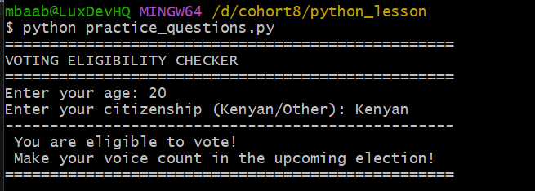

QUESTION 7: Loan Approval System
Write a program that:
- Asks for monthly salary (int)
- Asks for credit score (int)
- If salary >= 30000 AND credit score >= 700: "Loan Approved"
- If salary >= 30000 AND credit score between 600-699: "Loan Approved with higher interest"
- If salary < 30000 OR credit score < 600: "Loan Denied"
- Prints the result with the specific reason
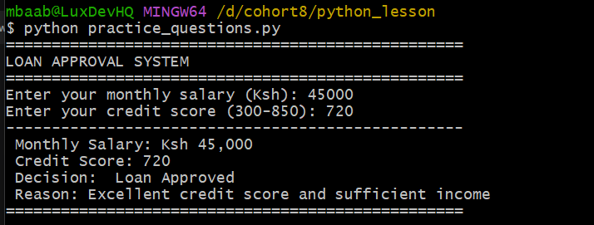

QUESTION 8: Fuel Level Warning
Write a program that:
- Asks for the fuel level in litres (int)
- If fuel < 10: " LOW FUEL! Please refuel immediately."
- If fuel between 10-25: " Fuel is running low. Plan to refuel soon."
- If fuel > 25: "✅Fuel level is good."
- If fuel > 50: " Fuel tank is full. You're good to go!"
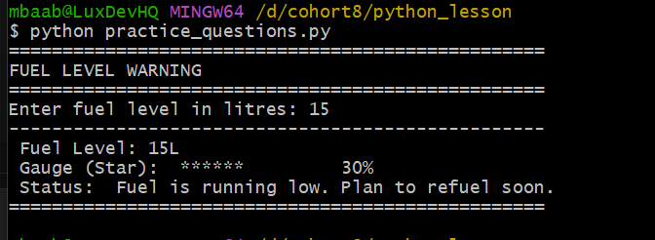

QUESTION 9: Matatu Fare Calculator (with passenger type)
Write a program that:
- Asks for distance in km (int)
- Asks if passenger is a student (yes/no)
- Base fare:
  - 0-5 km: Ksh 50
  - 6-15 km: Ksh 80
  - 16-30 km: Ksh 120
  - Above 30: Ksh 180
- Students get 20% discount
- Prints the final fare with discount applied if applicable
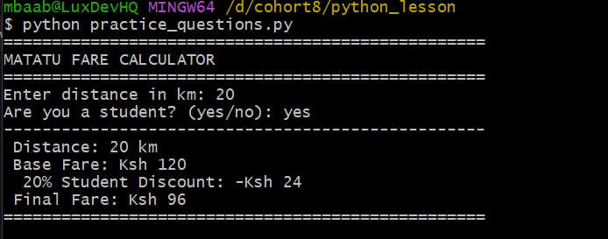

QUESTION 10: Password Strength Checker
Write a program that:
- Asks the user to create a password
- Checks password strength:
  - If length >= 8 AND contains a number: "STRONG password"
  - If length >= 8 but no number: "MEDIUM password - add numbers"
  - If length < 8: "WEAK password - must be at least 8 characters"
- Hint: Use .isdigit() to check for numbers in a string
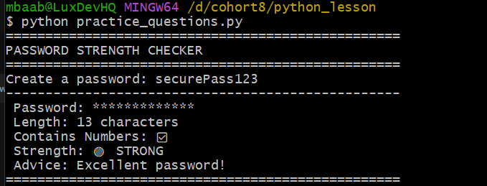

QUESTION 11: M-Pesa Transaction Fee Calculator
Write a program that:
- Asks for the amount to send (int)
- Calculates transaction fee:
  - If amount <= 100: Fee = 0
  - If amount between 101-500: Fee = 7
  - If amount between 501-1000: Fee = 12
  - If amount between 1001-1500: Fee = 18
  - If amount > 1500: Fee = 25
- Asks if user has a "bonga points" discount (yes/no)
- If yes, 50% off the fee
- Prints: "Amount: Ksh X | Fee: Ksh Y | Total: Ksh Z"
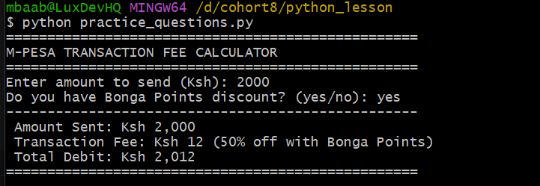

QUESTION 12: Restaurant Order System
Write a program that:
- Asks for the type of meal (breakfast/lunch/dinner)
- For breakfast: " Breakfast menu: Mandazi, Chapati, Tea"
- For lunch: " Lunch menu: Ugali, Rice, Beef, Vegetables"
- For dinner: "Dinner menu: Pilau, Chicken, Salad"
- Asks if the user wants a drink (yes/no)
- If yes, suggests a drink based on the meal type
  - Breakfast: "Try our Chai!"
  - Lunch: "Try our Fresh Juice!"
  - Dinner: "Try our Maziwa Lala!"
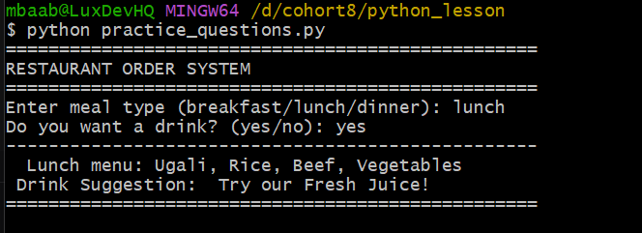

QUESTION 13: Grade Comment System
Write a program that:
- Asks for the student's name
- Asks for the score (0-100)
- Assigns grade and provides a comment:
  - A (80-100): "Excellent performance! Keep it up! "
  - B (70-79): "Good job! You're doing well. "
  - C (60-69): "Satisfactory. Room for improvement. "
  - D (50-59): "Needs improvement. Work harder! "
  - F (0-49): "Poor performance. Must retake. "
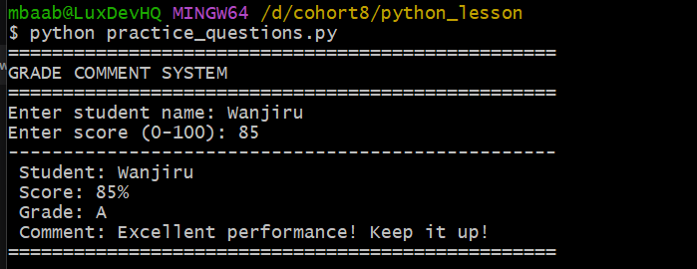

QUESTION 14: Electricity Bill Calculator
Write a program that:
- Asks for units consumed (int)
- Calculates bill:
  - First 50 units: Ksh 10 per unit
  - Next 50 units (51-100): Ksh 15 per unit
  - Next 100 units (101-200): Ksh 20 per unit
  - Above 200: Ksh 25 per unit
- If total bill > 2000: Apply 10% discount
- Prints the detailed breakdown and total bill

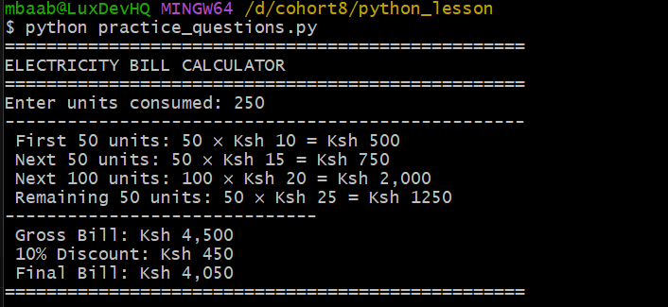

QUESTION 15: Complete Student Report Card
Write a program that:
- Asks for:
  - Student name
  - 4 subject scores (Math, English, Science, History) - all int
  - Attendance percentage (int)
- Calculates:
  - Total score (out of 400)
  - Average score
  - Grade based on average:
    - 80-100: A (Distinction)
    - 70-79: B (Merit)
    - 60-69: C (Credit)
    - 50-59: D (Pass)
    - Below 50: F (Fail)
- Determines promotion:
  - If average >= 50 AND attendance >= 75: "PROMOTED"
  - If average >= 50 AND attendance < 75: "CONDITIONAL - Improve attendance"
  - If average < 50: "REPEAT - Failed exams"
- Finds the highest score and subject
- Prints a complete formatted report card with separators
