Empirical Assessment of the Incremental Value of Traditional Calendar Symbols for Precipitation Classification: A Controlled Qimen-Feature Experiment on NOAA CPC Grids
Haopeng Li
City University Malaysia
[Pending author confirmation] Corresponding email, department, funding, contributions, ethics approval, and conflict-of-interest statements were not provided for this draft and are not invented. This manuscript does not proxy-declare “no conflicts” or “no funding.”

Abstract
Objective: To evaluate, on a reproducible public gridded precipitation product, whether traditional Qimen Dunjia noon-chart symbolic features add incremental value beyond seasonal baselines for daily wet/dry precipitation-occurrence classification. The study is a controlled methodological experiment, not a cosmological validation of divinatory systems, and it does not assess human-affairs prognostication. Methods: NOAA CPC Global Unified Gauge daily precipitation (product attributes CPC GLOBAL PRCP V1.0) was re-downloaded; this is not a China Meteorological Administration station series. From a download bbox of 18–54°N, 73–135°E, cells within 60 km of project administrative centroids were retained and thinned to one representative per 2° block, then five representatives with any invalid day in 2023–2025 were removed, yielding 267 comparison cells (8,928→2,786→272→267; no additional single-class drop). Wet days are totals ≥0.1 mm. Models train on 2023, select hyperparameters by 2024 mean log loss, and score 2025 once. Nine model families share the same verified 31-column feature matrix (eight Gods, eight Gates, nine Stars, Yin Dun/Fu Yin/Fan Yin/empty-Kan, day-of-year sine/cosine) and the same cells. The primary score is Brier; corrected all-cell F1, log loss, and ROC-AUC (pooled vs macro) are also reported. Uncertainty uses circular moving 10-day blocks (400 replicates, each covering 365 days). Results: On 2025, season-only L2 logistic regression attains Brier=0.1923 versus 0.1970 for Qimen+season (difference +0.0047, 95% interval 0.0033 to 0.0061). Month climatology is 0.1981; Qimen-only 0.2216; random forest 0.2028; histogram boosting 0.2105. Lead-1 persistence has the lowest Brier (0.1793) but uses yesterday’s wet/dry label and must not be called best under the same input set. Corrected F1 from confusion counts on all 267 cells: training-rate 0.1723, month 0.4568, season climatology 0.3921, season-only L2 0.4415, Qimen+season 0.4242, Qimen-only 0.2699, RF 0.3597, HGB 0.4676, persistence 0.6646. The earlier 0.7077 F1 that dropped all-dry forecast cells is withdrawn. Conclusions: Under this 267-cell design, Qimen columns do not reduce 2025 Brier beyond a seasonal curve, and unified F1 is also lower than season-only logistic regression. The negative increment is scientifically informative. Results do not generalize to a national census, do not support human-affairs claims, and 2025 overlaps a prior artifact test window, so it is not an untouched external test.
Keywords: Qimen Dunjia; NOAA CPC; precipitation classification; Brier score; seasonal baseline; incremental value; reproducibility

1. Introduction
The standard for incremental assessment is to compare, on the same cells, labels, and test window, probability scores with versus without symbolic columns, and to attach temporal-block uncertainty to the difference. A stably positive Brier difference (worse probabilities) rejects claims of symbolic skill under that design; computable encoding may still remain a legitimate engineering object.
Accordingly, the narrative is methods–controls–falsification: fix the product and funnel, freeze the 31-feature schema and hyperparameter rule, then release 2025 scores with the corrected F1. Optimizing the manuscript is not the same as beautifying performance; stating the negative increment clearly serves scientific communication better than redefining metrics.
Traditional calendar-symbol systems—here, Qimen Dunjia Gods, Gates, Stars, and structural board states—map civil date-time into discrete symbols. Encoding those symbols as machine-learning features and aligning them with public precipitation products yields a falsifiable statistical question: after seasonal controls, do the symbolic columns still improve probabilistic wet/dry scores? The question concerns association and incremental value, not cosmological proof.
Earlier private-repository district logistic artifacts reported historically stored accuracies, but metric definitions, sampling, and baseline controls were incomplete, and production weights were not retrained here. To avoid mixing an audit of old figures with a new experiment, the main text reports only the controlled CPC lattice experiment under a locally frozen protocol; legacy numbers, if mentioned, appear only as a separate historical note.
We re-download NOAA CPC unified gauge daily fields, fit nine model families on sparse centroid-neighborhood representatives, and compare Qimen features with seasonal baselines primarily by Brier score, with threshold metrics and a pooled calibration plot as complements. Boundaries are explicit: same-day date classification, not a deployable lead-time forecast; not CMA first-hand stations; not a 3,143-county national census; no human-affairs labels.

2. Related Work
Relative to “feeding divinatory texts into LLM fine-tuning,” featureization plus penalized logistic regression keeps a fixed input dimension, exportable coefficients, and nested contrasts (season-only / Qimen+season / Qimen-only). Any external chat API in the same repository is an optional narrative layer, not a training backbone or a hyperparameter of this experiment. All nine model families here are classical statistical or tree models; no LLM participated in fitting.
Public precipitation analyses must be distinguished from first-hand station observations. CPC grids are objectively analyzed from multi-source gauge reports at 0.5° resolution; a grid value is an analysis field, not a rain-gauge reading guaranteed to exist at that coordinate. Performance near an administrative centroid therefore must not be narrated as station forecast skill.
In ML precipitation classification, logistic regression, random forests, and gradient boosting are common baselines of differing flexibility. Placing tree models on the same 31 inputs is not a claim that trees are the strongest precipitation ML; rather, if nonlinear models still fail to beat season-only logistic regression on Brier, the defense that “linear models understate Qimen columns” is narrowed.
Logistic regression remains an interpretable probabilistic baseline [1]. In atmospheric statistics, climatological references precede skill claims [2]. Brier’s score and Murphy’s partition foreground reliability and resolution [3,4]; strictly proper scoring theory motivates probability metrics over lone accuracy [5]. Precipitation post-processing routinely finds strong seasonal/climatological baselines [6]. Spatiotemporal dependence argues against naïve random cross-validation [7]. Reproducible computational research requires inspectable data and code [8].
CPC unified gauge-based daily precipitation is a standard public grid; methodological background includes Xie et al. on East Asian daily gauge analysis [9] and Chen et al. on objective techniques for global daily gauge analyses [10], with the product portal maintained by NOAA PSL [11]. This paper uses bytes downloaded and hashed on 2026-11-07 and does not treat GitHub as the precipitation data source.

3. Data and Methods
The experiment path is isolated from production: fits do not rewrite production district weights (SHA-256 unchanged at 2777979421117c88adbace02c2419b922f257378753870d2368a1bd6a5101d11). Code enters through an isolation pull request so a research contrast is not silently deployed as an online divinatory service. GitHub supplies a recomputation entry point, but the formal data source remains NOAA CPC, not repository attachments.
The second correction touches metric definitions and interval construction only—no re-selection of hyperparameters and no change to stored probabilities: F1 uses all-cell confusion counts; bootstrap uses circular 10-day blocks covering 365 days with 400 draws. Performance shifts thus come from honest definitions, not from searching for prettier models.

3.1 Precipitation product and retrieval
Labels come from NOAA CPC GLOBAL PRCP V1.0 (mm; cell_methods=time: sum), retrieved monthly via PSL THREDDS NCSS for precip.YYYY.nc over 18–54°N, 73–135°E for 2023-01-01 through 2025-12-31 (1,096 days; 36 files). Invalid values are missing, never zero-filled. Real-time CPC files can be revised; this experiment pins the download-day bytes (hashes in download_manifest.json). A Beijing-area re-pull matched a prior decode at a checked cell despite differing container SHA caused by NCSS translation timestamps. The product is a gauge analysis field, not a first-hand gauge reading at the cell center, and not a CMA product.
Time is hours since 1900-01-01 00:00:00 (Gregorian). The experiment uses the resulting calendar date. Attributes do not establish a Beijing-time 00:00–24:00 or 20:00–20:00 total. The Qimen plate is the repository noon chart (hour 12, minute 0; tyme4ts 1.5.2) on that date string. Shifting the plate by ±1 day changed 2024 validation log loss for Qimen+season only from 0.58650 to 0.58588 and 0.58510; the primary join was not changed.

3.2 Sample construction (exclusion funnel)
The bbox includes foreign land and sea and is not “China.” Sequential filters (Table 1): 8,928 bbox centers → 2,786 within 60 km of project administrative centroids → 272 one-per-2° representatives → 267 after dropping five representatives with any invalid day in 2023–2025. Those five are missing on all 1,096 days and contribute neither wet nor dry observations; they are not a second single-class drop. All 267 complete cells have both classes in 2023 (single-class removals = 0). The 60 km rule is a centroid neighborhood, not a sovereign land mask and not a national/3,143-county census. Coefficients do not apply to unfitted cells.
Table 1. Sample exclusion funnel (sequential; not “272−5−5”)
Step | Removed | Remaining | Rule
Bbox 18–54°N, 73–135°E | — | 8928 | Download extent; foreign/sea included
≤60 km of admin centroids | 6142 | 2786 | Not a sovereign mask
One cell per 2° block | 2514 | 272 | Nearest to block center
Any invalid day | 5 | 267 | Fully missing; not zero-filled
Single class in 2023 | 0 | 267 | No extra drop

3.3 Labels, split, and features
The feature_check record confirms width 31, names matching the frozen list, source extractScoreFeatures sliced before pillar columns, feature-file SHA-256 93818ff4a305d26608ebeec476e9a906528418928986ded9a04fafdcf430734f, and selected precipitation float32 SHA-256 5969cb104a45058e31b61ba11d023d898312eae622a716b7db389d9de76ccd49. The run_id is derived from prefixes of the protocol id, precipitation bytes, and feature file for traceability, not for model choice.
Hyperparameter grids were completed on 2024: season-only L2 chose C=1 among {0.1,1,10,100} (validation log loss 0.5782); Qimen+season and Qimen-only chose C=0.1 (0.5865 and 0.6369). Random forest selected 200/4/20; histogram boosting selected learning rate 0.05, depth 3, 100 iterations. The correction refit reused these frozen points and did not retune on 2025.
Wet if daily total ≥0.1 mm. Train 2023 (365 days), validate 2024 (366), test 2025 (365). The 2025 wet-day rate on these cells is 0.4007; the 2023 mean is about 0.3888. Penalties/tree settings minimize mean 2024 log loss (ties keep the earlier grid point); coefficients use 2023 only. Threshold 0.5 is primary; a 2024 macro-CSI threshold is not used for model choice. Because a legacy district artifact already listed 2025-01-01–2026-08-27 as a test window, 2025 here is not an untouched external test—it is a new download and a different spatial design.
The extractor can emit 64 columns; this experiment keeps the first 31 verified against the frozen name list: eight Gods, eight Gates, nine Stars, Yin Dun/Fu Yin/Fan Yin/empty-Kan, and day-of-year sine/cosine. Column 32 (pillar feature 年支合地盘) is excluded. All nine models share this matrix, the same 267 cells, and seed 20261107; no class weight and no probability recalibration. Selected settings: season-only L2 C=1; Qimen+season C=0.1; Qimen-only C=0.1; random forest 200 trees, depth 4, min leaf 20; histogram boosting learning rate 0.05, depth 3, 100 iterations, early stopping off. The noon chart joins the CPC date label for same-day classification, not a deployable lead-time forecast. Metric correction refit the same settings; stored Brier matched the first run to 1e-8.

3.4 Model families and the persistence information set
Nine families: (1) training wet-day rate; (2) month climatology; (3) meteorological-season climatology (DJF/MAM/JJA/SON); (4) season-only L2 logistic; (5) Qimen+season L2; (6) Qimen-only L2; (7) random forest; (8) histogram gradient boosting; (9) lead-1 persistence. Climatologies and persistence use Laplace smoothing (k+1)/(n+2). Persistence estimates P(wet|yesterday wet/dry) on 2023 and, for 2025, uses the previous calendar day’s observed label—not same-day precipitation. Calendar-feature models do not receive that label, so persistence is a separate information set and must not be called best under identical inputs.

3.5 Metrics and uncertainty
Unless a denominator is truly zero, metrics are macro-averaged over 267 cells. Primary scores are Brier and log loss (lower better). At threshold 0.5 we report accuracy, balanced accuracy, precision, recall, F1, and CSI. F1=2TP/(2TP+FP+FN) from each cell’s confusion counts; cells with wet days but no wet forecasts receive F1=0 and remain in the average. The earlier practice that dropped “no positive prediction” cells and inflated training-rate F1 to 0.7077 is withdrawn (deprecated fields only). Precision is 0 when no wet forecasts are issued, with the count of such cells reported. ROC-AUC is listed as pooled (mixing cell-days; a constant local rate can rank wet climates above dry ones) versus macro (per-cell then average). The calibration figure is pooled.
Intervals use circular moving blocks of length 10, concatenated and trimmed to 365 days, 400 replicates, seed 20261107; the point estimate also uses all 365 days. An earlier interval that omitted the final five calendar days is withdrawn. Intervals capture temporal uncertainty for fixed cells and do not treat 267×365 cell-days as independent Bernoulli trials. Optional ten-day hit rates are not calendar decades. Environment: Python 3.12.3, numpy 2.5.4, scikit-learn 1.5.2, no GPU. Run id cpc-7276563d90f15c12. Code is recorded in isolation PR https://github.com/Gideon-li/giant-atlas-timber-sage/pull/2, commit 4e55230a1bd84ae26495cf67118e8254af4dc8fe (short 4e55230); runtime HEAD was 6fa07b5bbc4d76f995077d045f6cf97e7b2ee102 with a dirty worktree before CPC code was committed. Production district-weight SHA-256 is unchanged. The protocol is a local repository freeze, not a public preregistration.

4. Results
For cross-checking, paired differences are: Qimen+season versus season-only, Brier +0.0047 (+0.0033 to +0.0061), F1 −0.0172 (−0.0256 to −0.0074); versus month climatology, Brier −0.0011 (−0.0043 to +0.0023, covers 0), balanced accuracy −0.0115 (−0.0191 to −0.0037). On the 2026 supplement, Brier is 0.1955 (season-only), 0.1993 (Qimen+season), 0.2005 (month), 0.2220 (Qimen-only), 0.1821 (persistence); corresponding F1 values are 0.4600, 0.4440, 0.4715, 0.2839, 0.6696 (HGB F1 0.4881).

4.1 Primary 2025 results
The training-rate model forecasts wet on all 365 days in 65 cells and dry on all 365 days in 202 cells, so its macro precision is pulled down to 0.1341 by many zeros and F1 is 0.1723; deleting those 202 cells would resurrect the withdrawn 0.7077. Threshold metrics are thus highly sensitive to “willingness to forecast wet” and are better as diagnostics than as sole incremental verdicts.
Within calendar-feature models, Brier ranks roughly: season-only L2 (0.1923) < month climatology (0.1981) ≈ season climatology (0.1995) < Qimen+season (0.1970, slightly better than month but significantly worse than season-only) < random forest (0.2028) < histogram boosting (0.2105) < Qimen-only (0.2216) ≈ training rate (0.2218). The Qimen+season versus month Brier point estimate is slightly favorable but the interval covers zero, while the contrast versus season-only is stably unfavorable; together they do not support a stable climatology-beating gain from Qimen columns.
Table 2 summarizes 2025 macro metrics. Among calendar-feature models, season-only L2 has the best Brier; Qimen+season is worse; Qimen-only near the constant rate; tree models do not beat season-only L2 on Brier/log loss. Accuracies are 70.42% (season-only) and 69.38% (Qimen+season). Histogram boosting has the highest F1 among models without yesterday’s rain because it forecasts wet more often, yet its Brier is worse—threshold F1 and Brier answer different questions.
Table 2. 2025 test macro metrics (*persistence uses yesterday’s wet/dry label; different information set)
Model | Acc | BalAcc | F1 | Brier | LogLoss | AUC pool | AUC macro
Train wet rate | 0.6239 | 0.5000 | 0.1723 | 0.2218 | 0.6315 | 0.6582 | 0.5000
Month clim. | 0.6973 | 0.6075 | 0.4568 | 0.1981 | 0.5816 | 0.7476 | 0.6772
Season clim. | 0.6861 | 0.5876 | 0.3921 | 0.1995 | 0.5816 | 0.7413 | 0.6681
Season-only L2 | 0.7042 | 0.6109 | 0.4415 | 0.1923 | 0.5656 | 0.7628 | 0.7022
Qimen+season L2 | 0.6938 | 0.5960 | 0.4242 | 0.1970 | 0.5769 | 0.7497 | 0.6837
Qimen-only L2 | 0.6283 | 0.5114 | 0.2699 | 0.2216 | 0.6315 | 0.6630 | 0.5438
Random forest | 0.6858 | 0.5763 | 0.3597 | 0.2028 | 0.5904 | 0.7354 | 0.6745
Hist. boosting | 0.6777 | 0.5958 | 0.4676 | 0.2105 | 0.6194 | 0.7259 | 0.6583
Lead-1 persist.* | 0.7615 | 0.7245 | 0.6646 | 0.1793 | 0.5432 | 0.7516 | 0.7245
Paired differences (Qimen+season minus comparator; circular 10-day blocks, 400 draws): versus season-only L2, Brier +0.0047 (95% CI 0.0033–0.0061), F1 -0.0172 (-0.0256–-0.0074); versus month climatology, Brier -0.0011 (interval covers 0), balanced accuracy -0.0115. On 2024 selection log loss, season-only 0.5782 already beat Qimen+season 0.5865; the test does not reverse that order.
Precision denominators: training-rate has 202 cells with all-dry forecasts (precision 0), season-only 73, Qimen+season 44, histogram boosting 8, persistence 0. Ten-day hit rates (36 blocks, last 5 days dropped; not calendar decades): season-only 0.780, Qimen+season 0.770, month 0.777, persistence 0.817.

4.2 Figures: performance, calibration, and spatial deltas
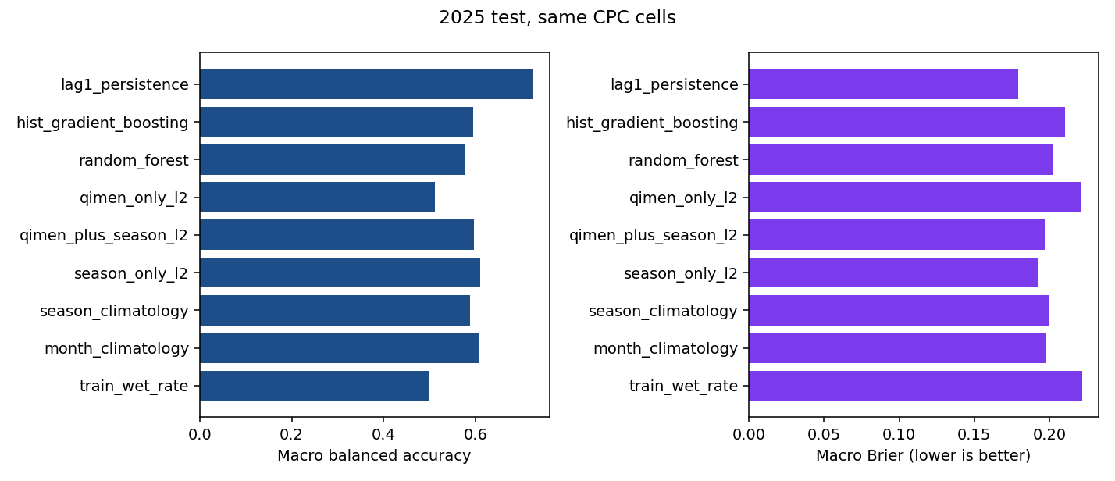
Figure 1. 2025 model performance comparison (lower Brier/log loss better; threshold metrics at 0.5)
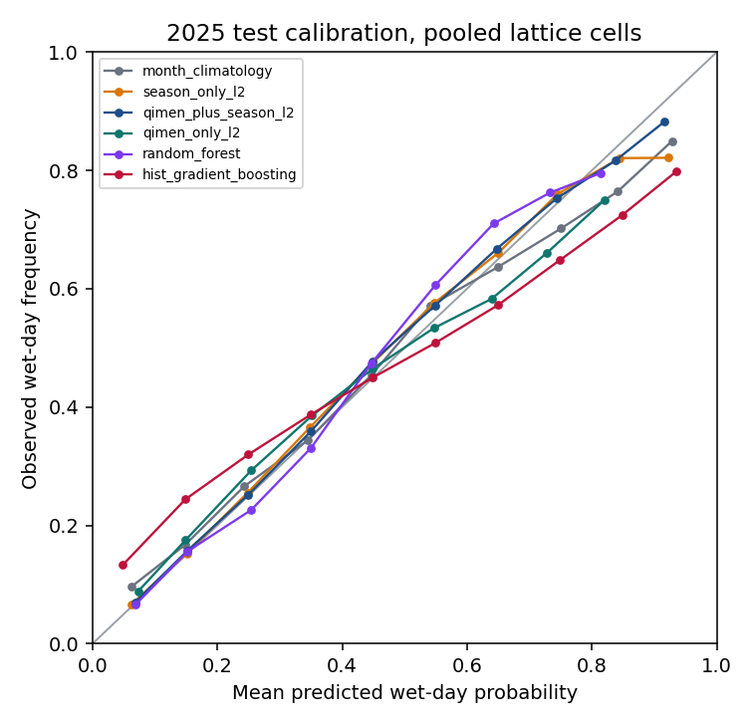
Figure 2. 2025 probability calibration (pooled cell-days; not per-cell macro)
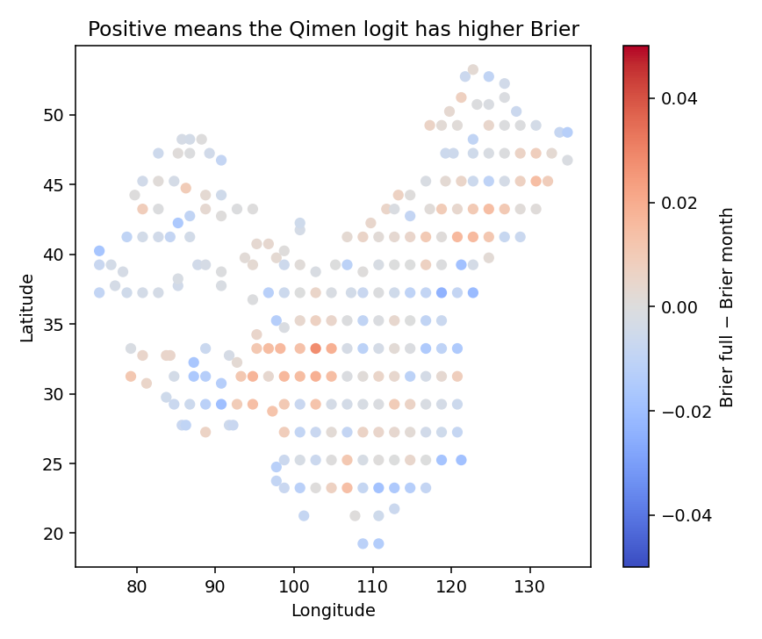
Figure 3. Map of cellwise Brier(Qimen+season)−Brier(month) (red = Qimen model worse; display clip ±0.05; table unclipped)
Calibration shows month rates and the season logit nearer the diagonal; histogram boosting bends away. The Brier-delta map is mixed in sign and does not support a stable Qimen improvement.

4.3 Latitude and seasonal strata
In every latitude band (<28°N, 28–35, 35–42, ≥42°N) and every meteorological season, Qimen+season has higher Brier than season-only L2 (pre-specified strata). Qimen-only remains near the training-rate baseline. No post-hoc band reverses the negative increment.
Table 3. Latitude-band and meteorological-season Brier strata (Qimen+season higher throughout)
Stratum | Season-only Brier | Qimen+season Brier | Delta
South <28°N (n=47) | 0.1998 | 0.2079 | +0.0080
Central 28–35°N (n=65) | 0.1986 | 0.2045 | +0.0058
North 35–42°N (n=79) | 0.1665 | 0.1709 | +0.0044
Far ≥42°N (n=76) | 0.2090 | 0.2110 | +0.0020
DJF | 0.1514 | 0.1564 | +0.0050
MAM | 0.2079 | 0.2108 | +0.0029
JJA | 0.2102 | 0.2162 | +0.0060
SON | 0.1988 | 0.2038 | +0.0050

4.4 2026 supplement (secondary)
After storing 2025 scores, the same selected settings were fit on 2023 only and applied to 2026-01-01 through 2026-11-05 (309 days; wet rate 0.4263). This window was not used to choose a model, threshold, or endpoints; it is a partial year and does not replace the 2025 test; labels remain the same CPC product family, not an independent truth source. Brier: season-only 0.1955, Qimen+season 0.1993, month 0.2005, Qimen-only 0.2220, persistence 0.1821. Corrected F1: 0.4600, 0.4440, 0.4715, 0.2839, 0.6696; histogram boosting F1 0.4881. Brier order matches 2025; F1 still does not rank the Qimen logit first among calendar-feature models.
Contrast | Point | 95% low | 95% high | Reading
Brier Qimen+season − season-only | +0.0047 | +0.0033 | +0.0061 | Qimen worse
F1 Qimen+season − season-only | −0.0172 | −0.0256 | −0.0074 | Qimen lower
Brier Qimen+season − month | −0.0011 | −0.0043 | +0.0023 | Covers 0
BalAcc Qimen+season − month | −0.0115 | −0.0191 | −0.0037 | Qimen lower
Table 4. 2025 paired differences (circular 10-day blocks, 400 draws, fixed 267 cells)
Model | Brier | F1 | Accuracy
Season-only L2 | 0.1955 | 0.4600 | 0.6997
Qimen+season L2 | 0.1993 | 0.4440 | 0.6922
Month climatology | 0.2005 | 0.4715 | 0.6896
Qimen-only L2 | 0.2220 | 0.2839 | 0.6355
Hist. boosting | 0.2090 | 0.4881 | 0.6804
Lead-1 persistence | 0.1821 | 0.6696 | 0.7588
Table 5. 2026-01-01–2026-11-05 supplement (secondary; not used for selection)

5. Discussion
On requests for p-values: under strong spatial dependence and a single time series, treating cell-days as independent yields spuriously narrow errors. This paper instead uses time-block bootstrap on fixed cells and states that intervals refer only to temporal resampling of those cells. A spatial-block bootstrap over the 267 representatives is not reported because thinning already altered spatial dependence and would require a separate protocol.
Finally, a negative increment is not a claim that Qimen symbols are useless for every task. It rejects only the protocol claim that same-day noon-chart 31-d symbolic columns improve CPC wet/dry probabilities beyond a seasonal curve. Different labels, lead times, longer training windows, or spatial supports would be new experiments—not reinterpretations of Table 2.
Same-signed negative increments across four latitude bands and four seasons weaken the explanation that failure is confined to one climate zone. Mixed signs on the map allow occasional local improvements, but macro averages and paired intervals do not support an overall positive increment. Follow-on work that retains Qimen columns may need different tasks or identification strategies rather than amplifying the present same-day Brier gap.
On “2025 is not external”: the legacy artifact already observed and reported a test window covering 2025, albeit with a different spatial design. One may still report scores on a new download and funnel, but wording must avoid “completely untouched prospective validation.” The 2026 supplement partially eases “only one test year,” yet shares the product family and is a partial year, so it remains secondary consistency evidence.
The central finding is a negative increment: adding Qimen columns atop an estimable seasonal curve does not improve 2025 probability scores and is stably worse under the circular-block interval. Validation-time model selection already pointed the same way, so the test is not an isolated accident. For traditional-knowledge digitization, the negative result still draws a boundary: computable encoding is feasible, yet symbolic columns need not improve precipitation classification beyond seasonal phase.
Accuracies near 70% are easy to over-read as “effectiveness.” With a wet rate near 0.40, seasonal baselines already reach similar levels; Brier and paired deltas versus season-only models are the appropriate incremental scale. Higher HGB F1 with worse Brier warns against anointing symbolic features with a single threshold metric.
Persistence’s superiority does not undercut the calendar-symbol conclusion: it consumes yesterday’s observation and belongs to another information set. For same-day symbolic increment, comparators must be season/month models. Likewise, pooled AUC can reward climate contrasts even for constant local rates, whereas macro AUC returns the training-rate model to 0.5; both must be reported separately.
Legacy district artifacts must remain isolated. Historically stored daily rain test means near 67.95% and revised ten-day aggregates near 79.05% arise from different spatial units, pipelines, and biased/post-corrected definitions; they are not this experiment’s results and must not be merged into Table 2. Production weights were unchanged; fits live in an isolation experiment path.

6. Limitations
Taken together, the following claims are not supported: a gain from Qimen columns once a per-cell seasonal curve is available; usable skill from Qimen columns with seasonal sine/cosine removed; calendar-feature probabilities better than yesterday’s wet/dry state; national, all-county, or all-land-grid coverage; 2025 as an untouched external test; a proven Beijing-time day boundary or first-hand station series; a CMA product; long-period climate conclusions from one training year; and any marriage, wealth, health, or examination claims. Listing these unsupported claims in Limitations reduces the risk of abstract quotation out of context.
Third-party products such as NASA POWER, if mentioned elsewhere, also cannot serve as independent truth: their corrected precipitation documentation often relies on CPC-family analyses. The sole label source here is the CPC V1.0 bytes downloaded and hash-pinned for this run.
Additionally, 31-d one-hot blocks may be nearly collinear across Gates/Stars; L2 mitigates but does not remove identification issues, and coefficient signs are not interpreted as “a given God causes rain.” The missing-value policy (no zero fill) avoids false dry days but also drops five coastal/island representatives entirely, further thinning spatial coverage.
(1) One training year limits interannual stability assessment. (2) The 267 representatives are spatially dependent and share product observations; intervals address time-block uncertainty only. (3) The 60 km neighborhood plus 2° thinning is not a land mask or national census. (4) Date alignment of daily totals with noon charts neither proves Beijing-time day boundaries nor yields a lead-time forecast. (5) Year 2025 overlaps a prior artifact test window. (6) Local protocol freeze ≠ public preregistration. (7) No human-affairs outcome labels. (8) Real-time CPC may later revise; conclusions bind to the pinned hashes.

7. Conclusions
Application implications should stay restrained: this study does not support noon Qimen symbols as necessary features for improving same-day precipitation probabilities; where interpretable calendar phase is desired, seasonal harmonics and month climatologies already provide cleaner baselines. Research code and hashes should be preserved alongside methodological negative results so that only positive narratives do not survive.
On NOAA CPC V1.0 and 267 centroid-neighborhood representatives, Qimen noon-chart columns do not reduce 2025 Brier beyond seasonal features, and unified F1 is also lower than season-only L2; Qimen-only tracks the constant baseline. Lead-1 persistence is better but cannot replace seasonal contrasts under the same input set. The negative increment constrains claims that calendar symbols necessarily improve precipitation classification, without licensing extrapolation to divinatory validation, national census coverage, or human prognostication.

Data and Code Availability
Precipitation data are the public NOAA CPC product (PSL portal [11]). Download manifests, exclusion funnel, metrics, results.json, prediction NPZ hash, environment, and logs are in the run package (run_id=cpc-7276563d90f15c12). Recomputation/plotting code is on isolation PR https://github.com/Gideon-li/giant-atlas-timber-sage/pull/2, commit 4e55230a1bd84ae26495cf67118e8254af4dc8fe; private URLs are not a public data release, and production weights were not merged from this experiment. Predictions may be verified by SHA-256 without committing large arrays.

Author Contributions, Funding, Ethics, and Conflicts of Interest
These statement items remain pending author confirmation. This manuscript does not proxy-write “no funding” or “no conflicts of interest.” Affiliation is stated as City University Malaysia per author instruction; corresponding email was not provided and is left blank.

Supplementary Note: Boundary with Legacy District Artifacts
Readers who also hold the v1 audit manuscript should note that v1 centers on historically stored metrics and definitional corrections, whereas v2 centers on a new download, funnel, fit, and metric correction. The titles and claim levels differ; they should not be collapsed into “one contradictory experiment,” but read as “audit the legacy artifact, then run the pre-specified contrast.” Production weights were not rewritten by either research manuscript.
Legacy private-repository district logistic artifacts reported stored daily rain test means near 67.95% and later reaggregated ten-day figures near 79.05%. Those numbers belong to another spatial design and evaluation vocabulary with known aggregation bias and missing baselines; they are not results of the present CPC lattice experiment and must not be co-tabulated with Table 2. This experiment did not retrain production district weights.

References
[1] Hosmer DW, Lemeshow S. Applied Logistic Regression. 2nd ed. New York: John Wiley & Sons; 2000. doi:10.1002/0471722146.
[2] Wilks DS. Statistical Methods in the Atmospheric Sciences. 4th ed. Amsterdam: Elsevier; 2019. doi:10.1016/C2017-0-03921-6.
[3] Brier GW. Verification of forecasts expressed in terms of probability. Mon Weather Rev. 1950;78(1):1–3. doi:10.1175/1520-0493(1950)078<0001:VOFEIT>2.0.CO;2.
[4] Murphy AH. A new vector partition of the probability score. J Appl Meteorol. 1973;12(4):595–600. doi:10.1175/1520-0450(1973)012<0595:ANVPOT>2.0.CO;2.
[5] Gneiting T, Raftery AE. Strictly proper scoring rules, prediction, and estimation. J Am Stat Assoc. 2007;102(477):359–378. doi:10.1198/016214506000001437.
[6] Hamill TM, Whitaker JS. Probabilistic quantitative precipitation forecasts based on reforecast analogs: Theory and application. Mon Weather Rev. 2006;134(11):3209–3229. doi:10.1175/MWR3237.1.
[7] Roberts DR, Bahn V, Ciuti S, et al. Cross-validation strategies for data with temporal, spatial, hierarchical, or phylogenetic structure. Ecography. 2017;40(8):913–929. doi:10.1111/ecog.02881.
[8] Peng RD. Reproducible research in computational science. Science. 2011;334(6060):1226–1227. doi:10.1126/science.1213847.
[9] Xie P, Yatagai A, Chen M, et al. A gauge-based analysis of daily precipitation over East Asia. J Hydrometeorol. 2007;8(3):607–626. doi:10.1175/JHM583.1.
[10] Chen M, Shi W, Xie P, et al. Assessing objective techniques for gauge-based analyses of global daily precipitation. J Geophys Res Atmos. 2008;113:D04110. doi:10.1029/2007JD009132.
[11] NOAA Physical Sciences Laboratory. CPC Global Unified Gauge-Based Analysis of Daily Precipitation. https://psl.noaa.gov/data/gridded/data.cpc.globalprecip.html (accessed 2026-11-07).
[12] Experiment record: run_id cpc-7276563d90f15c12; code commit 4e55230a1bd84ae26495cf67118e8254af4dc8fe; isolation PR https://github.com/Gideon-li/giant-atlas-timber-sage/pull/2 (authorized access only; not a public data release).

