RESULTS AND DISCUSSION

4.1 RESULTS

4.1.1 Result of Characterization of Materials used in the production of the Sample.

4.1.1.1 Particle Size Gradation Test Results
The sieve analysis was carried out in accordance with the steps prescribed in BS 812, Part 103, 1990. The results of the sieve analysis are presented in Table 4.1 and Table 4.2 for both river sand and granite respectively. While the gradation curves for river sand and granite are presented in Figure 4.1 and Figure 4.2. The gradation coefficient of both the river sand and the granite are presented in Table 4.3.

Table 4.1: Particle Size Distribution for Fine Aggregate
Sieve size  (mm) | Weight retained  (g) | % Weight retained | Cumulative % retained | Cumulative % passing
8.0 | 0 | 0 | 0 | 100
4.75 | 25.3 | 5.1 | 5.1 | 94.9
2.36 | 34.73 | 7 | 12.1 | 87.9
1.18 | 89.04 | 17.95 | 30.05 | 69.95
0.60 | 196.03 | 39.53 | 69.58 | 30.42
0.30 | 126.49 | 25.5 | 95.09 | 4.91
0.15 | 20.34 | 4.1 | 99.19 | 0.81
0.075 | 3.47 | 0.69 | 99.89 | 0.11
Pan | 0.5 | 0.10 | 100 | 0
Total | 495.90 |  | 310.94
Fineness modulus = $\frac{310.94}{100}=3.11$

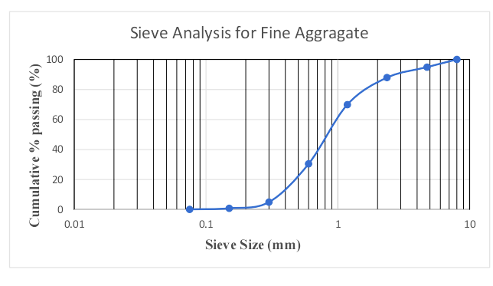

Fig. 4.1: Particle Size Distribution Graph for Fine Aggregate

Table 4.2: Particle Size Distribution of Granite
Sieve size  (mm) | Weight retained  (g) | % Weight retained | Cumulative % retained | Cumulative % passing
31.5 | 0.00 | 0.00 | 0.00 | 100
26.5 | 381.20 | 3.91 | 3.91 | 96.09
19.0 | 3635.57 | 37.29 | 41.20 | 58.80
12.5 | 3723.44 | 38.19 | 79.39 | 20.61
9.5 | 1177.20 | 12.07 | 91.46 | 8.54
4.75 | 681.91 | 6.99 | 98.46 | 1.54
Pan | 150.36 | 1.54 | 100 | 0.00
Total | 9749.68 |  | 567.06

Fineness modulus =$\frac{567.06}{100}=5.67$

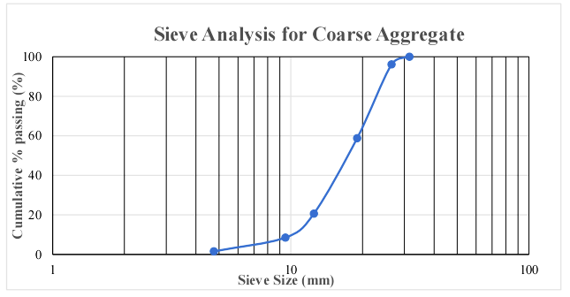

Fig. 4.2: Particle size distribution graph for coarse aggregate

Gradation coefficients
From Figure 4.1 and Figure 4.2, the coefficient of uniformity (Cu) and the coefficient of gradation (Cc) were obtained using the formula in Equation 4.1 and 4.2. The result of the gradation coefficients of the river sand and granite are shown in Table 4.3.
- Cu = $\frac{ D60}{D10}$ 4.1
- Cc = $\frac{ {\text{D}}^{\text{2}}30}{D60.D30}$ 4.2

Table 4.3: Result of river sand and granite gradation coefficient
Materials | D10 (mm) | D30 (mm) | D60 (mm) | Cu = $\frac{ D60}{D10}$ | Cc = $\frac{ {\text{D}}^{\text{2}}30}{D60.D30}$
River sand | 0.43 | 0.70 | 1.20 | 2.79 | 0.95
Granite | 9.82 | 13.86 | 19.20 | 1.96 | 1.02

4.1.1.2 Bulk Density Test Results
The bulk density of the river sand and the granite were carried out in accordance to BS 8122: 1995. The results from the test are shown in Table 4.4 and 4.5 below.

Table 4.4: Bulk density of river sand.
DESCRIPTION | TRIAL
Mass of empty cylinder (kg) | 4.4 (kg)
Mass of cylinder + sample (kg) | 6.1 (kg)
Volume of cylinder (m³) | 0.001 (m³ )
Bulk density of sample | 1700 (kg/m³

Table 4.5: Bulk density of granite.
DESCRIPTION | TRIAL
Mass of empty cylinder (kg) | 4.4 (kg)
Mass of cylinder + sample (kg) | 6.0 (kg)
Volume of cylinder (m³) | 0.001 (m³ )
Bulk density of sample | 1600 (kg/m³

4.1.1.3 Specific Gravity Results
The specific gravity on the river sand and the granite were carried out in accordance to BS 8122 : 1995. The results from the test are shown in Table 4.6 and Table 4.7 below.

Table 4.6: Specific gravity of river sand
DESCRIPTION | TRIAL (g)
Mass of empty pyncometer bottle, M1 (g) | 150.81
Mass of bottle + dry sample, M2 (g) | 468.69
Mass of bottle + dry sample + water, M3 (g) | 844.77
Mass of bottle filled with water only, M4 (g) | 648.42
Mass of dry sample, M5 =[M2]-[M1], (g) | 317.88
Mass of water occupying same volume as the sample, M6 =[M4]-[M3-M5], (g) | 1221.11
Specific gravity = M5/M6 | 2.61

Table 4.7: Specific gravity of granite
DESCRIPTION | TRIAL (g)
Mass of empty pyncometer bottle, M1 (g) | 1257.77
Mass of bottle + dry sample, M2 (g) | 2092.25
Mass of bottle + dry sample + water, M3 (g) | 2940.88
Mass of bottle filled with water only, M4 (g) | 2407.49
Mass of dry sample, M5 =[M2]-[M1], (g) | 834.48
Mass of water occupying same volume as the sample, M6 =[M4]-[M3-M5], (g) | 300.60
Specific gravity = M5/M6 | 2.77

Table 4.8: Summary of physical test results
Property | River Sand | Granite
Specific gravity | 2.61 | 2.77
Bulk density | 1700 | 1600
Fineness modulus | 3.11 | $$5.67$$
Coefficient of curvature, Cc | 0.95 | 1.02
Coefficient of uniformity, Cu | 2.79 | 1.96

4.1.1.4 X-Ray Flourescence (XRF) test result
Fig. 4.3 gives the elemental concentration of the metakaolin used in this experiment and Fig. 4.4 shows the graph of the constituent element in the Metakaolin.
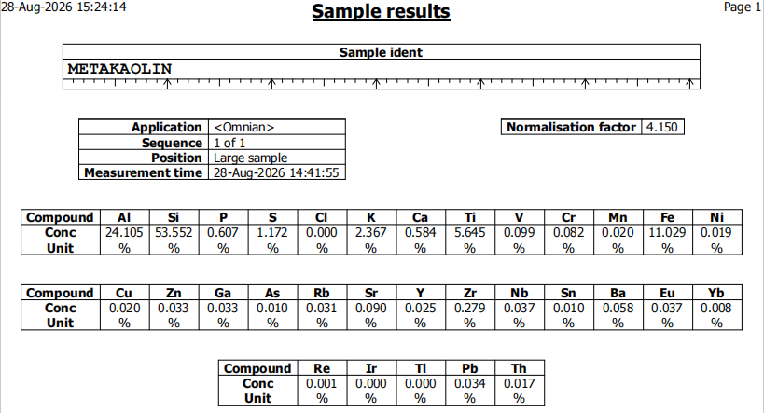

Fig 4.3: Elemental Concentration of the Metakaolin
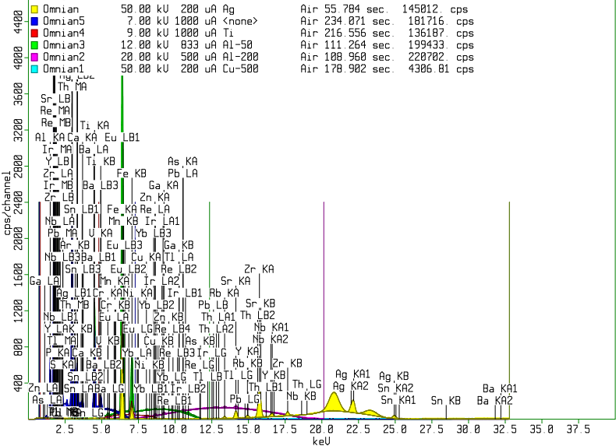

Fig. 4.4: Graph of the constituent element in the Metakaolin

4.1.1.5 X-Ray Diffraction (XRD) test result
Fig. 4.5 shows the graph of X-Ray Diffraction of the metakaolin sample.
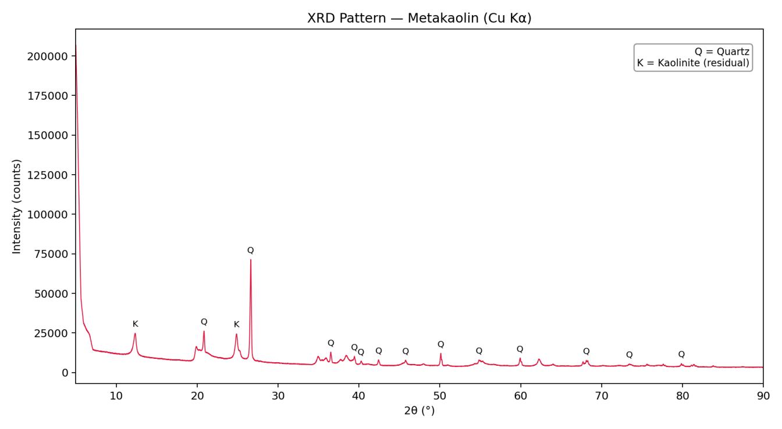

Fig 4.5 X-Ray Diffraction of the Metakaolin Sample

4.1.2 Result for Development of suitable mix ratio for the Bacteria-induced Metakaolin-based Geopolymer concrete.
Table 4.9 gives the actual compressive strength relative to each mix ratio

Table 4.9 Actual Compressive Strength
S/N | Mix Ratio | NaOH  (M) | NA2SiO3: NaOH ratio | Bacteria Dosage(%) | Activator-Binder ratio | Temperature(ºC) | Compressive Strength(MPa)
1 | 1:2:4 | 8 | 1.5:1 | 3 | 0.4:1 | 27 | 23.54
2 | 1:2:4 | 8 | 1.5:1 | 0 | 0.4:1 | 29 | 23.62
3 | 1:2:4 | 8 | 1.5:1 | 0 | 0.4:1 | 31 | 23.74
4 | 1:2:4 | 8 | 1.5:1 | 0 | 0.45:1 | 27 | 24.4
5 | 1:2:4 | 8 | 1.5:1 | 0 | 0.45:1 | 29 | 25.01
6 | 1:2:4 | 8 | 1.5:1 | 3 | 0.45:1 | 31 | 24.82
7 | 1:2:4 | 8 | 1.5:1 | 0 | 0.5:1 | 27 | 23.5
8 | 1:2:4 | 8 | 1.5:1 | 0 | 0.5:1 | 29 | 23.84
9 | 1:2:4 | 8 | 1.5:1 | 3 | 0.5:1 | 31 | 23.74
10 | 1:2:4 | 8 | 2:1 | 0 | 0.4:1 | 27 | 24.38
11 | 1:2:4 | 8 | 2:1 | 0 | 0.4:1 | 29 | 24.72
12 | 1:2:4 | 8 | 2:1 | 3 | 0.4:1 | 31 | 24.52
13 | 1:2:4 | 8 | 2:1 | 0 | 0.4:1 | 27 | 24.67
14 | 1:2:4 | 8 | 2:1 | 0 | 0.45:1 | 29 | 25.01
15 | 1:2:4 | 8 | 2:1 | 3 | 0.45:1 | 31 | 24.82
16 | 1:2:4 | 8 | 2:1 | 0 | 0.5:1 | 27 | 24.42
17 | 1:2:4 | 8 | 2:1 | 0 | 0.5:1 | 29 | 23.93
18 | 1:2:4 | 8 | 2:1 | 3 | 0.5:1 | 31 | 25.11
19 | 1:2:4 | 8 | 2.5:1 | 0 | 0.4:1 | 27 | 24.33
20 | 1:2:4 | 8 | 2.5:1 | 0 | 0.4:1 | 29 | 24.72
21 | 1:2:4 | 8 | 2.5:1 | 3 | 0.4:1 | 31 | 25.50
22 | 1:2:4 | 10 | 2.5:1 | 0 | 0.45:1 | 27 | 24.6
23 | 1:2:4 | 10 | 2.5:1 | 0 | 0.45:1 | 29 | 25.51
24 | 1:2:4 | 10 | 2.5:1 | 3 | 0.45:1 | 31 | 24.62
25 | 1:2:4 | 10 | 2.5:1 | 0 | 0.5:1 | 27 | 25.11
26 | 1:2:4 | 10 | 2.5:1 | 0 | 0.5:1 | 29 | 25.2
27 | 1:2:4 | 10 | 2.5:1 | 3 | 0.5:1 | 31 | 24.52
28 | 1:2:4 | 10 | 1.5:1 | 0 | 0.4:1 | 27 | 25.21
29 | 1:2:4 | 10 | 1.5:1 | 0 | 0.4:1 | 29 | 24.33
30 | 1:2:4 | 10 | 1.5:1 | 3 | 0.4:1 | 31 | 23.74
31 | 1:2:4 | 10 | 1.5:1 | 0 | 0.45:1 | 27 | 21.38
32 | 1:2:4 | 10 | 1.5:1 | 0 | 0.45:1 | 29 | 25.31
33 | 1:2:4 | 10 | 1.5:1 | 0 | 0.45:1 | 31 | 23.35
34 | 1:2:4 | 10 | 1.5:1 | 0 | 0.5:1 | 27 | 23.25
35 | 1:2:4 | 10 | 1.5:1 | 0 | 0.5:1 | 29 | 22.36
36 | 1:2:4 | 10 | 1.5:1 | 0 | 0.5:1 | 31 | 25.51
37 | 1:2:4 | 12 | 2:1 | 0 | 0.4:1 | 27 | 23.74
38 | 1:2:4 | 12 | 2:1 | 0 | 0.4:1 | 29 | 23.54
39 | 1:2:4 | 12 | 2:1 | 0 | 0.4:1 | 31 | 23.35
40 | 1:2:4 | 12 | 2:1 | 0 | 0.45:1 | 27 | 20.41
41 | 1:2:4 | 12 | 2:1 | 0 | 0.45:1 | 29 | 23.64
42 | 1:2:4 | 12 | 2:1 | 0 | 0.45:1 | 31 | 23.54
43 | 1:2:4 | 12 | 2:1 | 0 | 0.5:1 | 27 | 24.53
44 | 1:2:4 | 12 | 2:1 | 0 | 0.5:1 | 29 | 24.03
45 | 1:2:4 | 12 | 2:1 | 0 | 0.5:1 | 31 | 24.8
46 | 1:2:4 | 12 | 2.5:1 | 0 | 0.4:1 | 27 | 23.54
47 | 1:2:4 | 12 | 2.5:1 | 0 | 0.4:1 | 29 | 25.40
48 | 1:2:4 | 12 | 2.5:1 | 3 | 0.4:1 | 31 | 21.19
49 | 1:2:4 | 12 | 2.5:1 | 0 | 0.45:1 | 27 | 23.74
50 | 1:2:4 | 12 | 2.5:1 | 0 | 0.45:1 | 29 | 21.38
51 | 1:2:4 | 12 | 2.5:1 | 3 | 0.45:1 | 31 | 25.70
52 | 1:2:4 | 12 | 2.5:1 | 0 | 0.5:1 | 27 | 24.33
53 | 1:2:4 | 12 | 2.5:1 | 0 | 0.5:1 | 29 | 24.43
54 | 1:2:4 | 12 | 2.5:1 | 0 | 0.5:1 | 31 | 22.07
55 | 1:2:4 | 12 | 2.5:1 | 3 | 0.5:1 | 31 | 22.36
56 | 1:2:4 | 14 | 2.5:1 | 0 | 0.5:1 | 27 | 22.37
57 | 1:2:4 | 14 | 2.5:1 | 0 | 0.5:1 | 29 | 25.50
58 | 1:2:4 | 14 | 2.5:1 | 3 | 0.5:1 | 31 | 25.21
59 | 1:2:4 | 14 | 2.5:1 | 0 | 0.45:1 | 27 | 25.31
60 | 1:2:4 | 14 | 2.5:1 | 0 | 0.45:1 | 29 | 23.83
61 | 1:2:4 | 14 | 2.5:1 | 3 | 0.45:1 | 31 | 23.35
62 | 1:2:4 | 14 | 2.5:1 | 0 | 0.4:1 | 27 | 24.52
63 | 1:2:4 | 14 | 2.5:1 | 0 | 0.4:1 | 29 | 25.01
64 | 1:2:4 | 14 | 2.5:1 | 3 | 0.4:1 | 31 | 24.87
65 | 1:2:4 | 14 | 2:1 | 0 | 0.5:1 | 27 | 22.56
66 | 1:2:4 | 14 | 2:1 | 0 | 0.5:1 | 29 | 25.02
67 | 1:2:4 | 14 | 2:1 | 0 | 0.5:1 | 31 | 23.54
68 | 1:2:4 | 14 | 2:1 | 3 | 0.45:1 | 31 | 24.33
69 | 1:2:4 | 14 | 2:1 | 0 | 0.45:1 | 29 | 24.33
70 | 1:2:4 | 14 | 2:1 | 0 | 0.45:1 | 27 | 25.21

4.1.3 Result for Formulation of Mathematical Model for the Prediction of Compressive Strength of Sample.

4.1.3.1 Correlation Analysis
Prior to model development, a Pearson correlation analysis was conducted between each mix design variable and the measured compressive strength, following the exclusion of a small number of anomalous low-strength specimens attributable to casting or curing inconsistencies unrelated to mix design. The results are summarized in Table 4.10. Fig. 4.6 shows the graph of the correlation analysis. The SVR Model script is presented in appendix 2.

Table 4.10: Correlation of mix design variables with compressive strength
Variable | Correlation with Compressive Strength (r)
Activator Ratio (Na₂SiO₃:NaOH) | 0.311
Temperature (°C) | 0.144
Bacillus subtilis Dosage (%) | 0.114
L/B (A/B) Ratio | 0.040
NaOH Molarity | -0.026
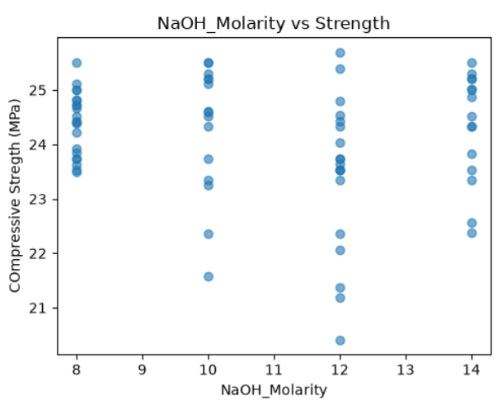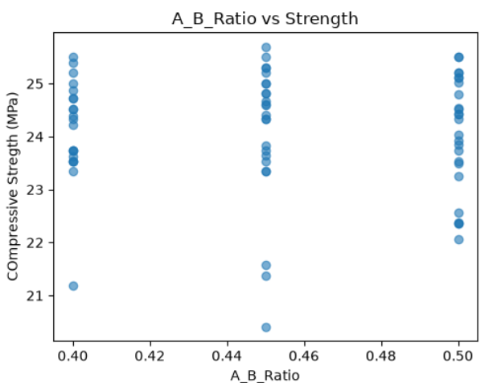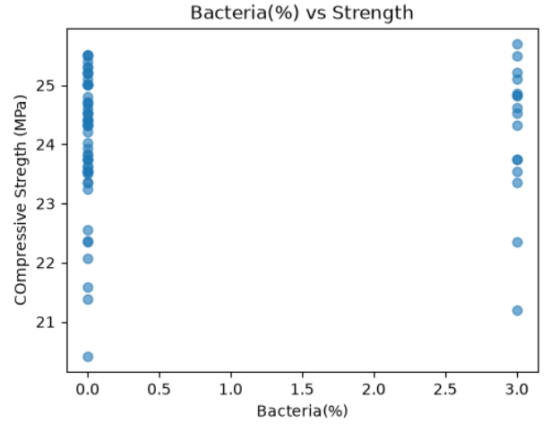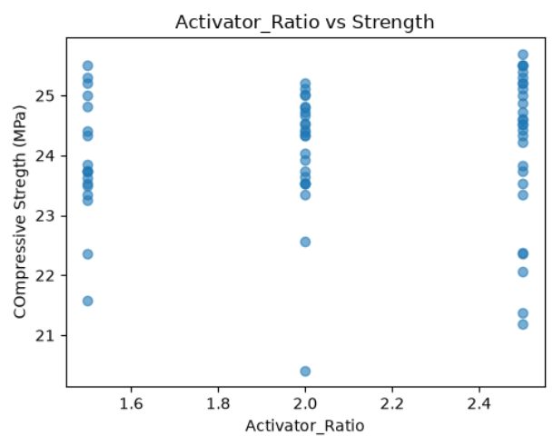
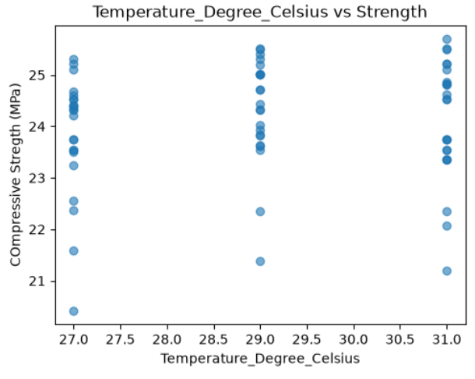

Fig. 4.6 Correlation Analysis

4.1.3.2 Model Training and Hyperparameter Optimization
The SVR model was trained using a radial basis function (RBF) kernel, with hyperparameters (C, epsilon, and gamma) optimized via 5-fold cross-validated grid search. The optimal hyperparameter combination is presented in Table 4.11.

Table 4.11: Optimal SVR hyperparameters
Hyperparameter | Optimal Value
Kernel | RBF
C (regularization) | 10
Epsilon | 0.5
Gamma | 0.01

4.1.3.3 Evaluation of the Developed Model.
The performance of the trained SVR model on both the training and held-out test sets is summarized in Table 4.12. Figure 4.7 shows the graph of Predicted versus actual compressive strength for the SVR model (test set).

Table 4.12: SVR Model Performance Metrics
Dataset | R² | MAE (MPa) | MSE | RMSE (MPa) | MAPE (%)
Training set | 0.2017 | 0.5312 | 0.3898 | 0.6243 | 2.17
Test set | -0.0428 | 0.6886 | 0.6612 | 0.8132 | 2.81
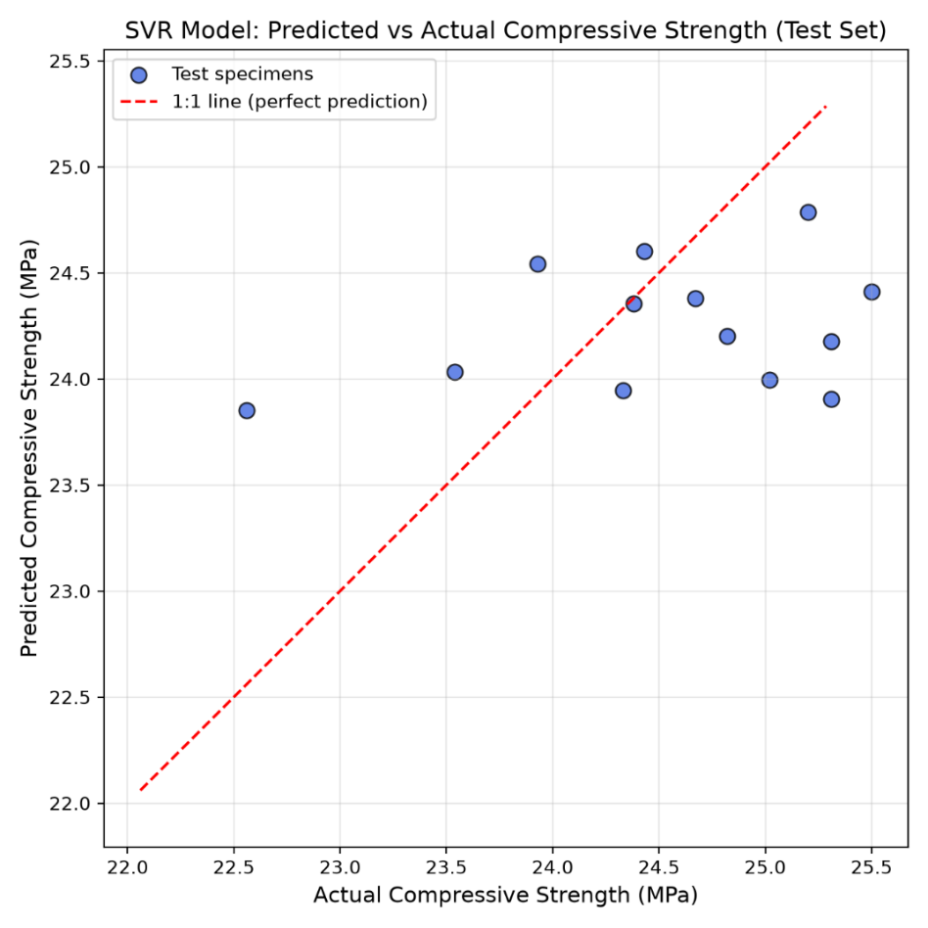

Fig. 4.7: Predicted versus actual compressive strength for the SVR model (test set)
4.1.4 Determination of Water Absorption Rate of Sample
Water absorption tests were conducted in accordance with BS 1881-122, with cubes oven-dried, weighed, then immersed in water for 24 hours before re-weighing. Some cubes were selected at random to act as a representative part of the whole set and Table 4.13 shows the summary of the water absorption rate of the samples.

Table 4.13: Water absorption results
Mix ID | Dry Weight (g) | Wet Weight (g) | Water Absorption (%) | Corresponding Mean Strength (MPa)
1 | 8.2 | 8.5 | 3.65 | 23.54
11 | 8.4 | 8.5 | 1.2 | 24.72
30 | 7.7 | 7.9 | 2.59 | 23.74
32 | 8.3 | 8.6 | 3.61 | 25.31
44 | 8.6 | 8.8 | 2.32 | 24.03
50 | 8.4 | 8.5 | 1.2 | 21.38
56 | 8.0 | 8.1 | 1.25 | 22.37
57 | 8.8 | 8.9 | 1.13 | 25.50

4.2 Discussion

4.2.1 Discussion of Characterization of materials used in the production of the Sample

4.2.1.1 Particle Size Gradation Discussion
According to ASTM C33 the recommended fineness modulus for fine aggregate is between 2.3 to 3.1. The river sand used had a fineness modulus of 3.11 which lies at the upper limit of the recommended range. This indicates that the sand is suitable for concrete production. The river sand has a coefficient of uniformity (Cu) of 2.79 and a coefficient of curvature (Cc) of 0.95. A well-graded sand require Cu of at least 6 and Cc between 1 and 3, the sand satisfies neither condition. According to the Unified Soil Classification System (USCS), the river sand is classified as poorly (Uniformly) graded sand (SP), indicating a uniform grain-size distribution dominated by particles of similar size.
Granite used had a fineness modulus of 5.67 and this is a reasonable value for coarse aggregate indicating that it is suitable for concrete production. It also had a Cu of 1.96 and Cc of 1.02 which suggests it is a uniformly graded coarse aggregate having 12.5mm as the highest recorded retained mass.
The poor grading of both aggregate implied a higher void content, which increased the volume of geopolymer paste required to fill the voids and coat the particles. It also reduced workability and compaction thereby affecting the strength of the concrete.

4.2.1.2 Bulk Density Discussion
The bulk densities of the river sand and granite were 1700 kg/m³ and 1600 kg/m³ respectively. These are within acceptable limits for concrete production. The lower bulk density of the granite is attributable to its larger particle size and higher void content.

4.2.1.3 Specific Gravity Discussion
The river sand had a specific gravity of 2.61, while the granite had a specific gravity of 2.77. Both values fall within the typical ranges reported for natural aggregates and indicates sound, normal-weight materials with the granite being slightly denser.

4.2.1.4 X-Ray Flourescence (XRF) Discussion
Fig. 4.3 gives the elemental concentration of the metakaolin used in this experiment.
- Si + Al together make up about 77.6% of the sample. This confirms that the material is genuinely reactive and suitable for geopolymerization.
- Si:Al molar ratio ~ 2.1:1. Pure kaolinite has theoretical Si:Al close to 1:1, so a ratio of ~2:1 suggests some free silica (quartz) impurity alongside the kaolinite, this is common in natural kaolin deposits and so not unusual or alarming.
- Fe2O3 (~11%). This is notably high for a “clean” metakaolin and is likely from iron oxide/hydroxide impurities (hematite, goethite) naturally present in the clay source. This high Fe content may have caused slight reduction in ultimate compressive strength compared to low-iron metakaolin.
- TiO2 (~5.6% Ti). This is also fairly high but titanium is largely inert in the geoplolymerization reaction.
- K2O (~2.4% K). Potassium can act as a secondary alkali activator alongside the NaOH/Na2SiO3 system, so this is an advantage.
- Sulfur (~1.2%) is another elemental constituent of the metakaolin which if present as sulfate can react with calcium sources (if any enter through aggregates or bacteria nutrient media) and potentially contribute to expansive/efflorescence issues over time.

4.2.1.5 X-Ray Diffraction (XRD) Discussion
Fig. 4.5 shows the X-Ray Diffraction of the metakaolin sample. The result is discussed below.
- The crystalline content is dominated by quartz, with a clear residual kaolinite signature superimposed. This quartz is essentially inert in geopolymerization acting as a filler and not binder. A high quartz content dilutes the reactive Si/Al available for the geopolymer gel and can partly be the cause of the lower-than-expected strength results which was obtained.
- In the 10-40º window, where metakaolin’s amorphous hump normally sits:~80% of the scattered area is broad/diffuse(amorphous-like), ~20% is attributable to sharp quartz + kaolinite peaks. This implies that the metakaolin appeared to have a majority amorphous fraction, which is good since this is the reactive phase in geopolymerization. But there is a non-trivial quartz load and a detectable unreacted kaolinite fraction, meaning calcination was not 100% complete or the source clay had a lot of quartz impurity. This is consistent with the XRF result obtained (elevated Fe).

4.2.2 Discussion of Development of suitable mix ratio for the Bacteria-induced Metakaolin-based Geopolymer concrete
Table 4.9 presents the mean compressive strength values obtained for all experimental mixes across the tested NaOH molarities (8M, 10M, 12M, and 14M), Na₂SiO₃:NaOH activator ratios (1.5, 2.0, and 2.5), and Bacillus subtilis dosages, following 28 days of ambient curing. Each value represents the average of [2/3] replicate cubes.
The highest compressive strength of 25.7 MPa was recorded for mix 51, corresponding to a NaOH molarity of 12M and an activator ratio of 2.5. The lowest strength of 20.41 MPa was observed for mix 40. This lowest strength observed in mix 40 which also have a NaOH molarity of 12M is as a result of improper compaction as honeycombs was seen on the cube signifying the presence of voids.

4.2.3 Discussion of Formulation of Mathematical Model for the Prediction of Compressive Strength of Sample.
For SVR with an RBF kernel, the prediction function is given in Equ 4.3 below:
f(x) = ⅀_{i} (α_{i} - α_{i*}). exp(-γ||xi – x||²) + b* 4.3
Where:
- xi = Each support vector (a subset of the training data points the model kept)
- (αi- αi*) = The dual coefficients (weights) learned during training
- K(xi, x) = The RBF kernel function: K(xi, x) = exp(-γ||xi – x||²)
- γ (gamma) = The tuned kernel coefficient
- b = The intercept
The mathematical model used in analyzing the compressive strength is given in Equ. 4.4 below:
Strength(x) = ⅀_{i} (α_{i} - α_{i*}). exp(-γ||xi – x||²) + b* 4.4

4.2.3.1 Interpretation of Model Performance
The model achieved an R² of 0.2017 on the training set, indicating that it captured a modest, though limited, relationship between the mix design variables and compressive strength during training. On the held-out test set, R² fell to −0.0428, indicating that the model did not generalize reliably to unseen specimens and performed comparably to a baseline that simply predicts the mean strength value. Despite this, the absolute error metrics remained relatively small in practical terms (test RMSE = 0.81 MPa, MAPE = 2.81%), reflecting the narrow range of measured compressive strength values across the dataset (approximately 21–26 MPa) rather than genuinely precise prediction. A low RMSE alongside a near-zero or negative R² is characteristic of datasets with limited target variance, where even an uninformative model can achieve a numerically small error.
The gap between training performance (R² = 0.2017) and test performance (R² = −0.0428) suggests that the SVR model, while able to partially fit patterns within the training data, did not learn a relationship robust enough to extrapolate to new specimens. Several factors likely contributed to this outcome.
Dataset size. With 70 specimens split into 56 training and 14 test samples, the dataset is comparatively small for a five-variable regression problem. Machine learning models, including SVR, generally require a larger sample size to reliably characterize multivariate, potentially nonlinear relationships; the available data may be insufficient to fully capture the influence of each mix variable on strength.
Weak individual variable correlations. The correlation analysis in Section 4.2.1 showed that most mix variables exhibited weak linear association with compressive strength, with the activator ratio showing the strongest relationship (r = 0.311) and NaOH molarity showing negligible correlation (r = −0.026). This weak underlying signal limits the ceiling of achievable model performance regardless of the algorithm or hyperparameters used.
Narrow strength range. The relatively tight spread of measured compressive strength values (approximately 21–26 MPa) reduces the variance available for the model to explain, which can suppress R² even when absolute prediction errors (MAE, RMSE) remain small.

4.2.3.2 Comparison with Existing Literature
To contextualize the model's predictive accuracy, Table 4.14 compares the performance of the present SVR model with SVR/ANN/regression-based models reported in related geopolymer concrete studies.

Table 4.14: Comparison of model performance with previous studies
Study | Method | R² | RMSE (MPa)
This study | SVR (RBF kernel) | -0.04 (test) | 0.81
Khan et al. (2021) | ANN | 0.867(R=0.931) | 4.99
Khan et al. (2021) | GEP | 0.930(R=0.964) | 2.64

The R² obtained in this study is lower than values typically reported in comparable geopolymer SVR/ANN modeling literature, which commonly report R² values above 0.80 on test data. This discrepancy is most plausibly attributable to the smaller dataset size and narrower strength range in the present study relative to those reported works, several of which draw on substantially larger experimental datasets.

4.2.4. Discussion of Water Absorption Rate of Sample
Table 4.13 shows the summary of the water absorption rate of the samples.
Water absorption ranged from 1.13% to 3.65%, with the lowest absorption recorded for mix 57 which has a corresponding molarity of 14M and the highest for mix 1 which has a corresponding molarity of 8M.
This finding corresponds with already existing literature which state that geopolymer concrete exhibit less water absorption than Ordinary Portland Cement concrete. It also aligns to the accepted standard of not more than 5% absorption.
4.2.5 Implications and Recommendations
The obtained results for this project on Modelling the Compressive Strength of Bacteria-induced Metakaolin-based Geopolymer Concrete indicate that, within the ranges of NaOH molarity (8–14M), activator ratio (1.5–2.5), Bacillus subtilis dosage, and curing temperature investigated in this study, the relationship between mix design and 28-day compressive strength is weaker than anticipated, and insufficiently captured by the available dataset to support strong predictive modeling.
This suggests that, within the tested parameter space, compressive strength may be governed more by experimental variability (casting, compaction, curing consistency) than by the mix design variables alone, or that the true relationship is nonlinear and would require a substantially larger dataset to resolve reliably.
For future work, this limitation could be addressed by expanding the dataset (additional mixes and replicate specimens), narrowing the parameter space around the activator ratio and systematically documenting and controlling casting/curing conditions to reduce extraneous variability that may be obscuring the true effect of mix design on strength.

