|  |  |
| --- | --- |
| Voting informed – Voting-informed.com | About Step 1, Step 2, Step 3 |
| Content of each web page  (no margin, padding, etc.) but vertical spacing | |
| Footer with disclaimer | |

***---Voting-Informed.com---***

***Helping You Vote Informed***

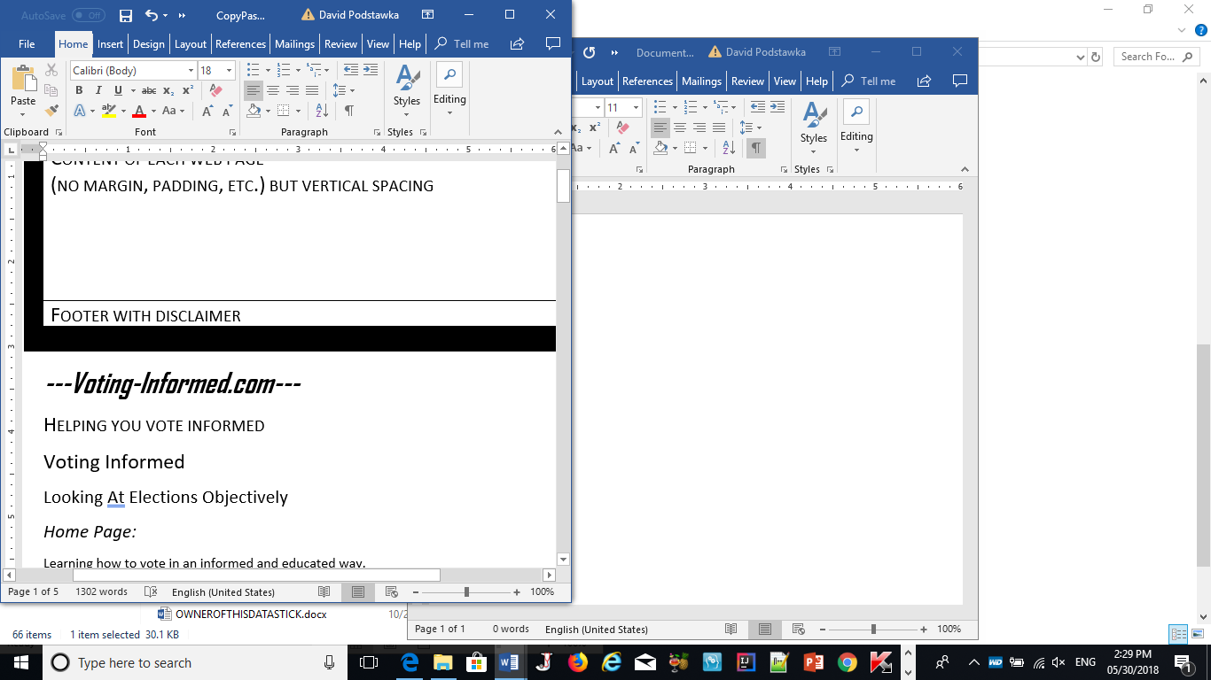

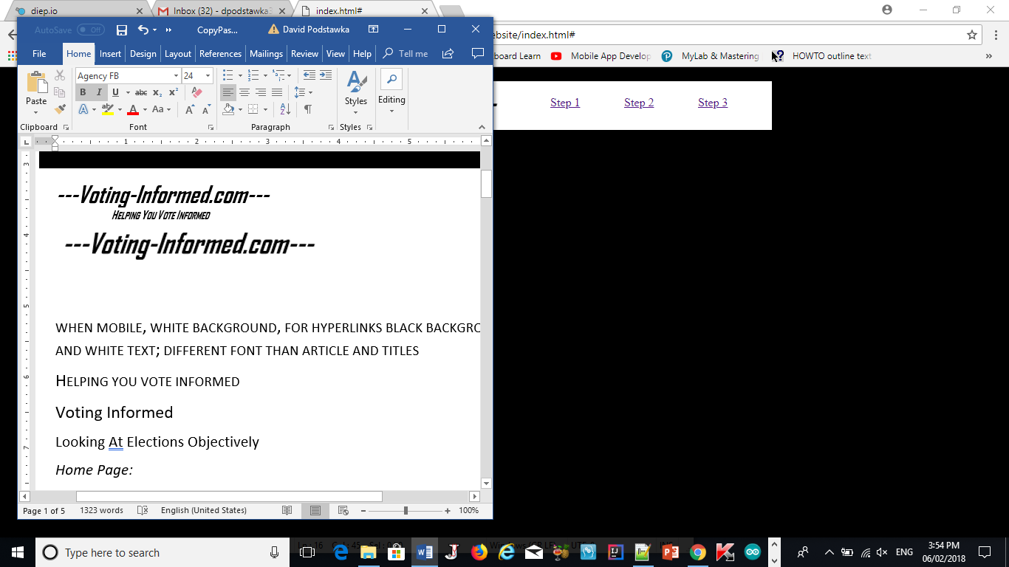

when mobile, white background, for hyperlinks black background and white text; different font than article and titles

Helping you vote informed

Voting Informed

Looking At Elections Objectively

*Home Page (not about page):*

Learning how to vote in an informed and educated way.

You are an adult. An adult with values, beliefs, and experience. You know what is important to you.

Conversely, you know what isn’t important to you, and what goes against your beliefs and principles.

When you vote, you want to support someone who represents what you value, someone whose goals and promises align with your needs, and someone, who through all this will strengthen your community, or your state or province, or your country.

However, informed voting has become so much more difficult. It is so easy to find headlines that tell you who to vote for, or where an elaborate story is made out of a quote, what the candidates say about each other, or simply speculation.

What is much harder to find, and is important for informed voting, is an objective comparison of the candidate’s values, goals, and plans for what they will accomplish while in office.

It has become clear to us that the latter is almost non-existent, and that both political and news media don’t give you enough credit for being smart enough to make a decision, when simply presented with facts, on your own.

We hope that we will help you learn how to gather all the facts and information you need to make an unbiased and informed voting decision.

[Learn More?](https://voting-informed.com/what-you-value-what-you-need)

*About Page:*

Thank you for visiting!

We hope you found this page useful.

Share this with your friends, and the people you care about! voting-informed.com can’t continue to exist without your continuous support.

voting-informed.com is not affiliated or supported by any political organization.

*Contact*

[info@voting-informed.com](mailto:info@voting-informed.com)

*(for footer) Terms and Conditions*

**Important**

Disclaimer

Last updated: June 23, 2017

The information contained on voting-informed.com website (the "Service") is for general information purposes only.

Voting Informed assumes no responsibility for errors or omissions in the contents on the Service.

In no event shall Voting Informed be liable for any special, direct, indirect, consequential, or incidental damages or any damages whatsoever, whether in an action of contract, negligence or other tort, arising out of or in connection with the use of the Service or the contents of the Service. Voting Informed reserves the right to make additions, deletions, or modification to the contents on the Service at any time without prior notice.

Voting Informed does not warrant that the website is free of viruses or other harmful components.

This Disclaimer is licensed by [TermsFeed Generator](https://termsfeed.com/) to Voting Informed.

*Step 1: What you Value.*

When you make your vote for you candidate, you want them to truly represent what you value, and promise to fulfill and advocate for your needs. You first need to establish what those are.

**Make a List**

Think of what values, and goals or accomplishments you want to see achieved by the winning candidate of this election, and make a list, from most to least important criteria.

Conversely, if you know what they are, you also should make a list of both the principles and goals you would not want your ideal candidate to have.

By writing down these list(s), you are much more aware of both the qualities and goals you want to see from your candidate.

With these fresh in your mind, and on paper, you are much better equipped for selecting your candidate based on the criteria you want, using unbiased evidence to truly make the correct choice for you.

[*Step 2*](https://voting-informed.com/finding-information)*: Finding Information*

Now that you’ve carefully made a list of the principles and goals you want out of your candidate, you are ready to find evidence to select your him, or her, in the most unbiased manner possible.

Finding unbiased and unfiltered information may require some searching. Below are a few suggestions to get you on the right track.

**Speech/Debate Transcripts**

The biggest strength in using a transcript is not having quotes or statements taken out of context. A proper transcript should include the entire text of what was said by the candidate(s) in the speech or debate.

In this way, you will get a better understanding of why the candidates made the statements they did, and not only get an unfiltered view of their principles, but the whole story as well.

If possible, find more than one transcript of a certain speech or debate. Some media sources may leave certain segments or bits of information out to better suit their narrative. By finding consistent information from more than one source, you can be more confident that your findings reflect reality and the truth.

**Filmed Speeches/Debates**

Upon reading a transcript, you may find that some of the responses or statements might not make sense, or even be controversial. Having footage of the speech or debate will help you understand the speaker’s tone, and context of the situation.

When searching for filmed speeches or debates, especially if you are opting to not use transcripts, try to find complete, unedited versions of the event. Only watching segments of the speech or debate will not give you complete context of the situation, or provide you with reasoning for why certain discussions or statements took place.

Lastly, make sure that the footage you are watching does not have a commentator. The commentator may sway you towards a certain candidate using his or her own bias. If you want your decision to be truly your own, you will need to remove as many of these external influencing factors as possible.

**Statements**

Statements released by candidates tend to be well-articulated pieces of writing on issues brought up during the election.

These statements are an easy way of determining the stance of the candidate on certain issues, and how they will accomplish them.

Similar to the previous headings, find the complete statements which do exclude any sections. An incomplete statement may compromise the stance they are trying to make, and the message they are trying to send you.

Use the list(s) you made in the first step to select your candidate based on the unfiltered, unedited events.

*Step 3: Open-minded Discussion*

Now, while you’ve done your homework, and have an idea of which candidate you will support based on your lists created by using facts and evidence, you should also be receptive towards the point of view of others.

You may find that certain principles the candidate holds, or goals they want to achieve, may affect you in ways you haven’t thought of yet.

**News/Political Media**

By watching political news, you may receive thoughtful conversation and reporting by experts on the issues the candidates discussing.

Having read transcripts or watched footage of the speeches or debates, you will be properly equipped to determine whether you are being misled by the media omitting, adding, or changing, information.

**Other voters**

Whether this is visiting forums, or chatting within your circle, you are ready to discuss your point of view with others.

While you are able to analyze the validity of claims, using evidence, don’t discount the thoughts of others. They may be just as informed as you are, but based their decision on selecting different principles, or goals of the candidate.

**You are human**

You are not infallible, and it is arrogant to think that you never make mistakes. Upon being shown appropriate evidence, be open to changing your point of view.

The reason you are here, is that you want your vote to be a reflection of what you value, and what you want achieved in your city, state, or country. By being proud and sticking to your mistake, you are not only being untrue with your vote, but untrue with yourself.