Sprint 3 - Agility Design Document

April 18, 2022

Table of Contents

1. Executive Summary 3

1.1 Project Overview 3

1.2 Purpose and Scope of this Specification 3

2. Product/Service Description 3

2.1 Product Context 3

2.2 User Characteristics 3

2.3 Assumptions 3

2.4 Constraints 3

2.5 Dependencies 4

3. Requirements 4

3.1 Functional Requirements 5

3.2 Security 5

3.2.1 Protection 5

3.2.2 Authorization and Authentication 6

3.3 Portability 6

4. Requirements Confirmation/Stakeholder sign-off 6

5. System Design 6

5.1 Algorithm 6

5.2 System Flow 6

5.3 Software 6

5.4 Hardware 6

5.5 Test Plan 7

5.6 Task List/Gantt Chart 7

5.7 Staffing Plan 7

# Executive Summary

## Project Overview

This project is to test our knowledge of software engineering. We test our knowledge of making algorithms, testing code, and making flow charts. Each group is assigned a robot that must do the following: Go around the Agility course. There are a series of requirements the robot must do while doing this course. Like speaking, and staying on the path, as well as maneuvering around obstacles.

## Purpose and Scope of this Specification

In scope

Modification of the third sprint, give a good deep analysis of sprint 3. It shows our knoledge from the previous sprints and how well we add it to the final sprint.

Out of Scope

It helps show our knowledge from the previous sprints. Gets us ready for future projects we have with a group.

# Product/Service Description

Some General factors that can affect the product and its requirements are:

* Robot battery
* Room availability
* Group member availability
* Other groups working on at the same time

## Product Context

It relates to other products because we are basically in our own software engineering group, working on a project. It relates to real world scenarios for future software engineers because you work in a group, and each member must do their part.

## User Characteristics

* Professors
* Students
* Group members
* Kids
* No experience required
* People do not need any technical expertise

## Assumptions

We would assume:

* that the rooms would be available on the times listed
* Our group will meet when scheduled too
* The robot block code will work when started
* The Robot is fully functioning and charged

## Constraints

* The room is not available
* The robot isn’t charged
* The block code doesn’t work
* Only one member of the group can meet
* The course tape is ripped

## Dependencies

* Robot must be charged
* Door to room must be unlocked
* Building must be open
* Sphero Edu app must be available with the code
* Lights in the room must work
* Area must be clear

Requirements

* In the following table there are a list of requirements that must be met to successfully complete the project. The robot must start on the x of the Agility course. The robot must successfully maneuver around each bottle, then jump over the binder and knock down all the pins(markers). The robot must do this while staying within the path required. When the robot successfully gets around the obstacles and jumps over the binder it knocks down markers.

Priority Definitions

The following definitions are intended as a guideline to prioritize requirements.

* Priority 1 – States the requirements that must be met to achieve the goal
* Priority 2 – States certain secondary needs that can help make the robots path of travel and code more accurate.
* A good requirement is:
  + Making sure the robot stays within the path

## Functional Requirements

|  |  |  |  |  |  |
| --- | --- | --- | --- | --- | --- |
| Req# | Requirement | Comments | Priority | Date Reviewed | SME Reviewed/Approved |
| Agility_01 | Blue light faces opposite direction of initial | Aligning the Robot to go on correct path. | 2 | 12/4/22 | Approved |
| Agility_02 | Robot Starts on the x at the beginning |  | 1 | 12/4/22 | Approved |
| Agility_03 | Robot goes along first line without hitting the glass bottle successfully |  | 1 | 12/4/22 | Approved |
| Agility_04 | Robot stops and delays for around one second | Helps make the robot more accurate on the tracks path | 2 | 12/4/22 | Approved |
| Agility_05 | Robot turns right and stays on the line without hitting over the second glass bottle successfully |  | 1 | 12/4/22 | Approved |
| Agility_06 | Robot stops and delays for one second | Helps make the robot more accurate on the tracks path | 2 | 12/4/22 | Approved |
| Agility_07 | Robot turns left and continues the path of travel without hitting over the third glass bottle successfully |  | 1 | 12/4/22 | Approved |
| Agility_08 | Robot stops and delays for one second | Helps make the robot more accurate on the tracks path | 2 | 12/4/22 | Approved |
| Agility_09 | Robot turns right and goes down the path jumping over the binder and stopping at the corner. |  | 1 | 12/4/22 | Approved |
| Agility_10 | Robot stops and delays for one second | Helps make the robot more accurate on the tracks path | 2 | 12/4/22 | Approved |
| Agility_11 | Robot turns right and goes straight hitting down all the markers successfully |  | 1 | 12/4/22 | Approved |

## Security

### Protection

* We all have our own emails and passwords that aren’t shared
* Our laptops and devices are locked with passcodes so no one can get in
* The Sphero Edu app is linked up to our personal emails where only we can view our code
* Our Git Hub is private so no one can see

### Authorization and Authentication

* Only we can work on our code and test the robot
* The Professor has access to the robot’s code
* Git Hub has authorization and requires you to sign in

## Portability

* Our laptops are portable
* Our Sphero Robot is portable
* The Sphero Edu app is on every device, so we always have access to it

# Requirements Confirmation/Stakeholder sign-off

|  |  |  |
| --- | --- | --- |
| Meeting Date | Attendees Name and Role | Comments |
| 12/4/2022 | Quaye, Gideon  (Block code) | A productive meeting. The robot was not successful a number of times, but after we figured out when it should go along each route, we were able to get it to be successful and knock down all markers "pins" |

# System Design

## Algorithm:

* Set robot speed to 55
* Rolls straight for 1.7 seconds
* Stop
* Delays for 1 second
* Sets speed to 59
* Turn right and roll for 1.97 seconds
* Stop
* Delays for 1 second
* Sets speed to 55
* Turns left and roll for 2.18 seconds
* Stop
* Delays for 1 second
* Sets speed to 150
* Turns right and roll for 1.97 seconds
* Stop
* Delays for 2 seconds
* Turns right and roll for 3 seconds
* Stop
* End program

## System Flow

## Software

The software language used in this program was block code from Sphero Edu

## Hardware

The Hardware platforms that were used to design and test this, was Sphero Edu app as well as Draw.io

## Test Plan

|  |  |  |  |  |  |
| --- | --- | --- | --- | --- | --- |
| Reason for Test Case | Test Date | Expected Output | Observed Output | Staff Name | Pass/Fail |
| Robot moved in zig zag line | 12/4/22 | Robot moved in zig zag line the course | Robot moved in zig zag line with the course but went off track slightly | Peter | Pass |
| Robot moved through the course to the ramp | 12/4/22 | Robot moved through the course to the ramp successfully | Robot went way off track | Peter | Fail |
| Robot moved through the course to the ramp | 12/4/22 | Robot moved through the course to the ramp | Robot dies.. | Peter | Fail |
| Robot moved through the course to the ramp | 12/4/22 | Robot moved through the course to the ramp | Robot moved through the course to the ramp with no error | Peter | Pass |
| Robot go through course and make the jump over the ramp and go to the pins | 12/4/22 | Robot go through course and make the jump over the ramp and go to the pins | Robot made the jump over, but did not stay on track after the jump | Peter | Fail |
| Robot go through course and make the jump over the ramp and go to the pins | 12/4/22 | robot go through course and make the jump over the ramp and go to the pins | Robot made it over the ramp but stopped to short | Peter | Fail |
| Robot go through course and make the jump over the ramp and go to the pins | 12/4/22 | Robot go through course and make the jump over the ramp and go to the pins | Robot only hit a few pins after successfully going over the ramp | Peter | Fail |
| Robot go through course and make the jump over the ramp and go to the pins | 12/4/22 | Robot go through course and make the jump over the ramp and go to the pins | Robot went through track successfully and made the jump perfectly over the ramp to the pins | Peter | Pass |
| Robot goes through the track and knocks over all of the pins | 12/4/22 | Robot goes through the track and knocks over all of the pins | Robot knocked over all of the pins and finished the track successfully | Peter | Pass! |

## Task List/Gantt Chart

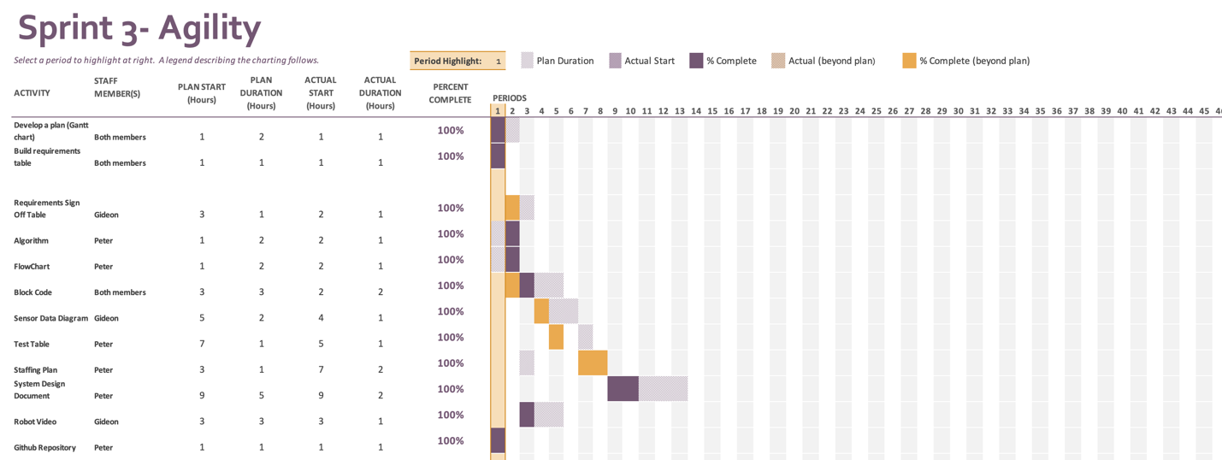

## Staffing Plan

|  |  |  |
| --- | --- | --- |
| Name | Role | Responsibility |
| Develop a plan (Gantt chart) | Planning Chart | Gideon composed Chart, both members molded ideas together for the chart. |
| Build Requirements table | Planning Table | All team members |
| Requirements Sign Off Table | Planning Table | Gideon |
| Algorithm | Provide the required performance of the robot | Peter |
| Flowchart | depicts how our software application will act to fulfill the algorithms needs | Peter |
| Block code | Instructs the robot to complete the course by the code created by team members | Both team members |
| Sensor Data Diagram | Data Diagram | Gideon |
| Test Table | Data Table | Peter |
| Staffing Plan | a chart/table that depicts the roles and responsibilities of each member | Peter |
| System Design Document | detailing system flow, algorithms, staffing plan, software/hardware, and Test Plan | Peter |
| Robot video | Video showing robot doing the correct instructions | Gideon |
| GitHub Repository | All members submit their work this Repository | Peter |