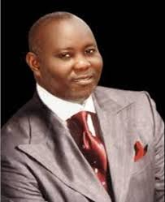**THE NIGER DELTA HERO – ATEKE TOM**

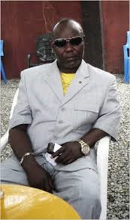The name Ateke Tom is one that brings memories of Patrotism and struggle for justice among the youths of Niger Delta. He is the Chairman of the Niger Delta vigilante force. Before the Amnesty, he led a militia group in the Niger Delta region which fought for better treatment for the Niger Delta youths. In the struggle for acknowledgement of the Niger Delta people, a lot of regrettable casualties was recorded, casualties he admits still weighs in his heart to today.

Ateke’s involvements in the armed struggle started as a clarion call of his people, to help get rid of certain dangerous miscreants in his community. Hence the early vigilante group in Okirika which he led in fighting against cult groups engaged in criminal and dangerous activities. This same vigilante group transformed to a militant group in answer to the cries of the neglected Niger Delta people.

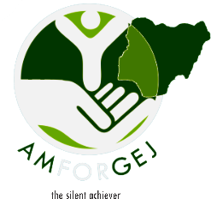During His struggle to liberate his people and earn the attention of the federal government, he reached out several times to various media organizations, seeking for the swift response of the federal government. He wanted this for various reasons; One for his people to find answers to their cries as soon as possible. Secondly, to return to his family who were scattered all over the country. He admitted that the fight was wearisome even though he never relented.

His years of fighting finally resulted in certain monumental achievements for the Niger Delta people. The creation of the Ministry of Niger Delta was one of these achievements. The president, Goodluck Ebele Jonathan was also a beneficiary of that struggle. After so many years an Ijaw man was given the opportunity to serve his country in the capacity of the vice president and later president. All of these succeeded in making the Niger Delta people feel relevant in their nation.

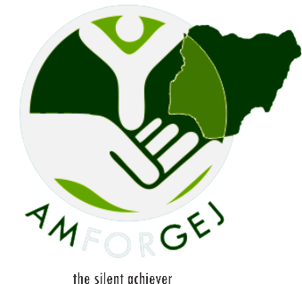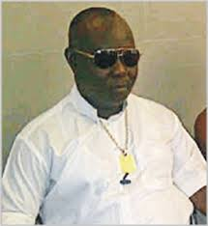Kate Sunday and Boma Lawson during the recent home coming celebrating /pageantry in honour of Ateke Tom informed all that the choice of Chief Ateke Tom for the honour was due to his selfless effort and desire to transform the youth of Niger Delta and make them useful citizens of the society. Having led the youth fight when fighting was necessary, he has expressed his willingness to partner with any organization interested in promoting service to humanity. He openly admits his desire to lead the youths in a more peaceful and wider network, the social media.