

THE STATE UNIVERSITY OF ZANZIBAR
SCHOOL COMPUTING, COMMUNICATION AND MEDIA STUDIES
DEPARTMENT OF COMPUTER SCIENCE AND INFORMATION
TECHNOLOGY

ZANHOTEL-AJIRA PORTAL SOFTWARE REQUIREMENTS SPECIFICATION (SRS)
Contents
ZANHOTEL-AJIRA PORTAL SOFTWARE REQUIREMENTS SPECIFICATION (SRS) 1
SOFTWARE REQUIREMENTS SPECIFICATION (SRS) 4
ZanHotel Ajira Portal 4
1. Introduction 4
1.1 Purpose 4
1.2 Document Conventions 4
1.3 Intended Audience 4
1.4 Product Scope 5
1.5 References 5
2. Overall Description 5
2.1 Product Perspective 5
2.2 Product Functions 6
2.3 User Classes 6
Job Seeker 6
Hotel 6
Admin 6
2.4 Operating Environment 6
2.5 Constraints 6
2.6 User Documentation 7
2.7 Assumptions 7
3. External Interface Requirements 7
3.1 User Interface 7
3.2 Hardware Interfaces 7
3.3 Software Interfaces 7
3.4 Communication Interfaces 7
4. System Features 8
4.1 User Registration 8
4.2 Job Posting 8
4.3 Job Application 9
5. Non-Functional Requirements 10
5.1 Performance 10
5.2 Safety 10
5.3 Security 11
5.4 Software Quality Attributes 11
5.5 Business Rules 12
5.6 Budget and Cost Estimation 12
5.6.1 Introduction 12
5.6.2 Cost Breakdown 13
Development Costs 13
Infrastructure Costs 13
Maintenance Costs 13
5.6.3 Total Budget 13
5.6.4 Summary 14
6. Other Requirements 14
APPENDICES 14
Appendix A: Glossary 14
Appendix B: System Design Models 15
B.1 Use Case Diagram 16
B.2 Data Flow Diagram (DFD) 17
Level 0 17
DFD Level 1 18
Class Diagram 19
19
Entity Relation Diagram (ERD) 20
Appendix C: To Be Determined List 20

Revision History

Name | Date | Reason For Changes | Version
GIDION MKASANGA GIDION | 14/04/2026 | INITIAL START | 1.0

SOFTWARE REQUIREMENTS SPECIFICATION (SRS)

ZanHotel Ajira Portal

1. Introduction

1.1 Purpose
This document specifies the functional and non-functional requirements of the ZanHotel Ajira Portal, a web-based recruitment platform that connects hotels with job seekers. It defines the system’s expected behavior, constraints, and performance requirements.
The purpose of this SRS is to serve as a reference for developers during implementation, for testers during validation, and for supervisors during evaluation. It ensures that all stakeholders have a consistent understanding of what the system should achieve and how it should operate.

1.2 Document Conventions
This document follows a structured numbering system where each requirement is uniquely identified. Functional requirements are labeled as FR-x, while non-functional requirements are labeled as NFR-x.
Technical terms such as API, database, and authentication are used consistently throughout the document. Headings and subheadings follow hierarchical numbering to improve readability and navigation.

1.3 Intended Audience
This document is intended for multiple stakeholders:
- Developers: to understand system functionality and design constraints
- Testers: to derive test cases and validation criteria
- Project Supervisors: to assess completeness and correctness
- End Users: to understand system capabilities
Readers are advised to begin with the Introduction and Overall Description sections to understand the system context, then proceed to System Features for detailed functional requirements.

1.4 Product Scope
The ZanHotel Ajira Portal is designed to streamline the recruitment process in the hotel industry by providing a centralized platform for job postings and applications.
Hotels can create job listings specifying roles, requirements, and deadlines. Job seekers can browse available opportunities, upload required documents such as CVs, and submit applications. The system also supports complaint submission and administrative management.
This system aims to improve efficiency, reduce manual recruitment processes, and enhance accessibility for both employers and job seekers.

1.5 References
This document is based on the following references:
- IEEE Software Requirements Specification Standard (IEEE 830/29148)
- Django official documentation (for backend implementation)
- React official documentation (for frontend development)
These references provide guidelines for system design, documentation structure, and implementation standards.

2. Overall Description

2.1 Product Perspective
The ZanHotel Ajira Portal is a standalone web application that operates within a client-server architecture.
The frontend, developed using React, provides an interactive user interface accessible through web browsers. The backend, implemented using Django REST Framework, processes requests, manages business logic, and interacts with the database.
The system communicates via HTTP/HTTPS protocols, with JSON used as the data exchange format.

2.2 Product Functions
The system provides the following core functionalities:
- User Registration and Authentication: Allows users to create accounts and securely log in
- Job Posting: Enables hotels to create and manage job listings
- Job Application: Allows job seekers to apply for available jobs
- Document Upload: Supports uploading CVs and certificates
- Complaint Submission: Enables users to report issues
- Admin Management: Allows administrators to monitor and control system activities
These functions collectively support the end-to-end recruitment process.

2.3 User Classes

Job Seeker
Job seekers are individuals looking for employment opportunities. They typically have basic technical skills and use the system to search for jobs, upload documents, and submit applications.

Hotel
Hotels act as employers. They require moderate technical skills to post jobs, review applications, and manage recruitment processes.

Admin
Administrators manage the overall system. They require advanced technical knowledge to monitor activities, resolve complaints, and enforce system rules.

2.4 Operating Environment
The system operates in a web-based environment and requires:
- A modern web browser such as Chrome or Firefox
- A server environment (Linux or Windows) for hosting the backend
- PostgreSQL database for data storage
This environment ensures cross-platform accessibility and scalability.

2.5 Constraints
The system must be developed using Django for the backend and React for the frontend, as specified by project requirements.
It must also operate over the internet, meaning offline functionality is not supported. Security mechanisms such as authentication and data protection must be implemented to safeguard user data.

2.6 User Documentation
The system will include:
- A user manual explaining how to register, apply for jobs, and navigate the system
- An admin guide describing system management functions
- Online help features integrated into the interface
These documents ensure that users can effectively utilize the system without extensive training.

2.7 Assumptions
The system assumes that users have access to internet-enabled devices and basic digital literacy.
It also depends on the availability of the backend server and database. Any failure in these components may affect system performance or accessibility.

3. External Interface Requirements

3.1 User Interface
The system provides a graphical user interface consisting of forms, dashboards, and navigation menus.
Users interact with the system through pages such as login, registration, job listings, and application forms. The interface is designed to be intuitive and user-friendly.

3.2 Hardware Interfaces
The system does not require specialized hardware. It can be accessed using standard devices such as desktop computers, laptops, tablets, and smartphones.

3.3 Software Interfaces
The frontend communicates with the backend through RESTful APIs. The backend interacts with the PostgreSQL database for data storage and retrieval.

3.4 Communication Interfaces
The system uses HTTP/HTTPS protocols for communication between client and server.
Data is transmitted in JSON format, ensuring compatibility and efficiency. Secure communication is enforced using HTTPS to protect sensitive data.

4. System Features

4.1 User Registration
This feature allows new users (Job Seekers and Hotels) to create accounts by providing personal information such as name, email address, and password.
The system performs input validation to ensure that all required fields are correctly filled and that the email format is valid. It also checks for email uniqueness to prevent duplicate accounts. Passwords are securely stored using encryption (hashing) techniques to protect user credentials.
During registration, users may be assigned specific roles (e.g., Job Seeker or Hotel), which determine their access rights and available functionalities within the system.
After successful registration, the system confirms account creation and allows users to log in using their credentials. In case of invalid input or duplicate email, appropriate error messages are displayed to guide the user.
Additionally, the system may include optional features such as:
- Email verification to confirm user identity
- Password strength validation to enhance security
- Form validation feedback to improve user experience
This feature serves as the entry point to the system and establishes user identity for all subsequent interactions.

4.2 Job Posting
This feature enables hotel users to create and manage job listings within the system.
Hotels can enter detailed job information, including:
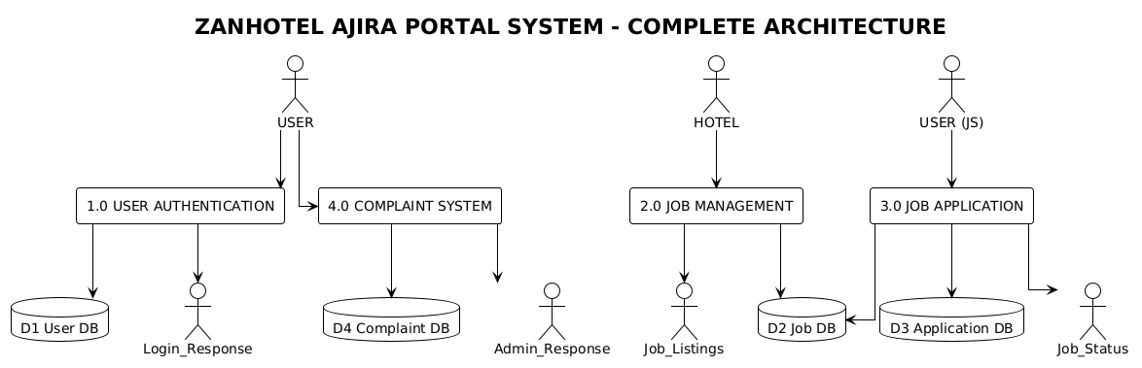
- Job title
- Job description
- Location
- Required experience
- Application deadline
The system validates all inputs to ensure completeness and correctness before storing the job data in the database. Once posted, the job becomes visible to all registered job seekers through the job listing interface.
Hotels are provided with options to:
- Edit job postings to update details
- Delete job postings when positions are filled
- View submitted applications for each job
The system ensures that:
- Only authenticated hotel users can post jobs
- Each job posting is associated with a specific hotel account
- Job listings are displayed in an organized and searchable format
Additional enhancements may include:
- Filtering and sorting of job listings
- Status indicators (e.g., open, closed, expired)
- Automatic expiration of jobs after deadlines
This feature is central to the platform as it provides the supply side of employment opportunities.

4.3 Job Application
This feature allows job seekers to browse available job listings and apply for positions that match their qualifications.
Job seekers can view detailed job information and submit applications by uploading required documents such as:
- Curriculum Vitae (CV)
- Certificates
- Photo

The system validates uploaded files to ensure they meet acceptable formats and size limits, preventing invalid or harmful uploads.
Once an application is submitted:
- The system records the application in the database
- Links it to both the job and the applicant
- Assigns a status (e.g., pending, reviewed, accepted, rejected)
Job seekers can track their applications, while hotel users can review submitted applications and make decisions accordingly.
The system ensures:
- A user cannot apply multiple times for the same job
- Applications are only accepted before the deadline
- Proper notification or feedback is provided after submission
Additional enhancements may include:
- Application status tracking dashboard
- Notification system (e.g., email alerts)
- Search and filtering of jobs before applying
This feature completes the recruitment workflow by connecting job seekers with job opportunities provided by hotels.

5. Non-Functional Requirements

5.1 Performance
- The system should respond to user requests within three (3) seconds under normal operating conditions to ensure smooth user interaction and prevent frustration.
- The system must support multiple concurrent users without significant performance degradation, ensuring scalability as the number of users increases.
- The system should be capable of handling at least 100+ simultaneous active users, ensuring it remains functional under moderate load conditions.
- Database queries must be optimized to ensure fast data retrieval and minimal latency, especially when fetching job listings and applications.
- The system should implement caching mechanisms (e.g., for frequently accessed data like job listings) to improve response time.
- The application should maintain consistent performance during peak usage periods, such as when many users are applying for jobs simultaneously.

5.2 Safety
- The system must ensure data integrity by preventing accidental data loss during operations such as submission or updates.
- Regular automated backups must be performed (e.g., daily backups) to enable recovery in case of system failure or data corruption.
- The system should include error-handling mechanisms to prevent crashes and ensure that failures do not result in loss of critical data.
- Input validation must be implemented to prevent incorrect or harmful data entry, which could compromise system stability.
- The system should provide confirmation prompts before critical actions (e.g., deleting job posts) to avoid unintended operations.
- In case of system failure, the system should support data recovery procedures to restore the most recent valid state.

5.3 Security
- User authentication must be enforced using secure mechanisms such as JWT (JSON Web Tokens) to ensure that only authorized users access the system.
- Sensitive data, including passwords, must be encrypted (hashed) using secure algorithms to prevent unauthorized access.
- The system must implement role-based access control (RBAC) to restrict access based on user roles (Job Seeker, Hotel, Admin).
- All communication between client and server must use HTTPS protocol to protect data during transmission.
- The system should protect against common web vulnerabilities such as:
  - SQL Injection
  - Cross-Site Scripting (XSS)
  - Cross-Site Request Forgery (CSRF)
- The system must include session management controls, such as automatic logout after inactivity, to prevent unauthorized access.
- File uploads (e.g., CVs, certificates) must be validated to prevent malicious file execution.
- The system should maintain audit logs to track user activities (e.g., login attempts, job postings), enhancing accountability and monitoring.

5.4 Software Quality Attributes
- The system should be reliable, ensuring consistent operation with minimal downtime, so that users can access services whenever needed without unexpected interruptions.
- The system should be user-friendly, with a clear and intuitive interface that allows users to navigate easily without requiring extensive training or technical knowledge.
- The system should be maintainable, meaning the codebase must be modular and well-documented to allow developers to efficiently implement updates, bug fixes, and new features.
- The system should be scalable, allowing it to handle increasing numbers of users, job postings, and applications without significant performance degradation.
- The system should ensure availability, targeting at least 99% uptime, so that users can reliably access the platform at any time.
- The system should be efficient, utilizing system resources such as memory and processing power optimally to avoid unnecessary overhead.
- The system should be portable, meaning it can run across different operating systems and devices without requiring major modifications.
- The system should be interoperable, allowing smooth interaction between frontend (React), backend (Django), and database (PostgreSQL).
- The system should be testable, enabling easy creation of unit tests and integration tests to verify functionality and detect defects early.
- The system should be robust, meaning it can handle unexpected inputs or errors without crashing and can recover gracefully from failures.

5.5 Business Rules
- Only registered hotels are allowed to post jobs, ensuring that all job listings originate from verified sources and are trustworthy.
- Only registered job seekers can apply for jobs, enabling proper tracking, accountability, and management of applications.
- Administrators have full control over system operations, including managing users, monitoring activities, and resolving complaints.
- A job posting must include mandatory fields such as job title, description, location, and deadline to ensure completeness and usefulness of information.
- Job applications must be submitted before the application deadline, ensuring fairness and consistency in the recruitment process.
- Each job seeker can apply to the same job only once, preventing duplicate applications and maintaining data integrity.
- Hotels can view and manage only their own job postings, ensuring data privacy and proper ownership control.
- Uploaded documents (CVs, certificates) must meet acceptable file formats and size limits, ensuring system security and storage efficiency.
- Administrators have the authority to remove inappropriate content or deactivate accounts that violate system policies.

5.6 Budget and Cost Estimation

5.6.1 Introduction
This section estimates development, deployment, and maintenance costs for the system.

5.6.2 Cost Breakdown

Development Costs
Item | Description | Cost (USD)
System Analysis & Design | Requirements + UML | 120
Subtotal |  | 120

Infrastructure Costs
Item | Description | Cost
Hosting | Cloud server | 120/year
Domain | .com registration | 15/year
SSL | Security certificate | 20
Database Hosting | managed DB | 60/year
Subtotal |  | 245/year

Maintenance Costs
Item | Description | Cost
Server maintenance | renewal | 120
Subtotal |  | 120/year

5.6.3 Total Budget
Category | Cost
Development | 120
Infrastructure | 245
Maintenance | 120
Total Initial Cost | 450 USD

5.6.4 Summary
The system is cost-efficient due to the use of open-source technologies (Django, React, PostgreSQL).

6. Other Requirements
- The system must support efficient database operations, ensuring fast data retrieval, insertion, and updates even with large volumes of data.
- The system should be accessible through standard web browsers without requiring additional software installations, ensuring ease of access for all users.
- The system should support responsive design, allowing it to function properly on desktops, tablets, and mobile devices.
- The system must comply with data protection and privacy principles, ensuring that user data is handled securely and responsibly.
- The system should allow for future integration with other systems such as payment platforms or external job portals.
- The system should maintain logs of system activities for monitoring, debugging, and auditing purposes.

APPENDICES

Appendix A: Glossary
This section defines technical terms and abbreviations used in the document to ensure clarity and consistent understanding among all stakeholders.
Term | Definition
API | Application Programming Interface, enables communication between systems
SRS | Software Requirements Specification
JWT | JSON Web Token used for secure authentication
DBMS | Database Management System
UI | User Interface

Appendix B: System Design Models

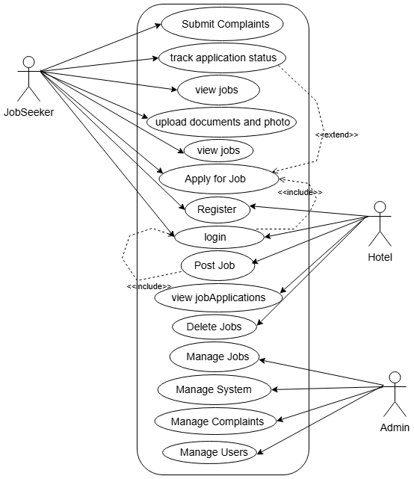
B.1 Use Case Diagram

B.2 Data Flow Diagram (DFD)

Level 0
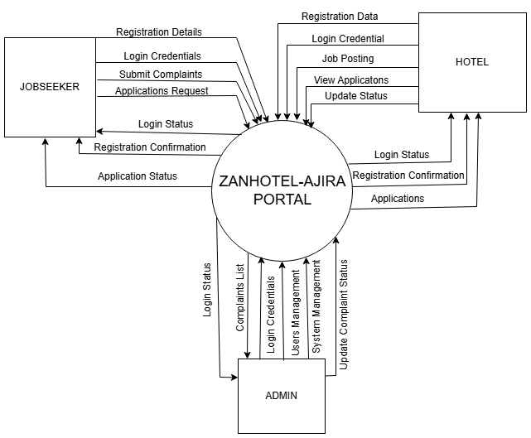

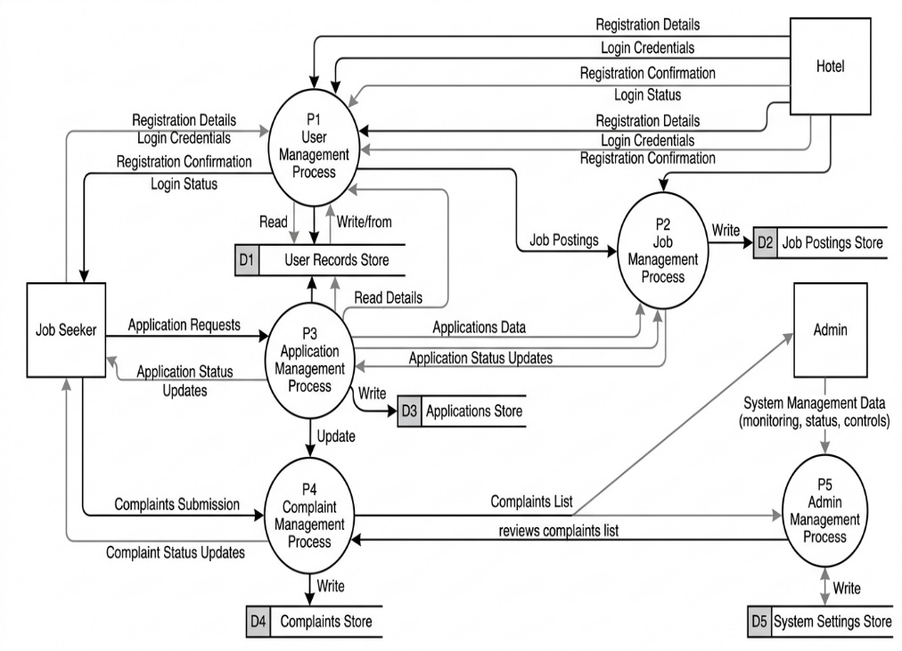
DFD Level 1

Class Diagram

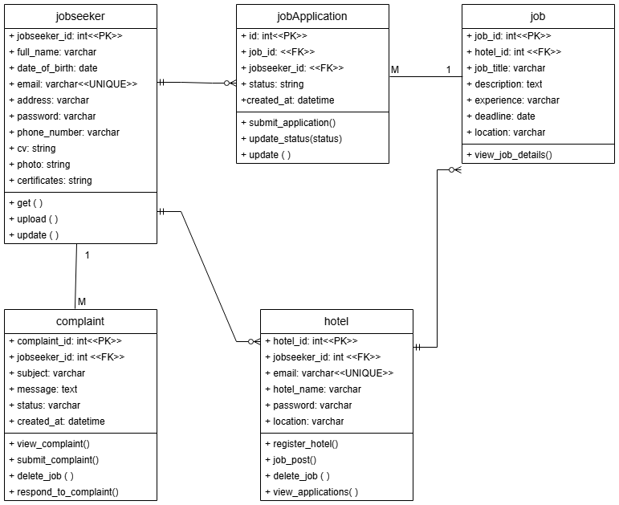

Entity Relation Diagram (ERD)
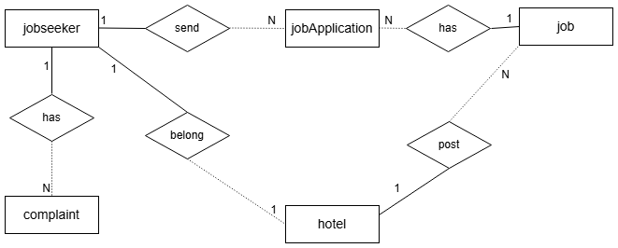

Appendix C: To Be Determined List
This section tracks items that are not yet finalized and require further clarification:
- Selection of final hosting platform (e.g., AWS, DigitalOcean)
- Definition of UI design standards and theme
- Final decision on security enhancements (e.g., 2FA)
- Integration with external services
- Performance benchmarking targets under real-world conditions

