**NAME :** GIDIYON S

**ROLL NO :** 727721EUIT039 **CA 1 PROJECT**

**QUESTION 1:**

1. Verify that the user can add a product to the cart by clicking on the "Add to Cart" button on the product page.

package com.Gidiyon.Ca1.Ques1;

import org.openqa.selenium.By;

import org.openqa.selenium.WebDriver;

import org.openqa.selenium.WebElement;

import org.openqa.selenium.chrome.ChromeDriver;

import org.openqa.selenium.chrome.ChromeOptions;

import io.github.bonigarcia.wdm.WebDriverManager;

public class TC_001 {

public static void main(String[] args) throws InterruptedException {

ChromeOptions co=new ChromeOptions();

co.addArguments("--remote-allow-origins=*");

WebDriverManager.*chromedriver*().setup();

WebDriver driver=new ChromeDriver();

driver.get("https://www.amazon.in/");

Thread.*sleep*(2000);

driver.findElement(By.*xpath*("//*[@id=\"twotabsearchtextbox\"]")).click();

driver.findElement(By.*xpath*("//*[@id=\"twotabsearchtextbox\"]")).sendKeys("Nike blazer shoes");

driver.findElement(By.*xpath*("//*[@id=\"nav-search-submit-button\"]")).click();

Thread.*sleep*(2000);

driver.navigate().to("https://www.amazon.in/Nike-Men-Blazer-VNTG-Bq6806/dp/B08Q8RRR6B/ref=sr_1_1?crid=1X76VXIHRGPCH&keywords=Nike+blazer+shoes&qid=1681289171&sprefix=nike+blazer+shoes%2Caps%2C1217&sr=8-1") ;

driver.findElement(By.*xpath*("//*[@id=\"add-to-cart-button\"]")).click();

WebElement cart=driver.findElement(By.*xpath*("//*[@id=\"nav-cart-count\"]"));

if(cart.getText().equals("1")) {

System.***out***.print("Added to cart is working successfully");

}else {

System.***out***.print("Added to cart is not working successfully");

}

}

}

**Output:**

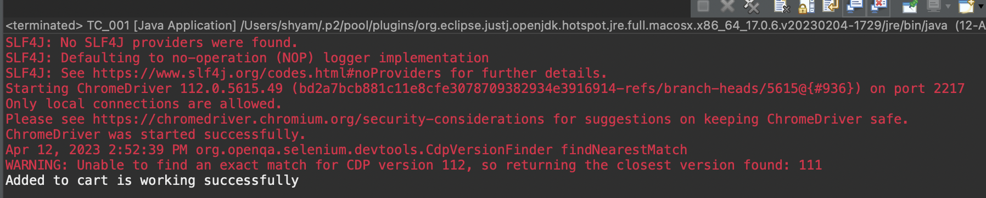

2. Verify that the user can remove a product from the cart by clicking on the "Remove" button next to the product.

package com.Gidiyon.Ca1.Ques1;

import org.openqa.selenium.By;

import org.openqa.selenium.WebDriver;

import org.openqa.selenium.WebElement;

import org.openqa.selenium.chrome.ChromeDriver;

import org.openqa.selenium.chrome.ChromeOptions;

import io.github.bonigarcia.wdm.WebDriverManager;

public class TC_002 {

public static void main(String[] args) throws InterruptedException {

ChromeOptions co=new ChromeOptions();

co.addArguments("--remote-allow-origins=*");

WebDriverManager.*chromedriver*().setup();

WebDriver driver=new ChromeDriver();

driver.get("https://www.amazon.in/");

Thread.*sleep*(2000);

driver.findElement(By.*xpath*("//*[@id=\"twotabsearchtextbox\"]")).click();

driver.findElement(By.*xpath*("//*[@id=\"twotabsearchtextbox\"]")).sendKeys("Nike blazer shoes");

driver.findElement(By.*xpath*("//*[@id=\"nav-search-submit-button\"]")).click();

Thread.*sleep*(2000);

driver.navigate().to("https://www.amazon.in/Nike-Men-Blazer-VNTG-Bq6806/dp/B08Q8RRR6B/ref=sr_1_1?crid=1X76VXIHRGPCH&keywords=Nike+blazer+shoes&qid=1681289171&sprefix=nike+blazer+shoes%2Caps%2C1217&sr=8-1") ;

driver.findElement(By.*xpath*("//*[@id=\"add-to-cart-button\"]")).click();

driver.navigate().to("https://www.amazon.in/gp/cart/view.html?ref_=nav_cart");

Thread.*sleep*(2000);

WebElement cart=driver.findElement(By.*xpath*("//*[@id=\"nav-cart-count\"]"));

if(cart.getText().equals("0")) {

System.***out***.print("Removing from cart is working successfully");

}else {

System.***out***.print("Removing from cart is not working successfully");

}

}

}

**Output:**

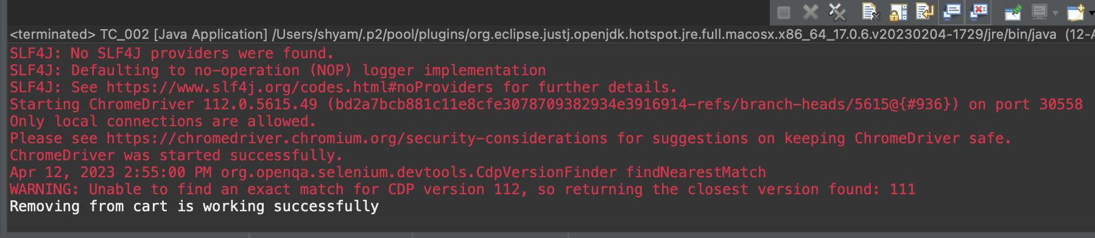

3. Verify that the user can update the quantity of a product in the cart by changing the quantity and clicking on the "Update" button.

package com.Gidiyon.Ca1.Ques1;

import org.openqa.selenium.By;

import org.openqa.selenium.WebDriver;

import org.openqa.selenium.WebElement;

import org.openqa.selenium.chrome.ChromeDriver;

import org.openqa.selenium.chrome.ChromeOptions;

import io.github.bonigarcia.wdm.WebDriverManager;

public class TC_003 {

public static void main(String[] args) throws InterruptedException {

ChromeOptions co=new ChromeOptions();

co.addArguments("--remote-allow-origins=*");

WebDriverManager.*chromedriver*().setup();

WebDriver driver=new ChromeDriver();

driver.get("https://www.amazon.in/");

Thread.*sleep*(2000);

driver.findElement(By.*xpath*("//*[@id=\"twotabsearchtextbox\"]")).click();

driver.findElement(By.*xpath*("//*[@id=\"twotabsearchtextbox\"]")).sendKeys("Nike blazer shoes");

driver.findElement(By.*xpath*("//*[@id=\"nav-search-submit-button\"]")).click();

Thread.*sleep*(2000);

driver.navigate().to("https://www.amazon.in/Nike-Men-Blazer-VNTG-Bq6806/dp/B08Q8RRR6B/ref=sr_1_1?crid=1X76VXIHRGPCH&keywords=Nike+blazer+shoes&qid=1681289171&sprefix=nike+blazer+shoes%2Caps%2C1217&sr=8-1") ;

driver.findElement(By.*xpath*("//*[@id=\"add-to-cart-button\"]")).click();

driver.navigate().to("https://www.amazon.in/gp/cart/view.html?ref_=nav_cart");

driver.findElement(By.*xpath*("//*[@id=\"a-autoid-0\"]")).click();

driver.findElement(By.*xpath*("//*[@id=\"quantity_2\"]")).click();

Thread.*sleep*(2000);

WebElement cart=driver.findElement(By.*xpath*("//*[@id=\"nav-cart-count\"]"));

if(cart.getText().equals("2")) {

System.***out***.print("Updating cart is working successfully");

}else {

System.***out***.print("Updating cart is not working successfully");

}

}

}

**Output:**

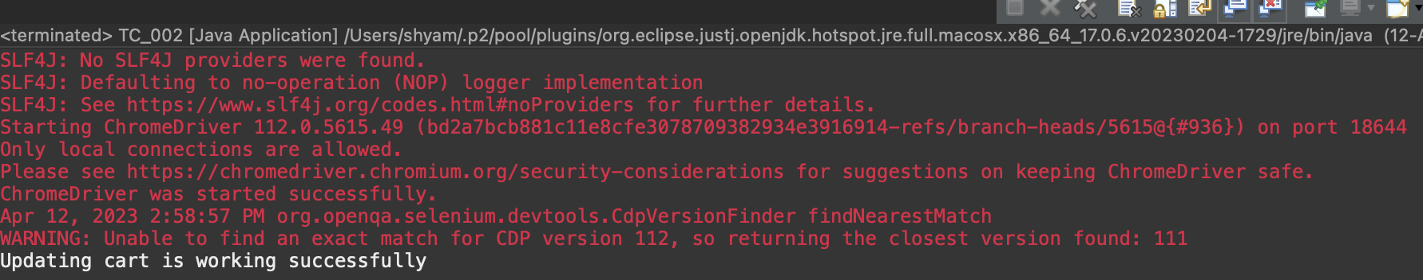

4. Verify that the user can proceed to the checkout page by clicking on the "Checkout" button on the cart page.

package com.Gidiyon.Ca1.Ques1;

import org.openqa.selenium.By;

import org.openqa.selenium.WebDriver;

import org.openqa.selenium.WebElement;

import org.openqa.selenium.chrome.ChromeDriver;

import org.openqa.selenium.chrome.ChromeOptions;

import io.github.bonigarcia.wdm.WebDriverManager;

public class TC_004 {

public static void main(String[] args) throws InterruptedException {

ChromeOptions co=new ChromeOptions();

co.addArguments("--remote-allow-origins=*");

WebDriverManager.*chromedriver*().setup();

WebDriver driver=new ChromeDriver();

driver.get("https://www.amazon.in/");

Thread.*sleep*(2000);

driver.findElement(By.*xpath*("//*[@id=\"twotabsearchtextbox\"]")).click();

driver.findElement(By.*xpath*("//*[@id=\"twotabsearchtextbox\"]")).sendKeys("Nike blazer shoes");

driver.findElement(By.*xpath*("//*[@id=\"nav-search-submit-button\"]")).click();

Thread.*sleep*(2000);

driver.navigate().to("https://www.amazon.in/Nike-Men-Blazer-VNTG-Bq6806/dp/B08Q8RRR6B/ref=sr_1_1?crid=1X76VXIHRGPCH&keywords=Nike+blazer+shoes&qid=1681289171&sprefix=nike+blazer+shoes%2Caps%2C1217&sr=8-1") ;

driver.findElement(By.*xpath*("//*[@id=\"add-to-cart-button\"]")).click();

// driver.navigate().to("https://www.amazon.in/gp/cart/view.html?ref_=nav_cart");

//

// driver.findElement(By.xpath("///*[@id=\"sc-buy-box-ptc-button\"]/span/input")).click();

driver.findElement(By.*xpath*("//*[@id=\"sc-buy-box-ptc-button\"]/span/input")).click();

WebElement ele=driver.findElement(By.*xpath*("//*[@id=\"authportal-main-section\"]/div[2]/div/div[1]/form/div/div/div/h1"));

String actual=ele.getText();

System.***out***.println(actual);

String expected="Sign in";

if(actual.equals(expected)) {

System.***out***.print("Navigated to sigin page");

}

}

}

**Output:**

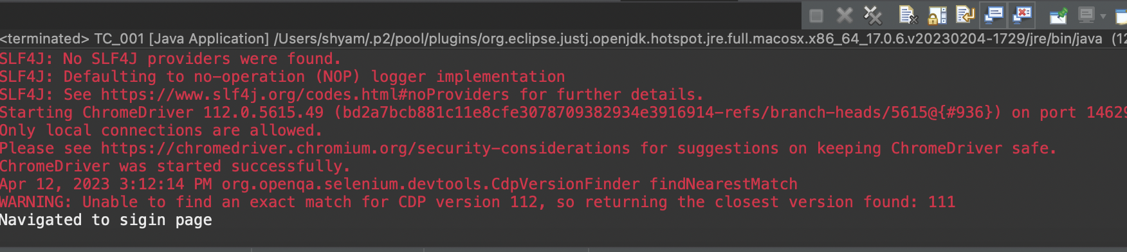

**QUESTION NO 2:**

1. Verify that the user can search any product on website and the corresponding search product details needs to be displayed

2. Print minimum 5 Names of the products displayed on the webpage

3. Verify that the user can filter the search results by category, price, and other parameters.

package com.Gidiyon.Ca1;

import java.util.List;

import org.openqa.selenium.By;

import org.openqa.selenium.Keys;

import org.openqa.selenium.WebDriver;

import org.openqa.selenium.WebElement;

import org.openqa.selenium.chrome.ChromeDriver;

import org.openqa.selenium.chrome.ChromeOptions;

import io.github.bonigarcia.wdm.WebDriverManager;

public class Ques2 {

public static void main( String[] args ){

ChromeOptions co=new ChromeOptions();

co.addArguments("--remote-allow-origins=*");

WebDriverManager.*chromedriver*().setup();//setting up chrome driver

WebDriver driver=new ChromeDriver();

driver.get("https://www.amazon.in");

driver.findElement(By.*xpath*("//*[@id=\"twotabsearchtextbox\"]")).sendKeys(“Shoes");

driver.findElement(By.*xpath*("//*[@id=\"twotabsearchtextbox\"]")).sendKeys(*Keys*.***ENTER***);

String a=driver.getTitle();

if(a.equals("Amazon.in : Shoes")) {

System.***out***.println("Title is Matched\n");

}

else {

System.***out***.println("Title is Mismatched");

}

List<WebElement> li=driver.findElements(By.*className*("s-line-clamp-2"));

for(int i=0;i<5;i++) {

System.***out***.println(li.get(i).getText());

}

driver.findElement(By.*xpath*("//*[@id=\"p_36/1318505031\"]/span/a/span")).click();

WebElement b=driver.findElement(By.*xpath*("//*[@id=\"search\"]/div[1]/div[1]/div/span[1]/div[1]/div[2]/div/div/div/div/div/div/div/div[2]/div/div/div[3]/div[1]/div/div[1]/div[2]/a/span[1]/span[2]/span[2]"));

System.***out***.print("Price 2,000-10,000 :"+b.getText());

driver.findElement(By.*xpath*("//*[@id=\"p_89/Samsung\"]/span/a/div/label/i")).click();

WebElement c=driver.findElement(By.*xpath*("//*[@id=\"search\"]/div[1]/div[1]/div/span[1]/div[1]/div[2]/div/div/div/div/div/div[2]/div/div/div[1]/h2/a/span"));

System.***out***.print("Price 2,000-10,000 & Puma: "+ c.getText());

}

}

Output: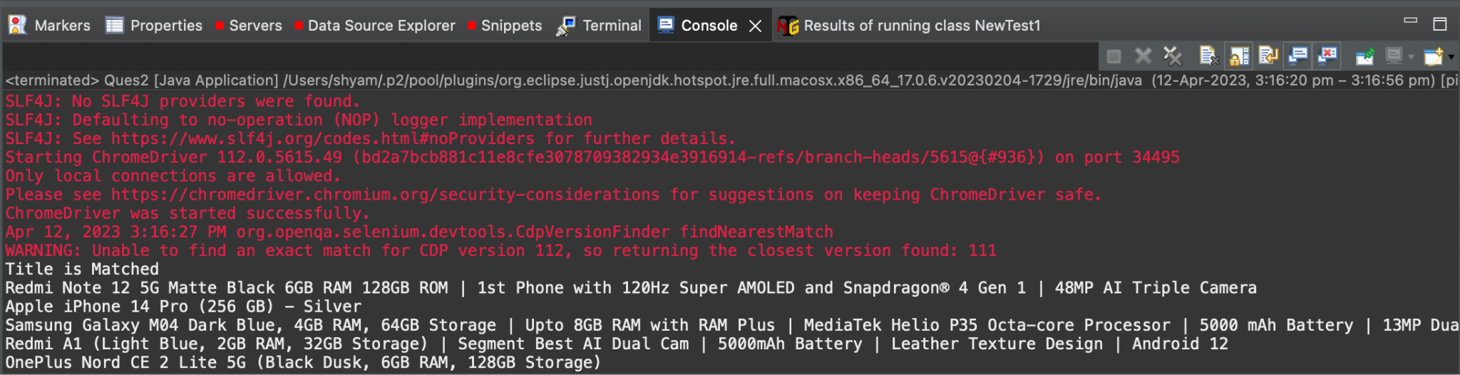

**QUESTION 3 :**

1.Verify that the once the user clicks on You account link,”Your account page” is displayed 2.Verify that user is able to track/view the orders by clicking on “Your order” 3.Verify that user is able to track the package by clicking on “track package” 4.Verify that user Is able to cancel the items from the list by clicking on “cancel items” 5.Verify that user is able to click on “View order details” to see the entire order summary

CODE :

package com.selenium.test.NewTest2.SelTest;

import java.util.List;

import org.openqa.selenium.By;

import org.openqa.selenium.JavascriptExecutor;

import org.openqa.selenium.Keys;

import org.openqa.selenium.WebDriver;

import org.openqa.selenium.WebElement;

import org.openqa.selenium.chrome.ChromeDriver;

import org.openqa.selenium.chrome.ChromeOptions;

import org.openqa.selenium.support.ui.Select;

import io.github.bonigarcia.wdm.WebDriverManager;

/**

* Hello world!

*

*/

public class App

{

public static void main( String[] args ) throws InterruptedException

{

WebDriverManager.chromedriver().setup();

ChromeOptions co = new ChromeOptions();

co.addArguments("--remote-allow-origins=*");

WebDriver driver=new ChromeDriver(co);

driver.get("https://www.amazon.in/ref=nav_logo");

driver.manage().window().maximize();

String title=driver.getTitle();

System.out.println(title);

if(title.equals("Online Shopping site in India: Shop Online for Mobiles, Books, Watches, Shoes and More - Amazon.in")) {

System.out.println("Verified title of the page");

}else {

System.out.println("Title not matched");

}

driver.findElement(By.id("nav-link-accountList")).click();

driver.findElement(By.id("ap_email")).sendKeys("Gidiyon28@gmail.com");

driver.findElement(By.id("ap_email")).sendKeys(Keys.ENTER);

driver.findElement(By.id("ap_password")).sendKeys("Fevi2802*");

driver.findElement(By.id("ap_password")).sendKeys(Keys.ENTER);

Thread.sleep(2000);

String name=driver.findElement(By.id("nav-link-accountList-nav-line-1")).getText();

if(name.equals("Hello, Gidiyon")) {

System.out.println("Successfully, signed in");

}else {

System.out.println("Sign in failed");

}

System.out.println("Testing Ended");

driver.quit();

}

}