**AUTOMATION TESTING USING SELENIUM**

**GIDIYON S**

**727721EUIT039**

Day: 04 – Class Exercise Lab

**Task-01: Selenese Commands**

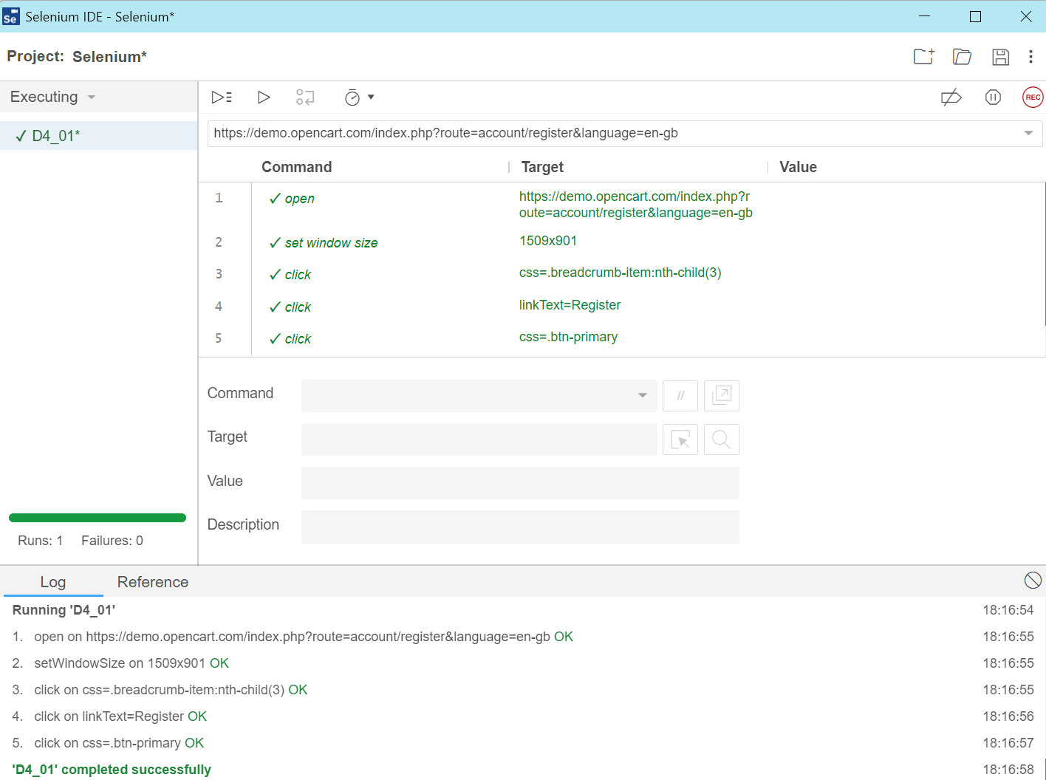

Junit Code:

// Generated by Selenium IDE

import org.junit.Test;

import org.junit.Before;

import org.junit.After;

import static org.junit.Assert.*;

import static org.hamcrest.CoreMatchers.is;

import static org.hamcrest.core.IsNot.not;

import org.openqa.selenium.By;

import org.openqa.selenium.WebDriver;

import org.openqa.selenium.firefox.FirefoxDriver;

import org.openqa.selenium.chrome.ChromeDriver;

import org.openqa.selenium.remote.RemoteWebDriver;

import org.openqa.selenium.remote.DesiredCapabilities;

import org.openqa.selenium.Dimension;

import org.openqa.selenium.WebElement;

import org.openqa.selenium.interactions.Actions;

import org.openqa.selenium.support.ui.ExpectedConditions;

import org.openqa.selenium.support.ui.WebDriverWait;

import org.openqa.selenium.JavascriptExecutor;

import org.openqa.selenium.Alert;

import org.openqa.selenium.Keys;

import java.util.*;

import java.net.MalformedURLException;

import java.net.URL;

public class D401Test {

  private WebDriver driver;

  private Map<String, Object> vars;

  JavascriptExecutor js;

  @Before

  public void setUp() {

    driver = new ChromeDriver();

    js = (JavascriptExecutor) driver;

    vars = new HashMap<String, Object>();

  }

  @After

  public void tearDown() {

    driver.quit();

  }

  @Test

  public void d401() {

    driver.get("https://demo.opencart.com/index.php?route=account/register&language=en-gb");

    driver.manage().window().setSize(new Dimension(1509, 901));

    driver.findElement(By.cssSelector(".breadcrumb-item:nth-child(3)")).click();

    driver.findElement(By.linkText("Register")).click();

    driver.findElement(By.cssSelector(".btn-primary")).click();

  }

}

**Task-02: Locators**

Code:

WebDriverManager.*chromedriver*().setup();

ChromeOptions co=**new** ChromeOptions();

co.addArguments("--remote-allow-origins=*");

WebDriver driver=**new** ChromeDriver(co);

driver.get("https://demo.opencart.com/index.php?route=account/register&language=en-gb");

driver.manage().window().maximize();

WebElement fn = driver.findElement(By.*id*("input-firstname"));

System.***out***.println(fn);

WebElement ln = driver.findElement(By.*id*("input-lastname"));

System.***out***.println(ln);

WebElement email = driver.findElement(By.*id*("input-email"));

System.***out***.println(email);

WebElement pw = driver.findElement(By.*id*("input-password"));

System.***out***.println(pw);

WebElement sub = driver.findElement(By.*id*("input-newsletter-yes"));

System.***out***.println(sub);

**Task-03: Locate the Below elements with XPath**

Code:

WebDriverManager.*chromedriver*().setup();

ChromeOptions co=**new** ChromeOptions();

co.addArguments("--remote-allow-origins=*");

WebDriver driver=**new** ChromeDriver(co);

driver.get("https://demo.opencart.com/index.php?route=checkout/voucher&language=en-gb");

driver.manage().window().maximize();

WebElement name = driver.findElement(By.*xpath*("//*[@id=\"input-to-name\"]"));

System.***out***.println(name);

WebElement email = driver.findElement(By.*xpath*("//*[@id=\"input-to-email\"]"));

System.***out***.println(email);

WebElement message = driver.findElement(By.*xpath*("//*[@id=\"input-message\"]"));

System.***out***.println(message);

WebElement urname = driver.findElement(By.*xpath*("//*[@id=\"input-from-name\"]"));

System.***out***.println(urname);

**Task-04: Web Navigation Commands**

Code:

WebDriverManager.*chromedriver*().setup();

ChromeOptions co=**new** ChromeOptions();

co.addArguments("--remote-allow-origins=*");

WebDriver driver=**new** ChromeDriver(co);

driver.get("https://j2store.net/free/");

driver.manage().window().maximize();

JavascriptExecutor js = (JavascriptExecutor) driver;

js.executeScript("window.scrollBy(0,1000)","");

driver.findElement(By.*linkText*("Clothing (5)")).click();

driver.navigate().back();

driver.navigate().forward();

driver.navigate().refresh();

driver.quit();

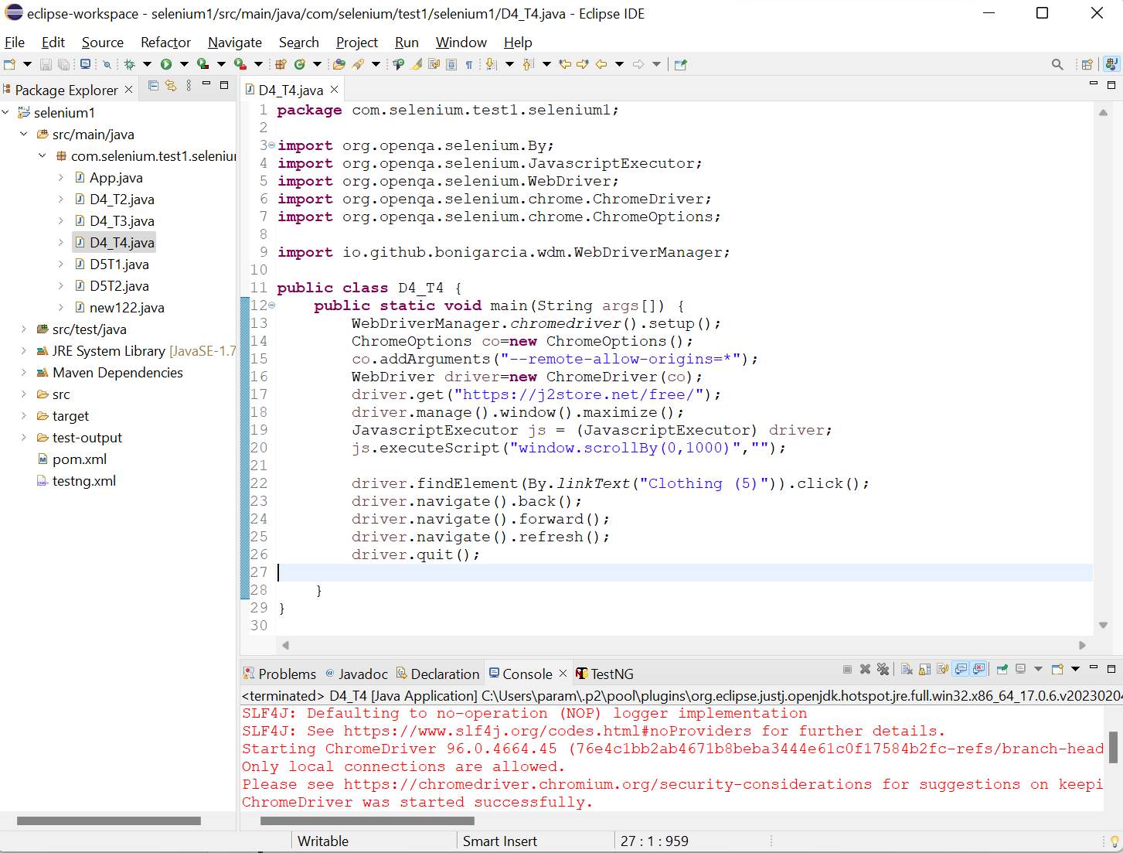

**Task-05.1: Web Driver Commands**

Code:

WebDriverManager.*chromedriver*().setup();

ChromeOptions co=**new** ChromeOptions();

co.addArguments("--remote-allow-origins=*");

WebDriver driver=**new** ChromeDriver(co);

driver.get("https://j2store.net/free/");

driver.manage().window().maximize();

JavascriptExecutor js=(JavascriptExecutor) driver;

js.executeScript("window.scrollBy(0,1000)","");

String url1="https://j2store.net/free/";

String url2="";

url2=driver.getCurrentUrl();

**if**(url1.equals(url2))

System.***out***.println("Correct 1st page");

driver.findElement(By.*linkText*("Clothing (5)")).click();

url1=driver.getCurrentUrl();

**if**(url1.equals("https://j2store.net/free/index.php/shop?filter_catid=11"));

System.***out***.println("Correct 2nd page");

driver.navigate().back();

driver.navigate().forward();

driver.navigate().refresh();

driver.quit();

**Task-05.2: Web Driver Commands**

Code:

WebDriverManager.*chromedriver*().setup();

ChromeOptions co=**new** ChromeOptions();

co.addArguments("--remote-allow-origins=*");

WebDriver driver=**new** ChromeDriver(co);

driver.get("https://j2store.net/free/");

driver.manage().window().maximize();

JavascriptExecutor js = (JavascriptExecutor) driver;

js.executeScript("window.scrollBy(0,1000)","");

driver.findElement(By.*linkText*("Clothing (5)")).click();

Thread.*sleep*(5000);

List<WebElement> li=driver.findElements(By.*xpath*("//h2[@class='product-title']"));

**for**(WebElement link:li) {

System.***out***.println(link.getText());

}

