Ex 3 – 305261083:

1.
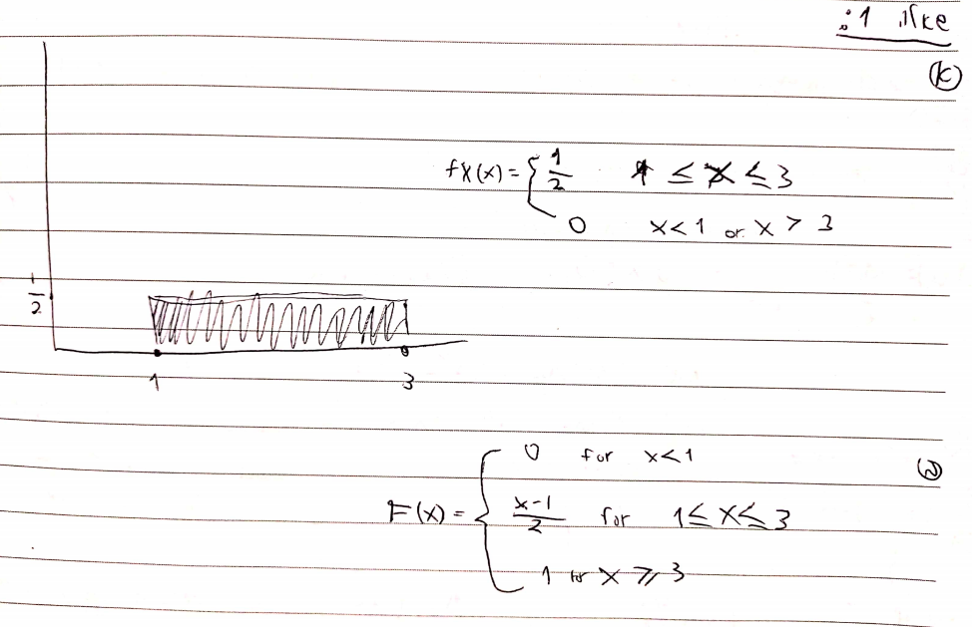

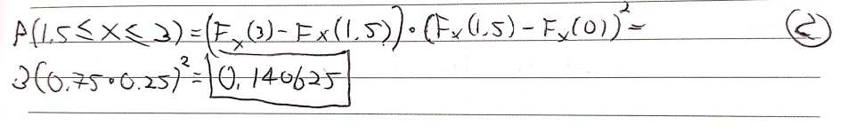

2.
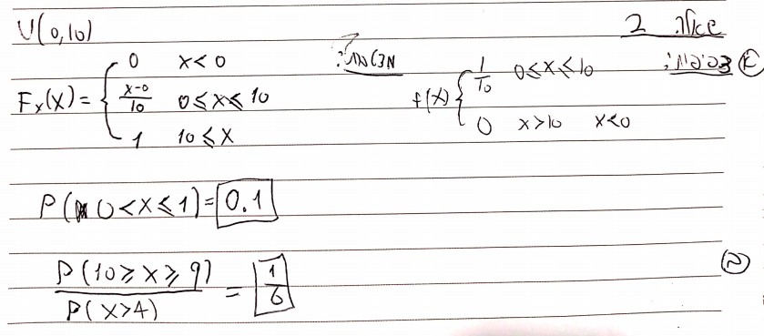

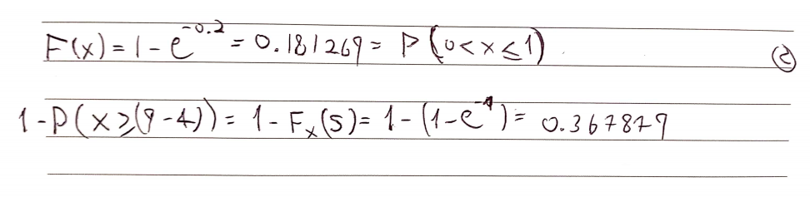

3.
a.
1-pnorm(120,100,13)
6.19679%
b.
pnorm(75,100,13)
2.72352%
5,000 * 2.72352 = 136
c.
qnorm(0.3,100,13)
93.18279 kg
5,000 * 0.3 = 1,500
d.
100 + 13 * 2 = 126 kg
1-pnorm(126,100,13)
2.275013%

