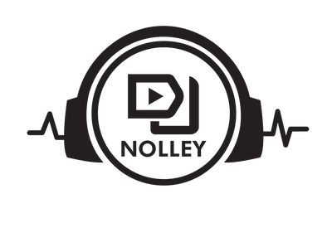

DJ NOLLEY
Phone
+254-798-384-369
Email djnolley254@gmail.com

DJ SERVICES AGREEMENT
(Governed by the Laws of the Republic of Kenya)
This DJ Services Agreement (“Agreement”) is made on this ___ day of __________ 2026,
BETWEEN
DJ Nolley, a professional Disc Jockey operating within the Republic of Kenya (hereinafter referred to as “the DJ”)
AND
______________________________, of ____________________________ (hereinafter referred to as “the Client”).
Both parties hereby agree as follows:

1. EVENT DETAILS
- Event Date: 28th March 2026
- Performance Time: 7:00 PM to 11:00 PM
- Total Duration: 4 hours
- Event Location: Kilimani

2. SERVICES TO BE PROVIDED
The DJ agrees to provide professional DJ services for the above-mentioned event, including:
- Music selection and live DJ performance suitable for the event
- Use of professional DJ skills, experience, and performance techniques
- DJ controller (Pioneer DDJ SX2)





DJ NOLLEY
Phone
+254-798-384-369
Email djnolley254@gmail.com

Any additional services (including MC services, extended performance time, special equipment, P.A system or lighting) shall be agreed upon separately in writing and may attract additional charges.

3. SOUND SYSTEM (PA SYSTEM)
- The Client shall provide a fully functional PA system, including speakers, amplifiers, mixers (if required), cabling, and power supply suitable for the event size and venue.
- The DJ shall not be held responsible for sound quality issues, interruptions, or performance limitations arising from faulty, inadequate, or poorly set up PA equipment provided by the Client.
- Any delay or interruption caused by PA system failure shall not constitute a breach of this Agreement by the DJ.

4. FEES & PAYMENT TERMS
- Total Fee: Kenya Shillings Twenty Thousand (KES 20,000)

Deposit
- A deposit of fifty percent (50%), being Kenya Shillings Ten Thousand (KES 10,000), shall be paid to secure the booking.
- The deposit shall be non-refundable.
- The balance of Kenya Shillings Ten Thousand (KES 10,000) shall be paid on or before the event date, unless otherwise agreed in writing.

5. CANCELLATION POLICY

Client Cancellation
- Any deposit paid shall be non-refundable.





DJ NOLLEY
Phone
+254-798-384-369
Email djnolley254@gmail.com

- If cancellation occurs less than 48 hours before the event, the DJ reserves the right to claim up to 50% of the total fee.

DJ Cancellation
- In the event of cancellation by the DJ due to unavoidable circumstances, all monies paid shall be fully refunded to the Client.
- The DJ may, where possible, assist in sourcing a replacement but shall not be obligated to do so.

6. EVENT CONDITIONS
- The Client shall provide a safe and secure working environment for the DJ.
- Stable power supply and adequate performance space must be provided.
- The DJ reserves the right to suspend or terminate performance if conditions are unsafe, hostile, or illegal.

7. OVERTIME
Any performance beyond 11:00 PM shall be subject to additional charges, which must be agreed upon before overtime performance begins.

8. LIABILITY & EQUIPMENT DAMAGE
- The DJ shall not be liable for interruptions caused by power outages, PA system failure, acts of God, or circumstances beyond reasonable control.
- The Client shall be responsible for any damage to the DJ’s equipment caused by guests, staff, or venue conditions.





DJ NOLLEY
Phone
+254-798-384-369
Email djnolley254@gmail.com

9. INTELLECTUAL PROPERTY & LICENSING
All music performed remains the intellectual property of the respective rights holders. Responsibility for public performance licensing rests with the event venue or Client.

10. GOVERNING LAW
This Agreement shall be governed by and interpreted in accordance with the laws of the Republic of Kenya.

11. ENTIRE AGREEMENT
This Agreement constitutes the entire understanding between the parties. Any amendments must be in writing and signed by both parties.

12. SIGNATURES
DJ
Name: DJ Nolley
Signature: 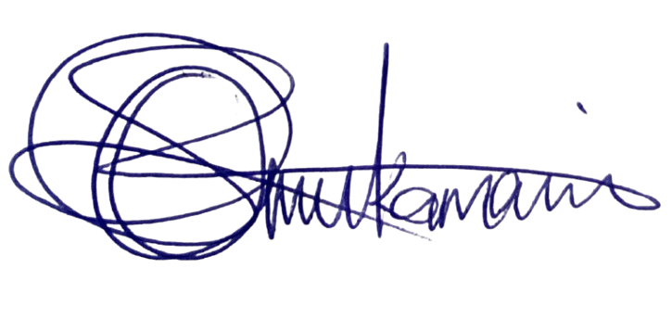
Date: 29th January, 2026

CLIENT
Name: ______________________________
Signature: __________________________
Date: _______________________________



