UNIVERSIDAD NACIONAL DE SAN AGUSTIN

**FACULTAD DE PRODUCCION Y SERVICIOS**

ESCUELA PROFESIONAL DE CIENCIA DE LA COMPUTACION



**PRACTICA 5: Pruebas Funcionales y xUnit**

Estudiante: Angie Alexandra Pino Huarsaya

Curso: Ingenieria de Software 2

Profesor: Edgar Sarmiento

Grupo: A

Arequipa-2022

**PRUEBAS FUNCIONALES Y XUNIT**

***\*Dependencias Necesarias***

pom.xml

|  |
| --- |
| <project xmlns=*"http://maven.apache.org/POM/4.0.0"* xmlns:xsi=*"http://www.w3.org/2001/XMLSchema-instance"* xsi:schemaLocation=*"http://maven.apache.org/POM/4.0.0 https://maven.apache.org/xsd/maven-4.0.0.xsd"*>  <modelVersion>4.0.0</modelVersion>  <groupId>lab5</groupId>  <artifactId>lab5-ex</artifactId>  <version>0.0.1-SNAPSHOT</version>  <name>Lab5</name>  <dependencies>  <dependency>  <groupId>com.amazonaws</groupId>  <artifactId>aws-lambda-java-core</artifactId>  <version>1.2.1</version>  </dependency>  <dependency>  <groupId>org.seleniumhq.selenium</groupId>  <artifactId>selenium-java</artifactId>  <version>4.6.0</version>  </dependency>  <dependency>  <groupId>junit</groupId>  <artifactId>junit</artifactId>  <version>4.13.2</version>  </dependency>  </dependencies>  </project> |

***\*Prueba Calculator***

|  |
| --- |
| **public** **class** Lab5 {  @Test  **public** **static** **void** main(String[] args) {  //Set up web driver (chrome, firefox,...)  //System.setProperty("webdriver.gecko.driver", "C:\\...\\Selenium\\Selenium WebDriver\\Java\\Libs\\geckodriver-v0.23.0-win32\\geckodriver.exe");    WebDriver driver = **new** ChromeDriver();  //Puts an Implicit wait, Will wait for 10 seconds before throwing exception  driver.manage().timeouts().implicitlyWait(10, TimeUnit.***SECONDS***);    //Launch website  driver.navigate().to("http://www.calculator.net/");    //Maximize the browser  driver.manage().window().maximize();    // Click on Math Calculators  driver.findElement(By.*xpath*("//*[@id=\"contentout\"]/table/tbody/tr/td[3]/div[2]/a")).click();    // Click on Percent Calculators  driver.findElement(By.*xpath*("//*[@id=\"occontent\"]/a[3]")).click();    // Enter value 10 in the first number of the percent Calculator  driver.findElement(By.*id*("cpar1")).sendKeys("10");    // Enter value 50 in the second number of the percent Calculator  driver.findElement(By.*id*("cpar2")).sendKeys("50");    // Click Calculate Button  driver.findElement(By.*xpath*("//*[@id=\"content\"]/table[1]/tbody/tr[2]/td/input[2]")).click();    // Get the Result Text based on its xpath  String result =  driver.findElement(By.*xpath*("//*[@id=\"cpar3\"]")).getText();    // Print a Log In message to the screen  System.***out***.println(" The Result is " + result);    //Close the Browser.  driver.close();  }  } |

Página usada

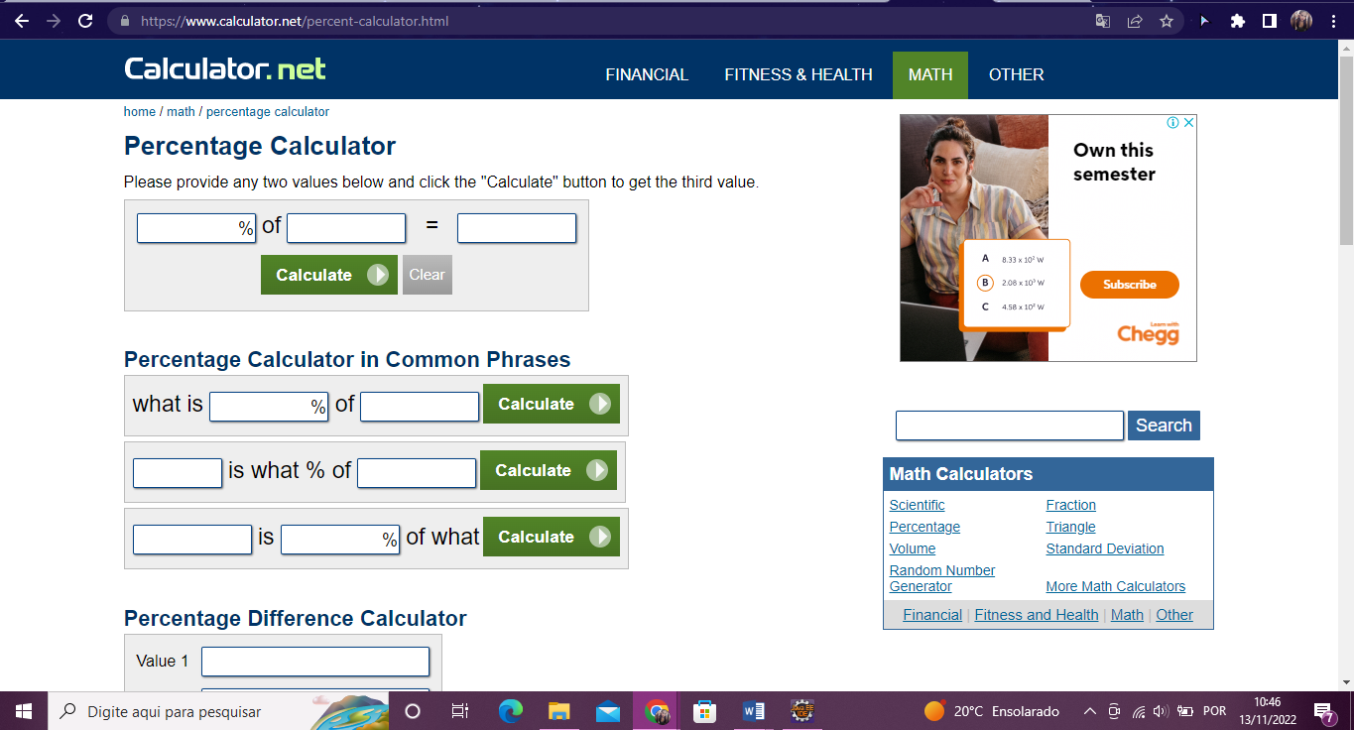

***\*Prueba Web Form***

|  |
| --- |
| **public** **class** Prueba {  @Test  **public** **void** eightComponents() {  WebDriverManager.chromedriver().setup();  WebDriver driver = **new** ChromeDriver();  driver.get("https://www.selenium.dev/selenium/web/web-form.html");  String title = driver.getTitle();  *assertEquals*("Web form", title);  driver.manage().timeouts().implicitlyWait(Duration.*ofMillis*(500));  WebElement textBox = driver.findElement(By.*name*("my-text"));  WebElement submitButton = driver.findElement(By.*cssSelector*("button"));  textBox.sendKeys("Selenium");  submitButton.click();  WebElement message = driver.findElement(By.*id*("message"));  String value = message.getText();  *assertEquals*("Received!", value);  driver.quit();  }  } |

Página usada

