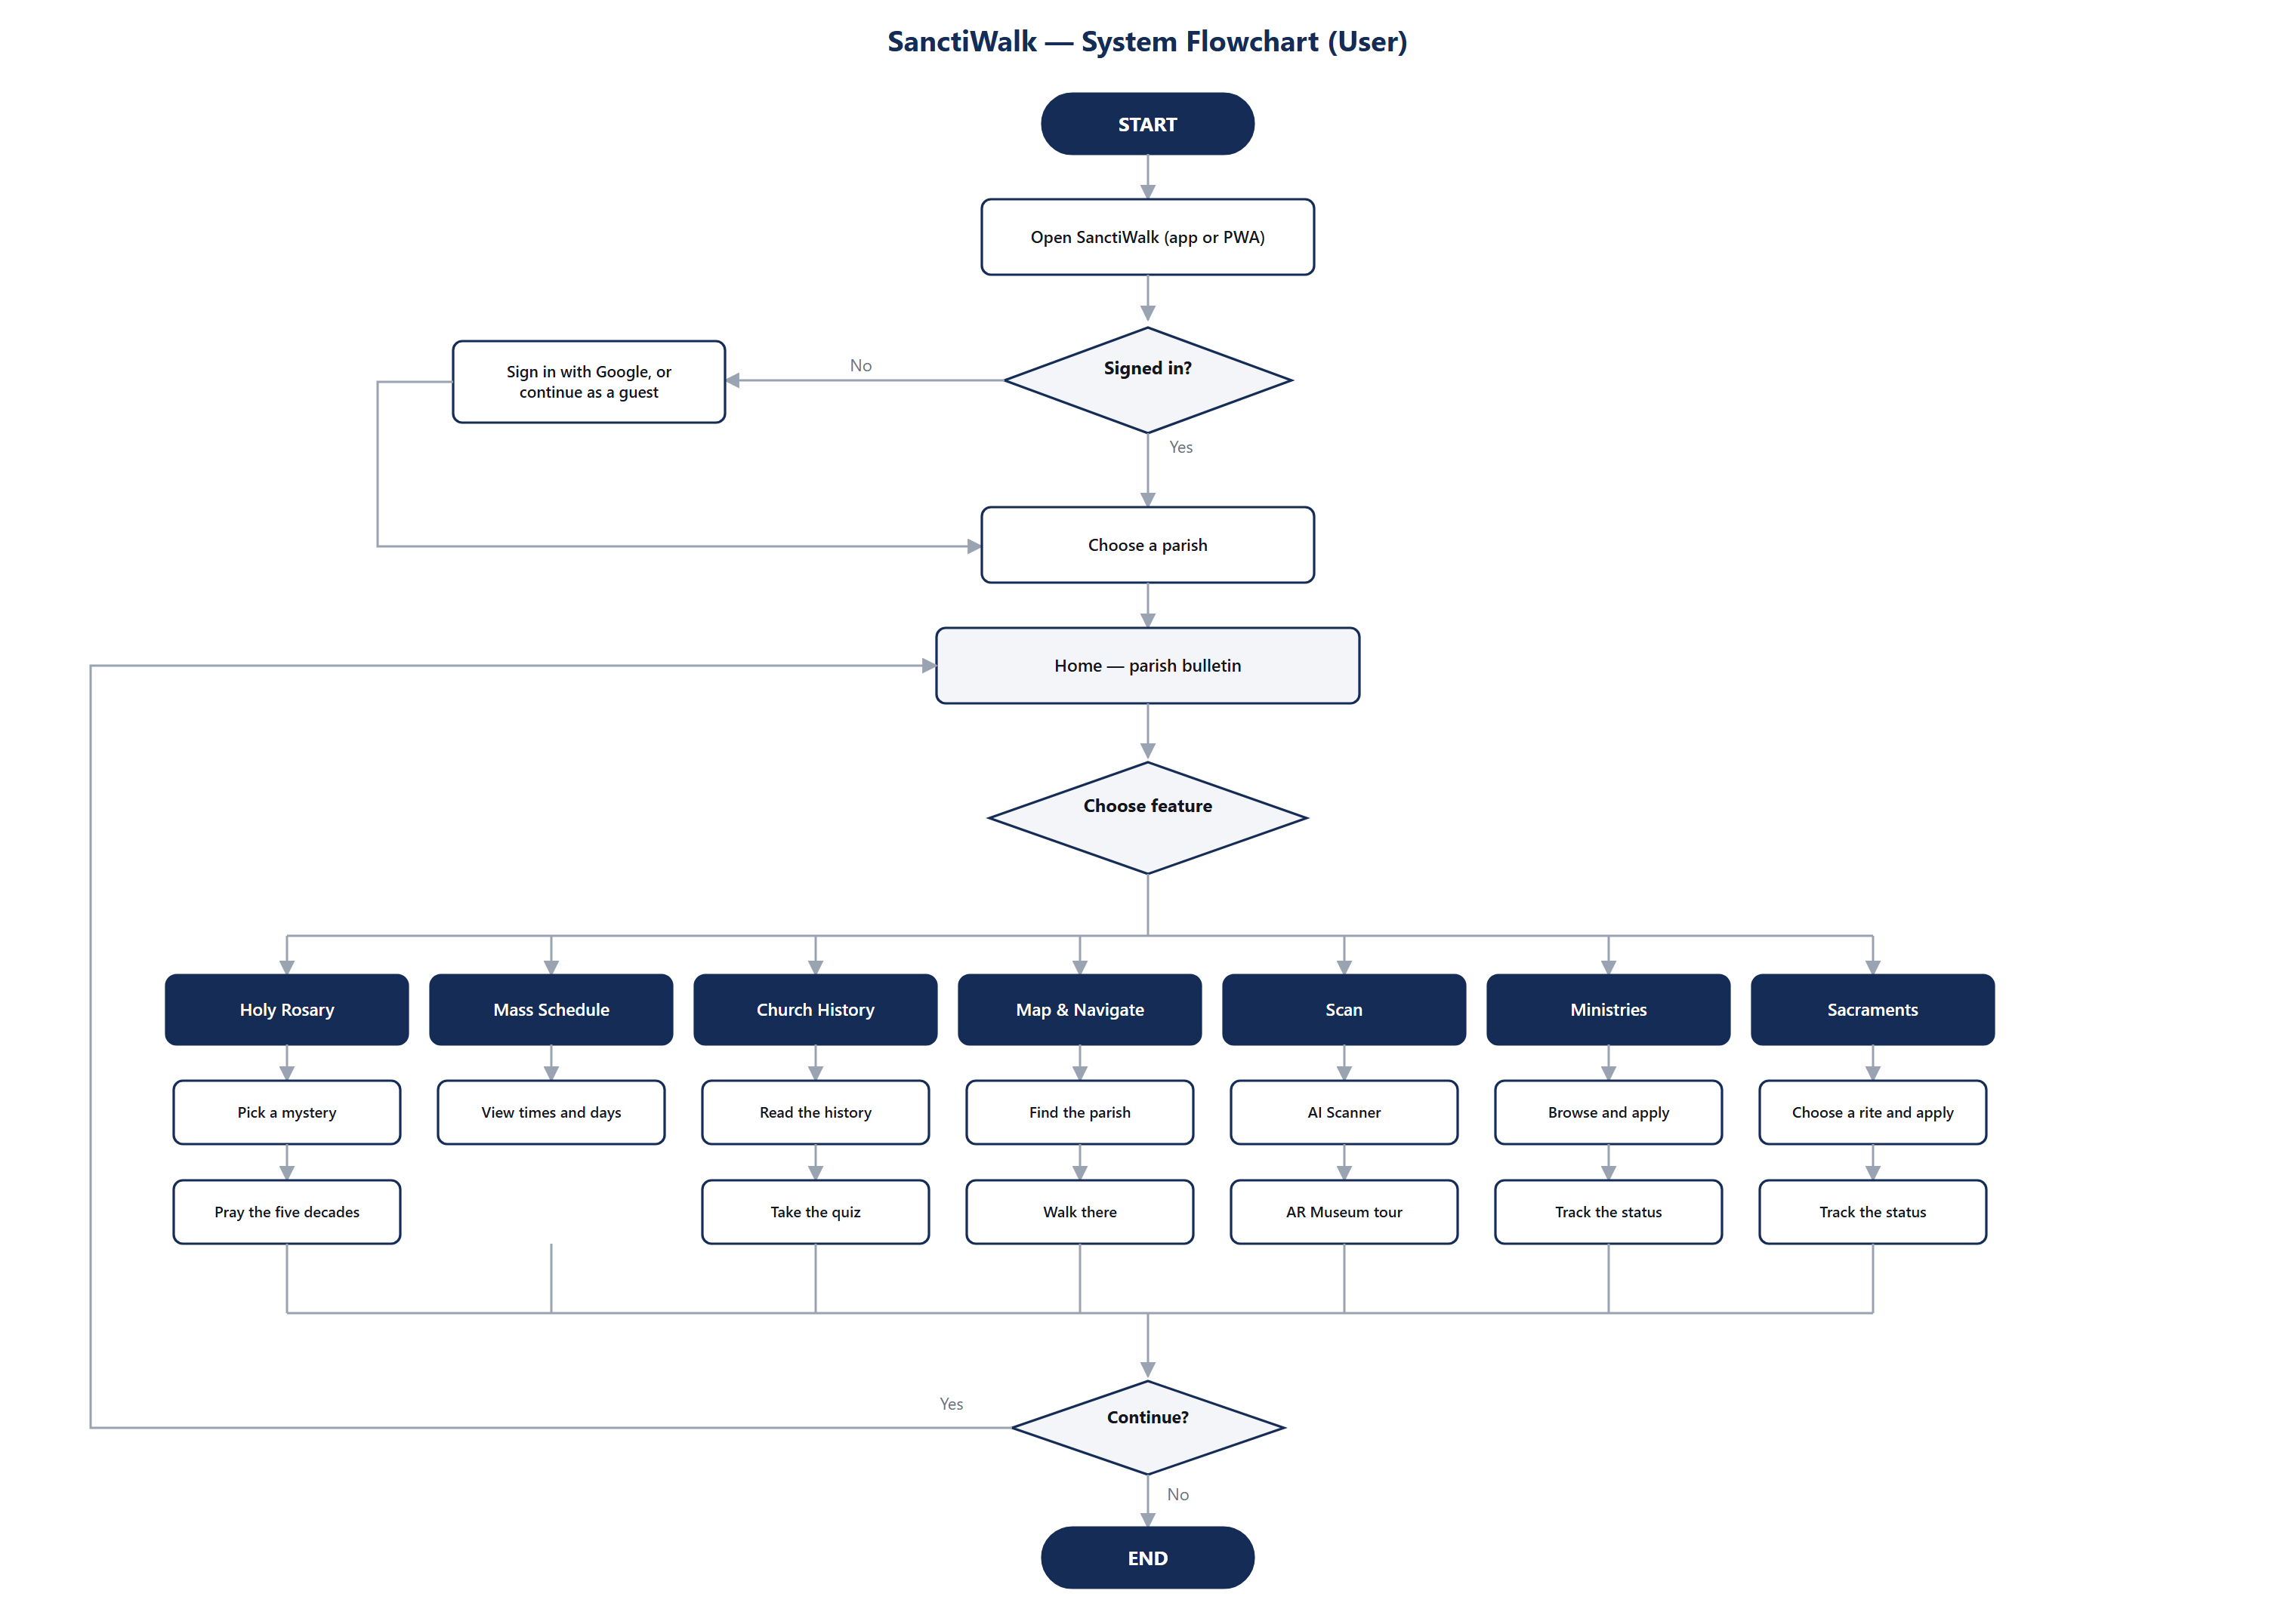
Figure 1 — System Flowchart (User)

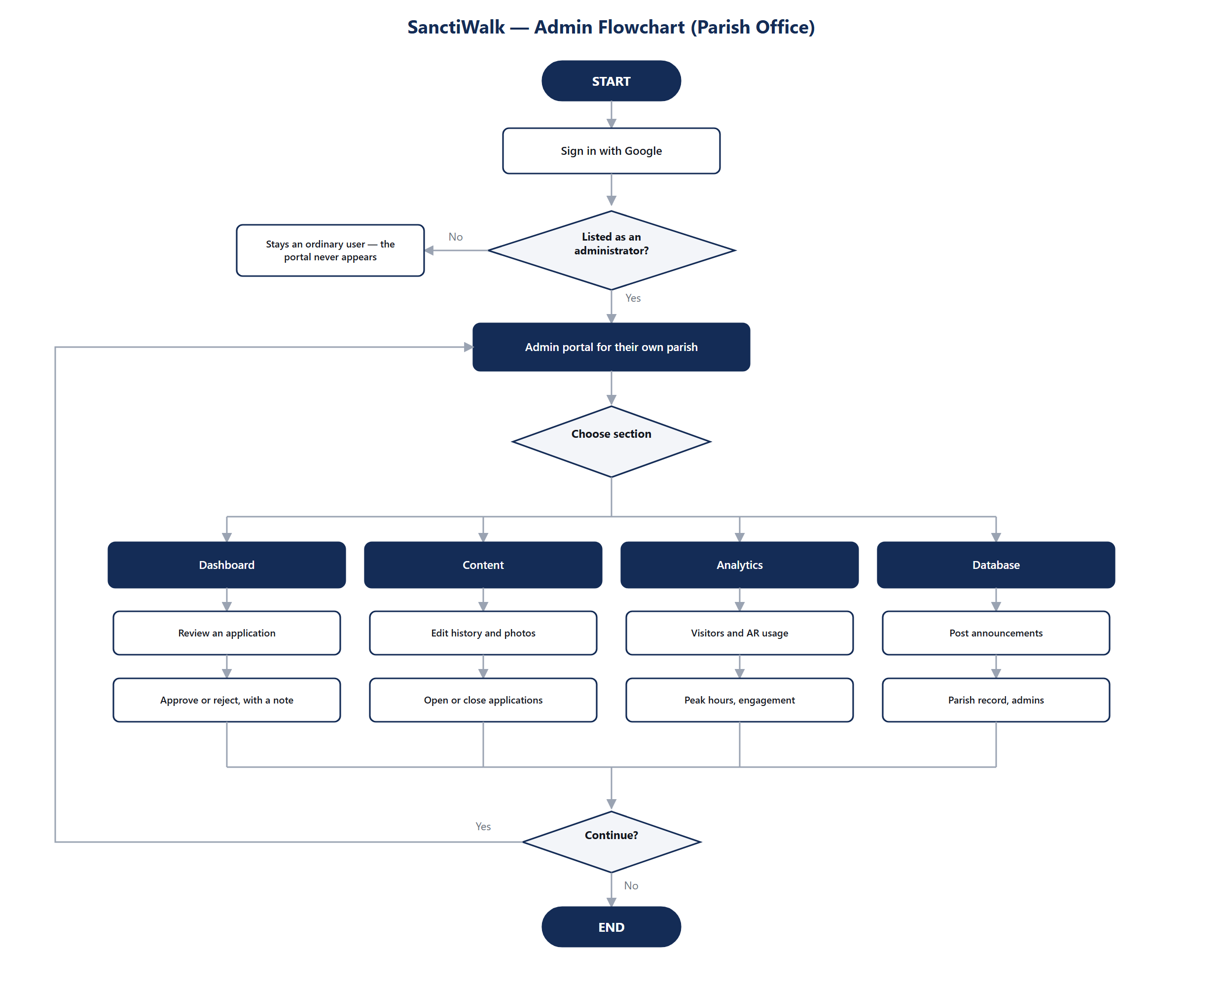
Figure 2 — Admin Flowchart (Parish Office)

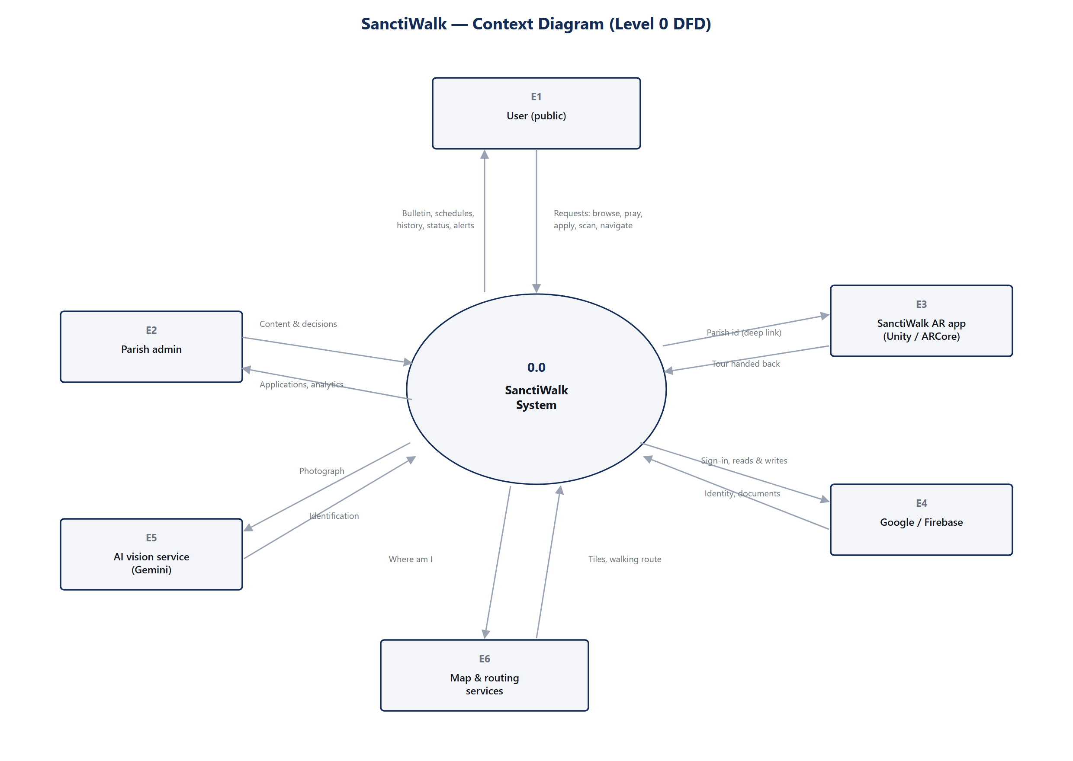
Figure 3 — Context Diagram (Level 0 DFD)

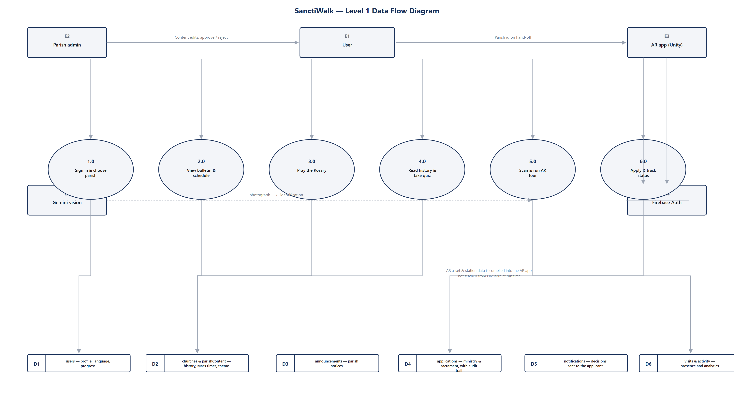
Figure 4 — Level 1 Data Flow Diagram

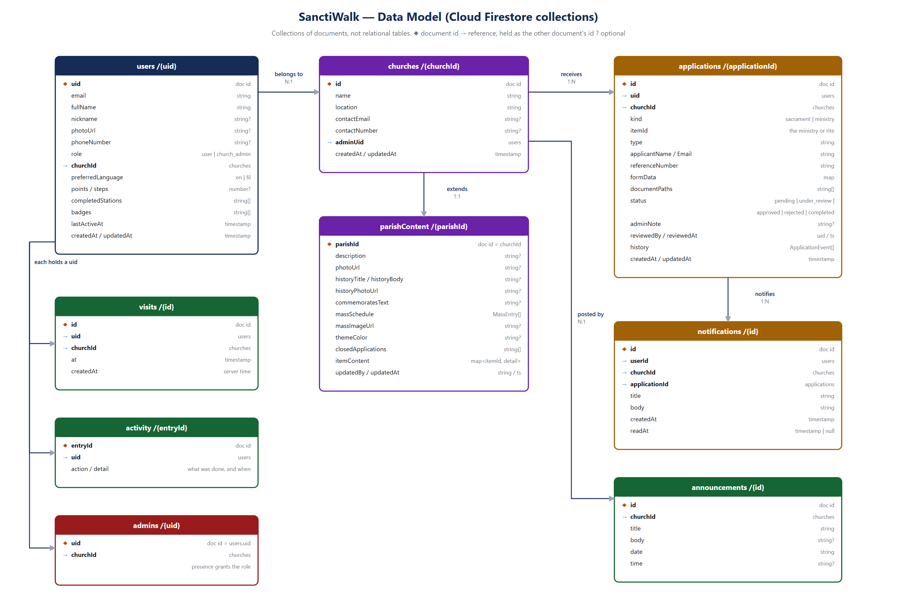
Figure 5 — Data Model (Cloud Firestore collections)

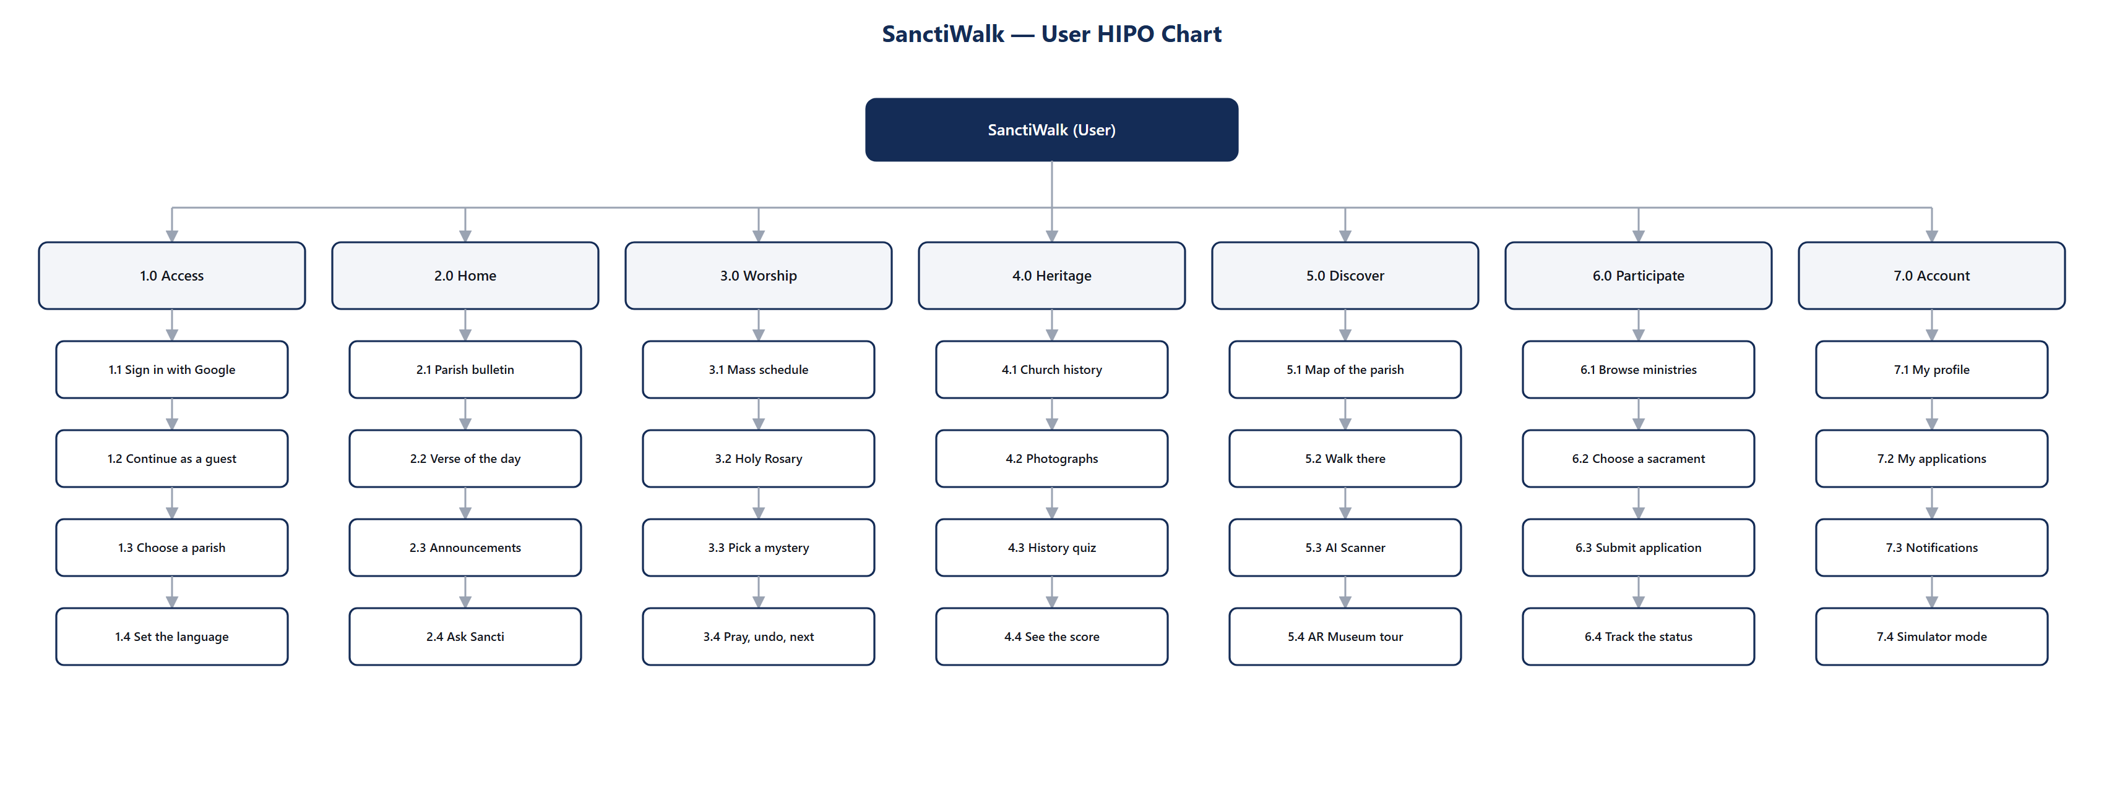
Figure 6 — User HIPO Chart

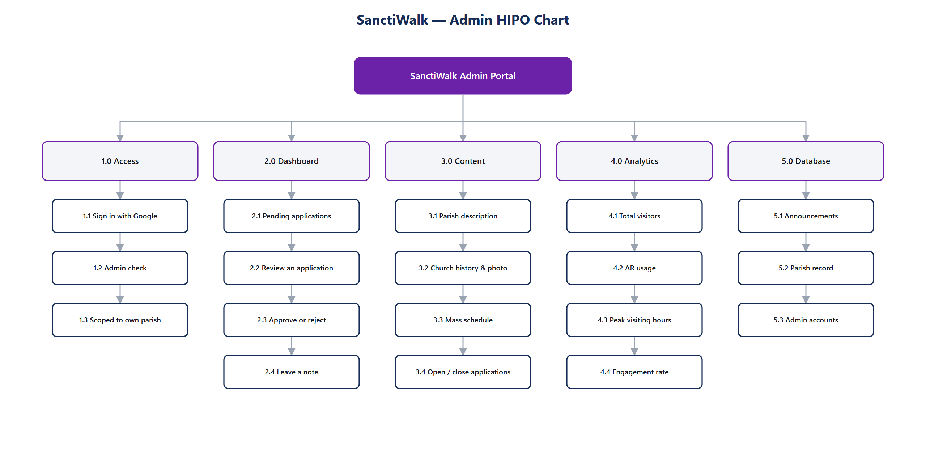
Figure 7 — Admin HIPO Chart

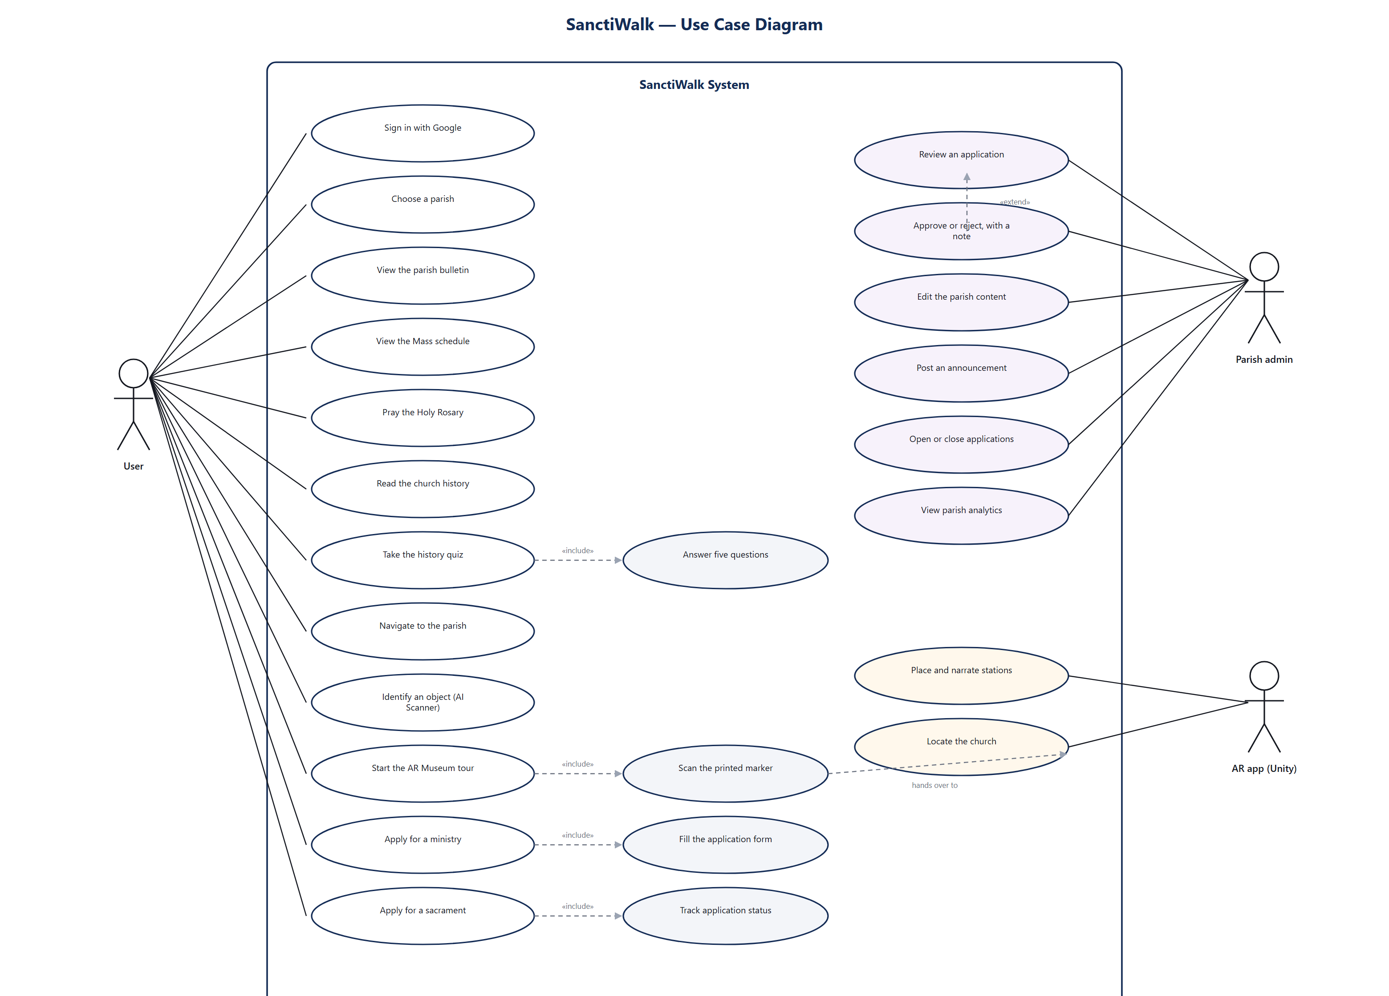
Figure 8 — Use Case Diagram

