SanctiWalk — App Screens
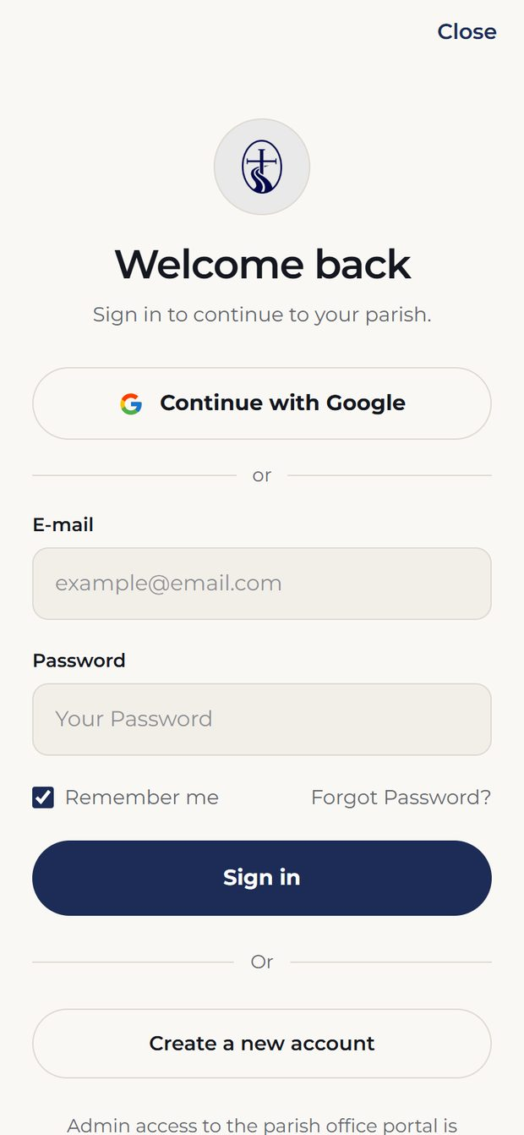  Sign in  Google sign-in, or continue as a guest. | 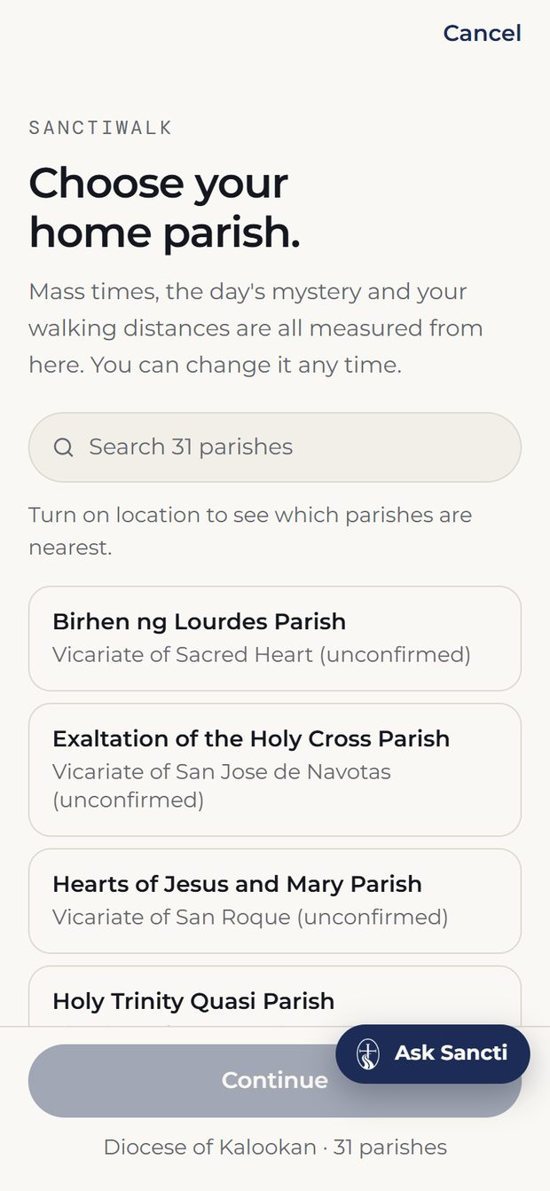  Select Parish  All 31 parishes of the diocese; two are live.

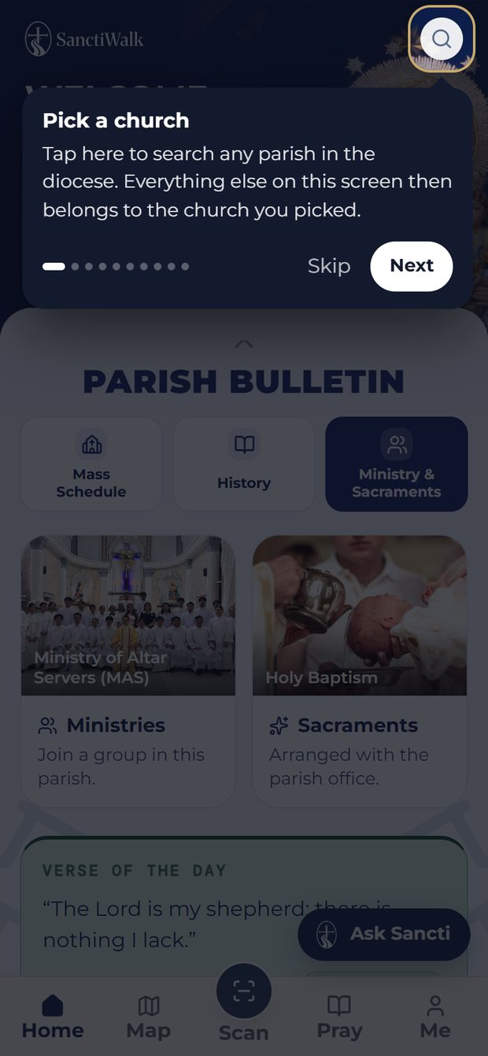  Onboarding  First-run coach marks, replayable from Me. | 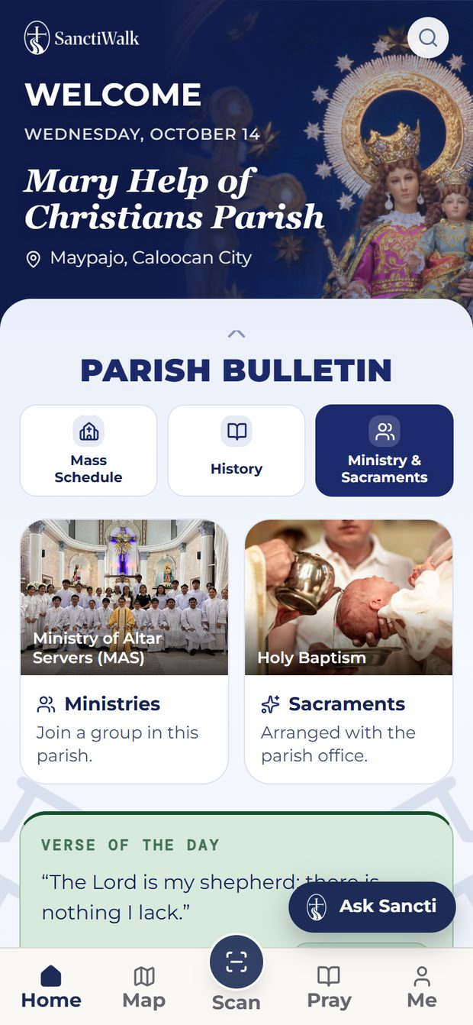  Home  The parish bulletin: patron, Mass, history, ministries, verse, notices.

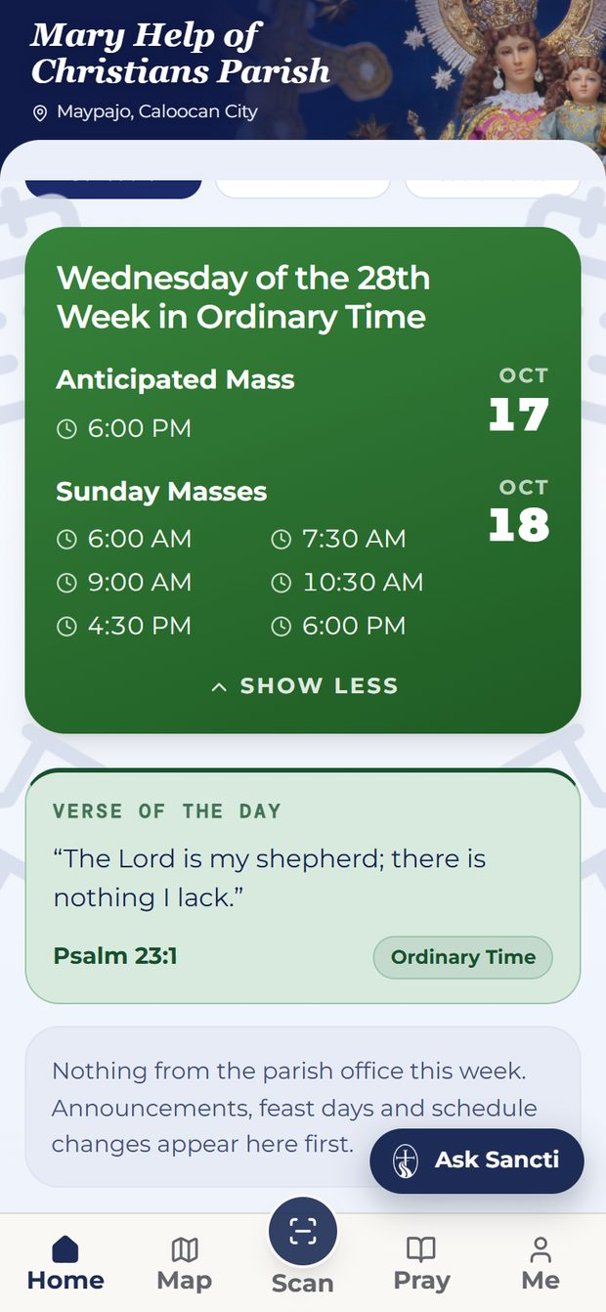  Bulletin — Mass Schedule  Times entered by the parish office, not hardcoded. | 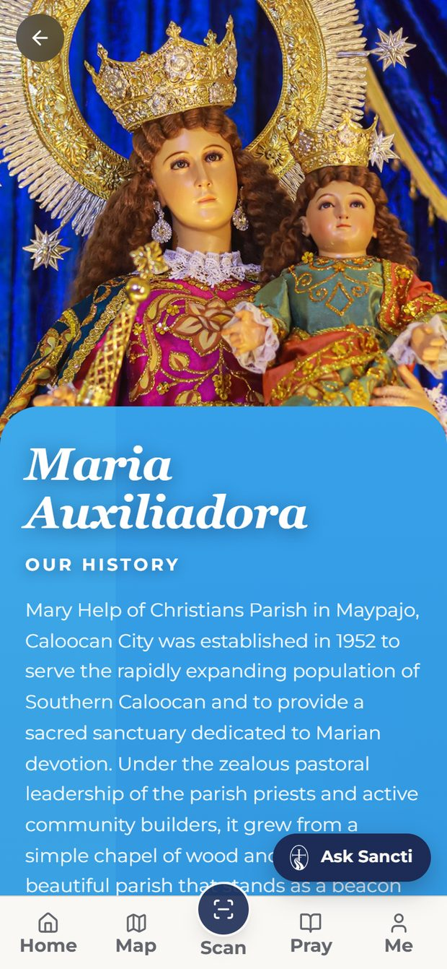  Church History  The parish's own history, bilingual, with photographs.

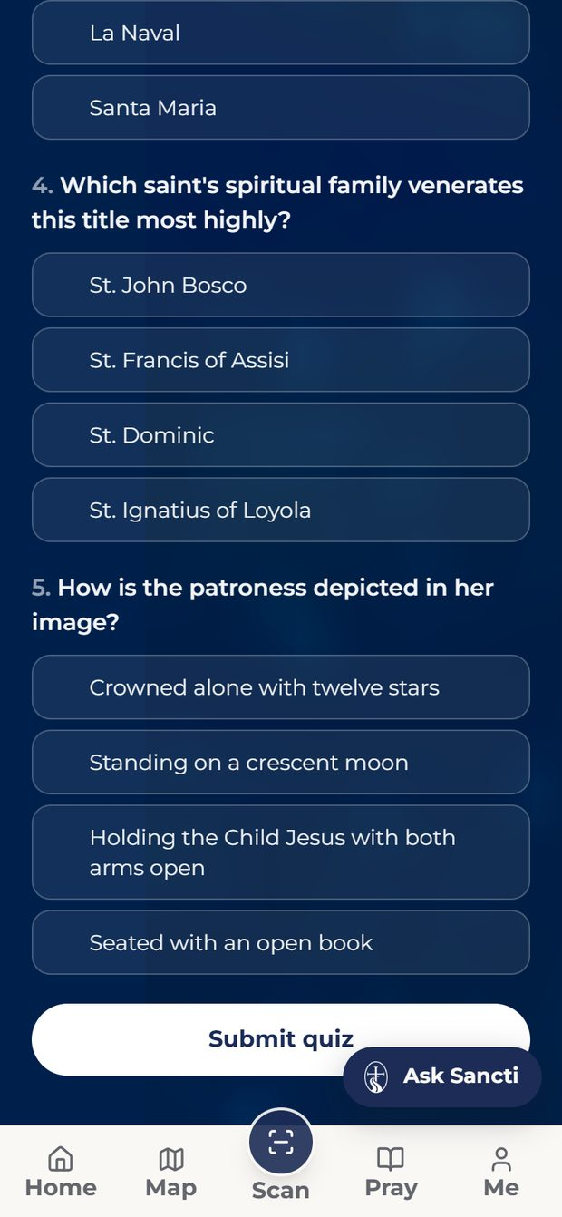  History Quiz  Five questions, every answer somewhere on the history page. | 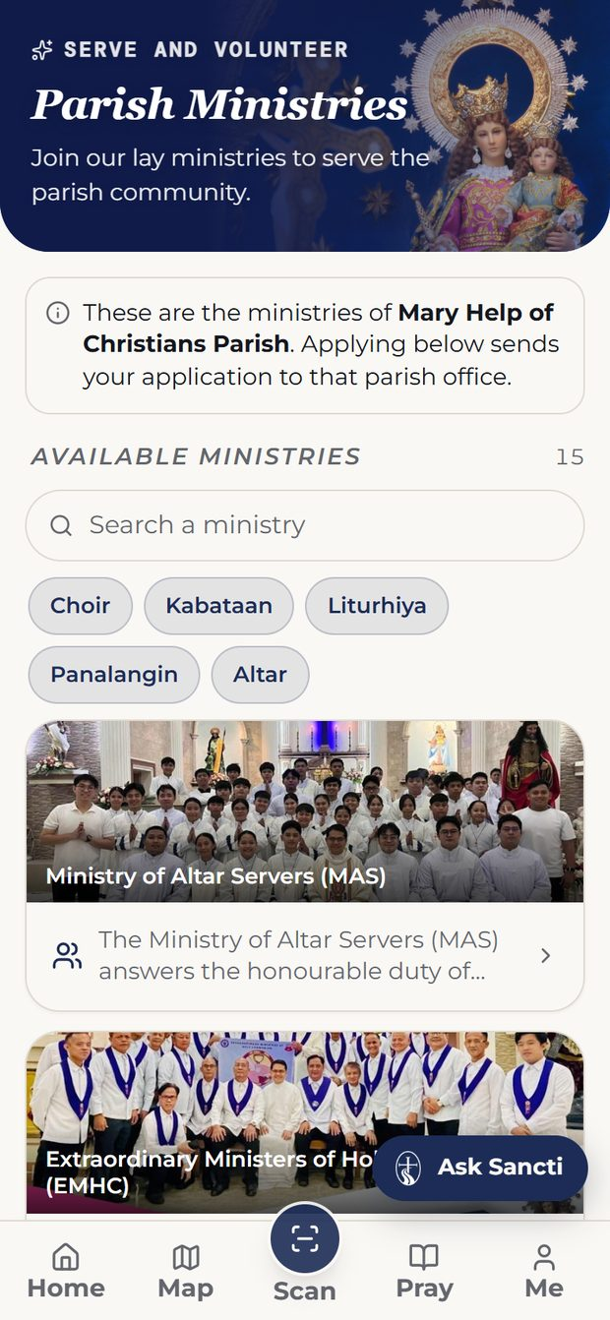  Ministries  This parish's ministries; closed ones say so.

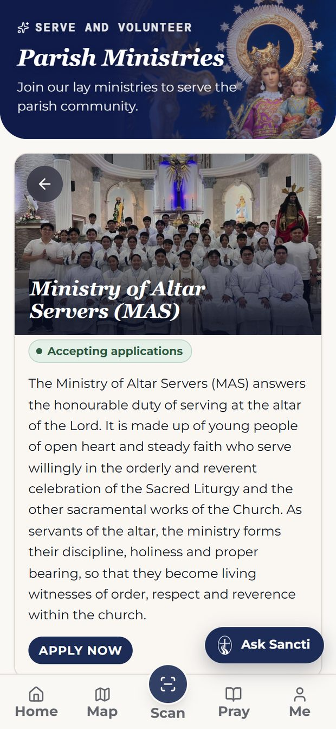  Ministry detail  What the ministry does, and what joining asks of you. | 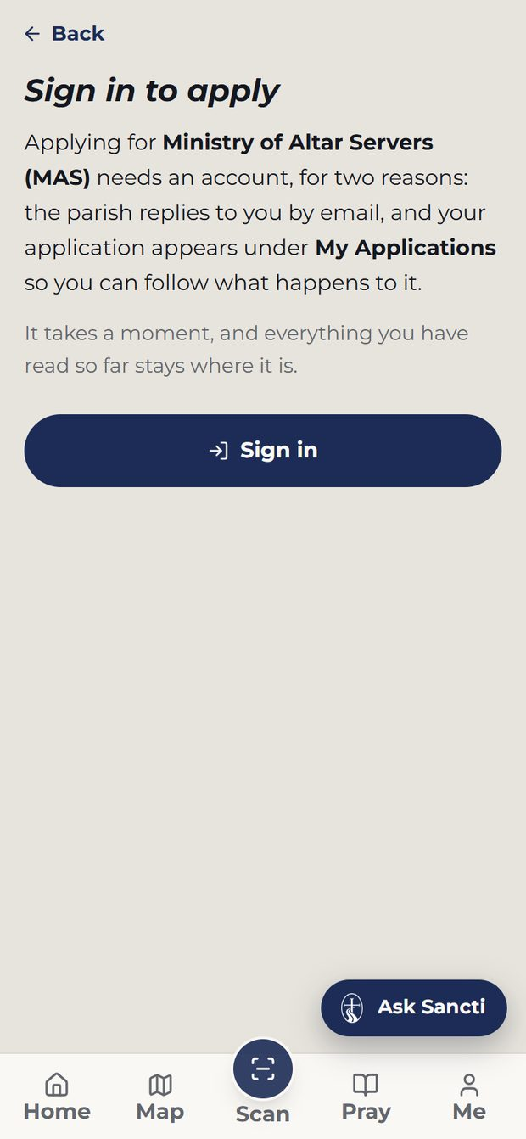  Ministry application  The form, and where it is sent.

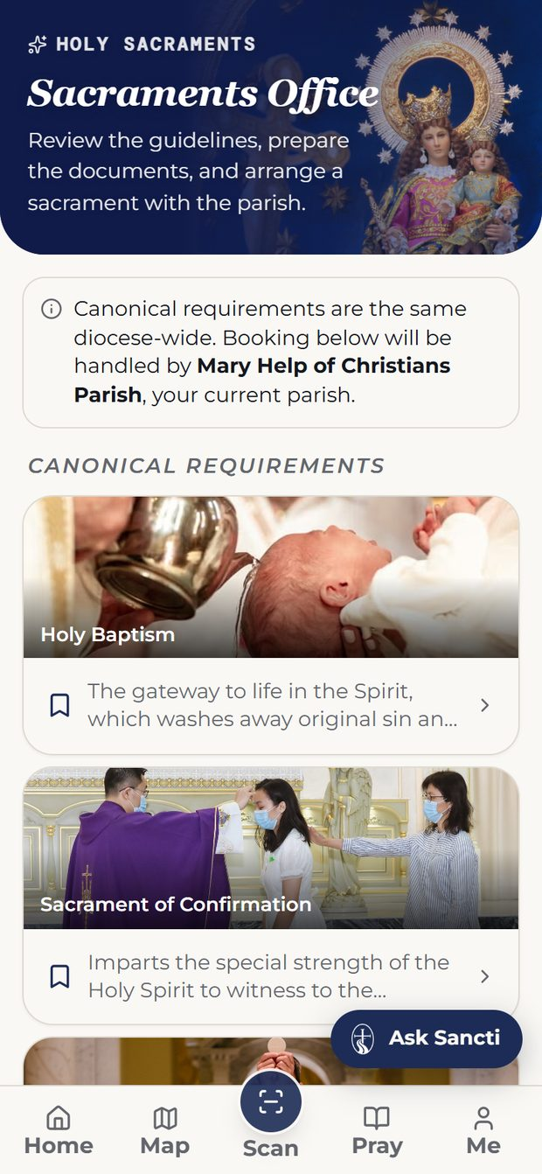  Sacraments  Choose a rite and read the canonical requirements. | 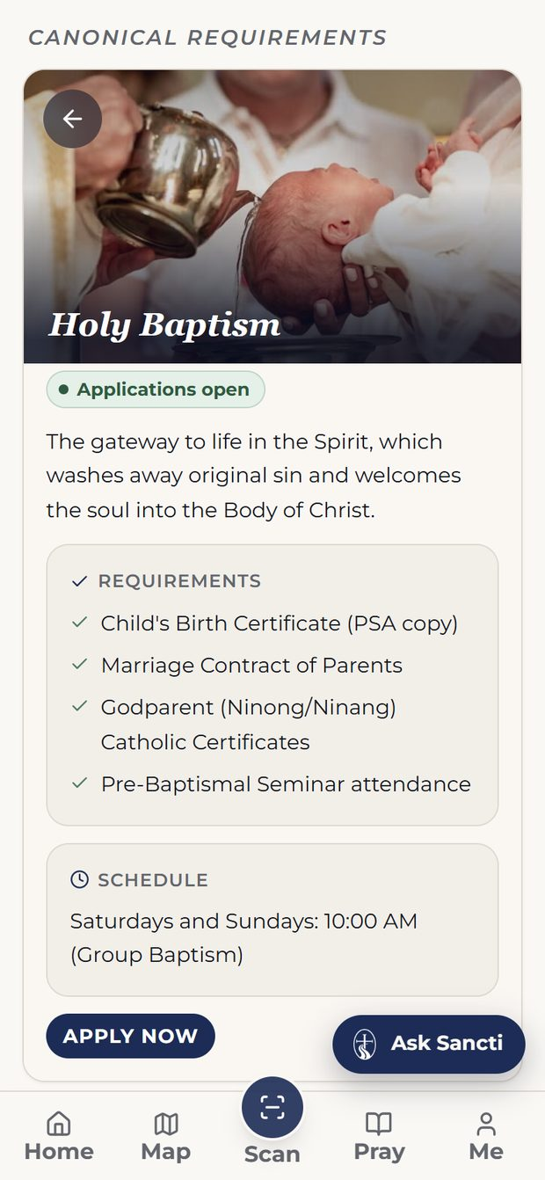  Sacrament detail  Requirements and schedule for the chosen rite.

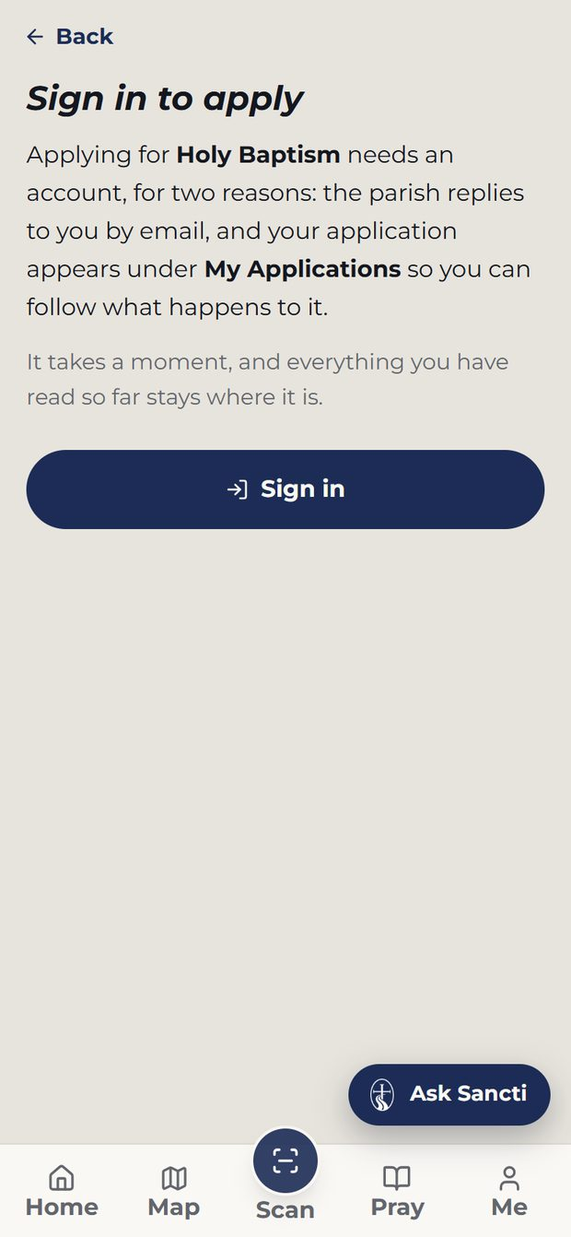  Sacrament application  The form, and where it is sent. | 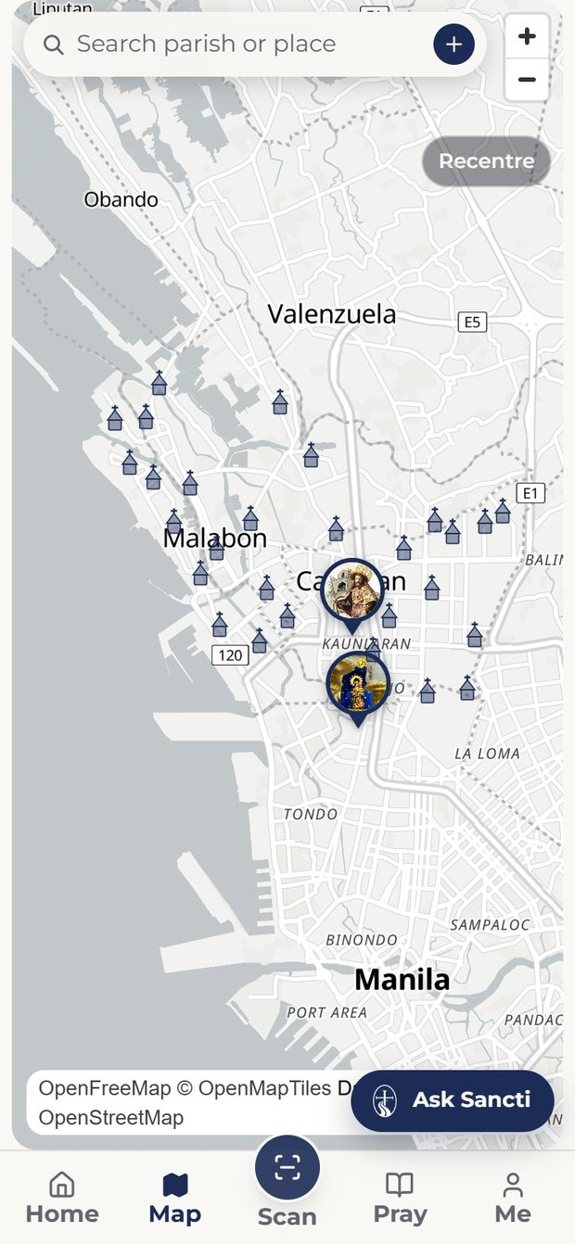  Map  The parish located, with walking navigation.

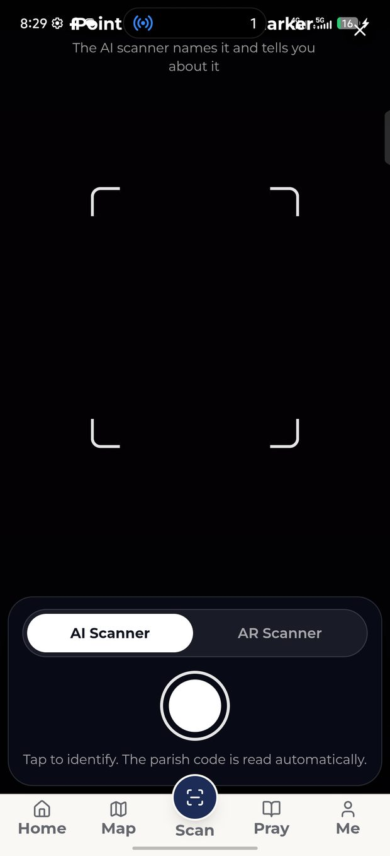  Scan — AI Scanner  Point, tap, and it names what you are looking at. | 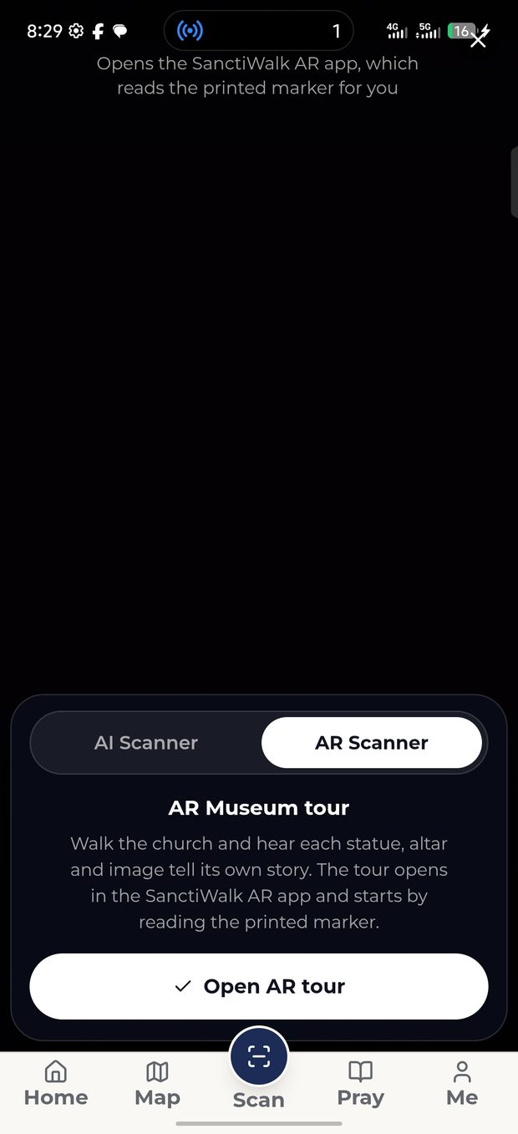  Scan — AR Scanner  The door to the AR Museum tour.

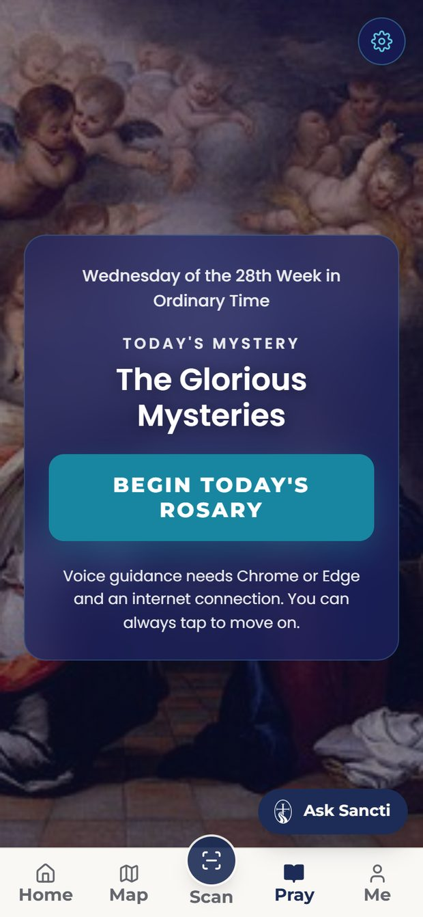  Holy Rosary  Mystery, then bead by bead, with undo and next. | 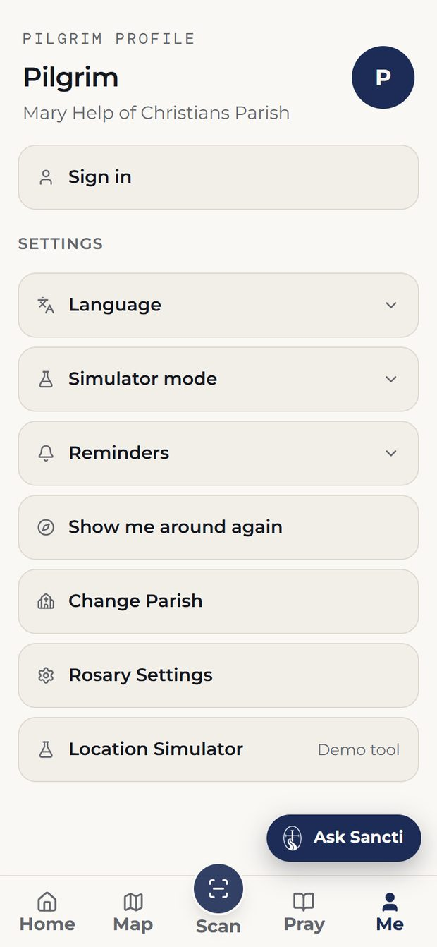  Me (signed out)  What a guest sees: settings, and an invitation to sign in.

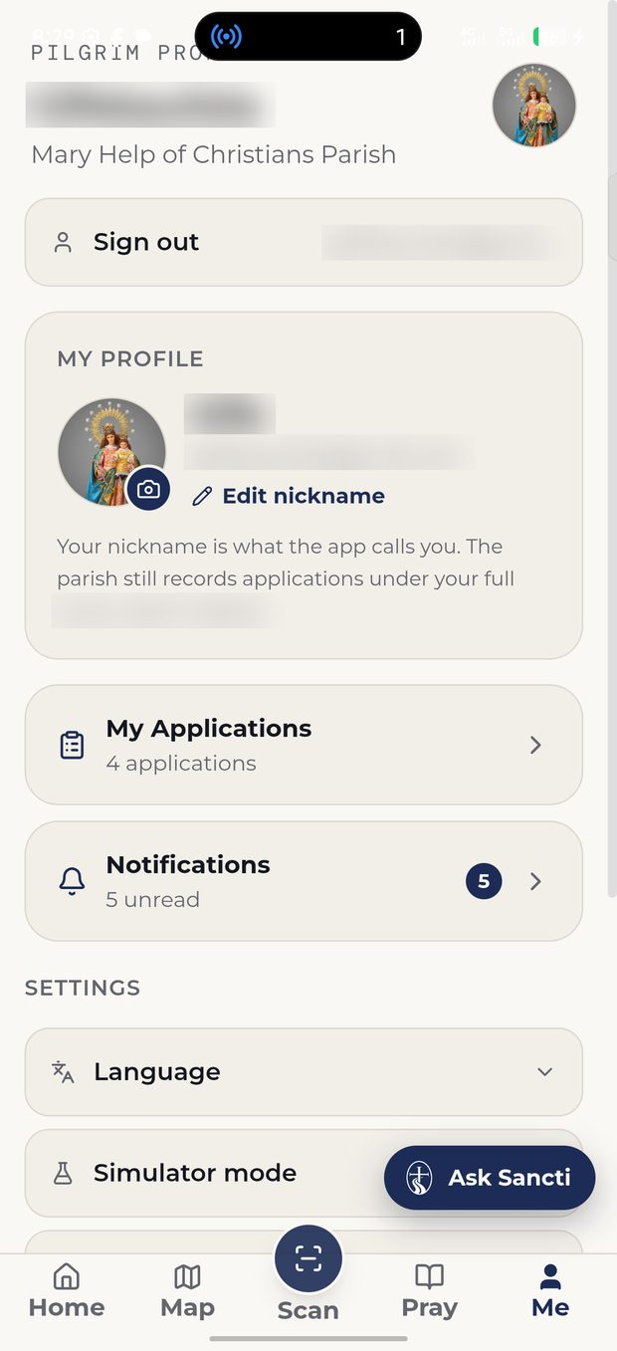  Me (signed in)  Applications and notifications, once there is an account. | 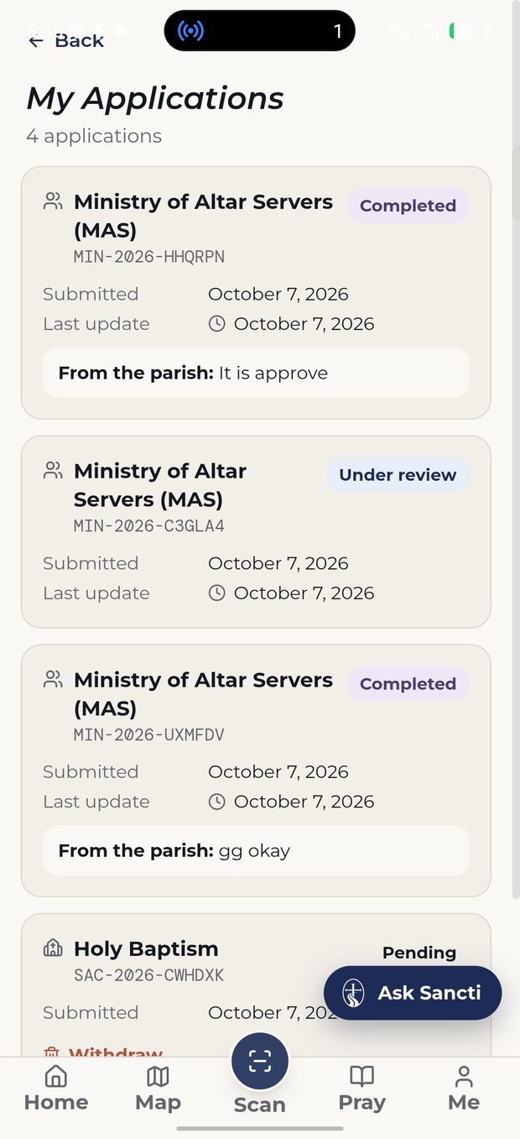  My Applications  Each application with its status and reference.

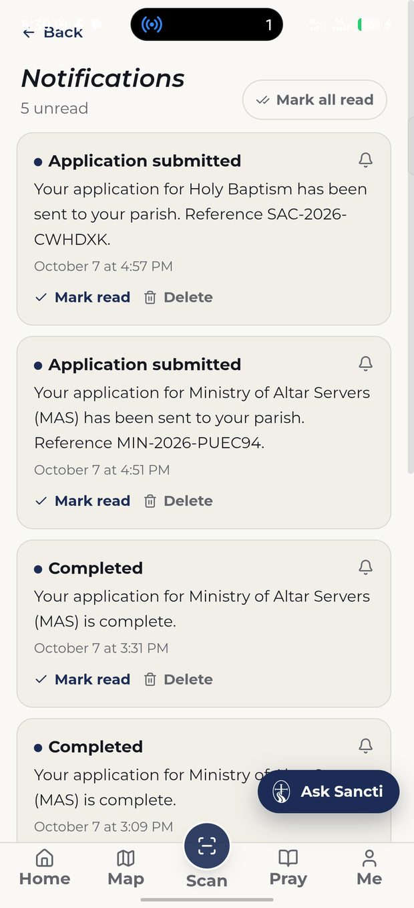  Notifications  Written as an application moves through review. | 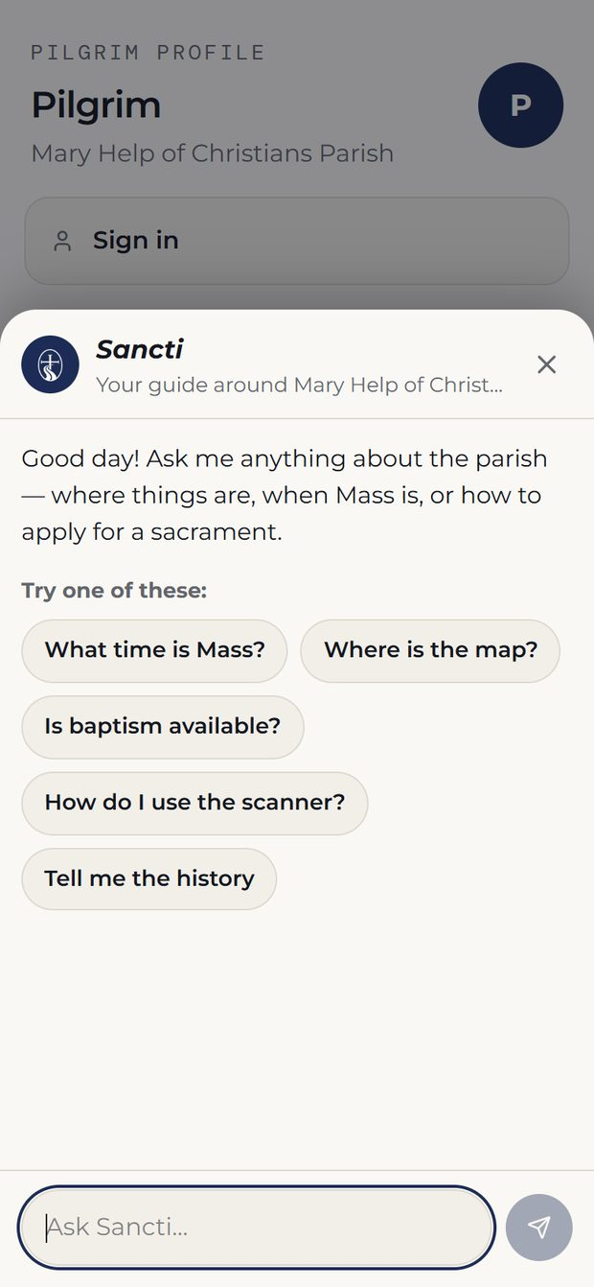  Ask Sancti  The assistant, as a sheet over the screen beneath.

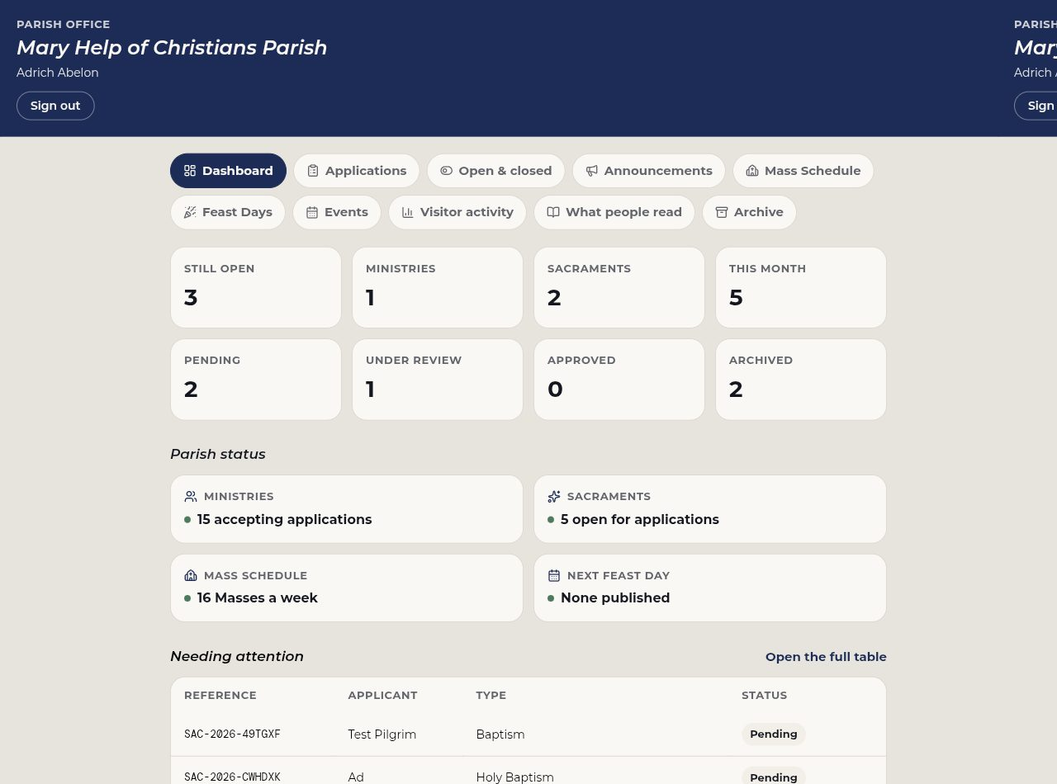
Admin — Dashboard
Parish figures and the state of every application.

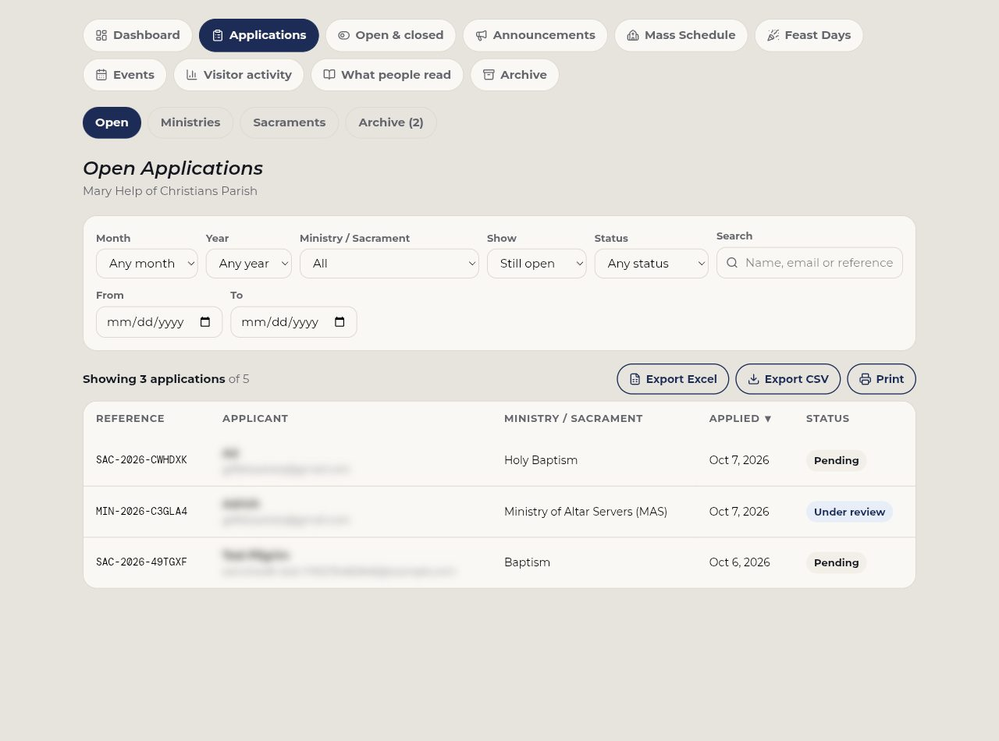
Admin — Applications
Review, filter and export; applicant details blurred.

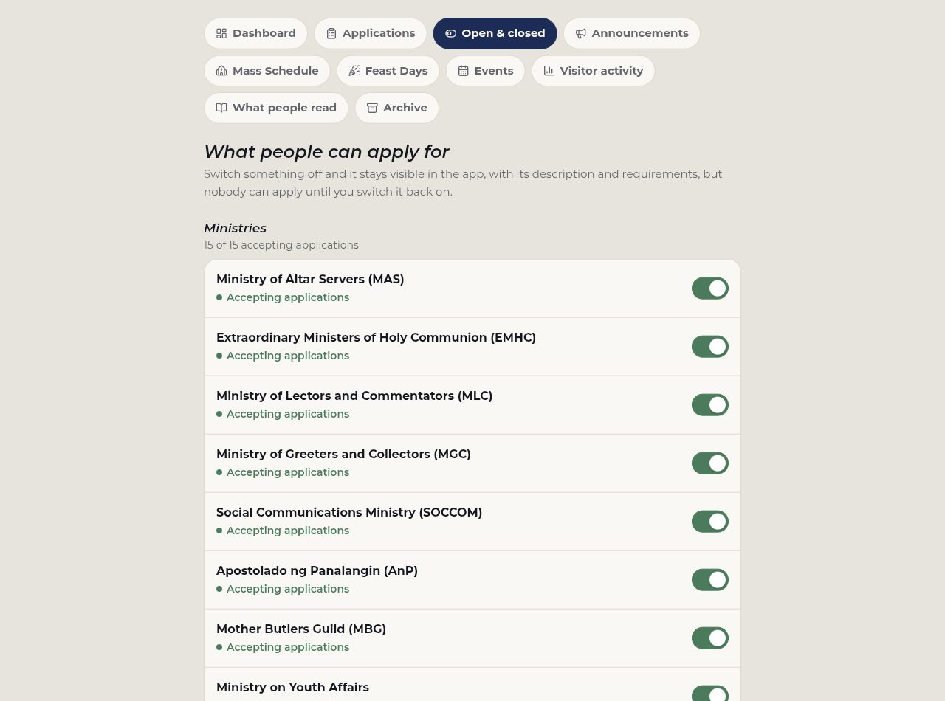
Admin — Open & closed
Which ministries and sacraments accept applications.

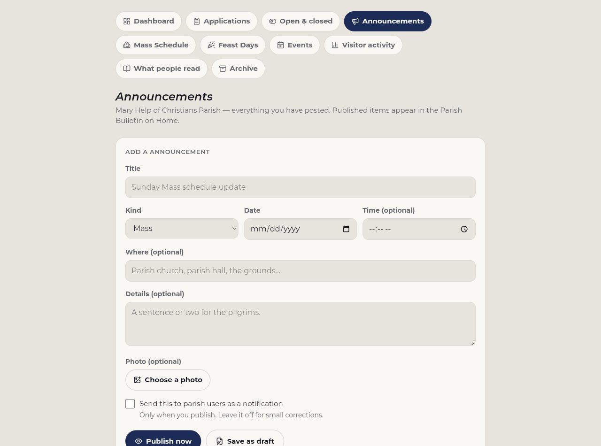
Admin — Announcements
What the parish posts to the bulletin.

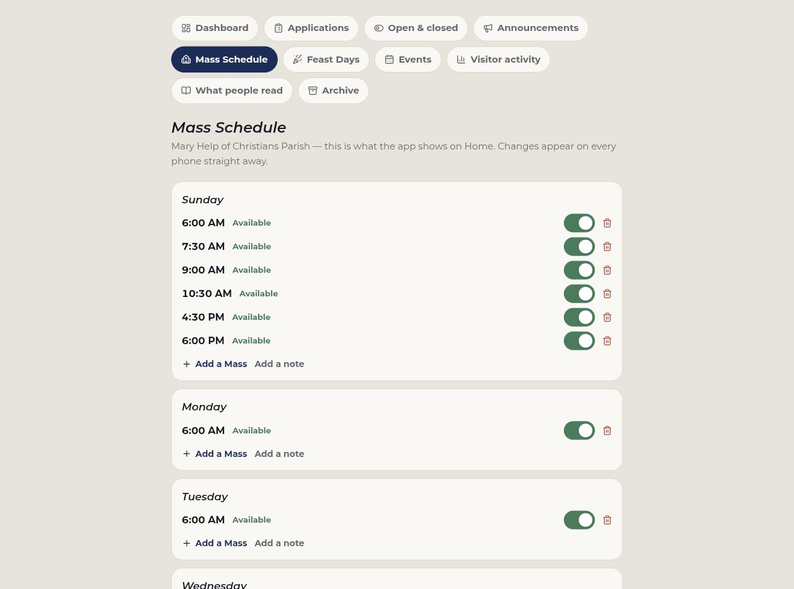
Admin — Mass Schedule
The times shown on Home, edited here.

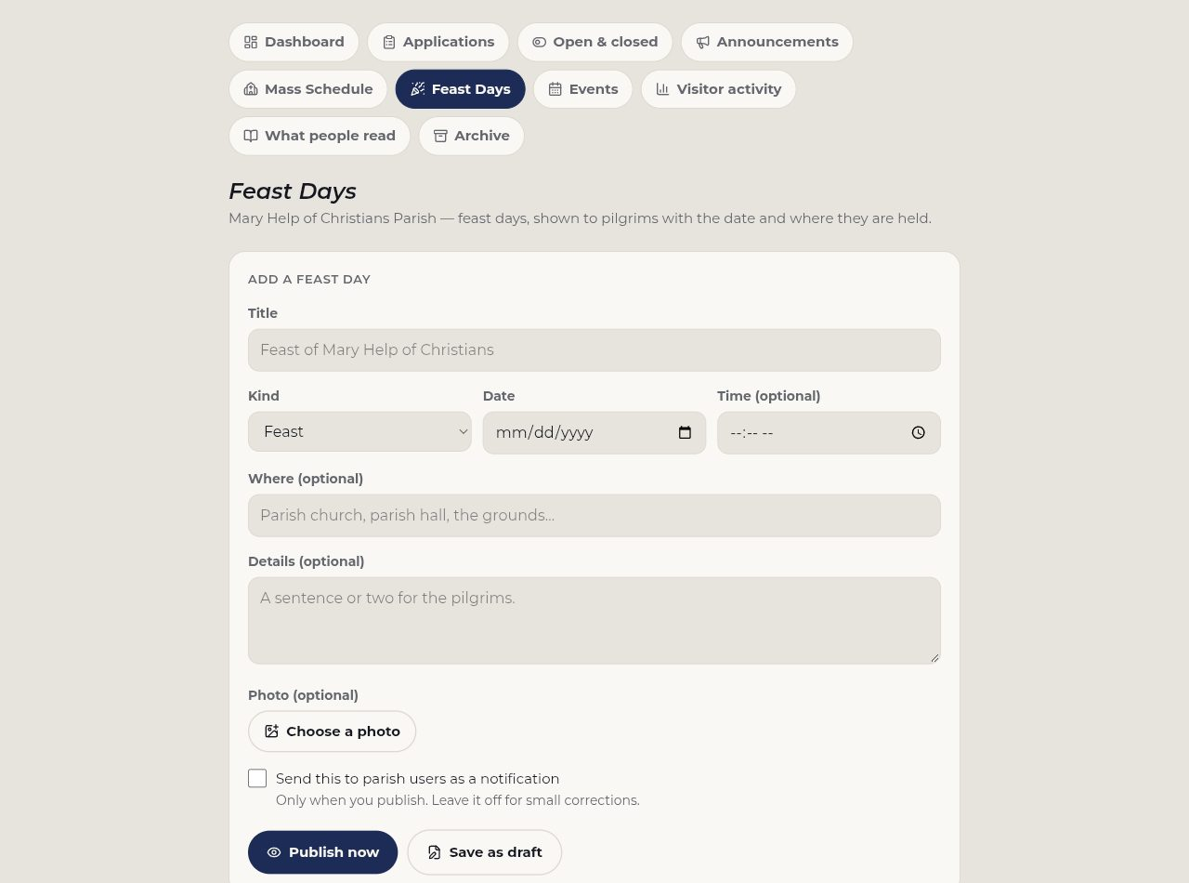
Admin — Feast Days
The parish's own calendar.

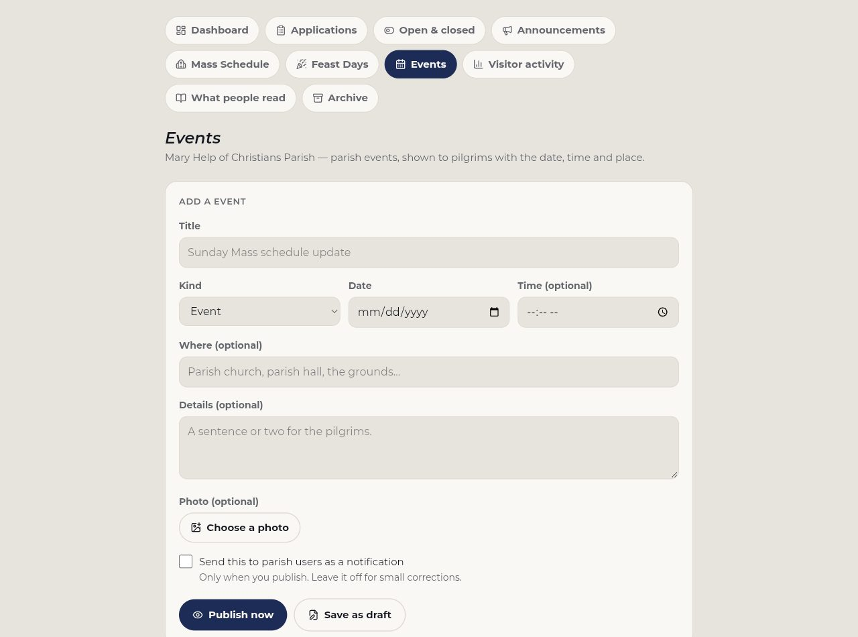
Admin — Events
Parish events.

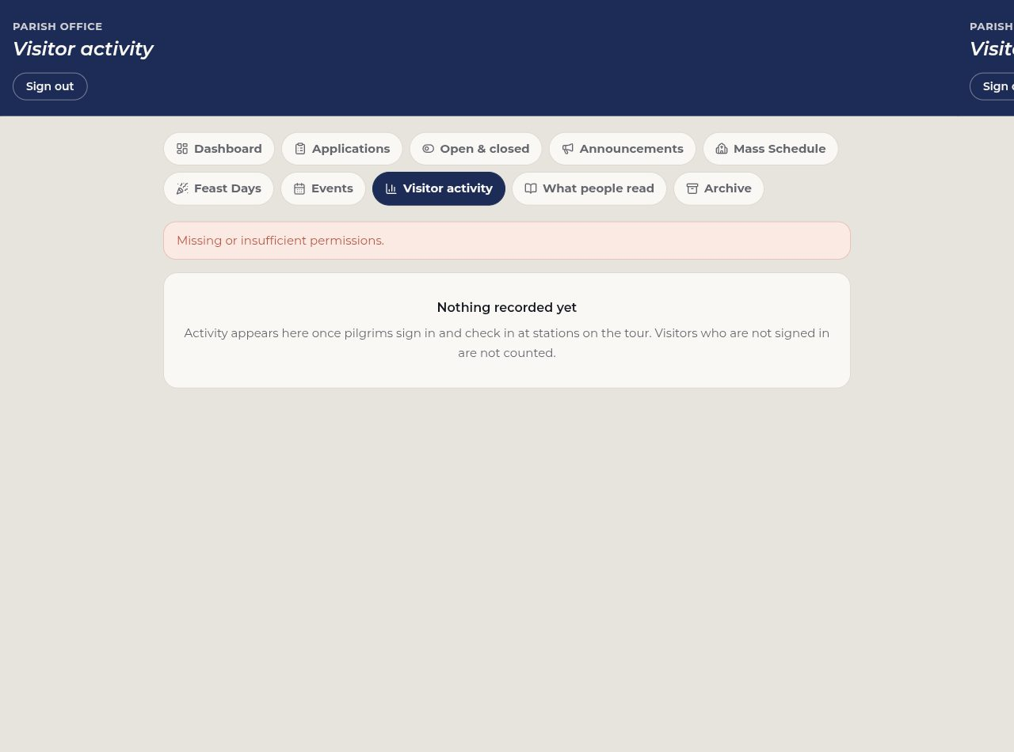
Admin — Visitor activity
How the parish is actually being used.

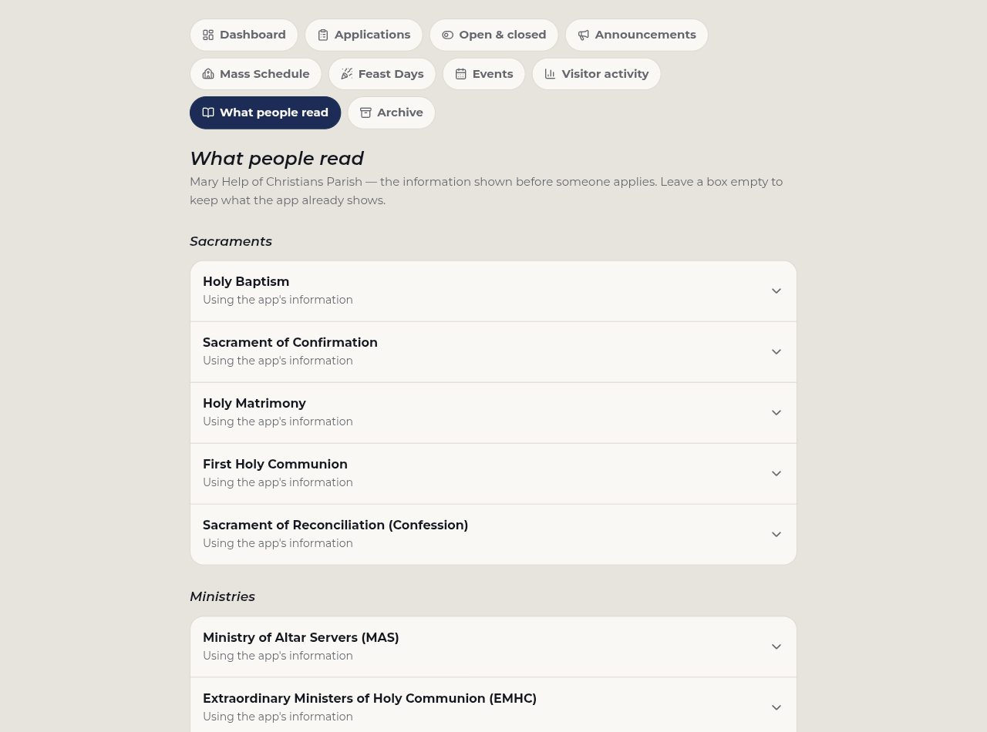
Admin — What people read
The text shown before someone applies.

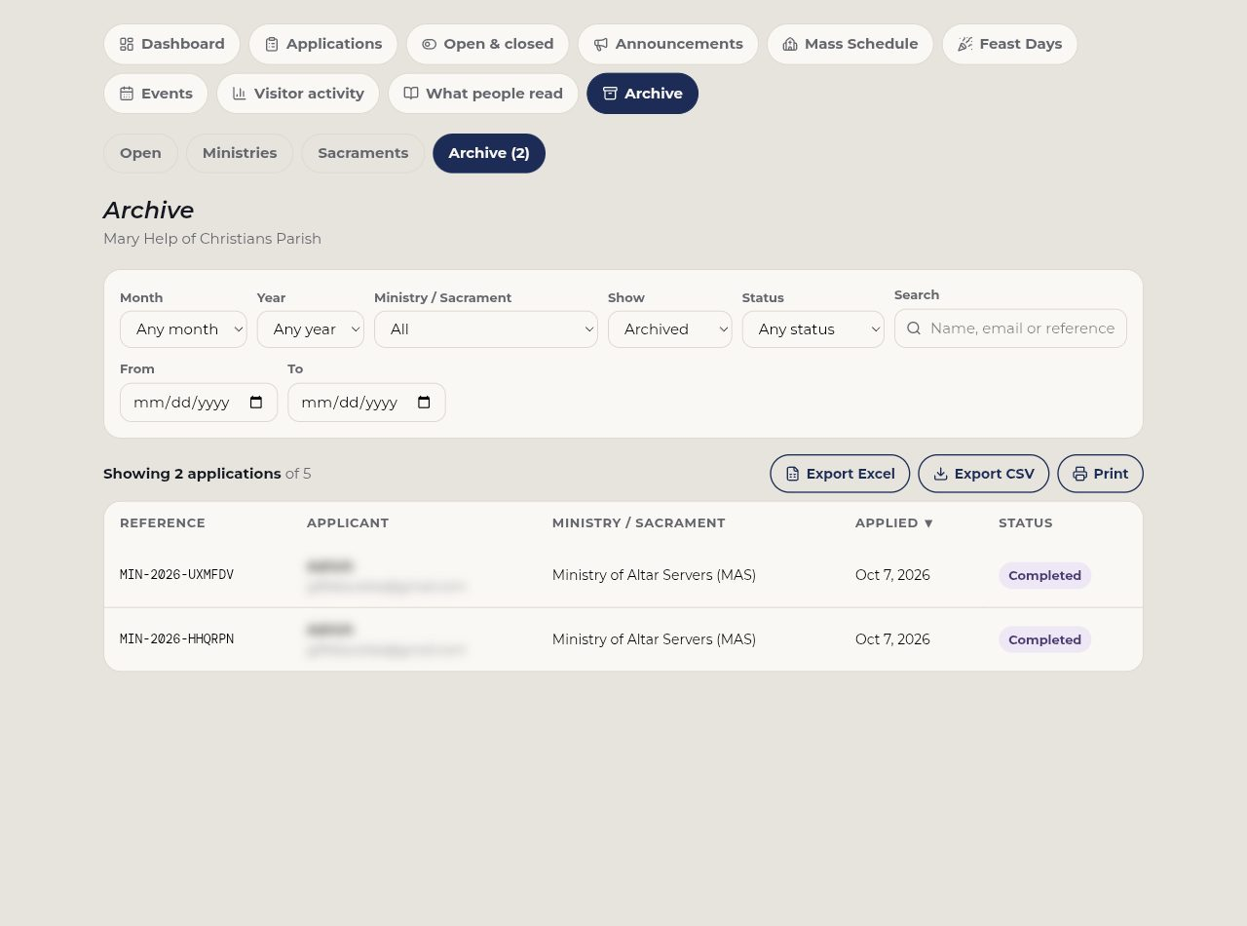
Admin — Archive
Applications already dealt with.

