

**MALAWI UNIVERSITY OF BUSINESS AND APPLIED SCIENCES**

**FACULTY OF ENGINEERING**

**DEPARTMENT OF CIVIL ENGINEERING**

COURSE TITLE : CIVIL ENGINEERING PRACTICE

COURSE CODE : CIV-CEP-221

SUBMITTED TO :ENGINEER T. MSUKWA

SUBMITTED BY : BLESSINGS MWAMUGHUNDA

REGISTRATION NO : BCET/23/SS/011

DUE DATE : 10 October, 2025

**WET SIEVING (ATTERBERG LIMIT TEST)**

1. **INTRODUCTION**

The engineering behavior of fine-grained soils is significantly influenced by their moisture content and particle size distribution. To assess these characteristics, two fundamental laboratory procedures or tests are conducted to effectively evaluate the results and these are: the ***Atterberg Limits* test** and ***Wet Sieving for particle size grading***. These tests are essential for soil classification, foundation design, and predicting performance under varying environmental conditions.

This report presents the results of Atterberg Limits testing—specifically the determination of the **Liquid Limit (LL)**, **Plastic Limit (PL)**, and **Plasticity Index (PI)**—alongside a **Wet Sieving test** conducted to evaluate the grading of fine particles. The procedures conducted in this test are in accordance with **BS 1377-2:1990**, which outlines standardized methods for soil testing in civil engineering applications. The soil tested was cohesive in nature, necessitating wet sieving to effectively separate fine particles for accurate grading analysis.

1. **BACKGROUND INFORMATION**

Wet sieving is a laboratory method used to determine the particle size distribution of fine-grained soils, particularly those containing cohesive materials such as silt and clay, which tend to form aggregates that resist separation under dry conditions. In accordance with **BS 1377-2:1990 Clause** **9**, the wet sieving procedure involves soaking the soil sample in water to soften and disaggregate particles, followed by washing the slurry through a stack of British Standard sieves—typically down to the **75 µm** aperture—using gentle agitation and rinsing to ensure complete separation of fines. The retained fractions on each sieve are then dried at **105–110°C** and weighed to calculate the percentage retained and passing, which are used to construct a semi-logarithmic grading curve. This method is essential for accurately classifying soils based on their gradation, especially when assessing their suitability for engineering applications such as foundation design, embankment construction, and drainage systems. The proportion of fines passing the 75 µm sieve is particularly important, as it influences the soil’s plasticity, permeability, and compaction behavior. Wet sieving provides a more reliable representation of soil structure.

1. **LITERATURE REVIEWS**

Kumar, A., & Singh, R**. (2024).** *Effect of Particle Size on Atterberg Limits:* The two conducted a detailed comparative study to evaluate how the choice of sieve size, specifically #40 (425 µm) versus #200 (75 µm), affects the determination of Atterberg limits in fine-grained soils with reference to **BS 1377 P2:1990**. Their research was motivated by the observation that coarse particles, even those smaller than 425 µm, may still influence the plastic behavior of soils if not adequately removed. The study involved testing multiple soil samples with varying clay content and mineralogy, using both sieve sizes to prepare specimens for Liquid Limit (LL) and Plastic Limit (PL) tests.

Mwale,T & Banda, J **(2023)** presented a critical examination of the traditional Plastic Limit (PL) test, highlighting its susceptibility to operator-induced variability and proposing wet sieving as a key procedural enhancement. The PL test, as defined in **BS 1377-2:1990,** involves rolling a soil sample into threads until it crumbles at a specific moisture content. While widely used, this method is inherently subjective—dependent on the technician’s rolling pressure, speed, and interpretation of when crumbling occurs. The authors argue that such variability undermines the reproducibility of PL results, especially in educational and comparative research settings.

Wet sieving plays a critical role in the preparation of soil samples for Atterberg limit testing, particularly under the guidelines of **BS 1377-2:1990**. This standard emphasizes that only the fraction of soil passing through a 425 µm sieve should be used for determining the Liquid Limit (**LL**) and Plastic Limit (**PL**), as these parameters are intended to reflect the behavior of fine-grained soils. The wet sieving process involves soaking the soil in water and agitating it to disaggregate particles, followed by sieving through the specified mesh. Coarser particles retained on the sieve are discarded, while the finer fraction is collected for further LL and PL testing. This method ensures that the influence of sand and gravel—materials that do not exhibit plastic behavior—is eliminated, thereby improving the accuracy and consistency of the test results.

Geotexan’s paper (**2022),** studied how particle size affects Atterberg limits, stressing that wet sieving helps isolate the truly plastic clay fractions. By removing coarse particles, the method can enhances consistency in Liquid Limit and Plastic Limit results. The authors advocate for wet sieving as a standard step in geotechnical labs, especially when testing soils with mixed grain sizes. They also highlight the importance of moisture control and equipment calibration to reduce variability.

1. **OBJECTIVES**

The objective of this test research was to determine the particle size distribution of the soil samples by using sieve analysis in order to determine the GRADING MODULUS (GM) so as to conduct soil classification mainly based on the gradation characteristics. This test not only determines the particle size distribution but also assesses the whether this soil is coarse grade, fine grade and well graded so as to classify its potential suitability for different construction purposes. For example, roadworks and foundation.

1. **MATERIALS USED**

some of the materials used when conducting his test were as follows;

* A digital balance
* Soil sample
* Oven
* Sieves of different sizes 0.425mm , 2.36mm, 1.18mm, 0.600mm, 0.150mm,

1. **PROCEDURES AND RESULTS**
   1. **PROCEDURES;**
2. Soil sample or aggregate was obtained and its mass measured using a digital balance. It was recorded as **MASS 1(M1).**

This mass was found to be **1738.88g**

1. The sample was passed through a 20mm sieve to remove oversized particles, and the sieving process was repeated several times to ensure thorough separation. The mass of soil that passes through the 20mm sieve was collected and its mass was recorded as **MASS 2(M2).** This mass was found to be **1599.13g.**

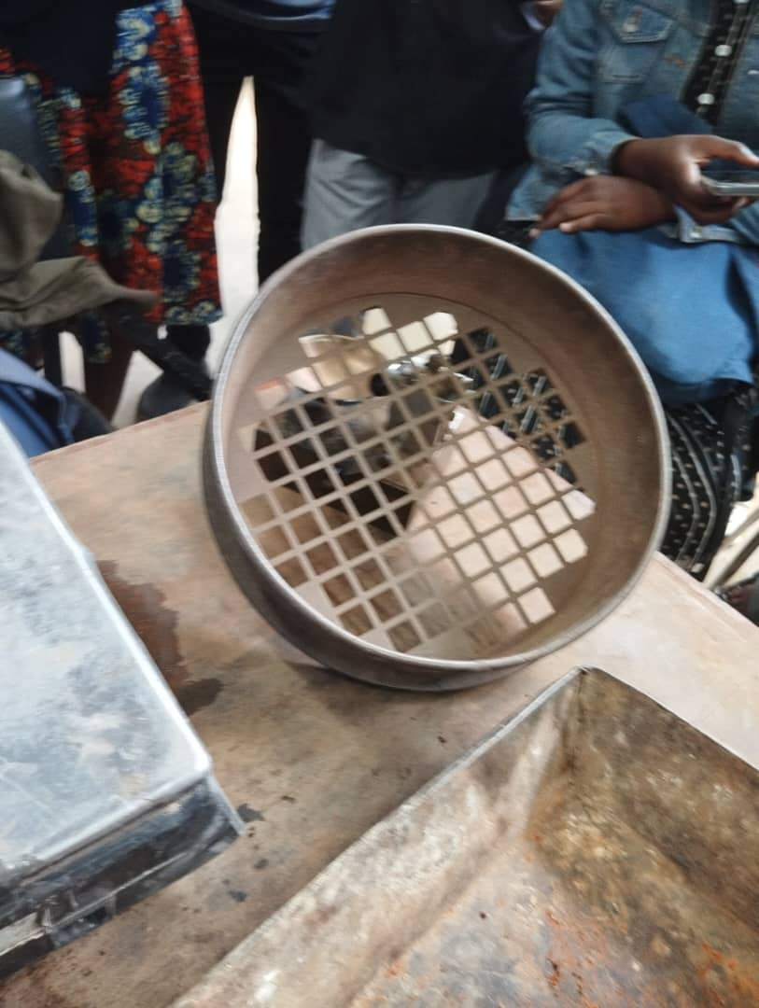

Figure 1a 20mm sieve

1. The soil that passed through the 20mm sieve was then put into a pan and it was divided into two equal portions using a riffle splitter or **quartering method**.

One portion was selected for wet sieving and its mass was measured and recorded as **MASS 3(M3).**  This mass was found as **691.81g**

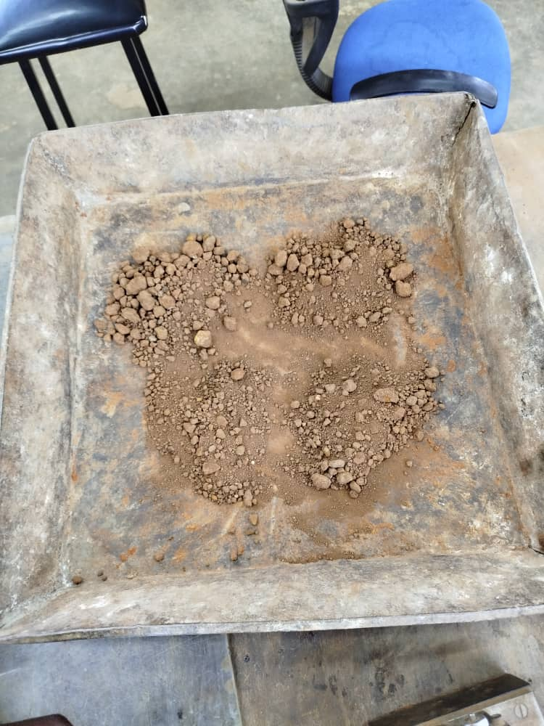

1. The soil sample of **MASS 3 (M3)** was then soaked in water for at least 4 hours to allow for complete dispersion of particles. After soaking in water, the sample was washed thoroughly using distilled water over a 0.075mm or 75µm sieve until the wash water was clear, with a minimum of 5-6 wash cycles.
2. The washed sample was then oven dried at a temperature of 105°C ± 5°C for 24 hours to ensure complete drying.
3. After drying in the oven for 24 hours, the dried soil was then weighed on a digital balance with a precision of ±0.01g, and its mass was recorded as **MASS 4(M4).**
4. The oven dried sample **MASS 4(M4)** was then subjected to mechanical sieving using standard sieves arranged in decreasing order of size, beginning with the 4.75mm sieve down to the 75µm sieve, and a pan was the at the bottom. The sieves were shaken for a duration of 10-15 minutes to ensure thorough separation. The mass retained on each sieve was measured and recorded using a digital balance.
5. Then the results were recorded.
   1. **RESULTS AND CALCULATIONS**

The results of this test were collected and presented in a tabular form for easy comprehension and are as follows;

|  |  |  |  |  |  |  |  |  |  |  |
| --- | --- | --- | --- | --- | --- | --- | --- | --- | --- | --- |
| |  | | --- | |  | | | | | | | | |  |  |  |
|  |  |  |
|  |  |  |
|  | | | | | | |  |  |  |
|  | | | | | | |  |  |  |
|  |  |  |  |  |  |  |  |  |  |
|  | | | | | | |  |  |  |
|  | | | | | | |  |  |  |
|  | | | | | | |  |  |  |
| **SAMPLE BY** |  | | | **REPORT DATE** |  | |  |  |  |
| **PROJECT SITE** |  | | | **TESTED BY** |  | |  |  |  |
| **SOURCE** | ELLIOT BORROW PIT 2 | | | **TEST METHOD** | BS 1377 - PART 2 : 1990 | |  |  |  |
|  | | | | | | |  |  |  |
| Initial |  |  | Mass Retained (g) | | Percentage | Cumulative |  |  |  |
| Dry Mass (g) |  |  | Actual | Corrected | Retained | % Passing |  |  |  |
| ***m1*** | **1738** |  | *318* | *m* | *(m/m1)*x*100* |  |  |  |  |
| 75.0 | mm |  |  |  |  |  |  |  |  |
| 63.0 | mm |  |  |  |  |  |  |  |  |
| 50.0 | mm |  | 0.0 | 0.0 | 0.0 | 100 |  |  |  |
| 37.5 | mm |  | 0.0 | 0.0 | 0.0 | 100 |  |  |  |
| 20.0 | mm |  | 0.0 | 0.0 | 0.0 | 100 |  |  |  |
| Passing 20 | mm | ***m2*** | 1599 |  |  |  |  |  |  |
| Total |  | ***(Check with m1)*** | 1738 |  |  |  |  |  |  |
| Riffled |  | ***m3*** | 692 |  |  |  |  |  |  |
| Riffled and washed | | ***m4*** | 423 |  |  |  |  |  |  |
| **Correction factor** | | ***(m2/m3)*** | **2.3115** |  |  |  |  |  |  |
| 14.0 | mm |  | 0.0 | 0.0 | 0.0 | 100 |  |  |  |
| 10.0 | mm |  | 0.0 | 0.0 | 0.0 | 100 |  |  |  |
| 5.0 | mm |  | 79.4 | 183.4 | 10.6 | 89 |  |  |  |
| Passing 5.0 | mm | ***m5*** | 344 |  |  |  |  |  |  |
| Total |  | ***(Check with m4)*** | 423 |  |  |  |  |  |  |
| Riffled |  | ***m6*** | 692 |  |  |  |  |  |  |
| **Correction factor** | | ***(m2/m3)x(m5/m6)*** | **2.3115** |  |  |  |  |  |  |
| 2.36 | mm |  | 120 | 278.3 | 16.0 | 73.4 |  |  |  |
| 1.18 | mm |  | 87 | 200.7 | 11.5 | 61.9 |  |  |  |
| 0.600 | mm |  | 53 | 121.5 | 7.0 | 54.9 |  |  |  |
| 0.425 | mm |  | 0 | 0.0 | 0.0 | 54.9 |  | 415 |  |
| 0.300 | mm |  | 0 | 0.0 | 0.0 | 54.9 |  |  |  |
| 0.212 | mm |  | 48 | 111.9 | 6.4 | 48.5 |  |  |  |
| 0.150 | mm |  | 11 | 24.6 | 1.4 | 47.0 |  |  |  |
| 0.075 | mm |  | 16 | 36.2 | 2.1 | 45.0 |  |  |  |
| Passing 0.075 | mm | **(Pan)** | 1 | 2.4 | 0.1 | 44.8 |  |  |  |
| **Grading Modulus** | | **GM** | |  | | --- | |  | | | | | **1.27** |  |  |  |
|  |  |  |

|  |  |  |  |
| --- | --- | --- | --- |
| |  | | --- | | SIEVE ANALYSIS  PSD CHART | | |  | | --- | | THE MUBAS - DEPARTMENT OF CIVIL ENGINEERING | |

BS 1377 : Part 2 - 1990

|  |  |  |  |
| --- | --- | --- | --- |
| CLIENT | 0 | DATE OF REPORT | 00 January 1900 |
| SOURCE | ELLIOT BORROW PIT 2 | TESTED BY | 00 January 1900 |

10

20

30

40

50

60

70

80

90

100

0.001

0.010

0.100

1.000

10.000

100.000

1000.000

Percentage Passing (%)

Particle Size (mm)

|  |  |  |  |  |  |  |  |  |  |  |  |
| --- | --- | --- | --- | --- | --- | --- | --- | --- | --- | --- | --- |
| Clay | Silt | |  | Sand | |  |  | Gravel |  | Cobbles | Boulders |
|  | Fine | Medium | Coarse | Fine | Medium | Coarse | Fine | Medium | Coarse |  |  |
| <0.002 | 0.002-0.006 | 0.006-0.02 | 0.02-0.06 | 0.06-0.2mm | 0.2-0.6mm | 0.6-2mm | 2-6mm | 6-20mm | 20-60mm | 60-200mm | >200mm |

* 1. **CALCULATIONS**

The sieve analysis revealed a cumulative retention pattern dominated by finer particles, with minimal retention on coarser sieves. After the results were used recorded the **GRADING MODULUS (GM)** was calculated as it is the main aim of this test. This **GM** was calculated using the Formula;



The **GRADING MODULUS (GM)** was found to be **1.27**

1. **DISCUSSION AND DATA ANALYSIS**

After calculation a **grading modulus of 1.27** obtained from the wet sieve analysis which in our case indicates a soil predominantly composed of fine particles, particularly silts and clays. This value falls below the typical range of 1.5–2.5, which can used to classify moderately graded soils suitable for sub-base or general fill applications. A grading modulus below 1.5 suggests poor gradation and limited coarse content, which correlates with low permeability and potentially high plasticity. This wet sieving method was conducted in accordance with **BS 1377-2:1990,** which ensures that only the fine fraction (passing 0.425mm sieve) was retained for Atterberg limit testing, thereby eliminating the influence of non-plastic coarse particles. This procedural step is critical for accurately assessing the soil’s plastic behavior, as coarse particles can disturb Liquid limit and Plastic Limit results if not removed. This low grading modulus supports the classification of the soil as fine-grained, and the consistency of the sieving process enhances the reliability of the Atterberg limit results.

1. **CONCLUSION**

From the wet sieve analysis conducted a grading modulus of 1.27 was obtained which has confirmed that the soil’s classified as fine-grained. This result shows the effectiveness of the wet sieving procedure in isolating the plastic fraction of the soil, which is crucial for accurate determination of Liquid and Plastic Limits values. The outcome reflects the soil’s likely behavior under varying moisture conditions, including its potential for shrink-swell activity and reduced drainage capacity. By adhering to **BS 1377-2:1990** standards, the test ensures that the data generated can be both reliable and suitable for engineering analysis. But all in all, the grading modulus serves as a quantitative indicator of the soil’s texture and supports its classification for further geotechnical evaluation.

1. **RECOMMENDATIONS**

From the results obtained, several recommendations can be realized and some of them are as follows;

1. Avoid using such fine-grained soils in drainage-sensitive applications without modification, due to their low permeability and potential for shrink-swell behavior.
2. Normalize the use the particle size distribution and grading modulus data in foundation design**,** road base selection, or concrete mix design to ensure safe and durable construction.
3. Use the grading modulus as a screening tool in future investigations to quickly assess soil texture and suitability for engineering purposes
4. Make it a point to recognize that soils with a grading modulus below **1.5** may require stabilization before use in structural or pavement layers.

**REFERENCES**

* **BS 1377-2:1990**: Methods of test for soils for civil engineering purposes – Part 2: Classification tests. British Standards Institution (BSI).
* **ASTM D6913 / D6913M-17**: Standard Test Methods for Particle-Size Distribution (Gradation) of Soils Using Sieve Analysis. ASTM International.
* **ASTM D422-63(2007) e2**: Standard Test Method for Particle-Size Analysis of Soils. ASTM International.