Faculty of Information and Communication Technology
Department Computer Science
 | ISC216D  PROJECT PRACTICALS - 20252
Examiner: KA Phuduhudu
Total: 75 + 10
Due Date : TBA

The objectives of the tasks are:
- To build an Information gathering machine.
- To find information about Operating System.
- To find information about devices on your Local area network.
- To connect to a server, find files and execute hidden steps

NB: the last task will also be used as a register – those students who did not do that task will get 0, even if their names have been included as part of the group.

TASK 1: SETTING UP INFORMATION GATHERING TOOL [35

- Download kali-linux-2025.2-installer-amd64.iso and install it under VirtualBox as follows. Use the excel file to determine the sizes of your Virtual Box VDI file, and all sizes specified below. (You may download it from myTUTorD2L) –
ENTER EACH GROUP MEMBER'S STUDENT NUMBER IN THIS COLUMN
StudentNumber | StuNum-Digits Sum
213456700 | 28
213936737 | 41
 | #VALUE!
100% OF VDI DRIVE SIZE in GB IS | 69
USE 25% FOR ROOT PARTITION SIZE (/ ) in GB | 18
USE 20% FOR HOME PARTITION SIZE (/home) in GB | 14
USE 5% FOR SWAP PARTITION SIZE (/swap) in GB | 4

Make this ScreenShot1 and put in your PowerPoint (5+5+5+5
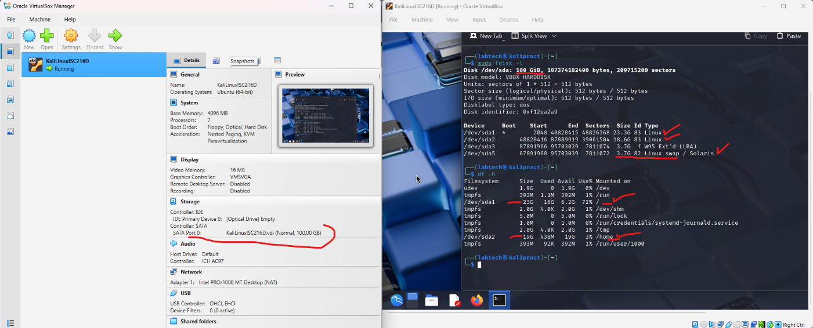

- NB: The Total hard disk size and the partitions must be have same exact size as indicated – use the excel sheets to get exact sizes.
- NB: This is meant to ensure that students create their own Linux VDI image from scratch.
- If a group member left the group after the VDI has been created – clarify that so their marks can be reduced

- Demonstrate how to use any two of the tools in two of the 16 categories except 16 – services and others grouping and nmap. ScreenShot2 (5
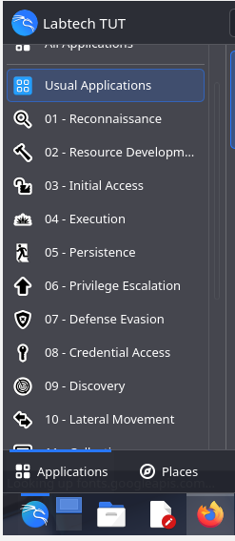 | NB: Don’t just open the tools but use them to achieve their typical use and make screenshot of the results – including a 4-line description of each.  For each demonstration of the tool, use one or two screenshots to proof that.  ScreenshotA & ScreenshotB

- Use Ventoy tool to run Hiren Boot CD from your USB flash drive. Then boot your laptop using Hiren Boot CD.
  - Make two screen shots ScreenShot3a/3b showing how to Reset a Lost Passwords. (5
  - Make two screen shots ScreenShot4a/4b showing how to Remove Malware and Viruses. (5

TASK 2: Target Enumeration and Port Scanning [25

- Scan Devices using Mobile Fing app
  - Connect 3 or more mobile phones to a Wifi LAN (not eduroam) (you may even try using mobile hotspot).
  - On one of the phones, install Fing App, then scan to see all devices you can see on that WLAN.
Make ScreenShot5 (5

- Scan Devices using a simple Windows Based application
  - In one of TUT labs, use the “Angry IP Scanner” to check how many PC in a LAN have Web Service running or File share running.
  - In one of TUT labs, use any two of the tools shown in this link: https://www.majorgeeks.com/mg/sortdate/networking.html
Give a 2-4 line explanation of what the tool does, and a screen shot of the results obtained when using the tool. ScreenShot6 (5

- On one of the PC – in the Lab or your laptop or anywhere:
  - Search, download and install LanSweeper tool.
  - Setup a username and password that can be used to scan PC in the labs – the username and password must be like the one being used by PCs in the lab/LAN
  - Scan the LAN and show how many network devices are discovered: Switches, Windows PC, Linux PC, etc.
Make ScreenShot7 (15

TASK 3: SIMULATING SOME OF THE TASKS IN from CSC.AC.ZA [15

- This task is simulating some of the tasks mentioned in : https://overthewire.org/wargames/bandit/bandit0.html
  - While on any TUT LAN, eduroam or using VPN, use ssh under Windows or Linux, to connect to emalabserv (you may find its IP address).

Each Member of the group must do this task using their login details. For each user, the username is StudentNumber password is Power99! (10

  - Find a file named 20steppass25 located somewhere in the Linux OS hierarchy system. You may use find, exec and cp command to find and copy the file to your home directory. You may use cat to open it and read the instructions therein! (5

