Faculty of Information and Communication Technology
Department Computer Science
 | ORS216D  PROJECT PRACTICALS - 20252
Examiner: KA Phuduhudu
Total: 100 - Due Date : TBA

TASK 1: RUNNING OTHER LINUX-BASED OS LIVE [20
NB: This Task will be also used to validate members of a group. If the pictures taken do not show all group members – 15 marks will be deducted from this task.
- Demonstrate your skill for running a that you can run install or run any Linux-based OS from.
  - Install Ventoy Tool in a USB Drive that has 16GB or more capacity
  - Use a Make three screen shots 2a/2b/2c showing how to Reset a Lost Passwords.
  - Download PrimeOS (the version suitable for your laptop) from Internet Download | PrimeOS or from \\168.172.155.233\softwares\iso (only within TUT Network) – safe that in the USB Drive’s larger partition.
  - Configure your laptop to boot from that USB Drive (the one running Ventoy tool). Boot Laptop to run PrimeOS live (Do not Install) – then:
    - Take one picture showing all group members holding that laptop running PrimeOS – all group members must appear in that Picture.
    - Use that picture as a wall paper for PrimeOS (if its possible) then make screenshot of that PrimeOS Desktop.
  - Configure your laptop to boot from that Ventoy USB Drive. Boot Laptop to run PrimeOS live (Do not Install) – use the picture from previous step as a wall paper(if its possible) from PrimeOS Desktop. ScreenShot2 (10
  - Write one paragraph explaining what PrimeOS will be suitable for and another paragraph explaining what EndlessOS will be suitable for?
ScreenShot3 (5+5

TASK 2: SETTING UP INFORMATION GATHERING TOOL [20

- Download ANY LINUX DISTRIBUTION and install it under VirtualBox as follows. Use the excel file to determine the sizes of your Virtual Box VDI file, and all sizes specified below. (You may download it from myTUTorD2L) –
ENTER EACH GROUP MEMBER'S STUDENT NUMBER IN THIS COLUMN
StudentNumber | StuNum-Digits Sum
213456700 | 28
213936737 | 41
 | #VALUE!
100% OF VDI DRIVE SIZE in GB IS | 69
USE 25% FOR ROOT PARTITION SIZE (/ ) in GB | 18
USE 20% FOR HOME PARTITION SIZE (/home) in GB | 14
USE 5% FOR SWAP PARTITION SIZE (/swap) in GB | 4

Make this ScreenShot4 and put in your PowerPoint (5+5+5+5
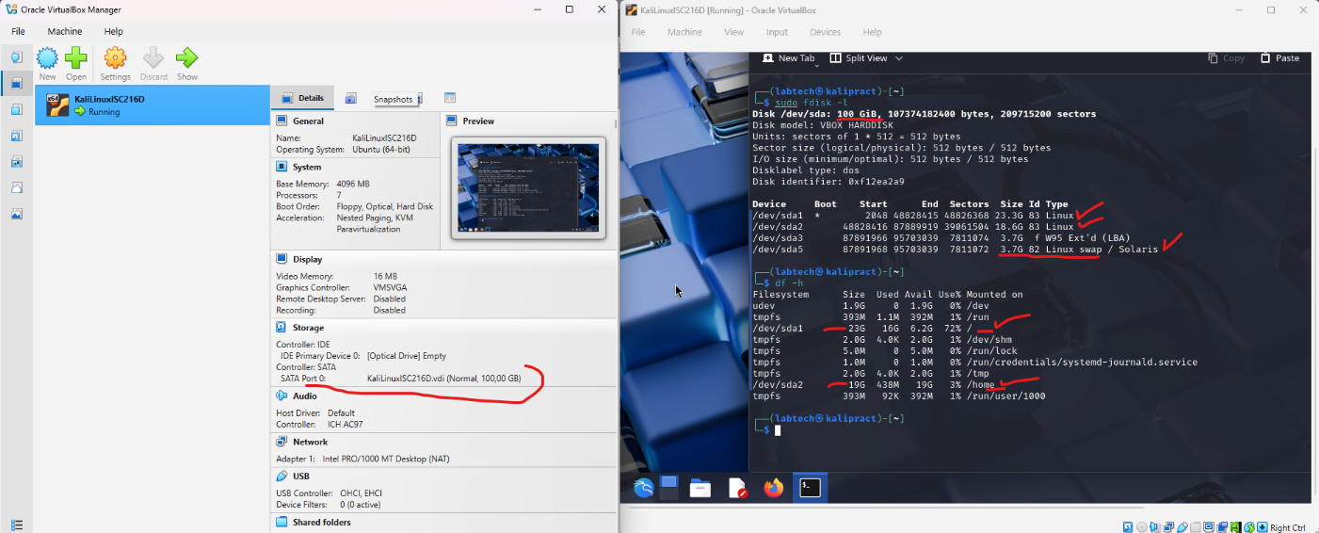

- NB: The Total hard disk size and the partitions must be have same exact size as indicated – use the excel sheets to get exact sizes.
- NB: This is meant to ensure that students create their own Linux VDI image from scratch.
- If a group member moves a different group after the VDI has been created – clarify that so their marks can be reduced

TASK 3: PARTITION AND USERS [30

- Using the remaining 50% of the hard disk size to create the following partitions and mount them as specified:

  - Create a partition that is 20% of the hard disk size, format it as ReiserFS and mount it as /ekhaya, primary partition
  - Create a partition that is 10% of the hard disk size, format it as NTFS and mount it as /storage, logical partition
  - Mount all these partitions!
Make ScreenShot6 similar to this- to show your partitions (10
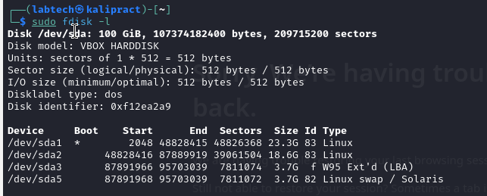

Make ScreenShot7 similar to this- to show mounted partitions (05
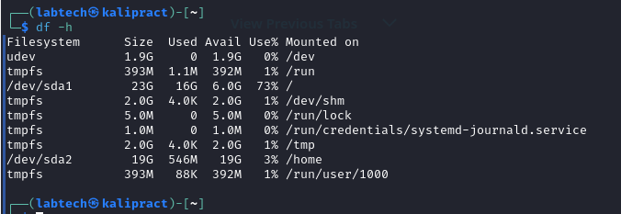

  - Create a group named NameGroup25S2 whose group ID is 2025.
  - Create a user for each of your group members as specified below:
Username | Shell | Default home | Main group | Additional group | Full Name
uSTUNUM  (e.g. u213456789) | /bin/bash | /ekhaya/ uSTUNUM | NameGroup25S2 | sudo | Surname_INIT

Make ScreenShot8 similar to this- to show all group members – it might be several screenshots ScreenShot8a, ScreenShot8b,… (10
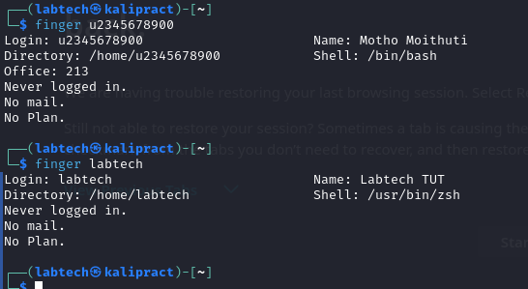

Make a ScreenShot9 similar to this- to show all group members – it might be several screenshots, ScreenShot9a, ScreenShot9b,… (5
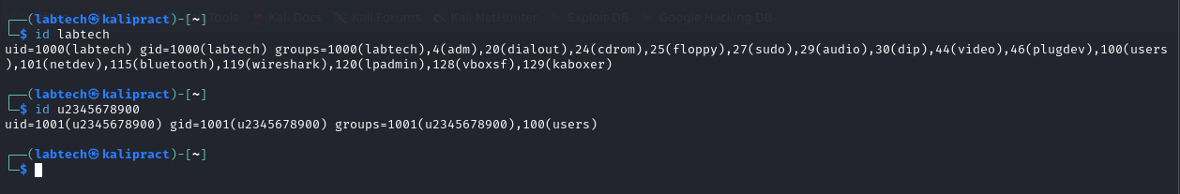

TASK 4: INSTALL SERVERS [3X10 = 30

- Install any three applications from any three of the four categories below. Use any method to install:
  - Learning Management System
    - Moodle
    - sakai
    - (or any Learning Management System)
  - Web Based System Management tool
    - Webmin
    - Usermin
  - Webservers
    - NGINX
    - Apache webserver
    - (or any Webserver)
  - SQL Database server
    - Mysql/mariadb
    - Microsoft MSSQL
  - Content Management System
    - Joomla
    - Plone
    - Freetube
    - Invidious
    - Plesk

Make three screeshots [ ScreenShot10, ScreenShot11, ScreenShot12) showing you running the three applications you installed. Put all screenshots in one presentation and upload – only ONE MEMBER OF THE GROUP MUST UPLOAD

~~~~~END OF QUESTION PAPER~~~~~

