Chosen Domain: Schedule Planner & Tracker
The idea is to create a way to plan out time and figure out how much of each project you can work on during the week. There will also be a way to add non-project related things like work, school, and sleep to get a rough estimate of your weekly breakdown. This can also be used to help plan out the week and make sure that each item has plenty of time to keep it moving forward.
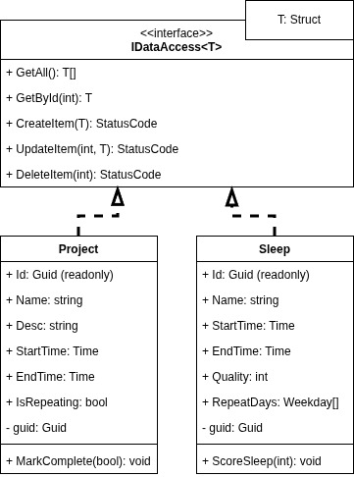
Current Diagram:

Code:
