📊 BI Consulting Portfolio
Client: AdventureWorks
Consultant: Colton Staggs
Course: IT420 – Business Intelligence
Date: December, 2025

📑 Table of Contents
- Front Matter
- Executive Summary
- 1. Data Audit & Initial Assessment (Week 1)
- 2. ETL Foundations & Data Cleaning (Week 2)
- 3. Warehouse Design & Schema Draft (Week 3)
- 4. OLTP vs OLAP Rationale (Week 4)
- 5. Executive Report Packet (SSRS – Static) (Week 5)
- 6. Interactive Reports (SSRS – Drill-Down & Parameters) (Week 6)
- 7. Baseline Dashboard (Power BI) (Week 7)
- 8. Storytelling Dashboard (AdventureWorksDW2022) (Week 8)
- 9. Multi-Page Executive Dashboard (Week 9)
- 10. Predictive Insights Dashboard (Week 10)
- 11. Final Handoff: Consulting Portfolio & Presentation (Week 11)
- Back Matter
- Final Recommendations for the Client
- Reflection on Professional Growth

📄 Executive Summary
The Business Intelligence was brought on to describe a process and provide a solution. We achieve that by making the data we are given translate to our needs. It is not safe for us to assume that the data is in a valid state when we arrive for the consultation.
Since it is the client who is requesting a solution, we reserve the right to provide suggestions as a result of our inquires and analysis. The client also has the right to ignore these recommendations, however they are done so at the risk of the client.
We request transparency and quick responses to our inquiries in order to provide an accurate and intuitive solution to your requested problem. As we request transparency, we shall also be held accountable and transparent in our part of the process. As such, here will be described the steps of our analysis.
Extracting from source. We have to first begin by collecting the data from the client and creating a copy that we can then use for further analysis.
Transforming the Extraction. We then have to ensure the data is devoid of errors and missing information. Either by defining a default value which can lead to skewed data in some instances, or by inquiring for more information to fill the empty spaces. This step then includes the shifting of the data to fit the expected structure that reflects what is best for the further analytical operations.
Loading the Transformation. We finally have to upload the data to our provider of choice. This makes it simple to then create operations that allow the client to see what they requested at both a high level and a low level if they so desire.
Preparing a report. In order to continue with the full transparency, we will provide a unaltered report of the data as a result of the ETL process (The first three steps we provided above). This report will contain the unaltered data in its most basic form.
Creating a dashboard. As a part of this analysis, we create an interactive dashboard that allows the client to look at their data, and get updated reports as time progresses and analytics change. This will allow the client to continue to make informed decisions, and see the process of their company grow. This dashboard will contain as much or as little information as is requested to be displayed towards the solution, and will be in a format that is simple to operate and interpret.
Receiving the Recommendations. At the end of this analytical process, the client will receive a list of recommendations to solve the problem, along with a description of the process we took to make them. They may also contain some additional insight if we believe that it is required, or optimal to move towards the provided solution.

Week 1 – Data Audit & Initial Assessment
Deliverables: Data Audit Memo, initial SQL imports.
Key Findings: Missing data across multiple files, Misspellings, Inconsistent Data.
Evidence:
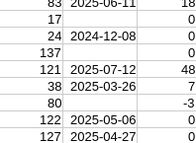
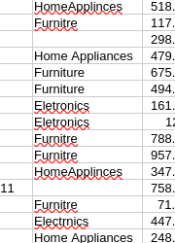
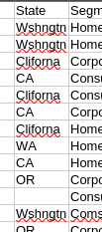

Week 2 – ETL Foundations & Data Cleaning
Deliverables: SSIS ETL package, cleaned staging tables.
Key Actions: Swap misspellings for correct items, unify inconsistencies, auto fill certain missing data.
Evidence:
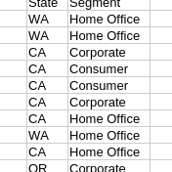

Week 3 – Warehouse Design & Schema Draft
Deliverables: Star Schema DDL + ERD diagram.
Fact & Dimension Tables: FactSales, DimProduct, DimCustomer.
Evidence:
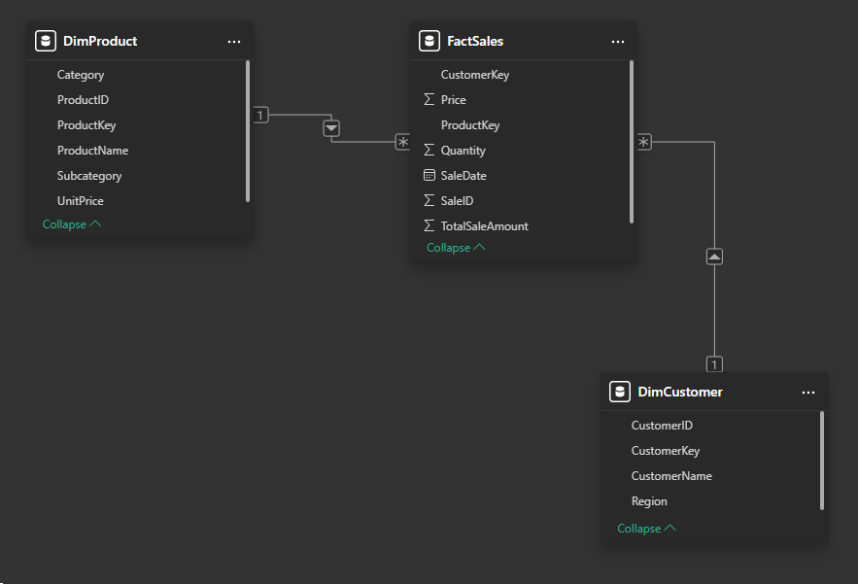

Week 4 – OLTP vs OLAP Rationale
Deliverable: Written memo comparing OLTP vs OLAP.
Key Point: OLTP stitches multiple tables together, OLAP stitches them to the fact table.
Evidence:
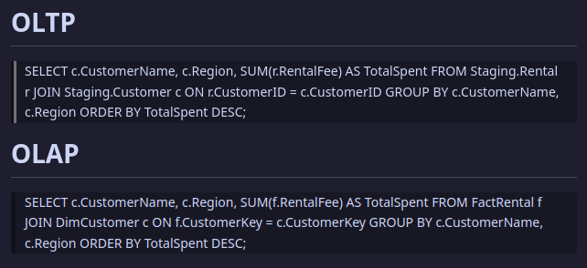

Week 5 – Executive Report Packet (SSRS – Static)
Deliverables: SSRS `.rdl` files + PDF report packet.
Highlights: #1 item is smartphone 7, Kentucky holds #1 in profit.
Evidence:
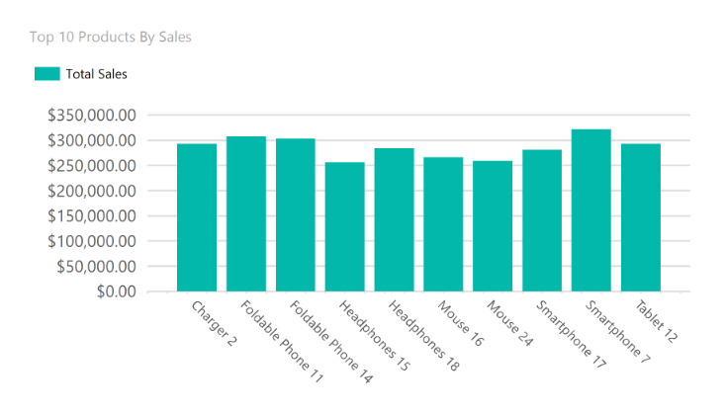

Week 6 – Interactive Reports (SSRS)
Deliverables: Drill-down and parameterized SSRS reports.
Example: Interactive feature was the ability to expand data by region.
Evidence:
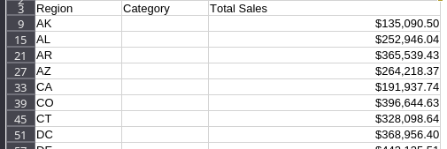
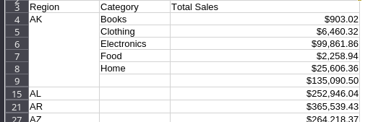

Week 7 – Baseline Dashboard (Power BI)
Deliverables: First Power BI dashboard (`.pbix`, PDF).
Content: KPI Card, Treemap, Year button slicer, Month button slicer
Reflection: Difference is consolidation vs full list.
Evidence:
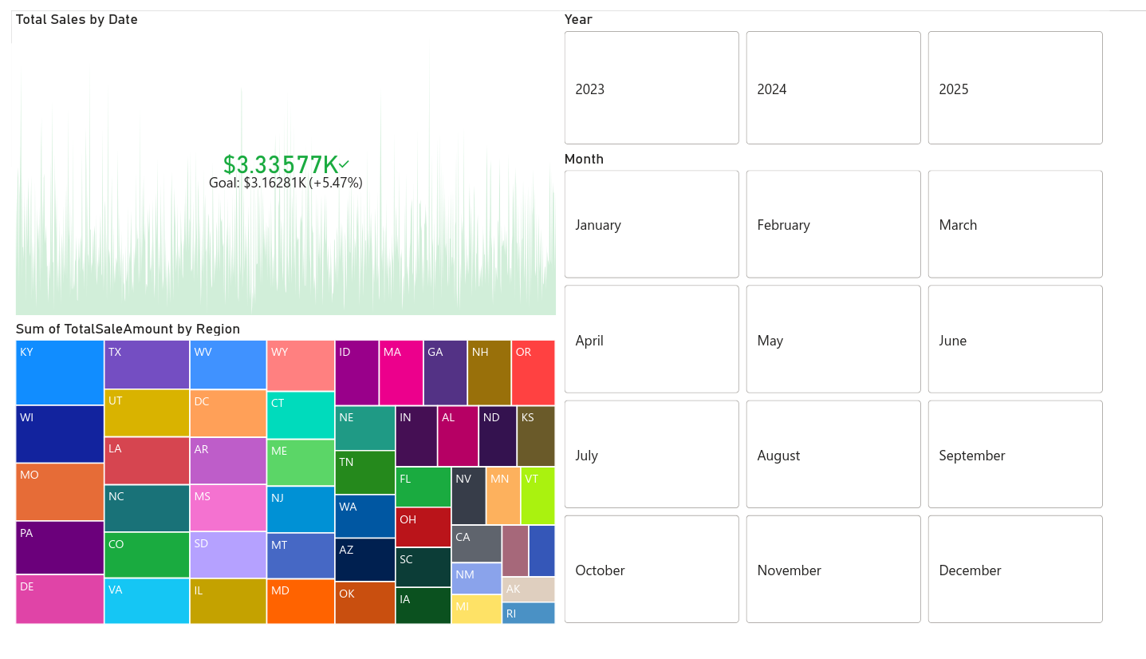

Week 8 – Storytelling Dashboard (AdventureWorksDW2022)
Deliverables: Enhanced dashboard (`.pbix`, annotated PDF, video walkthrough).
Focus: Customers.
Story Arc: Customers had a spike in Jan 2013, which was evenly spread through regions.
Evidence:
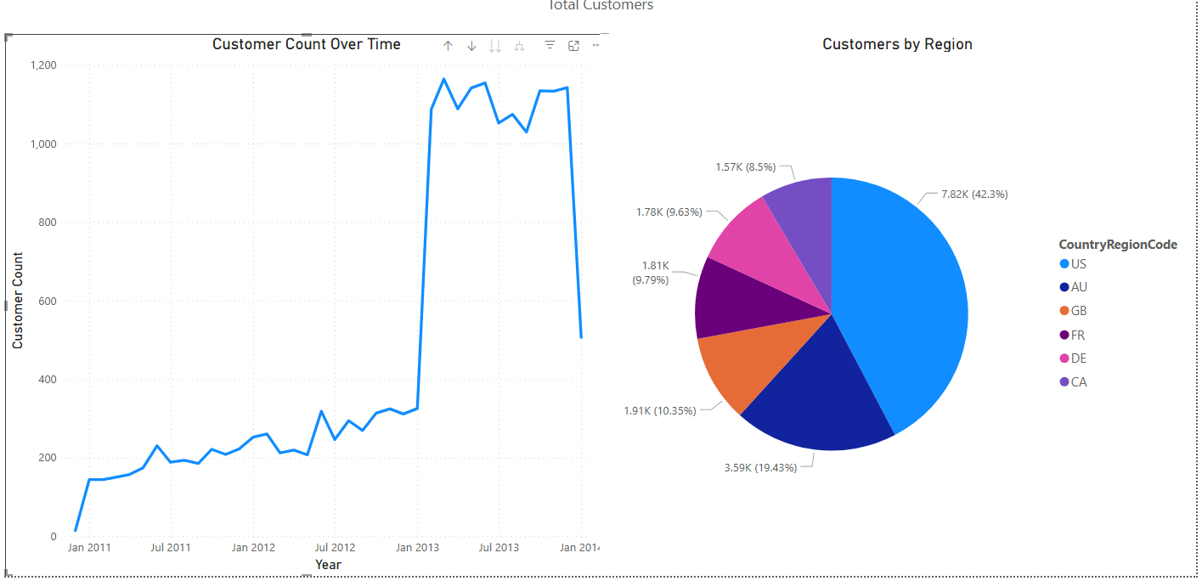

Week 9 – Multi-Page Executive Dashboard
Deliverables: Multi-page dashboard (`.pbix`, PDF packet).
Pages: Overview, Reseller Data, Internet Data, Data over time
Navigation: Each page had a back button, the main page included 3 buttons. Left went to internet data, middle went to data over time, right went to reseller data.
Evidence:
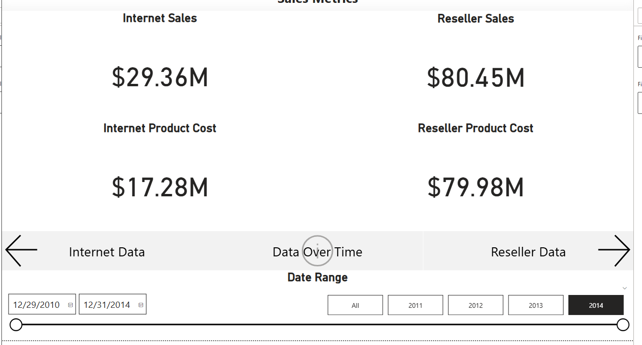

Week 10 – Predictive Insights Dashboard
Deliverables: Dashboard with clustering + classification (`.pbix`, PDF).
Clustering: One with high total sales, one with high total order count, and one where they are both low.
Classification: High Flow items, High Revenue items, Low flow & Low Revenue items.
Strategic Insight: Gives a quick contrast between the money makers and the fan favorite.
Evidence:
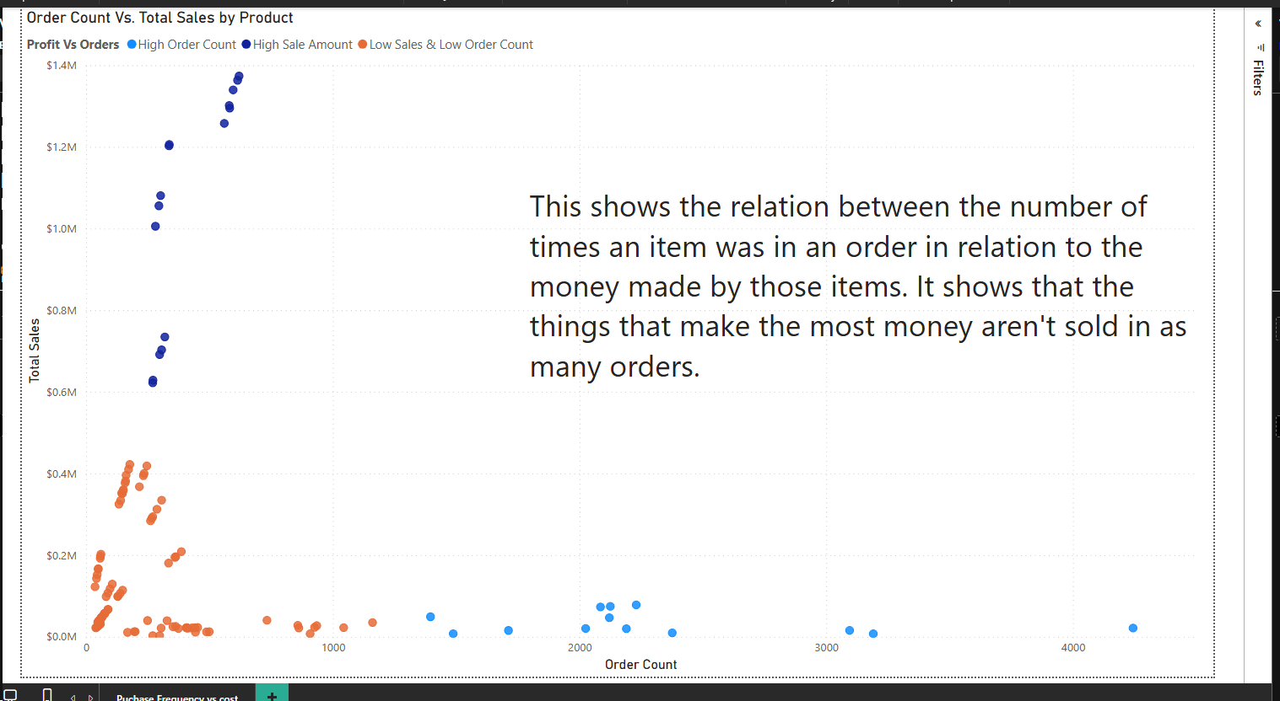

Week 11 – Final Handoff: Consulting Portfolio & Presentation
Deliverables: This portfolio document, organized artifact folder (SQL scripts, SSIS packages, SSRS `.rdl`, Power BI `.pbix`), and recorded presentation.
Evidence:
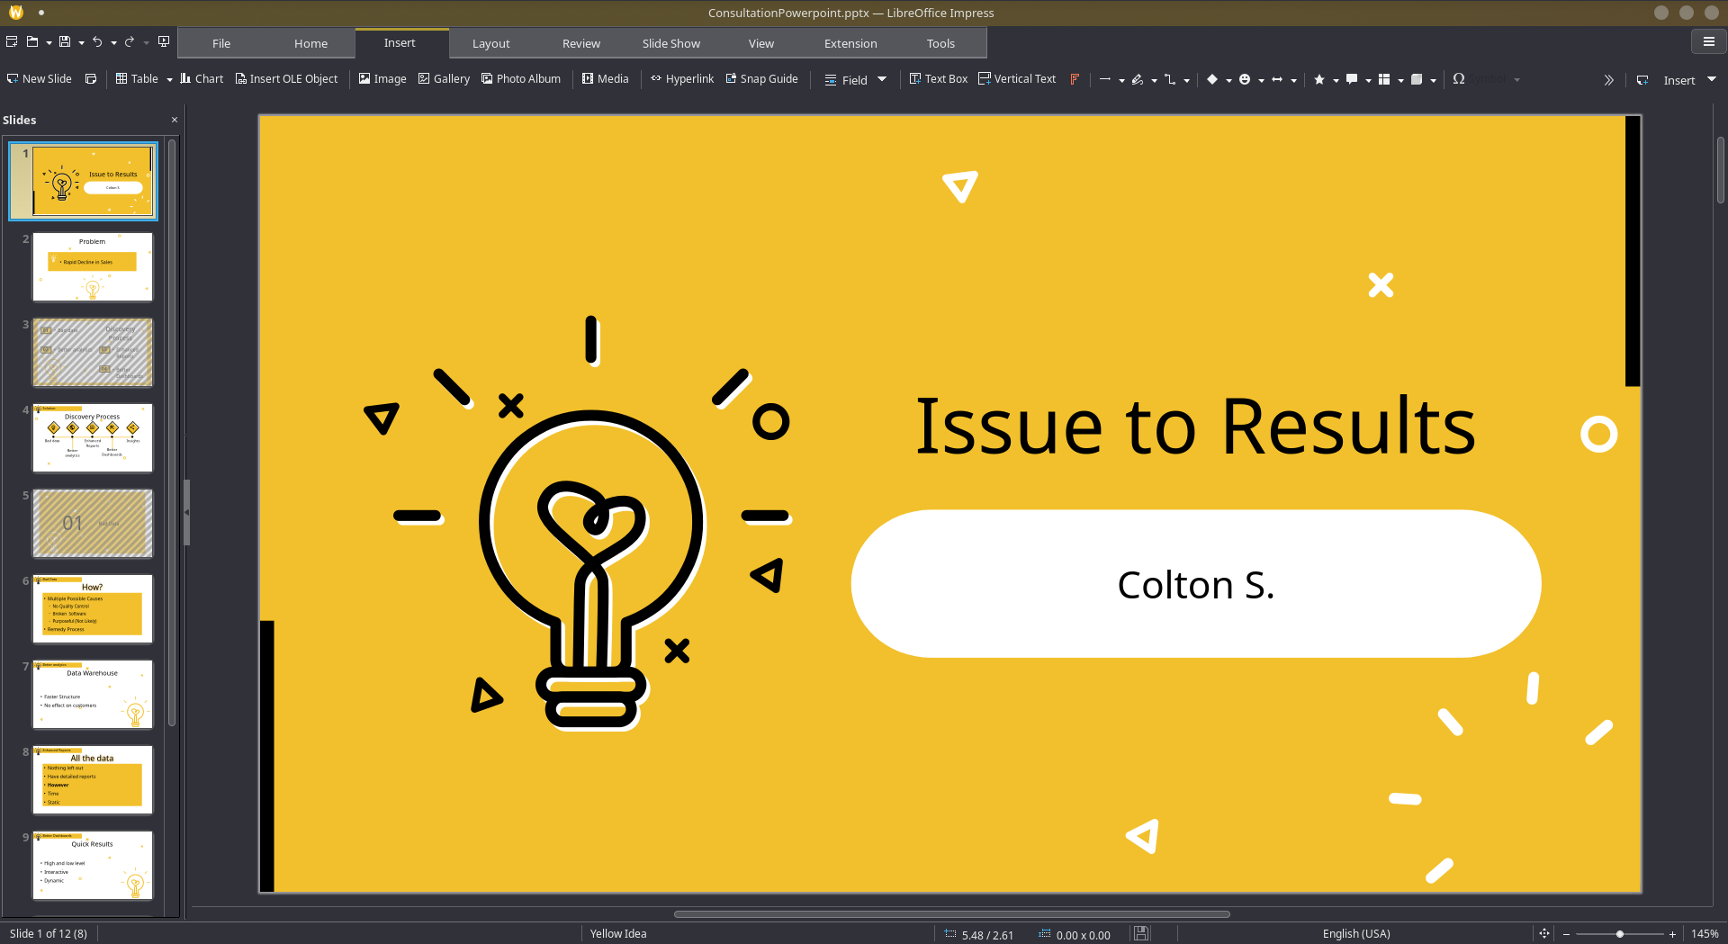

📌 Final Recommendations for the Client
Some simple avenues to look into.
- Increasing the customer base will increase the number of orders.
  - Look for items similar to those in high demand.
- Getting more money making items to have a more stable source of revenue.
  - Having a few high value items makes you too susceptible to a sudden crash.
- Look at competitors, what are they making money from, can you sell that too?
  - Often competitors are making money from better deals or exclusivity (Items that no one else has).
- Spread out variety of items if possible.
  - Bikes may be the main selling point, but is there a market for scooters? Maybe there is plenty of rides, but not enough safety items for them.

📝 Reflection on Professional Growth

Where I was. I started this quarter knowing nothing about the process of consultation, or business intelligence. With this little knowledge I also believed that the process of consultation more or less involved a third party looking at your company and providing a suggestion.
What I know now. I know now that a person partaking in business intelligence not only perceives the data and provides suggestions on the data, but also takes action to correct, transform and sustain it. They go through the process of ensuring the data is devoid of inaccuracies, in an expected format, and provides a way for the old data to be corrected for the new format whenever there is new items amended (This is what I mean by sustaining the data). They use tools like SSIS to provide a platform that is constantly updating the data used by further steps, from the data in its most primitive form. They then use tools like SSRS to create a transparent report that holds a copy of all the data in its corrected form. It is used as a bit of backing information to show that their analysis is correct based on the information provided. They then use tools like PowerBI to create an interactive platform that non consultation members can still use to access data even after it updates. It adapts to new introductions and only needs minimal changes when major reformations happen.
In addition to the knowledge, there was also the experience gained from using the tools to provide an ends to our needs. During this quarter, we had started with SSIS. SSIS had its quirks that made it a very difficult tool to learn and fix when bugs arose. While the graph based implementation of data translation and loading makes it very user friendly for those who do not program. It seems to hide some of the required information when encountering new things or handling issues. There was a multitude of items that had help buttons that redirected to help pages that no longer existed. In contrast to SSIS, the next tool we gained experience with using was SSRS. SSRS has many improvements over its sister software, but it was made for a differing purpose. Its goal is to create a report that can be printed and handed between people easily. There is not much else I can say on it other than that as most of our experience was not beyond the simple applications. Finally, the last tool we gained experience in was PowerBI. PowerBI is the dashboard building software that allows us to take our data and create a story based on the information we want to show. It can be setup in both a desktop and mobile configuration and can support multiple interconnected pages. It is almost akin to building a web page that hosts the results of the data provided to it, along with updating that data to reflect any changes made to the source.
In terms of communication, I believe I have gotten a minimal amount better. This is because I can more easily translate certain technical jargon into more non technical terms.
In future endeavors, I am unsure how much I will use what I learned from this class in applications of my target career. This is because my target career is more towards design rather than consultation and analysis.

