MEMORENDUM

To: Lenore Montalbano
From: Colton Staggs
CC: HR

Subject: Plan for meeting
The plan for this meeting is to begin by showing the most prevalent information for the meeting. I.E. If the sales by region are more important for the meeting, they will be shown first

If there is no importance of items for the meeting, then they will be shown in the order of products then by regions, and probably a product by region if needed (Not included).

Hopefully that will keep it quick

Colton
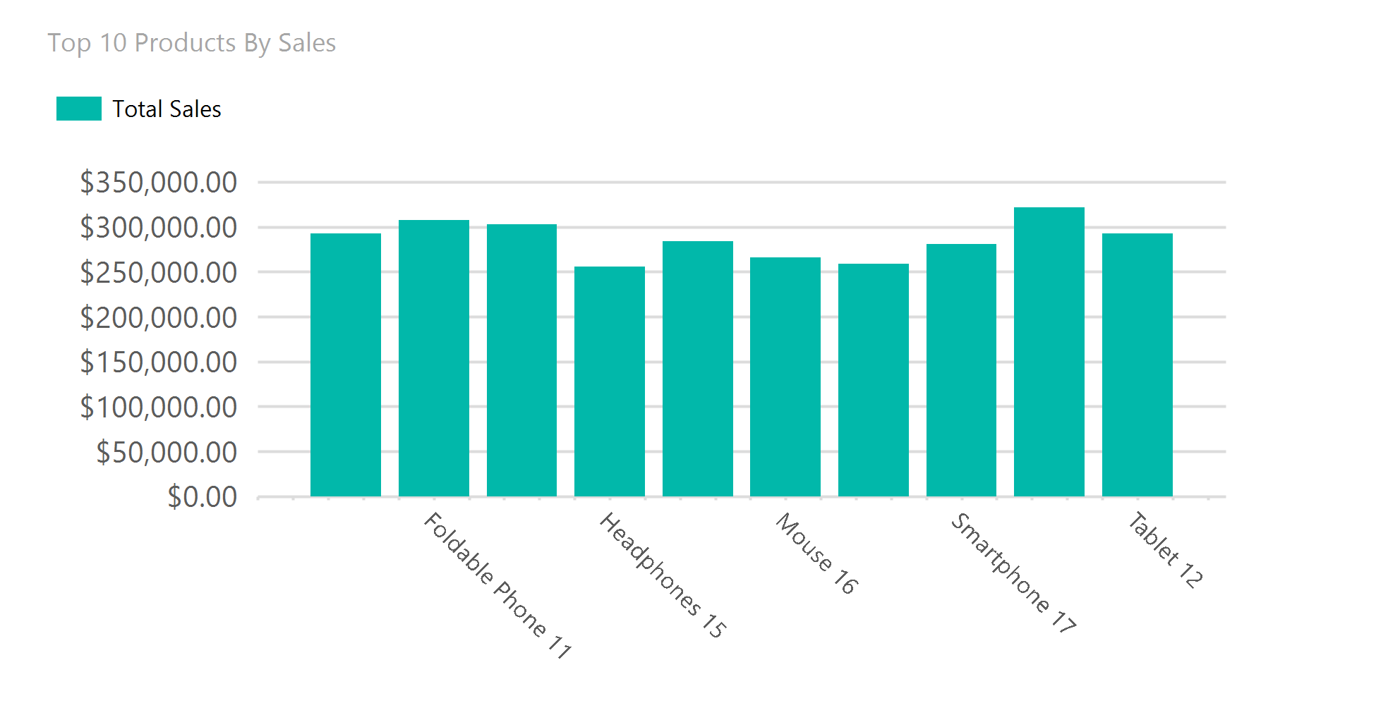
Couldnt get all of the labels to show
Total Sales By Region
Region
Total Sales
AK
$135,090.50
AL
$252,946.04
AR
$365,539.43
AZ
$264,218.37
CA
$191,937.74
CO
$396,644.63
CT
$328,098.64
DC
$368,956.40
DE
$442,135.51
FL
$227,471.12
GA
$291,676.19
HI
$139,551.12
IA
$206,533.45
ID
$292,915.36
IL
$354,001.41
IN
$258,747.18
KS
$234,562.77
KY
$580,926.98
LA
$411,961.54
MA
$292,864.07
MD
$309,687.05
ME
$321,281.90
MI
$150,230.58
MN
$202,415.16
MO
$515,714.75
MS
$364,107.34
MT
$315,050.63
NC
$407,203.37
ND
$235,497.00
NE
$272,687.48
NH
$290,458.65
NJ
$320,528.44
NM
$162,280.45
NV
$203,854.84
NY
$138,249.25
OH
$225,729.09
OK
$259,206.00
OR
$289,472.78
PA
$477,410.09

