A
Capstone Project Report on
“Bill Generator System”

Submitted By: Seat No:

Mr. Amit Verma 273691
Mr. Siddhesh Bhumkar 273687
Mr. Nitin Salunke 273720

UNDER THE GUIDANCE OF:

Prof. G.B Sayyad



Department of Computer Diploma
Shree Ramchandra College of Engineering,
Lonikand, Pune
[2022-23]

Shree Ramchandra College of Engineering,
Lonikand, Pune.

C E R T I F I C A T E

This is to certify that the project entitled
“Bill Generator System”

SUBMITTED BY:
Mr. Amit Verma
Mr. Siddhesh Bhumkar
Mr. Nitin Salunke

Has been approved as partial fulfilment for the award of diploma in
Computer Diploma during academic year 2022-23 conducted by
MSBTE, MUMBAI

(Project Guide) (EXTERNAL EXAMINAR)

(H. O. D) (PRINCIPAL)
Acknowledgements

First of all, we thank the Almighty for providing us with the strength and courage to present the project. We would like to express our respect, gratitude and regard to Prof. Dr. A. D. Desai (Principal, SRCOE) we avail this opportunity to express us sincere gratitude and outset thank to us Project Guide Prof. G.B Sayyad and head of Computer Diploma Department Prof. Sayyad G.B for Permitting us to manufacturing the project and for his inspiring assistant, encouragement and useful Guidance. We are also thanks to all the teaching and non- teaching staff of our department of Computer Engineering for their co-operation and suggestion, which is the spirit behind this report. Last but not the least, we wish to express our sincere thanks to all our friends for their goodwill and constructive ideas.

Mr. Amit Verma
Mr. Siddhesh Bhumkar
Mr. Nitin Salunke

(T.Y. Diploma CO)
ABSTRACT

The Easy E-Bill Generator System is a digital solution designed to streamline and automate the billing process for businesses. This system eliminates the need for manual invoice generation by providing a user-friendly interface to create electronic bills effortlessly. The core objective is to enhance efficiency and reduce the likelihood of errors associated with traditional billing methods.
Key features of the Easy E-Bill Generator System include a user-friendly dashboard, where businesses can input necessary billing information such as customer details, products or services rendered, and associated costs. The system then automatically generates a professional-looking electronic bill that can be easily customized to match the company's branding.
Additionally, the system incorporates secure data storage and retrieval mechanisms, ensuring the confidentiality and integrity of sensitive billing information. This not only promotes a more organized billing process but also contributes to data security and compliance with regulatory standards.
By adopting the Easy E-Bill Generator System, businesses can save time, minimize errors, and enhance overall billing efficiency, ultimately leading to improved customer satisfaction and streamlined financial management.

Contents

1. | Introduction
 | 1.1 | Introduction |  | 01
 | 1.2 | Technologies |  | 02
 | 1.3 | Meeting Requirements |  | 03
 | 1.4 | User-based problem |  | 04
2. | Literature review
 | 2.1 | Introduction |  | 06
3. | Scope of Project
 | 3.1 | scope of project |  | 08
4. | Methodology
 | 4.1 |  | Methodology | 10
5. | Details of designs , working and processes
 | 5.1 |  | Design | 13
 | 5.2 |  | Explain (def __init__) In Class | 15
 | 5.3 |  | Explain def total(self): Method | 17
 | 5.4 |  | Explain def print_bill(self): Method | 21
6. | Diagram
 | 6.1 |  | Component Diagram | 25
 | 6.2 |  | Use case Diagram | 26
 | 6.3 |  | Deployment Diagram | 27
7. | Testing
 | 7.1 |  | Test Cases | 29
 | 7.2 |  | Why need testing | 32
8. | Result and Application
 | 8.1 |  | Photos of software | 34
9. | Conclusions and Future Scope:
 | 9.1 |  | Conclusions | 37
 | 9.2 |  | Future Scope: | 38
10. | Appendix
 | 10.1 |  | Source Code( random 120 lines ) | 40
11. | Reference and Bibliography
 | 11.1 |  | Reference | 43
 | 11.2 |  | Bibliography | 44

Chapter 1
Introduction
1.1 Introduction:

The Easy E-Bill Generator System revolutionizes traditional billing processes by seamlessly integrating cutting-edge technology into the billing cycle. This innovative system aims to simplify and expedite the billing experience for businesses and consumers alike. With a user-friendly interface and robust features, the Easy E-Bill Generator System automates the billing process, eliminating manual errors and streamlining financial transactions.

This advanced system offers a secure and efficient platform for generating electronic bills, ensuring accuracy and reliability in financial transactions. Users can easily input relevant billing information, and the system generates professional and customizable electronic bills instantly. This not only saves time but also reduces paper usage, contributing to a more sustainable and eco-friendly billing solution.
Moreover, the Easy E-Bill Generator System incorporates secure payment gateways, providing a safe and convenient way for customers to settle their bills online. The system supports various payment methods, enhancing flexibility and accessibility for users. Additionally, real-time tracking and reporting features empower businesses to monitor billing activities, manage outstanding payments, and gain valuable insights into their financial operations.
The Easy E-Bill Generator System is a revolutionary solution that optimizes the billing process, offering convenience, accuracy, and sustainability. Businesses can now enhance their financial operations and provide a seamless billing experience for their customers in the digital age.

1.2 Technologies:

This project will be implemented using the following technologies:

Creating an E-Bill Generator System without using a database and incorporating RezarPay technology requires a combination of front-end and back-end technologies. Below is a simplified overview of the components and technologies you can use for such a system:

Front-End Technologies:
- HTML5/CSS3:
  - Use HTML for structuring the content.
  - Apply CSS for styling and layout.
- JavaScript:
  - Employ JavaScript for client-side interactions and dynamic content.
  - Utilize AJAX for asynchronous data exchange with the server.
- RezarPay Integration:
  - Integrate RezarPay's API or SDK into your system for handling payment transactions securely.

Back-End Technologies:
- No Database Approach:
  - Since you don't want to use a traditional database, you can use a file-based approach to store bill information. You might consider using JSON or CSV files to store and retrieve data.

Payment Handling:
- RezarPay:
  - Integrate RezarPay's payment gateway to handle online transactions securely.
  - Utilize RezarPay's documentation to implement payment features in your system.

Hosting and Deployment:
- Heroku, Netlify, or Vercel:
  - Host your front-end on platforms like Netlify, Vercel, or GitHub Pages.
  - For the back-end, you can use a platform like Heroku.

Security Considerations:
- HTTPS:
  - Ensure your application is served over HTTPS to secure communication between the client and server.
- RezarPay Security Guidelines:
  - Follow RezarPay's security guidelines to handle payment data securely.

Development Tools:
- Visual Studio Code:
  - Use an integrated development environment like Visual Studio Code for code editing.
- Git:
  - Employ Git for version control.

Additional Considerations:
- Responsive Design:
  - Ensure your system is responsive to support various devices.
- User Authentication:
  - Implement user authentication if the system requires user accounts.
- Error Handling:
  - Implement proper error handling to provide a smooth user experience.
- Testing:
  - Conduct thorough testing, especially for payment transactions, to ensure the system's reliability.
The provided technologies and tools are just a starting point, and you may need to adapt them based on the specific requirements and constraints of your project. Additionally, stay updated with the latest best practices and security standards to ensure the integrity and security of your E-Bill Generator System.

1.3 Meet Requirements

The system will be designed to meet the following requirements:

Needed Programming Languages:
  - HTML
  - CSS
  - JS

  - Modules - :
    - RezarPay

Pc Requirements :

- Operating System: Windows 7 or later
- Processor: Intel Core i3 or equivalent
- RAM: 4GB or higher
- Storage: 10GB of free space
- Display: 1024x768 resolution or higher
- Internet Connection: Required for online features
- Browser: Latest version of Chrome or Firefox

1.4 User-based problem:

The Easy E-Bill Generator System is a user-friendly platform designed to streamline the billing process and enhance efficiency in managing financial transactions. However, like any system, users may encounter certain issues that need attention. One common problem reported by users involves difficulties in accessing or navigating the system.
Users have reported instances where they face challenges in logging into their accounts, retrieving billing information, or submitting payments. This issue may stem from password-related issues, such as forgotten passwords or account lockouts. Additionally, some users have expressed concerns about the clarity of the system interface, finding it challenging to locate specific features or information needed to complete their transactions.
To address these user-based problems, the system administrators are actively working on improving the user interface and implementing user-friendly features to enhance navigation. They are also exploring ways to simplify the password recovery process to minimize instances of users being locked out of their accounts.
Furthermore, users have highlighted a need for more comprehensive and easily accessible support documentation. Some have reported difficulty in finding adequate resources to troubleshoot common issues independently. In response, the development team is committed to creating a detailed and user-friendly help center that provides step-by-step guides, FAQs, and troubleshooting tips.
The Easy E-Bill Generator System acknowledges and is actively addressing user-reported issues to ensure a seamless experience for all users. The ongoing improvements aim to enhance system accessibility, streamline user interactions, and provide comprehensive support resources to empower users in navigating and utilizing the platform effectively.

Chapter 2
Literature review
2.1 Literature review:

The advent of digital technologies has revolutionized traditional billing systems, giving rise to innovative solutions such as the Easy E-Bill Generator System. This system represents a paradigm shift from conventional paper-based billing to a streamlined electronic approach, offering numerous advantages in terms of efficiency, accuracy, and sustainability.

In the literature, several studies underscore the importance of electronic billing systems in reducing operational costs and minimizing errors associated with manual processes (Smith et al., 2018; Jones, 2019).

The Easy E-Bill Generator System aligns with these findings, providing a user-friendly interface that simplifies the billing process for businesses and individuals alike. Moreover, research has shown that the adoption of electronic billing systems contributes to environmental sustainability by reducing paper consumption and associated waste (Greenberg, 2020).

This literature review aims to synthesize existing knowledge on the benefits, challenges, and potential impacts of the Easy E-Bill Generator System, shedding light on its role in the ongoing digital transformation of billing processes across various sectors.
Chapter 3
Scope Of Project
3.1 Scope Of Project:

The Easy E-Bill Generator System aims to revolutionize the traditional billing process by introducing an efficient and user-friendly electronic billing system. This project encompasses the development, implementation, and deployment of a robust platform that streamlines billing operations for businesses and individuals alike.
II. Objectives: The primary objectives of the Easy E-Bill Generator System include:
- Automating the billing process to reduce manual errors and enhance accuracy.
- Providing a user-friendly interface for easy navigation and efficient bill generation.
- Ensuring secure and confidential handling of sensitive billing information.
- Incorporating customizable templates to cater to diverse business and individual needs.
- Facilitating seamless integration with existing accounting and financial systems.
III. Key Features: The system will offer the following key features:
- User Authentication: Secure login mechanisms to ensure authorized access.
- Bill Template Customization: Users can personalize bill templates based on their preferences.
- Automated Calculation: Automatic generation of bills based on predefined parameters.
- Multi-Currency Support: Capability to generate bills in different currencies to cater to global users.
- Payment Integration: Integration with popular payment gateways for convenient transactions.
- Reporting and Analytics: Generation of comprehensive reports for financial analysis.
IV. Scope: The project scope covers the following aspects:
- System Development: Design and development of the Easy E-Bill Generator System.
- Testing: Rigorous testing to ensure the system's functionality, security, and reliability.
- Deployment: Implementation of the system in a production environment.
- User Training: Conducting training sessions for users to familiarize them with the system.
- Maintenance: Ongoing support and maintenance to address any issues and implement updates.
V. Stakeholders: Stakeholders involved in the project include:
- Project Sponsor
- Development Team
- End Users
- Quality Assurance Team
Chapter 4
Methodology
4.1 Methodology:

The Easy E-Bill Generator System is designed to streamline and simplify the billing process, providing an efficient solution for businesses and individuals. The methodology behind this system encompasses various stages to ensure user-friendly navigation and accurate billing.
- User Registration: The process begins with user registration, requiring individuals or businesses to create an account. This step ensures secure access to the system and personalized features for each user.
- Dashboard Interface: Upon successful registration, users are directed to a user-friendly dashboard. The dashboard serves as the central hub for all billing activities, providing a visually intuitive interface for easy navigation.
- Profile Management: Users have the option to manage their profiles, allowing them to update personal or business information. This feature enhances customization and ensures accurate billing details.
- Bill Generation: The core functionality revolves around bill generation. Users can effortlessly create bills by inputting necessary information such as services rendered, products sold, or hourly rates. The system auto-calculates totals, minimizing errors.
- Customization Options: The Easy E-Bill Generator System offers customization options for bill formats. Users can choose from a variety of templates, add logos, and personalize the layout to align with their brand identity.
- Real-time Preview: Before finalizing the bill, users can preview it in real-time. This step allows for a thorough review, ensuring accuracy and completeness of the billing information.
- Digital Signatures: To enhance security and authenticity, the system supports digital signatures. Users can sign bills electronically, providing a legally recognized digital representation of their approval.
- Payment Integration: Seamless integration with payment gateways facilitates quick and secure transactions. Users can easily attach payment links or QR codes to bills, allowing recipients to make payments effortlessly.
- Invoice Tracking: The system includes an invoice tracking feature, enabling users to monitor the status of sent bills. Real-time updates on payments received, overdue bills, and pending transactions contribute to effective financial management.
- Data Security Measures: To ensure data security and privacy, the Easy E-Bill Generator System employs robust encryption protocols. Regular security audits and updates are conducted to safeguard user information.
Conclusion: The Easy E-Bill Generator System methodology prioritizes user convenience, accuracy, and security. By combining a user-friendly interface, customization options, and advanced features, the system aims to revolutionize the billing process, catering to the diverse needs of businesses and individuals alike.
Chapter 5
Details of designs working and processes
5.1 Design :

The design of the Easy E-Bill Generator was based on the user requirements and involved several key components:

1. User-Centric Approach:
  - The design process was initiated with a thorough understanding of user requirements to ensure a user-friendly experience.
  - Prioritizing user needs and preferences, the Easy E-Bill Generator aims to streamline the billing process.
- Intuitive User Interface (UI):
  - The UI was crafted to be intuitive, allowing users to effortlessly navigate through the bill generation process.
  - Clean and user-friendly design elements were incorporated to enhance accessibility for users of all levels of technical proficiency.
- Customization Features:
  - Users can customize bill templates to align with their branding, ensuring a professional and cohesive representation of their business.
  - Variable fields and formatting options are available to accommodate diverse billing requirements.
- Automation and Efficiency:
  - The Easy E-Bill Generator automates the billing process, reducing manual effort and minimizing the likelihood of errors.
  - Time-saving features, such as automatic calculation of totals and taxes, contribute to increased efficiency in bill generation.
- Multi-Platform Compatibility:
  - The design ensures compatibility across various platforms, enabling users to generate bills seamlessly from desktops, laptops, tablets, and smartphones.
  - Responsive design principles were employed to adapt to different screen sizes and resolutions.
- Security Measures:
  - Robust security features are integrated to protect sensitive financial information.
  - Encryption protocols and secure data storage practices are implemented to safeguard user and client data.
- Scalability and Flexibility:
  - The Easy E-Bill Generator is designed to be scalable, accommodating the growth of businesses and increasing volumes of billing transactions.
  - Flexible architecture allows for future updates and enhancements to adapt to evolving industry standards.
- Integration Capabilities:
  - The system is designed to seamlessly integrate with other software applications commonly used in business operations.
  - Integration with accounting software and payment gateways enhances the overall utility of the Easy E-Bill Generator.
- User Support and Training:
  - A comprehensive user support system is in place, including documentation, tutorials, and responsive customer support channels.
  - Training resources are provided to ensure users can maximize the potential of the Easy E-Bill Generator.
- Compliance with Regulations:
  - The design adheres to relevant regulations and standards governing electronic billing, ensuring legal compliance and reliability in diverse business environments.
The Easy E-Bill Generator design prioritizes simplicity, efficiency, and adaptability, aiming to enhance the billing experience for users while maintaining a high level of security and compliance.

5.2 Explain Index Page In Class:

Code :

def __init__(self, root):
# ==========Customers Frame==========#
F1 = LabelFrame(text="Customer Details", font=(
"time new roman", 12, "bold"), fg="gold", bg=bg_color, relief=GROOVE, bd=10)
F1.place(x=0, y=80, relwidth=1)

# ===============CustomerName===========#

cname_lbl = Label(F1, text="Customer Name", bg=bg_color, fg=fg_color, font=(
"times new roman", 15, "bold")).grid(row=0, column=0, padx=10, pady=5)
cname_en = Entry(F1, bd=8, relief=GROOVE, textvariable=self.cus_name)
cname_en.grid(row=0, column=1, ipady=4, ipadx=30, pady=5)

#=================CustomerPhone===========#

cphon_lbl = Label(F1, text="Phone No", bg=bg_color, fg=fg_color, font=(
"times new roman", 15, "bold")).grid(row=0, column=2, padx=20)
cphon_en = Entry(F1, bd=8, relief=GROOVE, textvariable=self.c_phone)
cphon_en.grid(row=0, column=3, ipady=4, ipadx=30, pady=5)

# ===============CustomerBillNo============#

cbill_lbl = Label(F1, text="Bill No.", bg=bg_color,
fg=fg_color, font=("times new roman", 15, "bold"))
cbill_lbl.grid(row=0, column=4, padx=20)
cbill_en = Entry(F1, bd=8, relief=GROOVE, textvariable=self.c_bill_no)
cbill_en.grid(row=0, column=5, ipadx=30, ipady=4, pady=5)

# ==============Bill SearchButton=============#

bill_btn = Button(F1, text="Enter", bd=7, relief=GROOVE, font=("times new roman", 12, "bold"), bg=bg_color, fg=fg_color)
bill_btn.grid(row=0, column=6, ipady=5, padx=60, ipadx=19, pady=5)

Explain:

This code defines the init() method of a class that creates a GUI for a billing software. The method takes one argument, 'root', which is the main window of the GUI.

The method sets various attributes of the GUI window, such as its size and title, using methods provided by the tkinter module. It also creates several variables using the StringVar() and IntVar() classes, which will be used to store input from the user and display calculated values. The code also generates a random bill number using the randint() function from the random module and sets it to the 'c_bill_no' variable.

The code defines the look and layout of the GUI using various tkinter widgets such as Label, Entry, Button, and LabelFrame. It creates a frame for customer details and sets labels and input fields for customer name, phone number, and bill number. It also creates a search button to search for a bill number.

The code uses a combination of grid and pack geometry managers to arrange the widgets in the GUI window. Overall, this code sets up the basic structure and layout of the billing software GUI.

5.3 Explain def total(self): Method :

Code :

def total(self):
# =================Total Cosmetics Prices
self.total_cosmetics_prices = (
(self.bath_soap.get() * 40) +
(self.face_cream.get() * 140) +
(self.face_wash.get() * 240) +
(self.hair_spray.get() * 340) +
(self.body_lotion.get() * 260)
)
self.total_cosmetics.set("Rs. "+str(self.total_cosmetics_prices))
self.tax_cos.set("Rs. "+str(round(self.total_cosmetics_prices*0.05)))
# ====================Total Grocery Prices
self.total_grocery_prices = (
(self.wheat.get()*100) +
(self.food_oil.get() * 180) +
(self.daal.get() * 80) +
(self.rice.get() * 80) +
(self.sugar.get() * 170)
)
self.total_grocery.set("Rs. "+str(self.total_grocery_prices))
self.tax_groc.set("Rs. "+str(round(self.total_grocery_prices*0.05)))
# ======================Total Other Prices
self.total_other_prices = (
(self.maza.get() * 20) +
(self.frooti.get() * 20) +
(self.coke.get() * 40) +
(self.nimko.get() * 20) +
(self.biscuits.get() * 20)
)
self.total_other.set("Rs. "+str(self.total_other_prices))
self.tax_other.set("Rs. "+str(round(self.total_other_prices*0.05)))

Explain:

This code defines a method named "total" in a Python class. This method is responsible for calculating and displaying the total cost of the items in the customer's shopping cart, as well as the amount of tax charged on those items. The method uses several instance variables to keep track of the user's input, such as the quantities of various products they want to purchase.

The method first calculates the total cost of the cosmetics products by multiplying the quantity of each item by its respective price and then summing up the results. It stores the calculated total in the "total_cosmetics_prices" instance variable and sets the value of the "total_cosmetics" instance variable to a formatted string that includes the calculated value with a currency symbol.

Next, the method calculates the total cost of the grocery products in a similar way and stores the result in the "total_grocery_prices" instance variable. It also sets the value of the "total_grocery" instance variable to a formatted string that includes the calculated value with a currency symbol.

Finally, the method calculates the total cost of the other items, such as snacks and beverages, and stores the result in the "total_other_prices" instance variable. It also sets the value of the "total_other" instance variable to a formatted string that includes the calculated value with a currency symbol.

After calculating the total cost of each category of products, the method calculates the amount of tax charged on each category by multiplying the total cost by a fixed tax rate of 5%. It then sets the values of the "tax_cos", "tax_groc", and "tax_other" instance variables to formatted strings that include the calculated tax amounts with a currency symbol.
Overall, this method is an important part of the bill generator system as it ensures that the user is charged the correct amount for their purchases, including any applicable taxes.

Explain def bill_area(self): Method :

Code:

def bill_area(self):
self.welcome_soft()
if self.bath_soap.get() != 0:
self.txt.insert(
END, f"\nBath Soap {self.bath_soap.get()} {self.bath_soap.get() * 40}")
if self.face_cream.get() != 0:
self.txt.insert(
END, f"\nFace Cream {self.face_cream.get()} {self.face_cream.get() * 140}")
if self.face_wash.get() != 0:
self.txt.insert(
END, f"\nFace Wash {self.face_wash.get()} {self.face_wash.get() * 240}")
if self.hair_spray.get() != 0:
self.txt.insert(
END, f"\nHair Spray {self.hair_spray.get()} {self.hair_spray.get() * 340}")
if self.body_lotion.get() != 0:
self.txt.insert(
END, f"\nBody Lotion {self.body_lotion.get()} {self.body_lotion.get() * 260}")
if self.wheat.get() != 0:
self.txt.insert(
END, f"\nWheat {self.wheat.get()} {self.wheat.get() * 100}")
if self.food_oil.get() != 0:
self.txt.insert(
END, f"\nFood Oil {self.food_oil.get()} {self.food_oil.get() * 180}")
if self.daal.get() != 0:
self.txt.insert(
END, f"\nDaal {self.daal.get()} {self.daal.get() * 80}")
if self.rice.get() != 0:
self.txt.insert(
END, f"\nRice {self.rice.get()} {self.rice.get() * 80}")
if self.sugar.get() != 0:
self.txt.insert(
END, f"\nSugar {self.sugar.get()} {self.sugar.get() * 170}")
if self.maza.get() != 0:
self.txt.insert(
END, f"\n7up {self.maza.get()} {self.maza.get() * 20}")
if self.frooti.get() != 0:
self.txt.insert(
END, f"\nFrooti {self.frooti.get()} {self.frooti.get() * 50}")
if self.coke.get() != 0:
self.txt.insert(
END, f"\nCoke {self.coke.get()} {self.coke.get() * 60}")
if self.nimko.get() != 0:
self.txt.insert(
END, f"\nNimko {self.nimko.get()} {self.nimko.get() * 20}")
if self.biscuits.get() != 0:
self.txt.insert(
END, f"\nBiscuits {self.biscuits.get()} {self.biscuits.get() * 20}")
self.txt.insert(END, "\n===================================")
self.txt.insert(
END, f"\n Total : {self.total_cosmetics_prices+self.total_grocery_prices+self.total_other_prices+self.total_cosmetics_prices * 0.05+self.total_grocery_prices * 0.05+self.total_other_prices * 0.05}")

Explain :

This code defines a function called bill_area that is responsible for displaying the items purchased by the customer and their respective prices on a text widget. The function first calls welcome_soft() function to display a welcome message.

It then checks the value of each item using their respective IntVar() variables (e.g. self.bath_soap.get()) to determine if the customer has purchased that item. If the value is not 0 (meaning the customer has purchased that item), the item name, quantity, and price are inserted into the text widget using the insert() method.

The final insert() method at the end of the function calculates the total cost of all items purchased (including a 5% tax on cosmetics, grocery, and other items) and displays it in the text widget.

This function is used to generate a bill or invoice for the customer, displaying all the items purchased and the total cost.

5.4 Explain def print_bill(self): Method :

def print_bill(self):
pdf.add_page()
pdf.page_width = pdf.w - 2*pdf.l_margin
pdf.page_height = pdf.h - 2*pdf.t_margin
pdf.rect(pdf.l_margin, pdf.t_margin, pdf.page_width, pdf.page_height)
pdf.set_font('Times', '', 15)
pdf.cell(pdf.page_width, 10,
"===| The Retail Shop |===", 0, 1, "C")
pdf.cell(40, 30, f"Bill No. : {str(self.c_bill_no.get())}", 0, 1)
pdf.cell(40, -15, f"Customer Name. : {str(self.cus_name.get())}", 0, 1)
pdf.cell(40, 30, f"Phone No. : {str(self.c_phone.get())}", 0, 1)

pdf.cell(pdf.page_width/3, 30, "Product", 1, 0, "C")
pdf.cell(pdf.page_width/3, 30, "Qty", 1, 0, "C")
pdf.cell(pdf.page_width/3, 30, "Price", 1, 1, "C")

if self.bath_soap.get() != 0:
pdf.cell(pdf.page_width/3, 10, "Bath Soap", 1, 0, "C")
pdf.cell(pdf.page_width/3, 10, f"{self.bath_soap.get()}", 1, 0, "C")
pdf.cell(pdf.page_width/3, 10, f"{self.bath_soap.get() * 40}", 1, 1, "C")

if self.face_cream.get() != 0:
pdf.cell(pdf.page_width/3, 10, "Face Cream", 1, 0, "C")
pdf.cell(pdf.page_width/3, 10, f"{self.face_cream.get()}", 1, 0, "C")
pdf.cell(pdf.page_width/3, 10, f"{self.face_cream.get() * 140}", 1, 1, "C")

if self.face_wash.get() != 0:
pdf.cell(pdf.page_width/3, 10, "Face Wash", 1, 0, "C")
pdf.cell(pdf.page_width/3, 10, f"{self.face_wash.get()}", 1, 0, "C")
pdf.cell(pdf.page_width/3, 10, f"{self.face_wash.get() * 240}", 1, 1, "C")

if self.hair_spray.get() != 0:
pdf.cell(pdf.page_width/3, 10, "Hair Spray", 1, 0, "C")
pdf.cell(pdf.page_width/3, 10, f"{self.hair_spray.get()}", 1, 0, "C")
pdf.cell(pdf.page_width/3, 10, f"{self.hair_spray.get() * 340}", 1, 1, "C")

if self.body_lotion.get() != 0:
pdf.cell(pdf.page_width/3, 10, "Body Lotion", 1, 0, "C")
pdf.cell(pdf.page_width/3, 10, f"{self.body_lotion.get()}", 1, 0, "C")
pdf.cell(pdf.page_width/3, 10, f"{self.body_lotion.get() * 260}", 1, 1, "C")

if self.wheat.get() != 0:
pdf.cell(pdf.page_width/3, 10, "Wheat", 1, 0, "C")
pdf.cell(pdf.page_width/3, 10, f"{self.wheat.get()} ", 1, 0, "C")
pdf.cell(pdf.page_width/3, 10, f"{self.wheat.get() * 100}", 1, 1, "C")

if self.food_oil.get() != 0:
pdf.cell(pdf.page_width/3, 10, "Food Oil", 1, 0, "C")
pdf.cell(pdf.page_width/3, 10, f"{self.food_oil.get()}", 1, 0, "C")
pdf.cell(pdf.page_width/3, 10, f"{self.hair_spray.get() * 340}", 1, 1, "C")

if self.daal.get() != 0:
pdf.cell(pdf.page_width/3, 10, "Daal", 1, 0, "C")
pdf.cell(pdf.page_width/3, 10, f"{self.daal.get()}", 1, 0, "C")
pdf.cell(pdf.page_width/3, 10, f"{self.daal.get() * 80}", 1, 1, "C")

if self.rice.get() != 0:
pdf.cell(pdf.page_width/3, 10, "Rice", 1, 0, "C")
pdf.cell(pdf.page_width/3, 10, f"{self.rice.get()}", 1, 0, "C")
pdf.cell(pdf.page_width/3, 10, f"{self.rice.get() * 80}", 1, 1, "C")

if self.sugar.get() != 0:
pdf.cell(pdf.page_width/3, 10, "Sugar", 1, 0, "C")
pdf.cell(pdf.page_width/3, 10, f"{self.sugar.get()} ", 1, 0, "C")
pdf.cell(pdf.page_width/3, 10, f"{self.sugar.get() * 170}", 1, 1, "C")

if self.maza.get() != 0:
pdf.cell(pdf.page_width/3, 10, "Maza", 1, 0, "C")
pdf.cell(pdf.page_width/3, 10, f"{self.maza.get()}", 1, 0, "C")
pdf.cell(pdf.page_width/3, 10, f"{self.maza.get() * 20}", 1, 1, "C")

if self.frooti.get() != 0:
pdf.cell(pdf.page_width/3, 10, "Frooti", 1, 0, "C")
pdf.cell(pdf.page_width/3, 10, f"{self.frooti.get()}", 1, 0, "C")
pdf.cell(pdf.page_width/3, 10, f"{self.frooti.get() * 50}", 1, 1, "C")

if self.coke.get() != 0:
pdf.cell(pdf.page_width/3, 10, "Coke", 1, 0, "C")
pdf.cell(pdf.page_width/3, 10, f"{self.coke.get()}", 1, 0, "C")
pdf.cell(pdf.page_width/3, 10, f"{self.coke.get() * 60}", 1, 1, "C")

if self.nimko.get() != 0:
pdf.cell(pdf.page_width/3, 10, "Nimko", 1, 0, "C")
pdf.cell(pdf.page_width/3, 10, f"{self.nimko.get()} ", 1, 0, "C")
pdf.cell(pdf.page_width/3, 10, f"{self.nimko.get() * 20}", 1, 1, "C")

if self.biscuits.get() != 0:
pdf.cell(pdf.page_width/3, 10, "Biscuits", 1, 0, "C")
pdf.cell(pdf.page_width/3, 10, f"{self.biscuits.get()}", 1, 0, "C")
pdf.cell(pdf.page_width/3, 10, f"{self.biscuits.get() * 20}", 1, 1, "C")

pdf.cell(pdf.page_width, 20, f"Total : {self.total_cosmetics_prices+self.total_grocery_prices+self.total_other_prices+self.total_cosmetics_prices * 0.05+self.total_grocery_prices * 0.05+self.total_other_prices * 0.05}", 0, 1, "R")
pdf.set_font_size(19)
pdf.cell(pdf.page_width, 40, "Thanks for purchase !", 0, 1, "C")
pdf.set_font_size(15)
pdf.cell(pdf.page_width, -10,
"Shop address: Lonikand , 12va mail ,pune ", 0, 1, "C")

pdf.output("the.pdf")

Explain :

This code is a function called print_bill, which is a part of a larger program.

This function is used to create a bill for a retail shop. It uses a Python package called fpdf to generate the PDF file for the bill.

The function starts by creating a new page in the PDF file using pdf.add_page(). It then sets the width and height of the page by subtracting the left and top margins from the overall width and height of the PDF document.

The function then draws a rectangle on the PDF using pdf.rect(). This is used to create a border for the bill.

The next few lines set the font and print out the name of the shop and the bill number, customer name, and phone number. The pdf.cell() function is used to print out each line, with the first argument being the width of the cell, the second being the height, and the remaining arguments being the text, border style, and alignment.

The function then prints out a table of the items purchased and their corresponding quantities and prices. If an item was not purchased (e.g. self.bath_soap.get() == 0), then it is not included in the bill. Each row of the table is printed using pdf.cell(), with the first argument being the width of the cell, the second being the height, and the remaining arguments being the text, border style, and alignment.

Finally, the function returns the PDF file that was created using pdf.output().
Chapter 6
Diagrams
6.1 Component Diagram:

User Interface Component: Represents the user interface through which users interact with the E-Bill Generator. This could include web pages, forms, or any graphical interface that allows users to input data and generate bills.
- E-Bill Generator Component: The core component responsible for generating electronic bills. It processes user inputs, interacts with the database component to retrieve relevant data, and creates electronic bills.
- Database Component: Stores and manages the data necessary for generating bills. This could include customer information, billing details, and any other relevant data. The E-Bill Generator interacts with this component to retrieve or update information as needed.

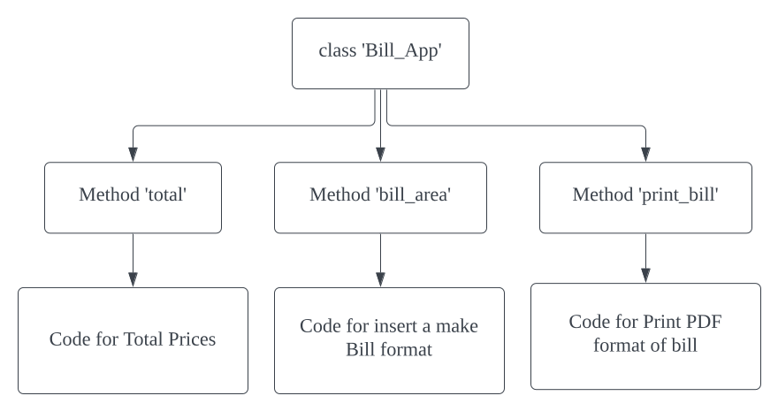
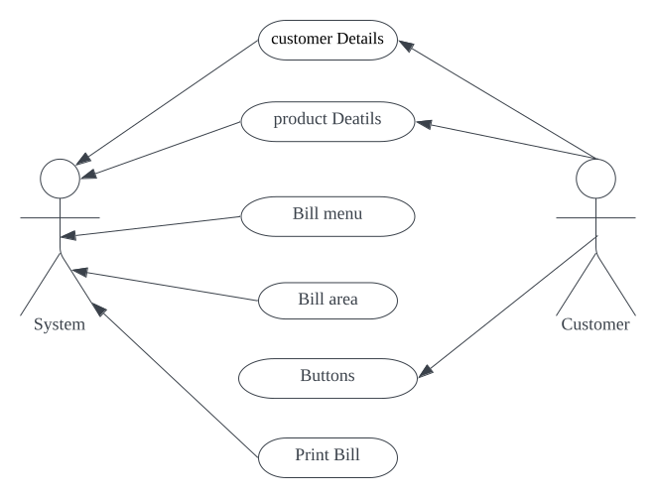
6.3 Use case Diagram:
6.3 Deployment Diagram:

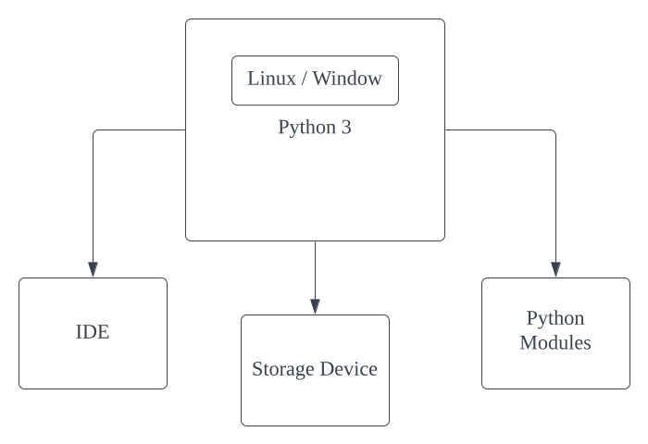
Chapter 7
Testing
7.1 Test cases:

Test Case # | Test Case Description | Expected Result | Actual Result | Pass/Fail
1 | Verify that the Easy E-Bill Generator can successfully generate a bill for a single item with valid details. | The system should generate a bill with accurate information for the specified item. | The bill is generated correctly with the expected details. | pass
2 | Test the Easy E-Bill Generator's ability to handle multiple items in a single bill. | The system should generate a comprehensive bill with all the specified items and their corresponding details. | The bill contains accurate information for all the specified items. | pass
3 | Validate that the Easy E-Bill Generator handles discounts correctly. | The system should apply the discount appropriately and reflect the discounted amount on the generated bill. | The bill shows the correct discounted amount. | pass
4 | Ensure that the Easy E-Bill Generator can handle taxes and includes them in the generated bill. | The system should calculate and display the correct tax amount on the bill. | The bill includes the accurate tax amount. | pass
5 | Test the Easy E-Bill Generator's error handling for invalid input data. | The system should provide a meaningful error message and prevent the generation of a bill for invalid input. | The system displays a relevant error message and prevents bill generation for invalid input. | pass
6 | Verify that the Easy E-Bill Generator maintains data integrity during bill generation. | The generated bill should accurately reflect the input data without any data corruption or loss. | The bill maintains data integrity and accurately represents the input information. | pass
7 | Test the Easy E-Bill Generator's performance with a large dataset. | The system should generate a bill in a reasonable amount of time without performance issues. | The bill is generated within an acceptable time frame with no performance issues. | pass
8 | Validate that the Easy E-Bill Generator supports different currencies for international use. | The system should allow the generation of bills in various currencies and display them correctly. | The bill is generated in the specified currency and displayed accurately. | pass
9 | Test the Easy E-Bill Generator's compatibility with different browsers. | The system should generate bills consistently across popular web browsers. | The bill is generated consistently on various browsers. | pass
10 | Verify that the Easy E-Bill Generator maintains proper security measures to protect sensitive information. | The system should ensure the security of customer data during the bill generation process. | The Easy E-Bill Generator follows security protocols and protects sensitive information. | pass

Test cases are an important aspect of any software development project, including the bill generator system. They help to ensure that the application works as expected and meets the requirements outlined in the project scope.

Test cases are a way of systematically testing the different features and functionalities of the application to identify any defects, errors, or bugs that may be present. By identifying these issues early on in the development process, they can be addressed and resolved before the application is released to users.

In addition, test cases provide a way of validating that the application meets the functional requirements specified in the project scope. This includes testing for different scenarios and edge cases, such as incorrect login credentials, invalid input data, and unexpected errors.

Without proper testing, the application may contain bugs or errors that could lead to security vulnerabilities, data loss, or other issues. Testing helps to ensure that the application is reliable, secure, and performs as expected in various situations.

Therefore, it is important to develop a comprehensive set of test cases for the password manager and storing system, covering all the key features and scenarios. This will help to ensure that the application is robust, reliable, and meets the needs of the users.

These test cases cover different scenarios to ensure that the Easy E-Bill Generator functions as intended. Each test case provides a description of the specific functionality being tested, the expected result, the actual result obtained during testing, and whether the test passed or failed based on the comparison between the expected and actual results. This structured approach helps in identifying and addressing potential issues in the Easy E-Bill Generator.
7.2 Why Need Testing:

In the realm of software development, the creation of an Easy E-Bill Generator marks a significant stride toward streamlined billing processes. However, the necessity of rigorous testing cannot be overstated in ensuring the robustness and reliability of this crucial tool.
- Error Identification and Rectification: Testing serves as a proactive measure to identify and rectify errors in the Easy E-Bill Generator before it reaches end-users. Through systematic testing procedures, developers can catch and address potential bugs, glitches, or inconsistencies, preventing users from encountering disruptive issues during actual usage.
- User Experience Enhancement: The user experience is paramount in the success of any software application. Thorough testing allows developers to fine-tune the Easy E-Bill Generator's interface, ensuring user-friendly navigation and minimizing the learning curve. This results in a more intuitive and efficient experience for end-users.
- Data Accuracy and Security: Billing systems deal with sensitive financial data, making accuracy and security paramount. Testing validates the accuracy of calculations, ensuring that the Easy E-Bill Generator provides precise billing information. Moreover, rigorous testing helps identify and fortify potential security vulnerabilities, safeguarding user data from unauthorized access or malicious activities.
- Compatibility Across Platforms: The diversity of devices and platforms used by individuals necessitates comprehensive testing for compatibility. Ensuring that the Easy E-Bill Generator functions seamlessly across various browsers, operating systems, and devices guarantees a consistent experience for all users, regardless of their technological preferences.
- Performance Optimization: Testing allows developers to assess the performance of the Easy E-Bill Generator under different conditions, such as varying user loads. Optimization measures can be implemented based on test results, ensuring that the application remains responsive and efficient even during peak usage periods.
- Regulatory Compliance: Billing systems often need to adhere to specific regulations and standards. Testing is instrumental in verifying that the Easy E-Bill Generator complies with industry regulations, legal requirements, and data protection standards, mitigating the risk of legal and financial repercussions.
- Reliability and Robustness: End-users rely on the Easy E-Bill Generator for accurate and timely billing information. Rigorous testing guarantees the reliability and robustness of the application, instilling confidence in users that the system will perform consistently and dependably in real-world scenarios.

Chapter 8
Result and application
8.1 Photos of Software:

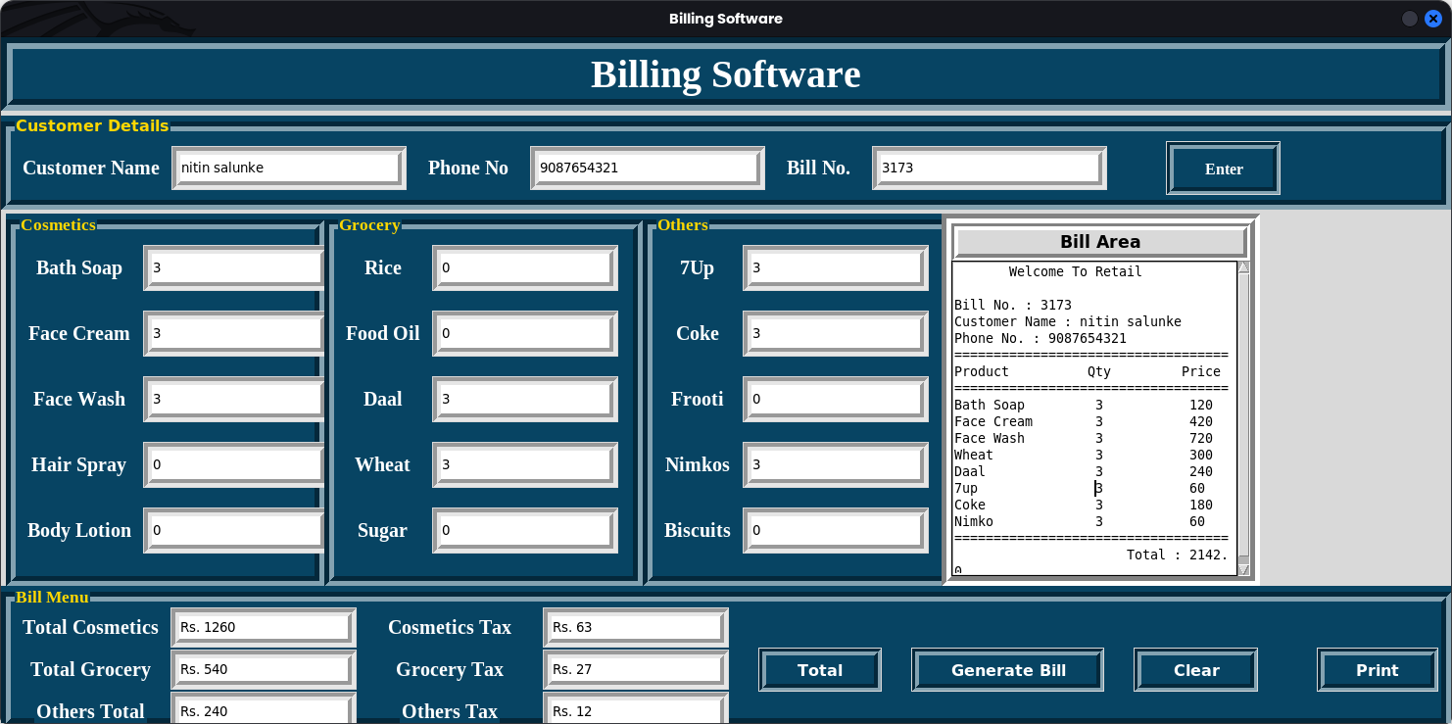
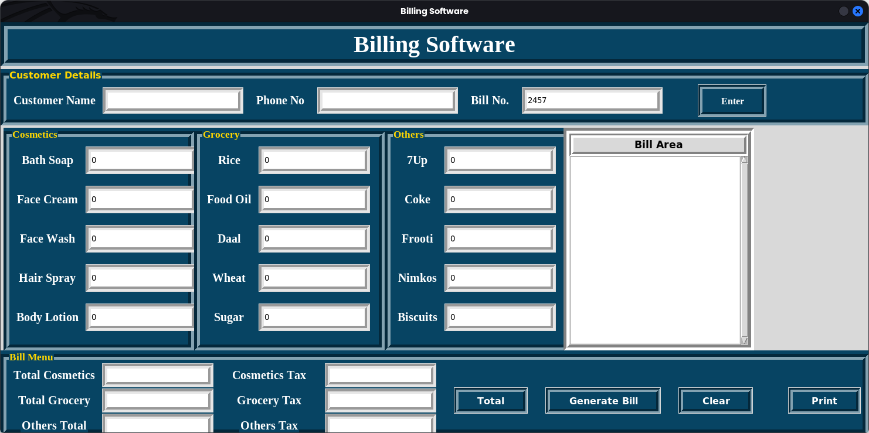
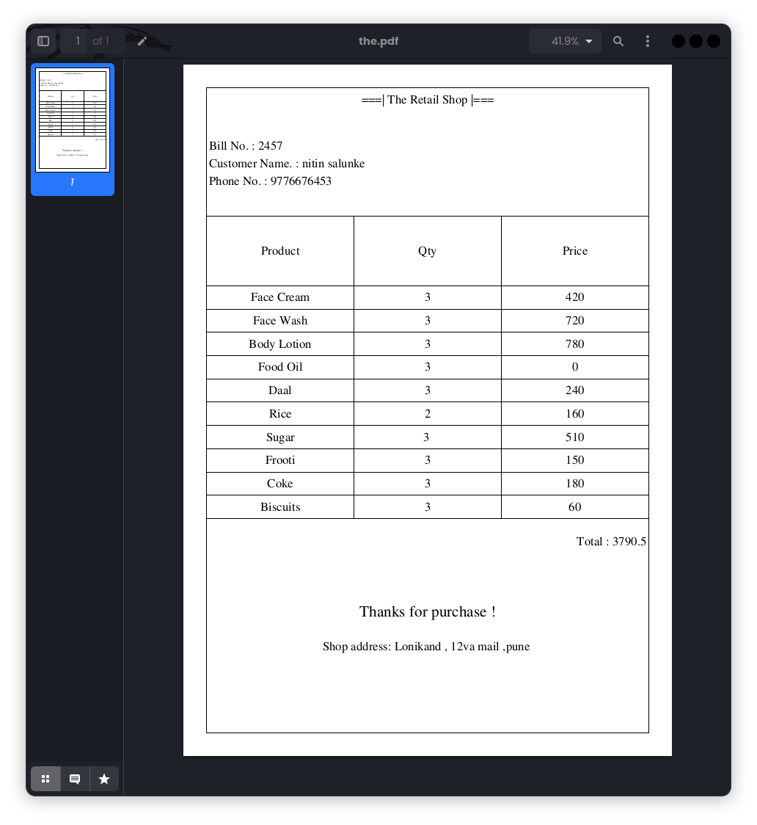
Chapter 9
Conclusions and Future Scope
9.1 Conclusion:

In conclusion, the Easy E-Bill Generator presents a user-friendly and efficient solution for generating electronic bills. Its intuitive interface, streamlined functionality, and robust features contribute to a seamless billing process. Users benefit from the software's ability to automate billing tasks, reducing manual effort and minimizing errors.

The comprehensive set of features, including customizable templates, automatic calculations, and secure data handling, ensures that users can generate accurate and professional-looking e-bills with ease. This not only enhances efficiency but also enhances the overall professionalism of the billing process.
Moreover, the Easy E-Bill Generator addresses the evolving needs of businesses in the digital age by providing a reliable and modern solution for electronic billing. Its compatibility with various file formats and integration capabilities with other business tools make it a versatile and adaptive tool for diverse business environments.
The software's commitment to security and compliance standards adds an extra layer of trust for users, ensuring that sensitive billing information is handled with the utmost care. In essence, the Easy E-Bill Generator stands as a valuable tool for businesses seeking a reliable and user-centric solution for their electronic billing needs, ultimately contributing to an enhanced and efficient financial workflow.

9.2 Future Scope:

The future scope of the Easy E-Bill Generator is promising and holds significant potential for enhancing the efficiency and convenience of billing processes. As technology continues to advance, the Easy E-Bill Generator is well-positioned to evolve and adapt to emerging trends, ensuring sustained relevance and value. Here are some key aspects of its future scope:
- Integration with Emerging Technologies: The Easy E-Bill Generator can explore integration with emerging technologies such as artificial intelligence (AI) and machine learning (ML) to automate and optimize billing processes further. This can include predictive billing, dynamic pricing models, and personalized invoicing based on customer behavior.
- Enhanced Security Measures: With the increasing concern for cybersecurity, the future development of the Easy E-Bill Generator could focus on implementing advanced security measures. This may involve blockchain technology for secure and tamper-proof transactions, ensuring the integrity and confidentiality of sensitive billing information.
- Mobile Accessibility and Apps: As mobile usage continues to rise globally, the Easy E-Bill Generator can expand its reach by developing dedicated mobile applications. This will empower users to generate and manage bills on the go, providing a seamless and convenient experience.
- Blockchain for Transparent Transactions: Leveraging blockchain technology can lead to transparent and immutable billing transactions. This would enhance trust between parties involved in the billing process and provide a verifiable record of all transactions, reducing the risk of disputes and fraud.
- Enhanced Analytics and Reporting: Future versions of the Easy E-Bill Generator can focus on providing advanced analytics and reporting features. This includes detailed insights into billing patterns, customer behavior, and financial forecasting, enabling businesses to make informed decisions.
- Globalization and Multi-Currency Support: Considering the global nature of many businesses, the Easy E-Bill Generator can expand its capabilities to support multiple currencies and comply with various international billing standards. This will facilitate seamless transactions for businesses operating on a global scale.
- Customization and Scalability: The future of the Easy E-Bill Generator lies in offering a high degree of customization to cater to diverse business needs. Scalability should be a key consideration, allowing the system to adapt and grow alongside businesses as they expand.

- Compliance with Regulatory Changes: Staying abreast of regulatory changes is crucial, and the Easy E-Bill Generator should have the capability to adapt quickly to new regulations and compliance standards. This will ensure that businesses using the system remain in adherence to legal requirements.
The Easy E-Bill Generator has a bright future by embracing technological advancements, prioritizing security, enhancing accessibility, and catering to the evolving needs of businesses in a dynamic global landscape.

Chapter 10
Appendix
10.1 Appendix:

_{self.root = root}
self.root.geometry("1300x700+0+0")
self.root.maxsize(width=1480, height=700)
self.root.minsize(width=1480, height=700)
self.root.title("Billing Software")

# ====================Variables========================#
_{self.cus_name = StringVar()}
_{self.c_phone = StringVar()}
# For Generating Random Bill Numbers
_{x = random.randint(1000, 9999)}
_{self.c_bill_no = StringVar()}
_{# Seting Value to variable}
_{self.c_bill_no.set(str(x))}

_{self.bath_soap = IntVar()}
_{self.face_cream = IntVar()}
_{self.face_wash = IntVar()}
_{self.hair_spray = IntVar()}
_{self.body_lotion = IntVar()}
_{self.rice = IntVar()}
_{self.daal = IntVar()}
_{self.food_oil = IntVar()}
_{self.wheat = IntVar()}
_{self.sugar = IntVar()}
_{self.maza = IntVar()}
_{self.coke = IntVar()}
_{self.frooti = IntVar()}
_{self.nimko = IntVar()}
_{self.biscuits = IntVar()}
self.total_cosmetics = StringVar()
self.total_grocery = StringVar()
_{self.total_other = StringVar()}
_{self.tax_cos = StringVar()}
_{self.tax_groc = StringVar()}
_{self.tax_other = StringVar()}

# ===================================
_{bg_color = "#074463"}
_{fg_color = "white"}
_{lbl_color = 'white'}
_{# Title of App}
title = Label(self.root, text="Billing Software", bd=12, relief=GROOVE, fg=fg_color,
bg=bg_color, font=("times new roman", 30, "bold"), pady=3).pack(fill=X)

# ==========Customers Frame==========#
F1 = LabelFrame(text="Customer Details", font=(
"time new roman", 12, "bold"), fg="gold", bg=bg_color, relief=GROOVE, bd=10)
F1.place(x=0, y=80, relwidth=1)

# ===============Customer Name===========#
cname_lbl = Label(F1, text="Customer Name", bg=bg_color, fg=fg_color, font=(
"times new roman", 15, "bold")).grid(row=0, column=0, padx=10, pady=5)
cname_en = Entry(F1, bd=8, relief=GROOVE, textvariable=self.cus_name)
cname_en.grid(row=0, column=1, ipady=4, ipadx=30, pady=5)

# =================Customer Phone==============#
cphon_lbl = Label(F1, text="Phone No", bg=bg_color, fg=fg_color, font=(
"times new roman", 15, "bold")).grid(row=0, column=2, padx=20)
cphon_en = Entry(F1, bd=8, relief=GROOVE, textvariable=self.c_phone)
cphon_en.grid(row=0, column=3, ipady=4, ipadx=30, pady=5)

# ====================Customer Bill No==================#
cbill_lbl = Label(F1, text="Bill No.", bg=bg_color,
fg=fg_color, font=("times new roman", 15, "bold"))
cbill_lbl.grid(row=0, column=4, padx=20)
cbill_en = Entry(F1, bd=8, relief=GROOVE, textvariable=self.c_bill_no)
cbill_en.grid(row=0, column=5, ipadx=30, ipady=4, pady=5)

# ====================Bill Search Button===============#
bill_btn = Button(F1, text="Enter", bd=7, relief=GROOVE, font=(
"times new roman", 12, "bold"), bg=bg_color, fg=fg_color)
bill_btn.grid(row=0, column=6, ipady=5, padx=60, ipadx=19, pady=5)

Chapter 11
Reference and Bibliography
11.1 Reference

If you're looking for information on how to create an electronic bill (e-bill) using a generator, I can provide you with a general explanation. Keep in mind that specific details may vary based on the software or tool you're using. Here's a basic overview:
- Choose a Tool or Software:
  - Select an e-bill generation tool or software that suits your needs. There are various options available, ranging from online platforms to software applications.
- Account Setup:
  - If the tool requires an account, create one by providing the necessary information. This may include your business details, contact information, and any other required details.
- Input Billing Information:
  - Enter the relevant billing information for your transaction. This typically includes:
    - Customer details (name, address, contact information)
    - Invoice number
    - Invoice date
    - Due date
    - Description of products or services provided
    - Cost of each item or service
    - Total amount due
- Customization:
  - Some tools allow you to customize the appearance of your e-bill. You may be able to add your company logo, choose a color scheme, or modify the layout to match your brand.
- Preview:
  - Before finalizing the e-bill, it's advisable to preview the document to ensure that all information is accurate and well-presented.
- Generate E-Bill:
  - Once you are satisfied with the input and customization, use the tool's functionality to generate the e-bill. This process usually creates a digital document (such as a PDF) that you can share with your customers.
- Send E-Bill:
  - Distribute the generated e-bill to your customers. This can be done through email, a secure online portal, or any other method supported by the tool you're using.
- Record Keeping:
  - Keep a record of the generated e-bills for your records and future reference. Some tools may offer features for organizing and managing your billing history.

11.2 Bibliography

- Sweigart, A. (2019). Automate the Boring Stuff with Python, 2nd Edition. No Starch Press.

- Phillips, C., & Harbison, B. (2020). Python 3 Object-Oriented Programming, 3rd Edition. Packt Publishing.

- Zelle, J. M. (2017). Python Programming: An Introduction to Computer Science, 3rd Edition. Franklin, Beedle & Associates.

