
NEXT-GEN HYDROGEN PRODUCTION
NEXT-GEN
HYDROGEN
PRODUCTION

INSTITUTIONAL INVESTOR MEMORANDUM

· MARCH 2026 · VERSION 3.0 · FOR QUALIFIED INSTITUTIONAL INVESTORS ONLY

1-Executive Summary
GigaCore is developing a next-generation hydrogen production system based on a proprietary next-gen electrochemical reactor architecture designed to materially improve the energy efficiency of water-based hydrogen production. Laboratory testing indicates system energy consumption of approximately 38 kWh/kg of hydrogen measured at the AC wall-plug input, representing roughly a 20–30% reduction compared with conventional alkaline and PEM electrolysis systems, which typically operate in the 50–55 kWh/kg range.
Because electricity typically represents 60–70% of hydrogen production cost, improvements in system efficiency directly translate into lower hydrogen production economics. Under base-case assumptions of $0.03–$0.05/kWh electricity, the GigaCore platform is modeled to produce hydrogen at approximately $2.16–$2.92/kg, approaching cost parity with grey hydrogen without reliance on subsidies or carbon credits.
The company is currently advancing the technology from laboratory validation toward pilot-scale industrial demonstration.

Technology Platform
Laboratory testing has validated several key system parameters:
• Energy efficiency: ~38 kWh/kg hydrogen (AC wall-plug measurement)
• Hydrogen production scale: ~1 kg H₂/hour laboratory module
• Hydrogen purity: >99.95%
The technology is currently assessed at Technology Readiness Level (TRL) 5–6, reflecting successful laboratory validation of the production mechanism. Advancing the system toward industrial deployment requires pilot-scale testing, extended durability evaluation, and independent third-party performance certification.
The reactor architecture is designed around a modular production system in which each base module produces approximately 1 kg of hydrogen per hour. Larger industrial systems are constructed by integrating multiple modules into a shared balance-of-plant infrastructure. This modular design enables incremental capacity expansion while simplifying manufacturing and system deployment.
Importantly, the architecture utilizes industrial-grade materials and does not depend on precious group metals such as iridium or platinum, which represent a major cost and supply-chain constraint for PEM electrolyzers.

Market Opportunity
The global hydrogen market currently consumes approximately 95 million tonnes of hydrogen per year, primarily produced using fossil-based processes such as steam methane reforming and coal gasification.
Major hydrogen demand sectors include:
• Ammonia production (~35 MTPA)
• Petroleum refining (~40 MTPA)
• Methanol production (~12 MTPA)
• Emerging hydrogen-based steel production
Decarbonization of these industries is expected to drive substantial demand for lower-carbon hydrogen production technologies capable of integrating with existing industrial infrastructure.
GigaCore’s initial commercial focus is on industries with existing captive hydrogen demand, including refineries, fertilizer producers, and steel manufacturers.
India represents the initial validation market due to its 10–12 MTPA domestic hydrogen demand, competitive renewable electricity pricing of $0.03–$0.05/kWh, and strong policy support for green hydrogen adoption.
Following pilot validation in India, expansion is expected to proceed in phases:
- India Validation (Years 1–3) – pilot deployment and early commercial systems
- GCC Expansion (Years 3–4) – joint-venture deployments with regional EPC partners
- Europe / United States (Years 4–5) – industrial hydrogen projects driven by decarbonization mandates

Business Model
GigaCore’s revenue model is structured around the deployment and long-term servicing of modular hydrogen production systems.
Primary revenue streams include:
Equipment Sales
Sale of standardized modular hydrogen production systems to industrial operators.
Operations & Maintenance Contracts
Long-term service agreements typically modeled at approximately 8% of system value annually, creating recurring revenue as the installed fleet expands.
Joint-Venture Deployment
Industrial partners finance plant construction and hydrogen offtake while GigaCore provides reactor technology, engineering integration, and operational oversight.
Hydrogen plants are expected to scale from pilot deployments to large industrial facilities producing 10,000–20,000 tonnes of hydrogen annually, with potential revenues of $30M–$60M per facility at $3/kg hydrogen pricing.

Intellectual Property & Competitive Defensibility
GigaCore’s intellectual property strategy focuses on protecting core reactor technology through trade secrets, proprietary operational know-how, and controlled system deployment during early commercialization.
Early commercial systems will be deployed under a “black-box” architecture in which critical reactor subsystems remain inaccessible to external operators. This deployment strategy protects proprietary design elements while the company builds operational datasets and pilot-scale validation.
Replication by incumbent hydrogen equipment manufacturers would likely require multiple years of development and tens of millions of dollars in R&D investment, given the specialized advanced energy systems expertise required for reactor development.

Capital Raise & Development Plan
GigaCore is raising $20 million in financing to fund the transition from laboratory validation to pilot-scale hydrogen production.
The financing will support:
• construction of a pilot hydrogen production system
• extended durability testing and performance validation
• expansion of the engineering and commercialization team
• development of pilot partnerships with industrial customers
The primary technical milestone is the demonstration of sustained 38 kWh/kg system efficiency at a continuously operating 1 kg H₂/hour pilot module, validated through independent third-party testing.
Successful completion of the pilot program will enable the transition to modular manufacturing and commercial hydrogen system deployment.

2 – Technology & Scientific Validation

1. Core Scientific Principle
Conventional alkaline and PEM electrolysis splits water via H₂O→ H₂ + ½ O₂. Gibbs free energy change ΔG=237 kJ/mol, corresponds to a theoretical minimum energy of ~33 kWh/kg H₂ (1 kg H₂ ≈ 500 moles → 237×500=118,500 kJ ≈ 32.9 kWh/kg). This thermodynamic limit corresponds to a reversible cell voltage of ~1.23 V, but real electrolyzers typically operate at ~1.8–2.1 V due to overpotentials & resistive losses; since kWh/kg ≈26.8×V, practical electrolyzers consume 50–55 kWh/kg.
This integrated operating regime enables hydrogen production at a lower overall electrical input than conventional electrolysis systems. The reactor architecture is designed around abundant industrial materials and engineered components, avoiding dependence on scarce precious group metals.

2. System Architecture & Thermodynamic Positioning
Hydrogen production efficiency is evaluated relative to the thermodynamic limit of water splitting and the performance benchmarks of current industrial electrolyzers. Laboratory testing of the Gigacore reactor system demonstrates approximately 38 kWh/kg H₂ measured at the full AC wall-plug input. This energy performance represents roughly a 20–30% reduction compared with conventional electrolysis systems, which typically operate in the range of 50–55 kWh/kg.
All reported performance metrics for the GigaCore system are measured using total AC wall-plug energy input to ensure real‑world consumption to ensure direct comparability with real-world industry benchmarks. This measurement reflects the complete system electrical load rather than isolated reactor performance. The wall-plug measurement includes the total electrical consumption of the integrated system, including reactor power, power electronics, water purification, thermal management, gas separation, control electronics, and hydrogen compression to ~30 bar. Energy consumption is measured at the grid interface using calibrated instrumentation, capturing total electrical input rather than isolated reactor performance.
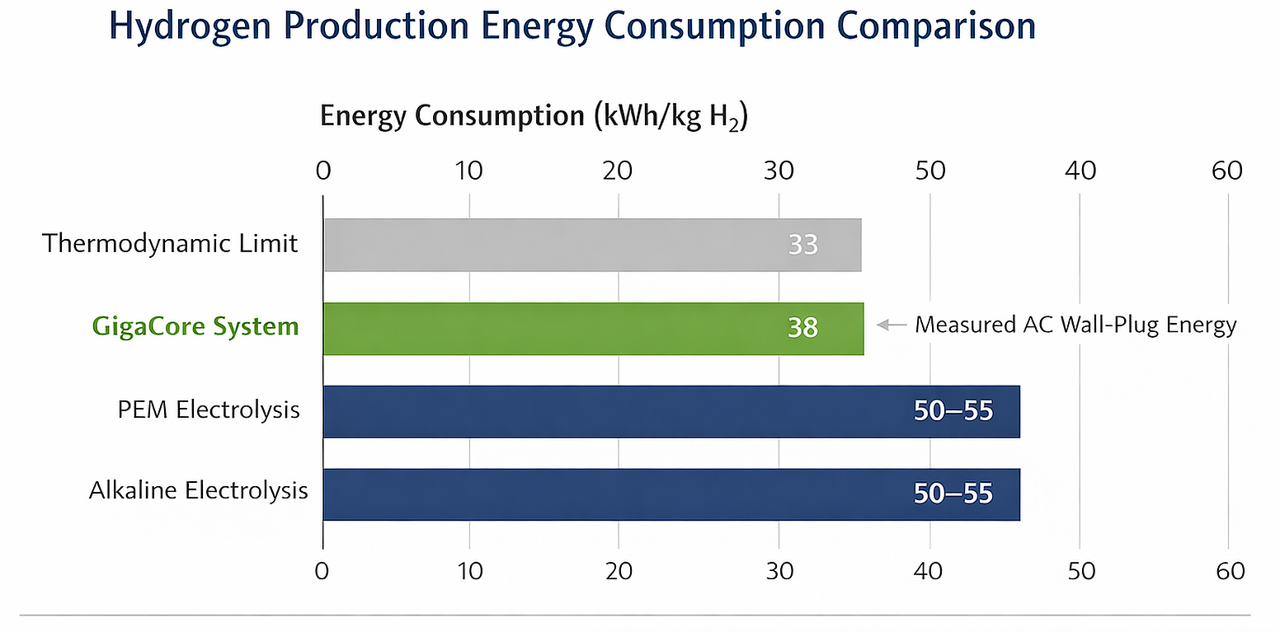
Key validated parameters:
- Efficiency: 38 kWh/kg measured at the AC wall-plug input
- H₂ Production Scale: Laboratory module producing ~1 kg H₂/hour.
- H₂ Purity: >99.95% purity normalized to a dry gas basis at 0°C and 1 atmosphere pressure.

3. Technology Readiness Level (TRL)
The core technology is currently assessed at Technology Readiness Level (TRL) 5–6. This classification reflects successful validation of the hydrogen production principle in a laboratory environment.
However, the technology has not yet been demonstrated under sustained industrial operating conditions. Advancing the system to TRL 7–8 will require:
• construction of semi-industrial modules
• extended continuous operation testing
• independent third-party performance validation
• verification of long-duration system durability

4. Engineering Scale-Up Pathway
Scaling the technology from laboratory modules to industrial deployment will occur through a modular stacking approach rather than the construction of a single large reactor. Each base module is designed to operate as a self-contained unit capable of generating 1 kg of H₂ per hour. Larger production systems are created by integrating multiple modules into a shared balance-of-plant system.
This modular architecture offers several advantages:
• simplified scale-up engineering
• improved system redundancy
• flexible deployment capacity
• reduced single-point failure risks
The primary engineering challenges during scale-up are expected to involve:
• maintaining stable operating conditions across larger active areas
• managing heat transfer within higher throughput modules
• optimizing fluid and gas flow across integrated module arrays

5. Materials & Process Medium
The GigaCore architecture explicitly utilizes no precious group metals (PGMs) such as iridium or platinum, which represent a major cost and supply chain constraint for PEM electrolyzers. The system instead utilizes industrial-grade materials available through established global supply chains.

6. Durability & Degradation
Long-term degradation behavior under industrial operating conditions remains under active evaluation.
Laboratory testing has demonstrated stable H₂ production during experimental duty cycles. The next stage of development will include extended duration testing with a target of 1,000 hours of continuous operation to establish baseline durability characteristics.

7. Commercialization Strategy
The commercialization strategy focuses on modular manufacturing and rapid industrial deployment through strategic partnerships. After validation at the semi-industrial stage, large-scale production will be established through a manufacturing partner tender process.
The hydrogen system uses a modular reactor architecture. Each module produces 1 kg of H₂ per hour, allowing capacity to scale by adding modules without redesigning the system.
Modules can be manufactured as standardized containerized units, enabling mass production similar to data-center server racks or modular electrolyzer systems. Large plants are built by assembling arrays of identical modules, enabling faster deployment and incremental capacity expansion.
Production per module:
1 kg/hour × 24 hours/day = 24 kg/day
24 kg/day × 365 days/year = 8,760 kg/year = 8.76 tonnes H₂ per year per module
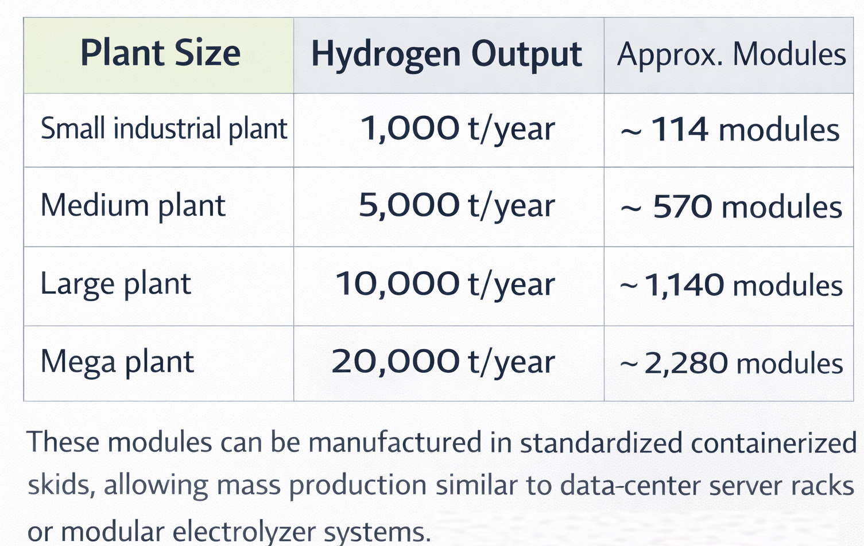
At a conservative hydrogen price of $3/kg, a 10,000-tonne/year plant would generate roughly $30 million annual revenue, consistent with recent refinery hydrogen procurement pricing in India.
Manufacturing is expected to be located in India, benefiting from lower engineering costs, strong supply chains, and proximity to growing hydrogen demand sectors. This modular approach enables rapid scaling while maintaining manageable capital deployment and flexible plant expansion.
Deployment Roadmap: Development and commercialization will follow a four-phase pathway from laboratory validation to industrial hydrogen production.
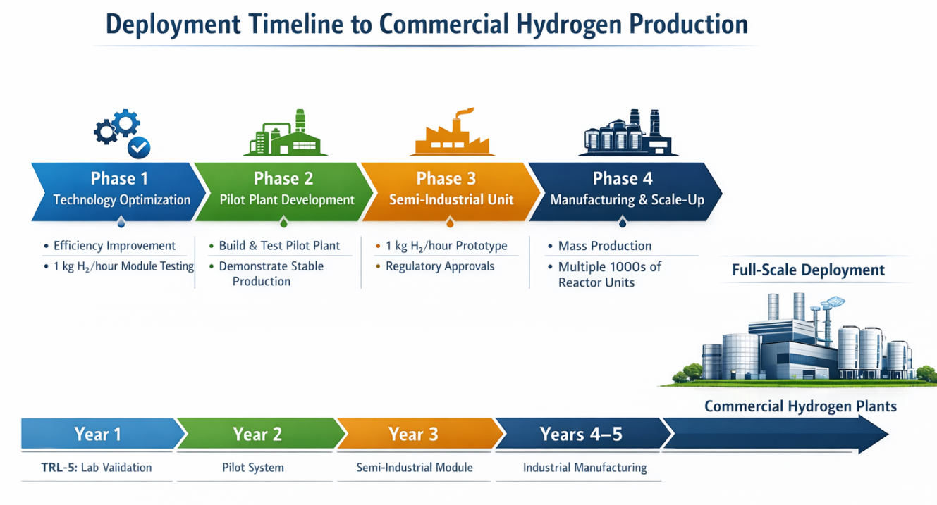

3 – IP, Defensibility & Replication Barriers

1. Intellectual Property Portfolio Overview
GigaCore’s intellectual property strategy prioritizes protection of core technology through trade secrets, operational know‑how, and controlled system deployment during the early commercialization phase. Rather than immediately disclosing core innovations through patent filings, the company maintains critical design and operating knowledge internally while building real‑world performance data and commercial traction. Patent filings covering are expected to be pursued once pilot system validation is complete and key claims can be supported by operational data.
Early systems are designed around a controlled “black‑box” deployment model in which critical subsystems remain inaccessible to external operators. Pilot and commercial units are installed, operated, and serviced directly by GigaCore personnel, preventing exposure of proprietary reactor architecture or internal components. This strategy protects the core technology during the most vulnerable stage of commercialization while preserving optionality for future IP filings.

2. Freedom to Operate (FTO)
GigaCore’s reactor architecture does not infringe existing hydrogen production patents. Internal assessments indicate that the company’s proprietary dissociation pathway differs fundamentally from conventional alkaline, PEM, and solid‑oxide electrolysis systems that dominate existing patent portfolios. At present, no external licensing obligations, university technology transfer agreements, or third‑party intellectual property encumbrances apply to the core system design.

3. Replication Barrier Analysis
Replication by large incumbents faces structural constraints in time, cost, and technical specialization.
Western hydrogen equipment manufacturers have invested heavily in conventional alkaline and PEM stack architectures, supply chains, and manufacturing infrastructure. Transitioning to a next-gen reactor system would require new expertise in advanced reactor design and non‑linear control systems. Achieving comparable development maturity is estimated to require approximately 3–5 years and tens of millions of dollars in R&D investment.
Chinese hydrogen manufacturers are currently focused on scaling conventional alkaline electrolyzer production to reduce capital costs. Their industrial strategy emphasizes manufacturing scale rather than fundamental reactor architecture redesign, and there are currently no widely known programs pursuing comparable next-gen hydrogen production pathways.
A critical bottleneck for replication is the availability of specialized advanced energy research expertise. GigaCore’s current research team provides a concentrated capability that would be difficult and costly for competitors to replicate quickly.

4. Supply Chain & Materials Risk
- Activation Element Sourcing: The architecture explicitly operates without precious group metals (PGMs) such as iridium, eliminating the primary supply chain bottleneck and cost volatility associated with PEM systems.
- Concentration & Rare Earth Risk: The system neutralizes rare-earth import dependencies.
- Recycling Loop Robustness: Net consumption costs are incorporated within the projected operating and maintenance framework.

5. Why the GigaCore Platform Is Difficult to Replicate
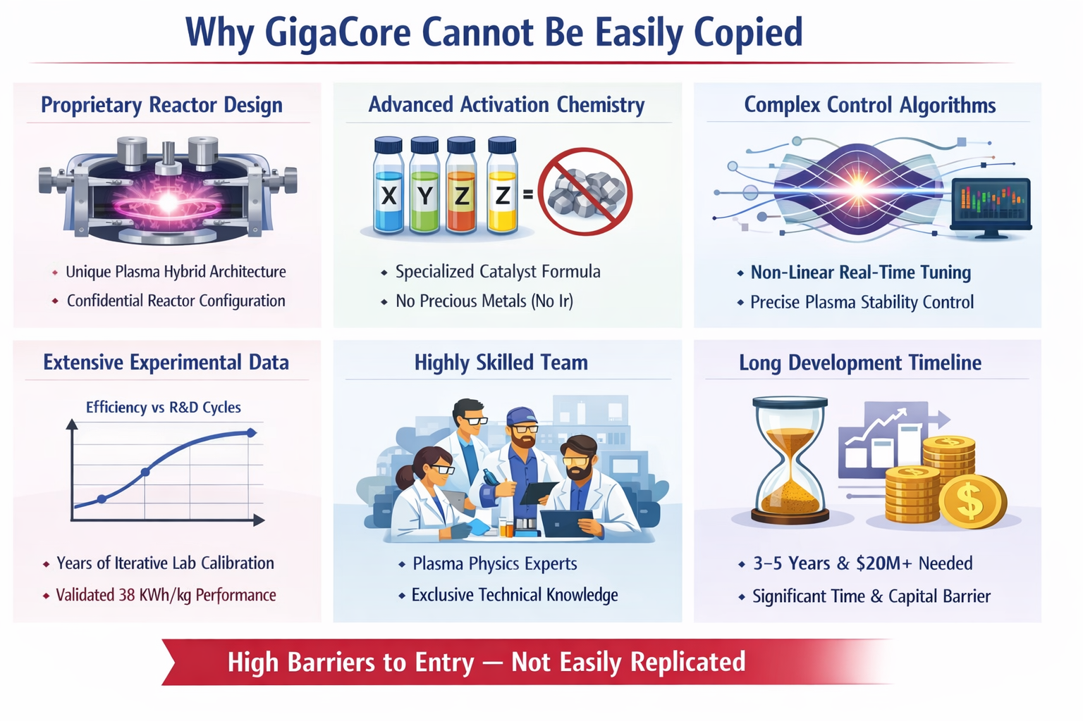

Strategic Defensibility
- Learning Curve Effects: Reactor performance improves significantly with iterative tuning and operational datasets. Early pilot deployments will generate proprietary performance and degradation data that further strengthen the technology learning curve advantage.
- Manufacturing barrier: The reactor architecture requires precision manufacturing tolerances and specialized reactor-compatible materials that are not part of conventional electrolyzer manufacturing supply chains.
- Black-Box Deployment Strategy: Early commercial systems will be installed and serviced directly by GigaCore, limiting external access to internal reactor components and reducing reverse-engineering risk.
- EPC Lock-in: EPC integration partnerships creating long-term infrastructure switching costs.

4 – Project Economics & Financial Model
1. Economic Thesis
Hydrogen production economics are dominated by electricity consumption, which typically represents 60–70% of the total cost of hydrogen production. The GigaCore economic thesis is therefore based on structural energy efficiency improvements that directly reduce the Levelized Cost of Hydrogen (LCOH).
By reducing system energy consumption to approximately 38 kWh/kg H₂, the platform has the potential to materially lower hydrogen production costs relative to conventional electrolysis systems operating at 50–55 kWh/kg.
Unlike many hydrogen projects that depend on policy incentives or carbon credits, the economic model is designed to remain competitive based primarily on operating efficiency and electricity cost.
2. Levelized Cost of Hydrogen (LCOH) Breakdown
The base-case model assumes GigaCore system energy consumption of approximately 38 kWh/kg H₂. The simplified cost structure below illustrates the resulting hydrogen production economics.
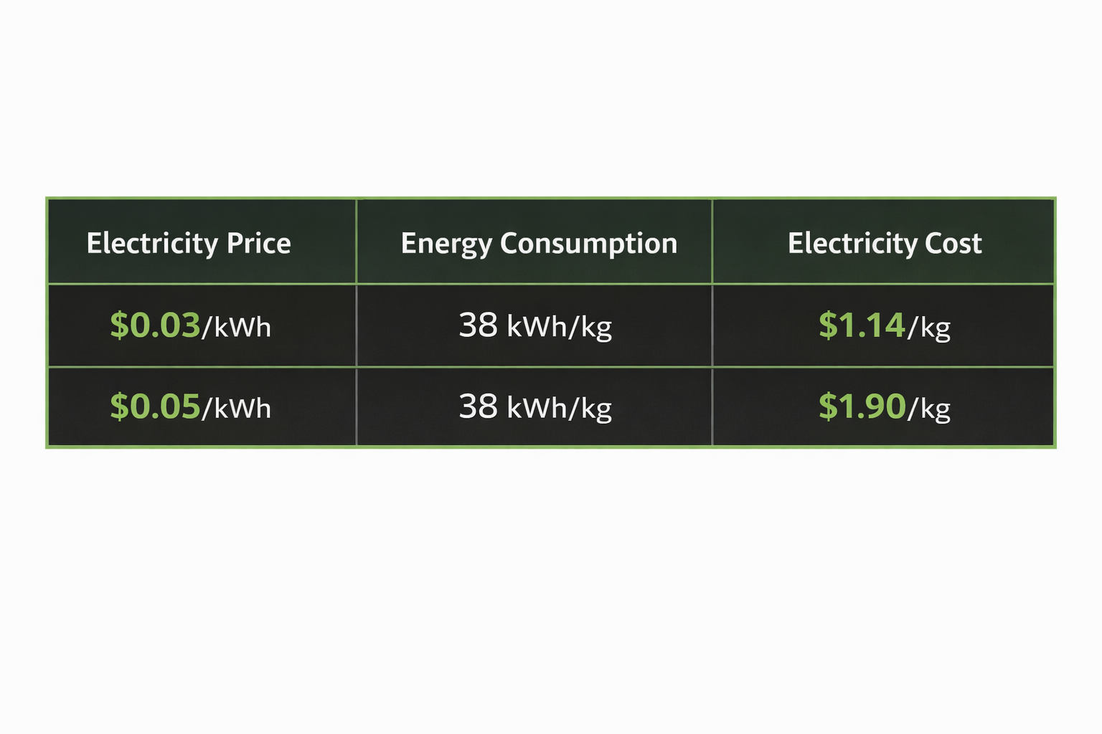
Electricity cost therefore represents the dominant component of hydrogen production economics.
Beyond electricity, several non-energy cost components contribute to overall hydrogen production economics.
Non-Electric Costs | Cost ($/kg) | Description
CapEx Recovery | $0.65 | System capital cost amortization of ~$1000/kW installed system cost
Maintenance & Consumables | $0.15 | Filters, membranes, catalyst reserves, stack replacement, service contracts
Plant Overhead | $0.07 | Labor, plant monitoring systems, and operational expenses
Compression & Storage | $0.12 | Industrial hydrogen compressed to ~30 bar
Water Treatment | $0.03 | Reverse osmosis / deionized water
Total Non-Electric Costs | $1.02/kg
For financial modeling purposes, the base-case installed system capital cost is assumed at approximately: ~$1,000 per kW of installed hydrogen production capacity. The system capital cost is amortized over a 20-year plant life, with stack replacement assumed approximately every 7–10 years as part of routine maintenance.
The resulting Levelized Cost of Hydrogen (LCOH) is therefore:
Electricity Cost ($/kg H₂) | LCOH At $0.03/kWh | LCOH At $0.05/kWh
Electricity Component | $1.14 | $1.90
Non-Electric Costs | $1.02 | $1.02
Total LCOH | $2.16/kg | $2.92/kg
This range $2.16–$2.92 per kg places our Levelized Cost of Hydrogen close to cost parity with grey hydrogen.

3. Competitive Benchmark
The following comparison illustrates how energy efficiency directly translates into hydrogen production cost advantages relative to incumbent electrolysis technologies operating under an identical electricity price of $0.030/kWh.
Electrolyzer LCOH Comparison (at $0.030/kWh)
Technology | System Energy (kWh/kg) | Estimated LCOH ($/kg) | Relative Advantage & Limitation
GigaCore (Base) | 38.0 kWh/kg | $2.16/kg | Verified at lab scale; no precious metals. Pilot validation pending.
Alkaline | 50.0–55.0 kWh/kg | ~$2.55/kg+ | Subject to thermodynamic efficiency plateau limit.
PEM | 45.0–55.0 kWh/kg | ~$2.65/kg+ | High CapEx due to 15–20% iridium supply constraints and stack replacements.
SOEC (High-Temp) | 40.0–48.0 kWh/kg | ~$2.50/kg+ | High capital intensity; significant thermal complexity; untested commercial durability.

A change of $0.01 per kWh in electricity price results in approximately ±$0.38/kg change in hydrogen production cost, highlighting the importance of low-cost renewable power supply.
4. Plant-Level Economics
The following model illustrates how hydrogen production economics scale across different plant capacities.
Pilot System and Industrial Scaling
Deployment Stage | System Configuration | Annual Hydrogen Capacity | CapEx | Purpose
Pilot Validation | Single module | ~8.76 t/year | $6.5M | Technical validation and certification
Early Commercial | Multi-module | Tens of tonnes/year | Project dependent | Initial revenue deployments
Industrial Plants | Parallel module arrays | Thousands of tonnes/year | Modular expansion | Industrial hydrogen production
Large Facilities | Thousands of modules | 10,000+ tonnes/year | Scaled infrastructure | Large industrial hydrogen supply
Hydrogen production systems are designed using a modular architecture in which each base module produces approximately 1 kg of hydrogen per hour. Larger hydrogen plants are created by integrating multiple modules into shared balance-of-plant infrastructure, allowing production capacity to scale incrementally while maintaining standardized manufacturing.

Hydrogen Plant Economics by Production Scale
Plant Size | Hydrogen Output | Approx Modules | Revenue (@ $3/kg)
Small Industrial Plant | 1,000 t/year | ~114 modules | $3.0M/year
Medium Industrial Plant | 5,000 t/year | ~570 modules | $15M/year
Large Industrial Plant | 10,000 t/year | ~1,140 modules | $30M/year
Mega Industrial Plant | 20,000 t/year | ~2,280 modules | $60M/year

As plant size increases, economies of scale reduce fixed cost per kilogram of hydrogen while improving overall system margins.

5. Financial Scaling Timeline

The commercialization of the GigaCore hydrogen platform follows a staged development pathway aligned with technology validation and manufacturing scale-up. Early phases focus on engineering validation rather than revenue generation, while later phases introduce commercial deployments and system sales.

Early development phases focus on engineering validation and therefore generate minimal or no commercial revenue. As industrial deployments increase, revenue is expected to grow through equipment sales and recurring O&M contracts.

The development and financial scaling timeline below illustrates the phased pathway from laboratory validation to industrial hydrogen deployment.
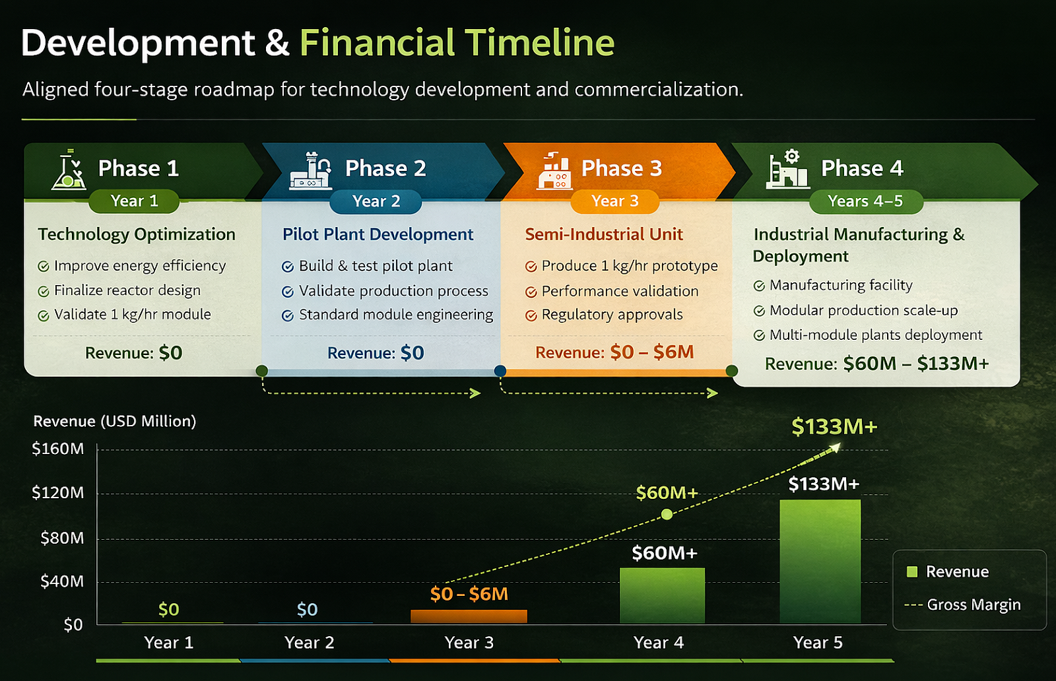

Revenue projections assume deployment of multiple industrial hydrogen systems ranging from 5,000 to 20,000 tonnes of annual hydrogen production capacity.

6. Business Model & Revenue Streams
GigaCore’s revenue model is structured around the deployment of modular hydrogen production systems and the long-term service of installed assets. Revenue generation evolves in parallel with technology validation, manufacturing scale-up, and industrial system deployment.
- Equipment Sales (Primary Revenue – Year 3+)
Sale of standardized modular hydrogen production systems to industrial customers.
- Operations & Maintenance (Recurring Revenue – Year 3+)
O&M contracts are modeled at approximately 8% of system value annually, typically structured as 5–10 year service agreements, creating a recurring revenue base as the installed fleet expands. Service contracts typically include system monitoring, preventive maintenance, and component replacement over the operating life of the plant.
- Joint Venture Deployment (Post-Pilot)
In these arrangements, partners finance plant construction and guarantee hydrogen offtake, while GigaCore provides reactor technology, engineering integration, and operational oversight.
Over time, revenue growth is expected to be driven by continued system deployment combined with recurring service income from the installed base of hydrogen production systems.

5 – Market Opportunity & Commercial Strategy

1. Market Overview
The global hydrogen market currently consumes approximately 95 million tonnes per year, supplied primarily through steam methane reforming (SMR) and coal gasification. Industrial hydrogen demand is highly concentrated within a small number of sectors including ammonia production, petroleum refining, methanol synthesis, and emerging direct-reduced iron (DRI) steelmaking.
Decarbonization of these sectors will require replacing existing fossil-based hydrogen production with lower-carbon alternatives capable of operating reliably within continuous industrial processes.
Primary Hydrogen Demand Segments
Sector | Global Demand | Adoption Driver
Ammonia (Fertilizer) | ~35 MTPA | Decarbonization mandates
Refining | ~40 MTPA | Hydrogen replacement for desulfurization
Methanol | ~12 MTPA | Feedstock substitution
Steel (DRI) | ~5 MTPA (rapid growth) | Low-carbon steel transition
Industrial adoption will occur where hydrogen systems can integrate with existing infrastructure and provide reliable long-duration operation for continuous industrial processes.

2. Target Customer Profile
Early commercial deployments are expected to occur within industries that already operate large captive hydrogen production systems.
Early Adoption Customer Segments
- Refineries (HPCL, IOCL)
- Fertilizer Producers (IFFCO, KRIBHCO)
- Steel (Tata Steel, JSW, JSPL)

3. Current Commercial Engagement
GigaCore has not yet executed binding Letters of Intent (LOIs) or commercial offtake agreements. Commercial engagement currently consists of exploratory discussions with major industrial hydrogen consumers in India. These discussions are focused on potential pilot deployment opportunities and evaluating long-term hydrogen supply pathways following successful technology validation.
The location for the pilot demonstration facility has not yet been finalized. Site selection will prioritize industrial locations with existing hydrogen demand, access to low-cost electricity supply, and a clear regulatory and permitting pathway suitable for pilot-scale deployment.

4. Industrial Integration Considerations
Industrial buyers will transition only if the CapEx friction of retrofitting is offset by immediate OPEX savings.
Factor | Incumbent SMR | GigaCore System
Hydrogen Source | Fossil-based | Water-based
Infrastructure | Established | Modular integration
Retrofit Requirement | None | Moderate
Decarbonization Benefit | None | High
Because hydrogen production typically operates as a captive industrial utility, new systems must integrate with existing infrastructure without interrupting plant operations.

5. India as Validation Beachhead
India represents the initial validation market due to its large captive hydrogen demand, competitive renewable electricity pricing, and strong policy support for green hydrogen adoption.
- Industrial Demand Base: India possesses 10–12 MTPA of localized domestic demand across refining and fertilizer, offering massive captive off-takers within close geographic proximity to the pilot site.
- Renewable PPA Rates: Industrial renewable Power Purchase Agreements (PPAs) range from $0.03 to $0.05/kWh. This low power cost allows GigaCore to test and validate near $2.00/kg LCOH economics without requiring premium green subsidies.
- Policy Tailwinds: The Indian government's $530M SIGHT program provides production-linked incentives. However, GigaCore’s base economic model explicitly excludes these grants. The policy acts purely as an upside demand accelerator, ensuring that the company competes on core unit economics rather than policy dependency.

6. Global Commercial Expansion
Expansion is phased, sequenced, and capital-light.
- Phase 1: India Validation (Months 0–36)
  - Entry Mechanism: Direct equipment sales (Small Demo & Mid Blocks) and recurring O&M contracts.
  - Capital Intensity: Moderate (Localized multi-site module assembly).
  - Regulatory Drivers: SIGHT program and domestic decarbonization targets.
- Phase 2: GCC Expansion (Months 37–48)
  - Entry Mechanism: Joint Ventures (JV) with regional Middle Eastern EPC and infrastructure partners.
  - Capital Intensity: Low. EPC partners finance the balance-of-plant.
  - Margin Profile: High. Shifts from hardware margins to asset-light IP royalties.
  - Regulatory Drivers: sovereign investment programs supporting large-scale green ammonia export projects
- Phase 3: EU / US Expansion (Months 49–60+)
  - Entry Mechanism: Direct equipment sales and project partnerships with large industrial operators and EPC contractors.
  - Capital Intensity: Moderate; deployment driven by industrial hydrogen demand and regulatory mandates.

6 – Capital Raise & Use of Funds

1. Capital Raise Overview
The financing will provide a full runway for the technical validation programme under institutional governance.
The capital raise of $20M is designed to fund the transition from laboratory-validated physics into independently certified, bankable industrial performance data.
- Scaling from laboratory proof-of-concept experiments to a continuously operating 1 kg H₂/hour pilot module.
- Demonstrating sustained 38 kWh/kg system efficiency at a continuously operating 1 kg H₂/hour pilot module.

2. Detailed Use of Funds Allocation
The $20M capital allocation is structured to directly support the key technical, operational, and commercial milestones required for pilot-scale validation.
Category | Amount | % of Raise | Purpose
Pilot Plant Construction | $6.5M | 32.50% | Engineering, fabrication, and installation of the pilot hydrogen production system, including reactor modules, civil works, electrical infrastructure, and compression equipment.
R&D & Tech Validation | $2.0M | 10.00% | Continuous run testing, performance monitoring, durability analysis, and independent third-party certification.
Team & Organizational Build-Out | $2.7M | 13.50% | Supporting the existing core team and selective hiring of key leadership roles.
Commercial Development | $1.5M | 7.50% | Advancing discussions toward pilot partnerships and LOIs.
Office, Permits & Compliance | $1.0M | 5.00% | Office operations, legal and administrative costs, regulatory approvals (factory licensing and safety compliance), and ongoing corporate governance requirements.
Contingency & Working Capital | $2.5M | 12.50% | Explicit buffer to absorb fixed-price EPC slips or integration delays.
Strategic Reserve | $3.8M | 19.00% | Strategic reserve to ensure continuity and provide flexibility during pilot deployment and early commercialization.

This capital structure is designed to retire the primary technical and operational risks associated with pilot-scale validation before initiating large-scale commercial manufacturing.

7– TEAM, GOVERNANCE & EXECUTION
Leadership Structure
The leadership structure is organized across three functional pillars: technology development, infrastructure deployment, and corporate finance. Technical leadership is anchored by the Chief Technology Officer responsible for reactor design, hydrogen systems engineering and intellectual property development. Infrastructure development, project execution and commercialisation are led by senior executives with experience delivering large-scale industrial and energy infrastructure projects. Collectively the team brings 150+ years of combined experience across energy, infrastructure, and advanced industrial systems.
LEADERSHIP TEAM

NAME | ROLE | BACKGROUND
Manish Kothary | Chief Executive Officer | Entrepreneur and technology founder developing scalable hydrogen and next-gen energy systems for industrial decarbonisation. Brings 25+ years of experience building and scaling ventures across technology, financial platforms and industrial infrastructure. Previously senior roles at Barclays Global Investors, Wells Fargo and Pacific Gas & Electric. M.Sc Computer Science, University of South Carolina; BE Electrical Engineering, IIT Roorkee.
Vandit Verma | President – Infrastructure & Energy Platforms | Leads global infrastructure development and commercialisation of advanced energy platforms. Cross-border project structuring, strategic capital partnerships. Experience in hydrogen and low-carbon fuel systems, rare earth extraction and waste-to-energy infrastructure across North America, Europe and emerging markets. B.Eng Mechanical Engineering, Ryerson University, Canada.
Igor Kuntzevitsky | Chief Technology Officer (Hydrogen & Reactor Systems) | Leads reactor architecture, hydrogen systems engineering and IP development. Inventor of multiple granted U.S. patents covering hydrogen production pathways and critical mineral recovery systems (hydrocarbon gas pathways, red mud processing). Expertise spans matrix reactor systems, controlled partial oxidation and integrated hydrogen purification. Masters in Mechanical Engineering, Uzbekistan.
Harsha Jayaram | Systems Integration & Project Development Officer | 30+ year energy industry executive with leadership roles across hydrogen, industrial gases, carbon capture and renewable infrastructure. Former senior executive at Praxair/Linde, Ohmium, Tecnicas Reunidas and Waaree. Specialist in techno-commercial validation, hydrogen project structuring and large-scale energy infrastructure deployment.; BE Chemical Engineering, University of Mumbai.
J. Gupta | Head of R&D – India | Leads hydrogen technology validation, reactor optimisation and scale-up for GigaCore’s advanced energy platforms. 14+ years at leading energy companies across hydrogen, CCUS, catalysts and refinery-scale systems. Specialist in electrochemical modeling, advanced materials and techno-economic evaluation of hydrogen systems. PhD, IIT, Delhi.
Prashanth Shetty | Business Development | Leads business development across GigaCore’s hydrogen and energy infrastructure platform, driving institutional investor engagement, commercialisation strategy and strategic partnerships. Former executive leader at Verdigris, EMC and SAP with experience spanning global go-to-market strategy and enterprise technology platforms. MBA, The Wharton School; MS Engineering, Stanford University.
Ajeet Saran | Head of Projects & Operations | 30+ years of industrial leadership across manufacturing, operations, logistics and regulatory interface. Spent nearly 25 years at Tata Steel in senior roles spanning mining, power, sales and supply chain. Brings deep expertise in large-scale industrial project execution, operations management and government liaison; BE Electrical Engineering, IIT-BHU; PG Supply Chain, XLRI.
Gautam Ghosh | Director Finance | Chartered Accountant with extensive experience in financial governance, accounting systems, taxation and corporate structuring. Former leadership roles at Motorola Solutions India, Coca-Cola India and Nestlé India. Earlier career at Price Waterhouse advising multinational companies on India market entry and financial structuring; B.Com (Hons), SRCC, Delhi University.

Governance Structure
GigaCore operates under a structured governance framework designed to support institutional capital participation and large-scale infrastructure deployment. Strategic oversight is provided by the Board of Directors, supported by an advisory board with expertise in project finance, energy infrastructure and global technology commercialization. Operational management is led by the executive leadership team responsible for technology development, project execution and commercial strategy.
Strategic Advisors
The company is supported by a group of senior advisors with deep experience across energy infrastructure financing, venture capital and global technology commercialization.
Upal Basu
Upal Basu is a General Partner and Managing Member at NGP Capital, a global venture capital firm managing over $2 billion across the U.S., Europe, China, and India. He leads the North America office and global software investments under a “Convergence” thesis focused on robotics, industrial systems, applied AI, space and dual-use technologies. With 25+ years of experience, he has led over 20 investments with 10 successful exits and previously co-founded and exited a global mobile security platform exceeding $50M in revenue. A Stanford M.S. in Engineering and Harvard MBA, he brings deep capital markets expertise and global scale-up insight to GigaCore’s advanced industrial technology strategy and institutional investor positioning.
GigaCore is in the process of expanding its advisory board to include senior leaders from global hydrogen, industrial engineering and project finance institutions.

8– Risks & Mitigation
This section summarizes the principal risks associated with the commercialization of the next-gen hydrogen production platform, along with the mitigation strategies implemented to reduce downside exposure.Downside protection is structured through milestone-based validation gates that trigger structured technical reassessment, controlled architectural refinement, and disciplined redeployment of improvements prior to further scale expansion if defined performance thresholds are not met.
Major development risks and the mitigation to each risk are summarized below:
1. Technology Performance Risk (Scale-Up Efficiency): GigaCore’s core claim is a wall-plug energy of ~38 kWh/kg H₂. Achieving this at industrial scale is unproven. Mitigation: The company adopts a phased validation (starting with a 1 kg/day pilot) to test the full system at rated current. Independent labs (NABL-accredited, e.g. TÜV SÜD India, Bureau Veritas, DNV or SGS) will measure efficiency using ISO-standard methods. Only after demonstrating near-thermodynamic efficiency in continuous operation will we proceed.
2. Engineering Scale-Up Risks: Enlarging reactor size may introduce non-linear effects (reactor field uniformity, thermal management, gas handling). Mitigation: A modular approach allows incremental scaling (stacking reactor units). Pilot modules are instrumented for reactor stability and temperature control. The team will conduct detailed simulations and a 1 kg/h pilot before mass production. Key engineering tasks (e.g. high-frequency power electronics, advanced controls) are allocated R&D milestones. A design freeze before scale-up includes robustness testing in laboratory reactors. Scale-up risks are tracked in a formal engineering risk register, and critical failures (e.g. loss of reactor field uniformity) would trigger alternative designs or process controls.
3. Materials & Supply Chain Risk: Competing electrolyzers often rely on scarce platinum-group catalysts, which face price volatility. Mitigation: GigaCore’s electrodes are deliberately free of PGMs. We use readily available materials that are industrially sourced. Supply chain risk is mitigated by qualifying multiple vendors for core modules and targeting local manufacturing partnerships (e.g. domestic stack assembly). The manufacturing strategy (including potential JV with an EPC or stack fabricator in India) diversifies sources and avoids single-point failures.
4. Durability & Lifetime Risk: Component degradation under continuous duty could reduce output or raise OPEX. Mitigation: Extended pilot testing (≥1,000 h at design output) will quantify degradation rates. Real-time diagnostics will be used. The design allows for modular replacement of wear parts. Early detection of wear will inform maintenance intervals. The pilot’s operating profile (including planned downtime) is used to model long-term uptime; if durability falls short, target cycle life expectations and warranty terms will be adjusted accordingly.
5. Certification & Safety Risk: Commercial hydrogen systems must meet stringent safety standards. Mitigation: From the outset, the pilot design conforms to recognized codes. This includes compliance with ATEX/IECEx (for any explosive atmospheres), IEC 61010 or equivalent (electrical safety), and pressure-vessel codes (ASME). The safety enclosure and control system are designed per SIL requirements (IEC 61508). Prior to pilot deployment, GigaCore will engage an accredited third-party to audit the system against standards. Certification workstreams run in parallel with technical development: for example, pressure tests and IECEx approvals are planned immediately after the first prototype is built. Achieving “NABL-calibrated” measurement status and external certification of performance (especially hydrogen purity and leak containment) is a key gating milestone before any commercial project.
6. Electricity Price & Economic Risk: Electricity typically drives ~60–70% of hydrogen cost. A rise in power costs could erode the project economics. Mitigation: The India-first strategy targets regions with abundant renewables. Recent bids in India have secured solar power at only ₹2.6 (~$0.03) per kWh. We assume $0.03–$0.05/kWh in our base case. Efficiency gains further reduce price sensitivity. We plan to negotiate long-term PPAs or captive renewables for pilot and first-of-a-kind plants to lock in rates. The economic model includes sensitivity to higher power prices; conservative cases show that even at $0.06/kWh, hydrogen remains competitive versus legacy sources. Any exposure beyond $0.05/kWh will be mitigated by demand-response or hybrid renewable storage to smooth intermittency.
7. Market Adoption & Regulatory Risk: End users (refineries, ammonia plants) may hesitate to adopt new technology absent proven reliability. Mitigation: The India strategy focuses on captive hydrogen consumers under policy support (e.g. India’s Green Hydrogen Mission). By co-locating the pilot at an existing captive site (e.g. a large refinery or fertilizer plant), we validate under realistic operating conditions and build customer confidence. We have preliminary discussions (MOUs) with potential anchors. Early engagement with regulators ensures clarity on interconnection and permitting. Offtake risk is managed by structuring the first sale as an industrial-power-plant demonstration (reducing purity or uptime requirements initially) rather than relying on merchant hydrogen sales. A successful pilot and onsite integration serve as a case study for rapid scaling.
8. Competitive Replication Risk: Large electrolyzer manufacturers could attempt to copy the concept. Mitigation: GigaCore’s approach has several barriers: it requires new power electronics expertise and a proprietary reactor-electrode design. Most incumbents are heavily invested in PEM/alkaline technology roadmaps. The lead time between lab results and pilot deployment (plus multi-year development of advanced controllers) makes immediate replication difficult. Any competitor process would face a similar R&D schedule, giving GigaCore time to advance and scale its own manufacturing.
9. CAPEX & Financing Risk: The pilot and scale-up require significant capital (estimated $6.5M direct cost for pilot, plus buffer). Mitigation: Project costs are broken into milestones tied to funding tranches. The capital raise explicitly includes a $2.5M (≈12.5%) contingency to cover overruns, as shown by detailed vendor quotes. We will use standard EPC contracts with fixed-price components where possible. Construction risk is monitored monthly; any deviation triggers the contingency reserve. Financial modeling assumes staged drawdowns: for example, 50% of capital raise is allocated up front for the pilot, 50% held until certification results. The company is also exploring co-investment by strategic partners and subsidized financing under India’s clean-energy programs to reduce equity dilution.

9– APPENDIX – Detailed Hydrogen Market Report
HYDROGEN PROJECT – INDUSTRY BENCHMARKS & ASSUMPTIONS
Parameter | Value / Range | Source / Note
TECHNOLOGY
Alkaline Electrolysis – Energy Intensity | 50-55 kWh/kg H2 | IEA Global H2 Review 2024; IRENA
PEM Electrolysis – Energy Intensity | 52-58 kWh/kg H2 | IEA 2024; BloombergNEF H2 Market Outlook
SOEC (High-Temp) – Energy Intensity | 37-42 kWh/kg H2 | Topsoe, Ceres Power, Bloom Energy specs
AEM Electrolysis – Energy Intensity | 43-48 kWh/kg H2 | Enapter, Oil India Jorhat data
CFE (Hysata) – Energy Intensity | 41.5 kWh/kg H2 | Hysata 2024; Nature Energy
CAPEX (ELECTROLYZER)
Alkaline – Current (2024) | $500-900/kW | IEA 2024; BNEF
PEM – Current (2024) | $800-1200/kW | IEA 2024; BNEF
SOEC – Current (2024) | $1500-2500/kW | IRENA; Topsoe
Alkaline – 2030 target | $200-400/kW | IRENA Electrolyzers 2025
PEM – 2030 target | $250-500/kW | IRENA; DOE H2 Shot target
HYDROGEN PRICES (LEVELIZED COST)
India (SIGHT auctions 2024) | $4.00-5.50/kg | MNRE SIGHT results; ET Energy
India (long-term 2030 target) | $1.50-2.50/kg | India NGHM target
Europe (green, current) | $4.50-7.00/kg | BNEF; Hydrogen Council 2025
USA (IRA subsidy scenario) | $1.00-2.50/kg | DOE H2Shot; IRA 45V $3/kg PTC
Grey H2 (SMR, global avg) | $0.90-2.50/kg | IEA 2024 – cost-competitive benchmark
Blue H2 (SMR+CCUS) | $1.20-2.00/kg | Reliance target; IEA
ELECTRICITY PRICES
India Solar (new PPA 2024-25) | $0.018-0.030/kWh | MNRE solar auction results
India Hybrid (solar+wind) | $0.022-0.035/kWh | SIGHT tender results
Europe (PPA grid-scale wind/solar) | $0.040-0.065/kWh | Ember; LevelTen Europe
USA (Renewable PPA 2024) | $0.025-0.045/kWh | NREL ATB 2024
Middle East (solar) | $0.014-0.025/kWh | Saudi NEOM; Oman projects
CAPACITY FACTORS
India Solar (Rajasthan/Gujarat) | 28-35% | MNRE data
India Hybrid (solar+wind) | 40-55% | MNRE; SECI data
24/7 RTC (pumped hydro backed) | 80-90% | Greenko/AM Green; SBS reports
Europe Wind (offshore) | 45-55% | IRENA 2024
Electrolyzer utilization (effective) | 35-55% | IEA World Energy Outlook 2024
OPEX BREAKDOWN (% of total OPEX)
Maintenance & Consumables | ~40% | Benchmark: IRENA 2023 Green H2 Costs
Fixed Plant Overhead | ~25% | Industry average
Compression & Storage | ~20% | IEA H2 storage cost analysis
Water Treatment | ~15% | IRENA; project-level disclosures
UNIT CONVERSIONS
Ammonia from H2 (mass ratio) | ~5.6 kg NH3 per kg H2 | Haber-Bosch stoichiometry
GOVERNMENT INCENTIVES (INDIA)
SIGHT Tranche I incentive | ₹50/kg H2 (~$0.60/kg) | MNRE SIGHT 2023 results
SIGHT Tranche II incentive | ₹60/kg H2 (~$0.72/kg) | MNRE SIGHT 2024 notification
India NGHM target (2030) | 5 MMTPA green H2 | India NGHM official plan 2023
India Production subsidy pool | ₹17,490 Cr over 3 yrs | NGHM budgetary allocation
USA IRA Section 45V (clean H2) | $3.00/kg (max Tier 1) | IRS/DOE 45V final rules 2024
EU RFNBO multiplier | 2x renewable counting | EU Delegated Regulation 2023/1185

HYDROGEN & GREEN AMMONIA PROJECT DATASET | 41+ Projects | As of March 2026
Company Name | Project Name | Technology | H2 Production (MT/yr) | Total CAPEX (USD) | H2 Price High ($/kg) | Revenue ($/kg) | Start / Operational Date | All Partners | Source / Notes
ACME Group | Bikaner Integrated Green H2 & Ammonia Pilot | Alkaline | 175 | $15,000,000 | $4.75 | $3.80 | 2021 | ACME Cleantech Solutions; Solar PV supplier; alkaline electrolyzer vendor | World's first integrated green H2+ammonia plant; 5 MW solar + 500 Nm³/hr electrolyzer; Source: ACME GHC website, Bikaner project page
ACME Group | Oman Duqm Green Ammonia Plant – Phase 1 | Alkaline | 18,000 | $490,000,000 | $5.00 | $4.00 | 2027 | ACME Green Hydrogen & Chemicals Co SAOC; Shuangliang (electrolyzer); JinkoSolar (solar PV); Yara Clean Ammonia (offtake 100 ktpa); NYK Line (shipping) | Phase 1: 80 MW alkaline electrolyzers (Shuangliang); 487.5 MW JinkoSolar N-type modules; Yara offtake signed; debt closed mid-2023. Source: Reuters; ACME GHC; Yara press release
ACME Group | VOC Port Green Hydrogen Hub – Tamil Nadu | Alkaline | 245,000 | $7,700,000,000 | $4.75 | $3.80 | 2027-2030 (phased) | VOC Port Authority; Sembcorp Green Infra (port infrastructure); ACME Cleantech Solutions | 3-phase plant; Phase 1: 438 kt/yr ammonia ($1.4B CAPEX); ₹52,474 Cr total (~$6.4B); 5 GW solar + 1.5 GW electrolyzer at full buildout. Source: ACME GHC TN page; VOC Port Authority announcement
ACME Group | Gopalpur Green Ammonia Plant – Odisha (Phase 1) | Alkaline | 89,000 | $3,300,000,000 | $4.75 | $3.80 | 2029 | Tata Steel SEZ Ltd (land/infrastructure); IHI Corporation Japan (JV – offtake from 2029); NYK Line (shipping) | Phase 1: 400 ktpa green ammonia; Japanese offtake partner (IHI) from 2029; ₹270B (~$3.3B) Reuters-confirmed. Source: Reuters 2023-08-25; ET Energyworld 2025
AM Green (AMG) | Kakinada Green Ammonia Hub – Phase 1 (1.5 MTPA) | Alkaline (John Cockerill) | 267,000 | $10,000,000,000 | $4.75 | $3.80 | 2027 (Phase 1: 0.5 MTPA) | John Cockerill (1.3 GW electrolyzers); Casale/Toyo/Air Liquide (ammonia synthesis); Uniper (500 kt/yr offtake); RWE (50 kt/yr offtake); Keppel (offtake); DP World (port logistics); Rotterdam Port; Yara; BASF | FID Aug 2024; brownfield urea plant conversion; 7.5 GW solar+wind+pumped hydro; 2 GW/yr electrolyzer mfg JV at Kakinada. Source: AM Green press; John Cockerill announcement; RFNBO certification
AM Green (AMG) | Tuticorin Green Ammonia Plant | Alkaline | 178,000 | $4,500,000,000 | $4.75 | $3.80 | 2028 | RWE (200 kt/yr offtake); AM Green; technology partners | 1 MTPA plant at VOC Port; FID expected 2025; RWE 200 kt/yr signed. Source: AM Green website; RWE press release
AM Green (AMG) | Kandla Green Ammonia Facility | Alkaline | 267,000 | $5,500,000,000 | $4.75 | $3.80 | 2029 | Kandla Port; DP World; AM Green | 1.5 MTPA plant at Kandla Port; domestic + export via Kandla. Source: AM Green website
Adani New Industries Ltd (ANIL) | Mundra Green Hydrogen Ecosystem (Phase 1 – 1 MMTPA H2) | Alkaline / PEM / AEM (multi-tech) | 1,000,000 | $50,000,000,000 | $4.38 | $3.50 | 2030 (Phase 1); 2035 (3 MMTPA) | TotalEnergies (25% equity ANIL); Cavendish Renewable Technology (electrolyzer tech); W2E + Windnovation (wind turbines); APSEZ – Adani Ports; Kowa Holdings Asia JV (Japan/Taiwan offtake); coal India / SJVN (PPAs for AM Green) | 30 GW hybrid renewables at Khavda; 5 GW electrolyzer gigafactory planned; 1 MMTPA H2 by 2030 then 3 MMTPA. 5 MW pilot commissioned Jun 2025 in Kutch. Source: ANIL investor presentation; TotalEnergies press; Economic Times
Avaada Energy | Gopalpur Green Ammonia Plant – Odisha | Alkaline | 90,000 | $2,500,000,000 | $4.88 | $3.90 | 2028 | Tata Steel SEZ (infrastructure); Gridco (300 MW power banking, 25-yr); Gopalpur deep-sea port; maritime logistics partners | Greenfield; ~500 ktpa ammonia; 625 MW solar + 500 MW wind tendered Oct 2024; foundation Feb 2024 by CM Patnaik; Gridco banking agreement Feb 2025. Source: Avaada press releases; Gridco agreement
BPCL | Bina Refinery 5 MW Green Hydrogen Plant | PEM | 780 | $5,500,000 | $6.25 | $5.00 | 2025-04-26 | BPCL (BOO model); electrolyzer vendor (undisclosed); renewable power PPA | Commissioned Apr 26 2025 in 15 months; 2.15 t/day = 785 t/yr; supplying Bina refinery hydrotreaters. Follow-on: 5 ktpa BOO plant tendered (target Apr 2028). Source: BPCL press release Apr 2025
GAIL (India) Limited | Vijaipur Green Hydrogen Plant – 10 MW PEM | PEM | 4,500 | $22,000,000 | $5.62 | $4.50 | 2024 | ITM Power (PEM electrolyzer supplier); GAIL natural gas grid (blending trial) | First 10 MW PEM in India; hydrogen blended into GAIL natural gas pipeline (pilot ≤8%); target 310 MW electrolyzer by 2030 → 45 ktpa. Source: GAIL annual report; company press
Gentari (Petronas) | AM Green Kakinada Green Ammonia – Gentari Stake | Alkaline (John Cockerill) | 267,000 | $10,000,000,000 | $4.75 | $3.80 | 2027 (first production) | AM Green (majority); GIC (Singapore); ADIA (Abu Dhabi); John Cockerill (electrolyzers); Uniper; RWE; Keppel (offtake); DP World (logistics); Gentari supply 2.4 GW solar/wind + 350 MW/2,100 MWh BESS | Gentari signed 650 MW RTC renewable PPA Dec 2024; 2.4 GW solar/wind + 350 MW BESS for AM Green. Source: Gentari Petronas annual report 2023; AM Green FID press release
HPCL | Visakhapatnam Refinery Green Hydrogen Plant | Alkaline / PEM (pilot) | 370 | $4,000,000 | $6.25 | $5.00 | 2024 | Ocior Energy (BOO 5 ktpa supply contract awarded Jul 2025 at ₹328/kg); HPCL R&D Centre | 370 tpa plant commissioned; India's first green H2 at any refinery; followed by Ocior 5 ktpa BOO (commissioning ~2028) at ₹328/kg. HPCL R&D testing PEM, ALK, AEM, SOE. Source: Parliamentary Q&A Jul 2023; HPCL sustainability report 2024
Hygenco Green Energies | Gopalpur Green Ammonia Project (TSSEZ Phase 1) | Alkaline | 66,000 | $2,000,000,000 | $4.88 | $3.90 | 2026-2027 (Phase 1: 600 tpd) | Tata Steel SEZ Ltd; Topsoe (DynAMMO™ synthesis license); REC Limited ($280M financing MoU); Ameropa (offtake term sheet – EU/Asia); Mitsubishi Power/JICA (future integration MoU) | Phase 1: ~600 tpd ammonia (0.22 Mtpa); Phase 2: 1.1 Mtpa by 2028; 625 MW solar + 500 MW wind tendered Oct 2024; groundbreaking Jun 2025. Source: Hygenco press; Topsoe Nov 2024; REC MoU Sep 2024
IOCL | Panipat Refinery 10 KTPA Green Hydrogen (L&T BOO) | Alkaline / PEM | 10,000 | $500,000,000 | $5.62 | $4.50 | 2026-2027 | L&T Energy GreenTech (BOO developer, 25-yr supply); GH4India JV (L&T 33.3% + IOCL 33.3% + ReNew 33.3%); SECI (SIGHT allocation) | India's largest green H2 plant; 25-yr BOO supply to IOCL; GH4India JV incorporated Aug 2023. Source: L&T press 2025; IOCL sustainability report; GH4India company filing
JERA Co. / ReNew Power | JERA-ReNew Green Ammonia JV (India) | Alkaline | 355,000 | $10,000,000,000 | $4.75 | $3.80 | 2027-2030 | JERA Co. Inc (Japan; 50%); ReNew Power (India; 50%); offtake to JERA Japan for coal co-firing and ammonia fuel | JV to develop ~2 MTPA green ammonia for JERA Japan coal co-firing and fuel ammonia; phased across ReNew's India pipeline. Source: JERA-ReNew press release 2022; ReNew investor presentation
JSW Energy / JSW Neo Energy | Vijayanagar Green Hydrogen Plant (3.8 KTPA SIGHT) | Alkaline | 3,800 | $120,000,000 | $5.62 | $4.50 | 2025-11-11 | JSW Steel (7-yr offtake: 3,800 tpa H2 + 30,000 tpa O2 for DRI); SECI SIGHT (₹67.6 Cr incentive over 3 yrs); OECD certified | Commissioned Nov 11 2025; 25 MW alkaline; 27 MW RTC renewable; co-located with JSW Steel DRI unit. LOA Feb 2024 (36-mo commissioning window). Source: JSW Energy stock exchange filing Nov 2025; OECD case study
Larsen & Toubro (L&T Energy GreenTech) | Kandla Green Hydrogen & Ammonia Giga Hub | Alkaline + PEM | 400,000 | $12,000,000,000 | $4.75 | $3.80 | 2028-2032 | Kandla Port Trust; L&T electrolyzer manufacturing unit; IOCL (Panipat offtake separately); potential sovereign wealth fund equity | Phased 3 GW electrolyzer + 8 GW renewables; 400 ktpa H2 → 2 Mtpa ammonia. LTEG also manufactures electrolyzers domestically. L&T FY25 energy order book: ₹87,569 Cr. Source: L&T annual report FY25; LTEG press
NTPC Limited | Pudimadaka Green Hydrogen Hub (Andhra Pradesh) | Alkaline / PEM | 500,000 | $22,000,000,000 | $4.38 | $3.50 | 2028-2032 | Andhra Pradesh state; NTPC Renewable Energy Ltd (NREL); JICA/JBIC (Japanese funding); various EPC | Flagship hub; 5 GW electrolyzer at full buildout; 1,500 tpd target; multiple MoUs with Japan, Germany, Singapore. NTPC 5 MW pilot at Vindhyachal already operational. Source: NTPC green hydrogen strategy 2023; JICA MoU
Ocior Energy | Gujarat Green Ammonia Facility (1 MTPA) – Kutch | Alkaline | 178,000 | $4,850,000,000 | $4.75 | $3.80 | 2027 (Phase 1: 0.1 MTPA) | Government of Gujarat (MoU); Kandla Port (export); KBR K-GreeN tech (Odisha); Aker Solutions (FEED, Odisha); HPCL (5 ktpa BOO supply contract Jul 2025 at ₹328/kg) | Phase I: 0.1 MTPA; Phase II: 1 MTPA via Kandla; Odisha project also 1 MTPA at Gopalpur (HLCA Jan 2023). KBR K-GreeN – first India implementation. Source: Ocior press 2023; KBR press release; HPCL tender award Jul 2025
Ocior Energy | Gopalpur Green Ammonia Facility (1 MTPA) – Odisha | Alkaline (KBR K-GreeN) | 178,000 | $4,850,000,000 | $4.75 | $3.80 | 2026-2027 (Phase 1: 200 ktpa) | KBR (K-GreeN technology licensor – first India); Aker Solutions (FEED); TSSEZ (Tata Steel SEZ); Gopalpur port | First K-GreeN ammonia technology in India; FEED complete; Phase 1: 200 ktpa ammonia. Source: KBR press release; Aker Solutions FEED award; Odisha HLCA
Ohmium International | Ohmium PEM Electrolyzer Manufacturing & Deployment (Bangalore) | PEM | 70 | $200,000,000 | $6.25 | $5.00 | 2022 (Bangalore factory open) | Greenko Group (India partnership); Mitsui (Japan distribution); SNAM (Italy); European utility customers | First electrolyzer factory in India (Bangalore); modular PEM M Series; 1 MW modules; deployments in India, Europe, US; SIGHT winner for India projects. Source: Ohmium press 2022; Series B announcement
Oil India Limited | Jorhat Green Hydrogen Pilot – 100 kW AEM | AEM | 4 | $2,000,000 | $7.50 | $6.00 | 2022-04 | IIT Guwahati (R&D); IITG pipeline blending study; NRL (Numaligarh Refinery Ltd) – downstream | India's first 99.999% pure green H2 pilot; 10 kg/day capacity; 500 kW solar; commissioned record 3 months. Source: Oil India press Apr 2022; company sustainability report
ONGC | ONGC-Greenko (ZeroC) Green Ammonia JV – Mangalore | Alkaline (John Cockerill) | 178,000 | $5,000,000,000 | $4.75 | $3.80 | 2028 | Greenko ZeroC (50% JV partner); ONGC Green Limited (50%); John Cockerill (electrolyzers); Uniper (250 ktpa offtake exclusive negotiations); ONGC decarbonization roadmap | 50:50 JV ONGC-ZeroC; 1 MMTPA ammonia; Uniper 250 ktpa exclusive offtake negotiations; ONGC established ONGC Green Limited early 2024. Source: ONGC press 2024; Decarbonization roadmap Jul 2024
Reliance Industries | Jamnagar Blue H2 (CCUS) to Green H2 Transition | SMR+CCUS (blue); PEM+Alkaline (green planned) | 500,000 | $10,000,000,000 | $3.12 | $2.50 | 2025-2028 (blue); 2030+ (green) | Stiesdal A/S (HydroGen electrolyzer technology JV); Reliance New Energy Solar (electrolyzers, solar, batteries, fuel cells); giga factories in Jamnagar | World's largest petcoke gasifier (8.75 MMTPA); 10 gasifiers; blue H2 at $1.2-1.5/kg via syngas+CCUS (interim); 5 GW solar module + electrolyzer + battery + fuel cell giga factories planned. Source: Reliance AGM 2022; Reuters
ReNew Power | Vizhinjam Green H2 & Ammonia Hub – Kerala | Alkaline | 220,000 | $3,200,000,000 | $4.75 | $3.80 | 2027-2030 | Kerala government; Vizhinjam International Port; GH4India JV (L&T+IOCL+ReNew); JERA (offtake JV) | 220 ktpa H2 → 1.1 Mtpa NH3; 2 GW electrolyzer; 5-6 GW captive renewables; 50M L/day water; 3-phase each 36-42 months. Source: ReNew investor deck; Kerala MoU 2022
Sembcorp Industries | Sembcorp Green Infra – Thoothukudi Port + GAIL Blending | Alkaline | 4,500 | $2,900,000,000 | $5.00 | $4.00 | 2028 | VOC Port Authority (Thoothukudi); ACME Group (co-developer port infrastructure); Singapore MAS (financing); Sembcorp Green Infra Renewable Energy Farms | Sembcorp Green Infra: $2.9B port infrastructure project at VOC Port with ACME; Sembcorp also has GAIL blending MoU and Singapore H2 import strategy. Source: Sembcorp annual report 2024; VOC Port announcement
Greenko Group (ZeroC) | Greenko Green Ammonia Program (ONGC JV + standalone) | Alkaline (John Cockerill) | 356,000 | $15,000,000,000 | $4.75 | $3.80 | 2026-2030 | ONGC Green Ltd (50% JV at Mangalore); John Cockerill (electrolyzers); AM Green (spin-off; Uniper/RWE offtake); ADIA; GIC; Abu Dhabi Investment; IHI Japan | Greenko operates 10+ GW solar/wind/pumped hydro in India; ZeroC is a molecule arm; ONGC JV 1 Mtpa at Mangalore; AM Green is a spin-off targeting 5 Mtpa total. Source: Greenko annual report; ONGC press 2024
GH4India Private Limited | GH4India JV – India Green Hydrogen Platform | Alkaline + PEM | 10,000 | $500,000,000 | $5.62 | $4.50 | 2026-2027 | L&T Energy GreenTech (33.3%); IOCL (33.3%); ReNew Power (33.3%); SECI/SIGHT mechanism | JV incorporated Aug 25 2023; authorized capital ₹3 Cr; target: green H2 + ammonia + methanol for IOCL refineries; Panipat 10 ktpa BOO awarded to L&T. Source: GH4India ROC filing Aug 2023; L&T press
Welspun New Energy | Welspun Green Hydrogen & Ammonia Program | Alkaline | 330,000 | $11,160,000,000 | $4.75 | $3.80 | 2027-2032 | Tata Chemicals (offtake partner); Welspun Group companies; government MoU partners; port logistics | 21 project pipeline across RE-rich states; integration with Welspun's steel + textiles manufacturing; Tata Chemicals MoU for supply. Source: Welspun press 2022-2024; company ESG report
EvacAD | EvacAD Vacuum-Assisted Alkaline Electrolysis Technology | Alkaline (vacuum-assisted) | 40 | $5,000,000 | $6.25 | $5.00 | 2024 (pilot) | IIT partner (technology); Indian startup ecosystem | Startup focused on vacuum-assisted alkaline electrolysis for improved efficiency; pilot stage. Source: EvacAD company profile; MNRE startup program

