**Fitness_Tracker**

**Showcasing key Querying and Optimizing Data**

1. **Write Complex SELECT Queries**

**-- Find all users aged between 20 and 30**

**-- Get the latest health metric of a user**

1. **Use JOINs, Subqueries, and Aggregation Functions**

**-- Get user workouts with exercise names and duration**

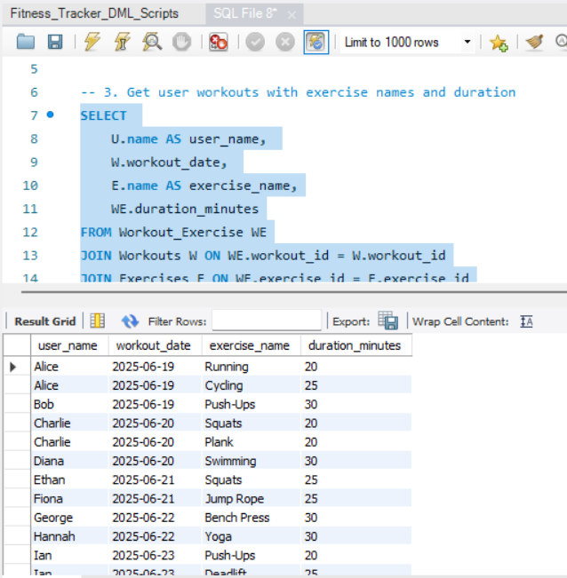

**-- Show all health metrics for users with their name**

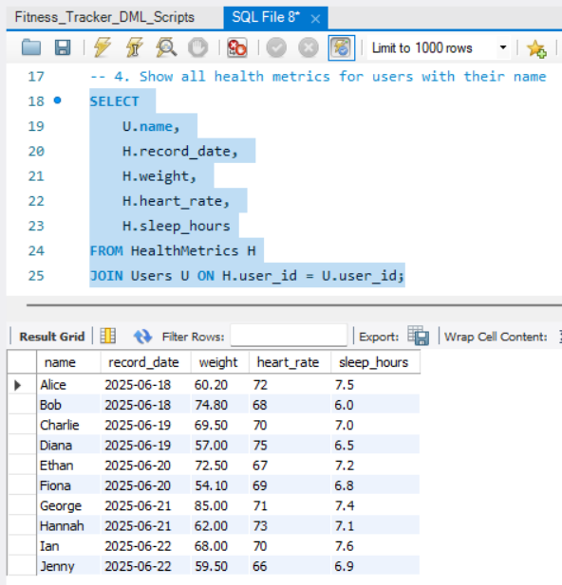

**-- Total number of workouts each user has done**

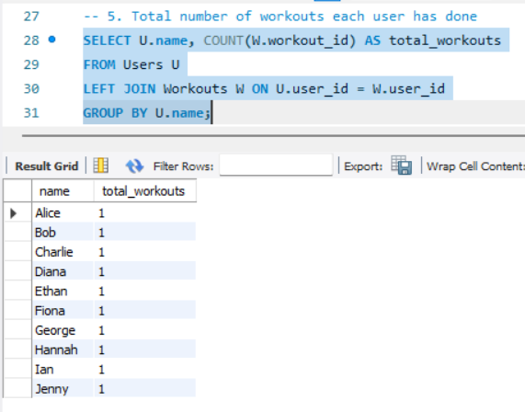

**-- Average calories burned per minute for each category**

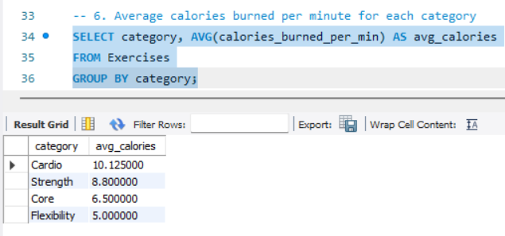

**-- Find users who burned more than the average calories in a workout**

**-- Get users whose latest recorded weight is below 60kg**

1. **Optimize with Indexes**

* + CREATE INDEX idx_user_id ON Workouts(user_id);  
    ➤ Speeds up filtering by **w.user_id = 1**
  + CREATE INDEX idx_workout_date ON Workouts(workout_date);  
    ➤ Speeds up the date range filter **w.workout_date >= CURRENT_DATE - INTERVAL '30 days'**