**Abstract**

The main task of this document is to give a specification of the requirements that our system has to fulfil adopting the IEEE-STD-830-1993 standard for RASD documentation . It also introduces the functional and non-functional requirements via UML diagrams and a high level specification of the system. In the last part of this document it presents the formal model of the specification using Alloy analysis.

The information in this document are intended for the stakeholders and the developers of the project. For the stakeholders this document presents a description useful to understand the project development, meanwhile for the developers it’s an useful way to show the matching between the stakeholders’ requests and the developed solution.

**Introduction**

In this section we will explain which are the main scopes of the Travlendar+ application and we will provide a general overview of all the features.

**Purpose**

The main purpose of the RASD document (Requirement Analysis and Specification Document) is to highlight the domain in which the system will work and the primary use cases.

The document below specifies who will use the system, the reason for which the system is developed, what services will be provided and the environment in which the system finds its use.

We will need to define the functional and not functional requirements of the system.

**2.1 Product Perspective**

We are going to release a cross-platform web application which will be able to run on every device. This application won't provide an interface for the service administrator, because it is possible from the server side. As we are developing a WebApp, we are willing to release custom API for any future application in order to facilitate further implementations.

**World and Machine model interpretation**

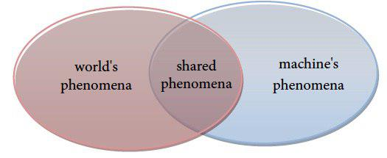

Figure 2.1: Relation between world and machine phenomena.

From now on we will refer to world as everything that not concern our system and machine as everything about our system. Therefore world's phenomena are all the external events happening in the world and machine's phenomena are the events related to the system. There are as well some shared phenomena which are observable by both the parts.

In our case the world's phenomena are:

* Bus out of service or other mechanical failure in public transports
* Closed roads due to a public demonstration

In our case the machine's phenomena are:

* Estimation and managing of users' free time
* Database query
* User's registration

In our case the shared phenomena are:

* Tracking of public transport's means
* Strikes and public services manifestation

**Product Functions**

The product provide to users a simple and user-friendly interface to schedule their events and help them to organize their journey. In particular the system is expected to be able to:

* Let the guest register and log in as users
* Schedule several events for every user
* Computate the best possible path for the daily journey
* Notify the user if the current journey is not realizable and why
* Interact with third part and sharing services
* Let the user buy tickets for the ride
* Support the user during the whole travel
* Allow the user to insert his preferred choice for the used transports
* Gives a real time evaluation of the environmental conditions (like strikes and
* weather situation) and uses it to nd the best choice for the journey.