**VOLUNTEER**

**Here** -> link to the pop-up screen (contact form)

**PARTNER WITH US**

**Here** -> link to the pop-up screen (contact form)

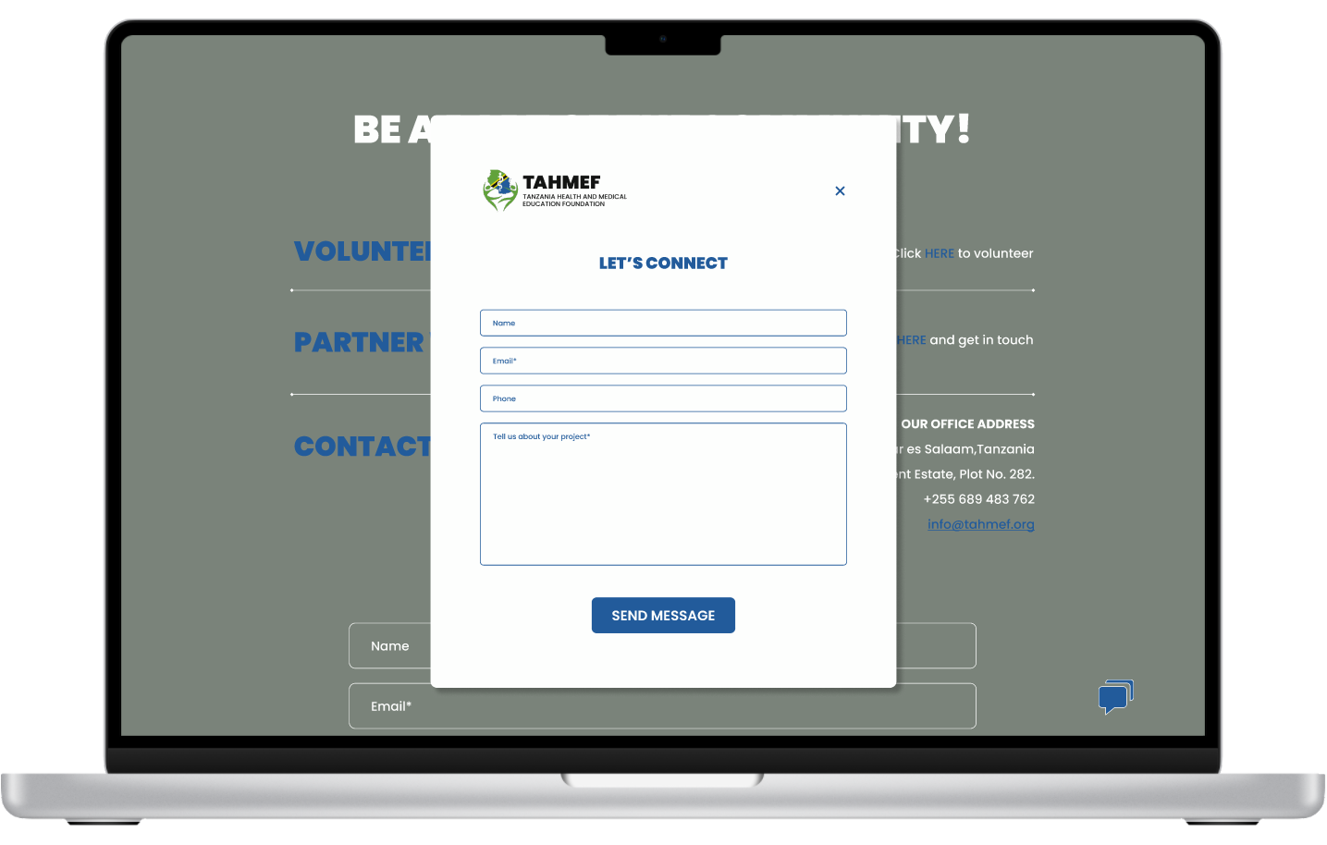

**CONTACT US**

[**info@tahmef.org**](mailto:info@tahmef.org) -> link to the email address: [info@tahmef.org](mailto:info@tahmef.org)

**ON SCREEN CONTACT FORM** (below all the links) -> linked to their email address

