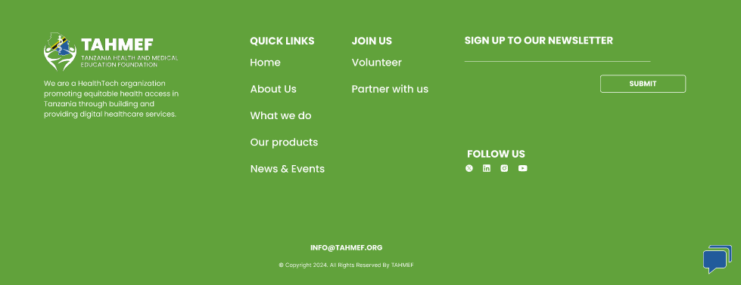

**QUICK LINKS:**

**Home** -> link to the Hero section

**About us** -> link to About us section

**What we do** -> link to Our approach

**Our products** -> link to Our products section

**News & Events** -> external link to <https://www.linkedin.com/build-relation/newsletter-follow?entityUrn=6936969384481435649>

**JOIN US:**

**Volunteer** -> link to the Contact section

**Partner with us** -> link to the Contact section

**SOCIAL MEDIA LINKS:**

**LinkedIn**: <https://www.linkedin.com/company/72457421>

**Instagram**: <https://www.instagram.com/tahmef/>

**X** formerly Twitter: <https://twitter.com/JoinTAHMEF>

**YouTube**: <https://www.youtube.com/channel/UC3Q3K2pwx9fYBZc4qrxSvSg>

**Newsletter link:** <https://www.linkedin.com/build-relation/newsletter-follow?entityUrn=6936969384481435649>

**Newsletter code:**

<style>

.libutton {

display: flex;

flex-direction: column;

justify-content: center;

padding: 7px;

text-align: center;

outline: none;

text-decoration: none !important;

color: #ffffff !important;

width: 200px;

height: 32px;

border-radius: 16px;

background-color: #0A66C2;

font-family: "SF Pro Text", Helvetica, sans-serif;

}

</style>

<a class="libutton" href="<https://www.linkedin.com/build-relation/newsletter-follow?entityUrn=6936969384481435649>" target="_blank">Subscribe on LinkedIn</a>