Ansible is a tool to manage multiple remote systems from a single command center. In Ansible, the single command center is known as the control node and the remote systems to be managed are known as managed nodes. The following describes the 2 nodes:

1. Control node:
   * The command center where Ansible is installed.
   * Supported systems are Unix and Unix-like (Linux, BSD, macOS).
   * Python and sshd are required.
   * Remote systems to be managed are listed in a YAML or INI file called an inventory.
   * Tasks to be executed are defined in a YAML file called a playbook.
2. Managed node:
   * The remote systems to be managed.
   * Supported systems are Unix/Unix-like, Windows, and Appliances (eg: Cisco, NetApp).
   * Python and sshd are required for Unix/Unix-like.
   * PowerShell and WinRM are required for Windows.

Connect to the instance with ssh:

ssh -i ~/.ssh/Gihan4.pem ec2-user@<public-ip>

.ini | .yml

Checks with ping:

ansible -i hosts.ini -m ping all

add to the inventory.ini

instance1 ansible_host=<public-ip> ansible_user=ec2-user ansible_ssh_private_key_file=~/.sshsh/Gihan4.pem

Ansible playbooks are configuration files in a YAML format that tell Ansible what to do. A playbook executes its assigned tasks sequentially from top to bottom. Tasks in playbooks are grouped by a block of instructions called a play. The following diagram shows the high level structure of a playbook.

gihanroey@gihanroey-VirtualBox:~/ansible-project$ ansible -i hosts.ini --list-hosts all

hosts (1):

instance1

ansible all -i hosts.ini -m shell -a "hostname"

it’s like running the command “hostname” on all servers that are in the hosts.ini list.

ansible all -i hosts.ini -m shell -a "df -h"

creat user “test”:

ansible all -i inventory.ini -b -K -m user -a "name=test"

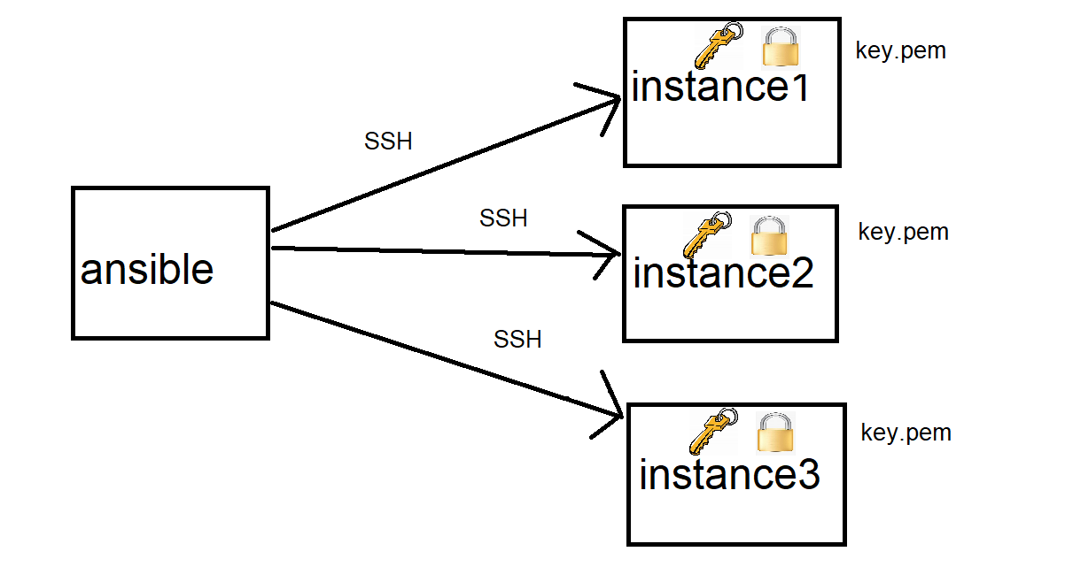

When the ip is replaced:

1. Run the following command to remove the outdated host key entry from the **known_hosts** file:

ssh-keygen -f "/home/gihanroey/.ssh/known_hosts" -R "3.124.2.231"

ansible-playbook -i inventory.ini playbook.yml