# Exercise 1

## Files directories and gzip

1. Create the following directory structure using commands we learned in class

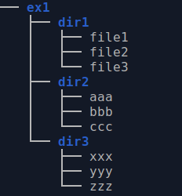

A:cd ex1   
mkdir "dir1" "dir2" "dir3"  
Cd dir1  
touch "file1" "file2" "file2"  
…

1. Copy **file1** **file2** and **file3** to **dir2**

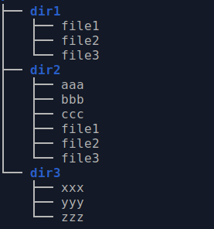

1. Delete file1 file2 and file3 from dir1

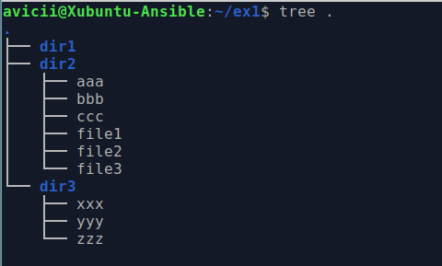

1. Rename all the files in dir3 to have extension of **.mp3**

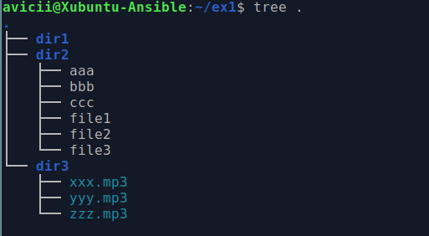

1. Remove **dir1**

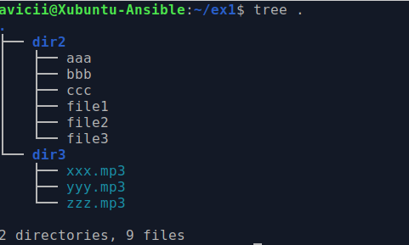

1. Move dir2 to dir3

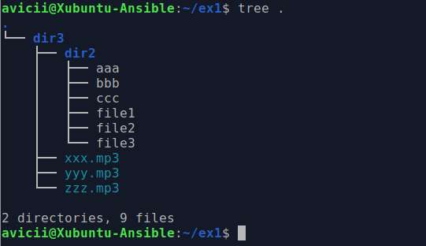

1. Create a copy of **dir3** name **dir3.bck**

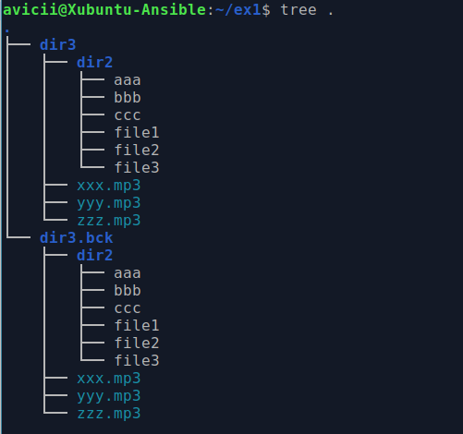

1. Compress **dir3.bck** into a gzip file with the name **dir3.bck.gzip** and then remove **dir3.bck**

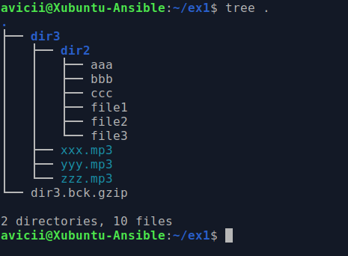

1. Consider the following command which uses a **for** loop to print files in a directory

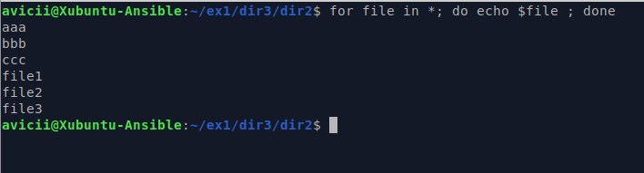

Use a loop to rename all the files in **dir2** (which is now in **dir3**) to have the extension of **mp3**

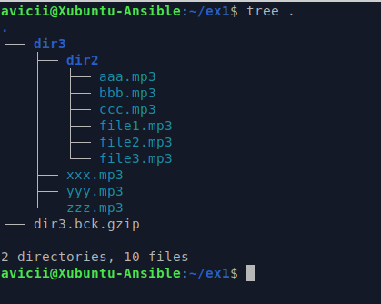

## Grep find and sed commands (sort and uniq)

1. Run **cat /etc/passwd**
2. Open the file with **more** and **less**

A: more /etc/passwd  
less /etc/passwd (q to exit)

1. Print all the lines of the file that **end** with the word **in**

A: grep 'in$' /etc/passwd | sort

1. Print all the lines of the file that **start** with the letter **a**

A: grep '^a' /etc/passwd | sort

1. Print all the lines of the file that **contain a word that start with h and end with e** (hint: regular expression)

A: cat /etc/passwd |grep h*e

1. Print the first 5 lines of the file

A: head -5 /etc/passwd

1. Print the last 7 lines of the file

A: tail -7 /etc/passwd

1. Print the second half of the file (hint: count how many lines in the file)

A: wc –l /etc/passwd = 48  
tail -24 /etc/passwd

1. Print all the lines in the file replacing the word **bash** with the word **tcsh**

A: sed s'/bash/ncsh/g' /etc/passwd |grep ncsh

## Find

1. Find the file **bbb.mp3** (using a find command)

A: Find –name bbb.mp3

1. Find all the files that have extension of mp3

A: Find –name *.mp3

1. Find all the files that have **file** in their name

A: Find –name *file*

1. Find all the files that have **file** in the name and compress them

A: sudo find / -name “file” | tar -zcvf filepr.gz -

## bashrc

* 1. Create a welcoming banner message that will appear whenever you log in into your terminal. The command you will need is called **banner**. Try to run it and you will be asked to install a certain package.



A: apt install sysvbanner

Banner welcome

* 1. Try to create the following output whenever you log in to your user. 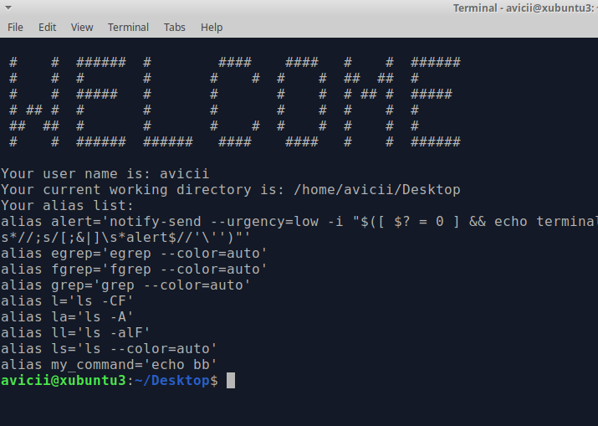

A: nano .bashrc

Banner welcome

* 1. If you wanted to add this for all users how would you do it?

A: I will get into the file with sudo

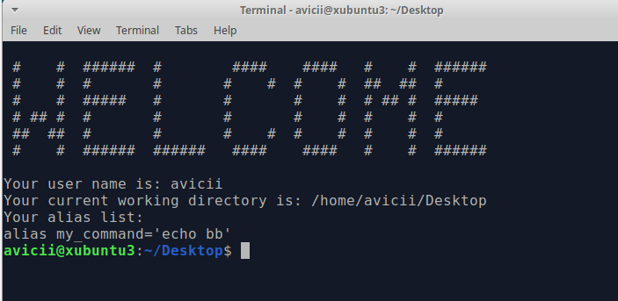

* 1. Can you figure out why not all of the aliases were printed this time?