2D Transformations - Complete Professional Notes
Translation, Scaling, Rotation, Reflection, Shearing, and Composition
Generated on 2026-04-18

Table of Contents
- 1. 2D Translation Note (Theory + Exact Matrix)
- 2. 2D Scaling Note (Theory + Exact Matrix)
- 3. 2D Rotation Note (Theory + Exact Matrix)
- 4. 2D Reflection Note (Theory + Exact Matrix)
- 5. 2D Shearing Note (Theory + Exact Matrix)
- 6. Composing Transformations in 2D (Detailed Note)

2D Translation Note (Theory + Exact Matrix)

Relevant Files
- Main demo: tutorials/lineDrawing/05_2d_translation.py
- Composition demo (all transforms): tutorials/lineDrawing/10_composing_transformations_.py
- Source reference set: tutorials/2Dtrasformations/notes/2D-Transformations.pptx.pdf

Theoretical Base
Translation is a rigid transform that moves every point by the same vector.

For translation vector t = (tx, ty):
- x' = x + tx
- y' = y + ty

Important properties:
- Distances and angles are preserved.
- Orientation is preserved.
- Translation does not depend on the point position relative to origin.

Exact Matrix Forms

2x2 form is not enough
Translation cannot be represented by only a 2x2 matrix in Cartesian form.
It requires homogeneous coordinates.

Homogeneous 3x3 matrix
T(tx, ty) =

```text
| 1 0 tx |
| 0 1 ty |
| 0 0 1 |

Applied to a point:

```text
| x' | | 1 0 tx | | x |
| y' | = | 0 1 ty | * | y |
| 1 | | 0 0 1 | | 1 |

Non-Origin Handling (General Composition Rule)
For transformations around a pivot p = (px, py), we use:

```text
T(px, py) * M * T(-px, -py)

For translation alone, pivot wrapping is unnecessary because translation is already global:

```text
P' = T(tx, ty) * P

Parameter Meaning
- tx: shift along x-axis (right if positive)
- ty: shift along y-axis in Cartesian coordinates (up if positive)

Worked Example
Given P = (20, -10), tx = 35, ty = 15:

- x' = 20 + 35 = 55
- y' = -10 + 15 = 5

So P' = (55, 5)

Cartesian Plane Graph
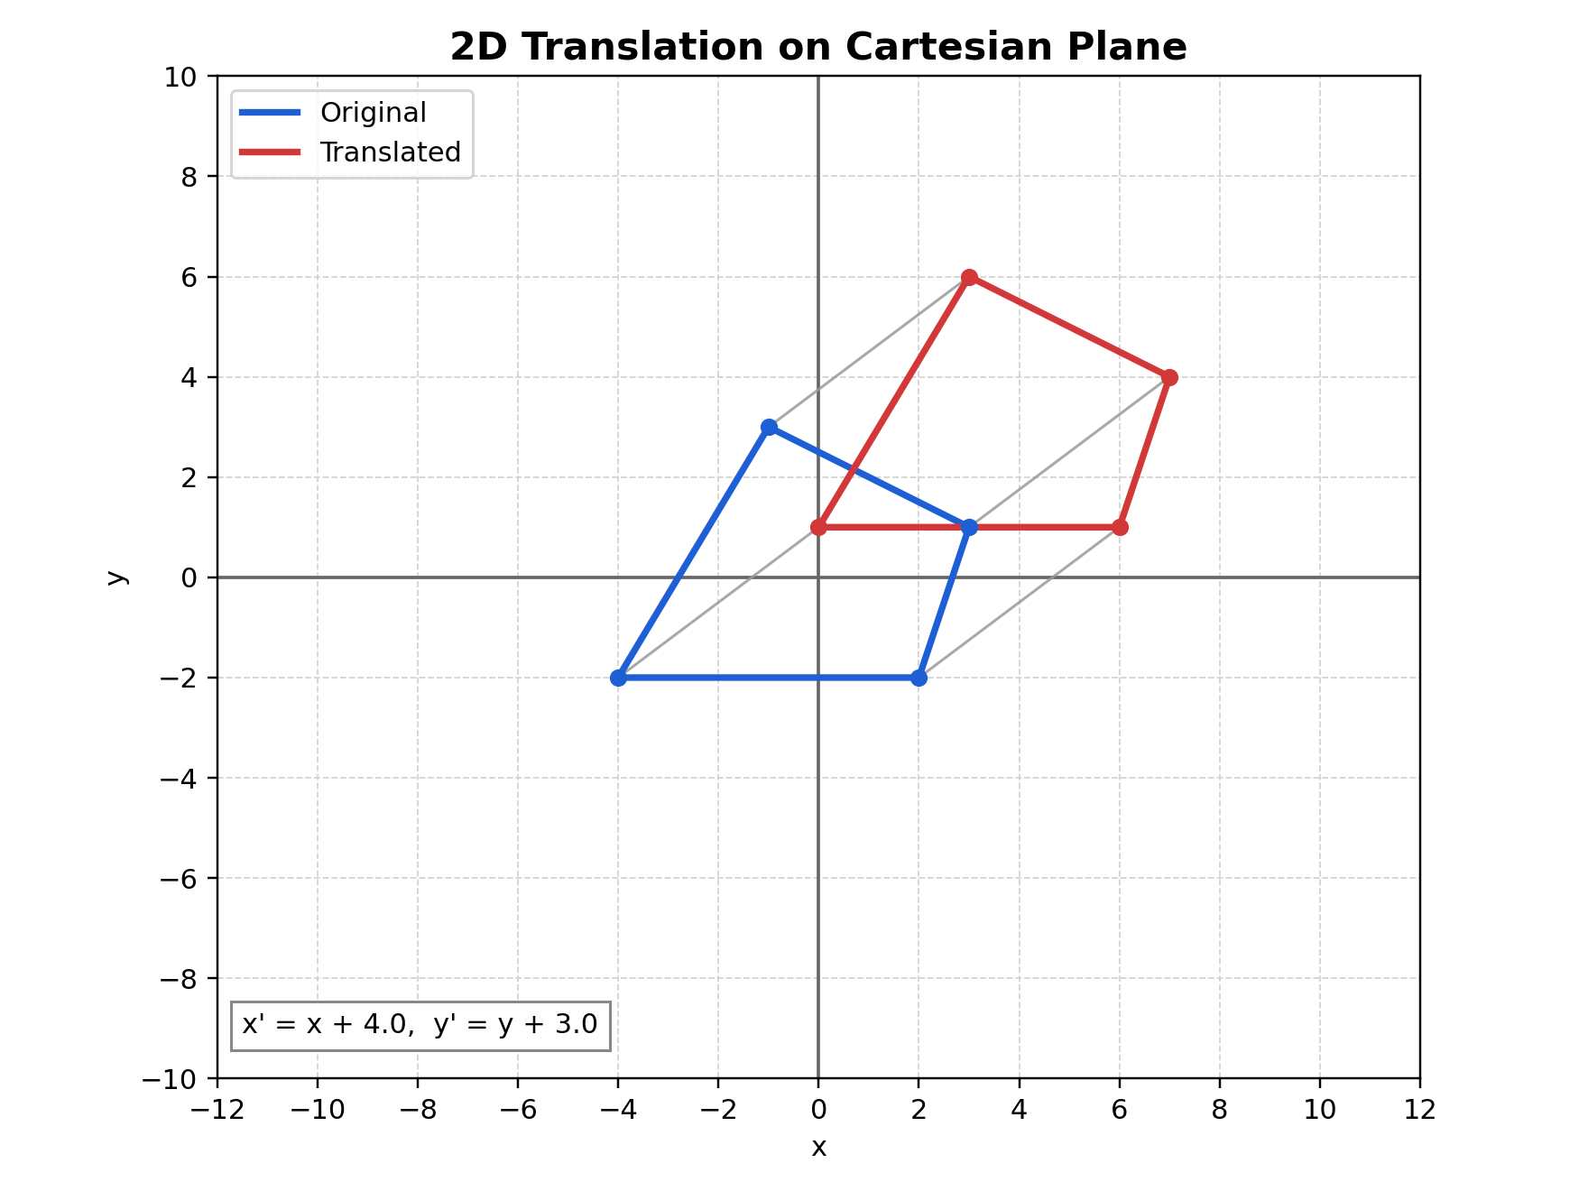
Figure: Translation graph on Cartesian plane

Figure description: blue is the original polygon, red is the translated polygon, and gray segments show vertex displacement vectors.

How to Verify in Code
In tutorials/lineDrawing/05_2d_translation.py:
- The matrix top-right value is tx.
- The matrix middle-right value is ty.
- Every vertex connector (gray line) should be parallel and same length for same tx, ty.

Common Mistakes
- Mixing screen-space y direction with Cartesian y direction.
- Trying to encode translation in a 2x2 matrix.
- Applying translation before/after other transforms without understanding order.

Quick Practice
- Set tx = 0, ty = 120 and confirm only vertical shift occurs.
- Set tx = -80, ty = -60 and verify every vertex moved by exactly (-80, -60).
- Compare T(30, 10) then T(-30, -10) to confirm identity effect.

2D Scaling Note (Theory + Exact Matrix)

Relevant Files
- Main demo: tutorials/lineDrawing/06_2d_scaling.py
- Composition demo: tutorials/lineDrawing/10_composing_transformations_.py
- Java reference: tutorials/2Dtrasformations/java_notes/scaling.java

Theoretical Base
Scaling changes size by multiplying coordinates by scale factors.

About origin:
- x' = sx * x
- y' = sy * y

About pivot p = (px, py):
- x' = px + sx * (x - px)
- y' = py + sy * (y - py)

Important properties:
- Uniform scaling if sx = sy.
- Non-uniform scaling if sx != sy.
- Negative scale flips orientation across one axis.

Exact Matrix Forms

About origin (2x2)

```text
| sx 0 |
| 0 sy |

### About origin (3x3 homogeneous)

```text
| sx 0 0 |
| 0 sy 0 |
| 0 0 1 |

About arbitrary pivot p = (px, py)

```text
S_p = T(px, py) * S * T(-px, -py)

Expanded exact 3x3 matrix:

```text
| sx 0 px*(1-sx) |
| 0 sy py*(1-sy) |
| 0 0 1 |

Composition Rule (Non-Origin Workflow)
When scaling around a point not at origin:
- Translate to origin: T(-px, -py)
- Scale at origin: S(sx, sy)
- Translate back: T(px, py)

Parameter Meaning
- sx: x-axis scale factor
- sy: y-axis scale factor
- p = (px, py): fixed point of scaling

Interpretation:
- sx > 1 or sy > 1 -> enlargement
- 0 < sx < 1 or 0 < sy < 1 -> reduction
- sx < 0 or sy < 0 -> reflection combined with scaling

Worked Example
Scale P = (40, 10) about pivot (20, -10) with sx = 1.5, sy = 0.5:

- x' = 20 + 1.5*(40 - 20) = 50
- y' = -10 + 0.5*(10 - (-10)) = 0

Result: P' = (50, 0)

Cartesian Plane Graph
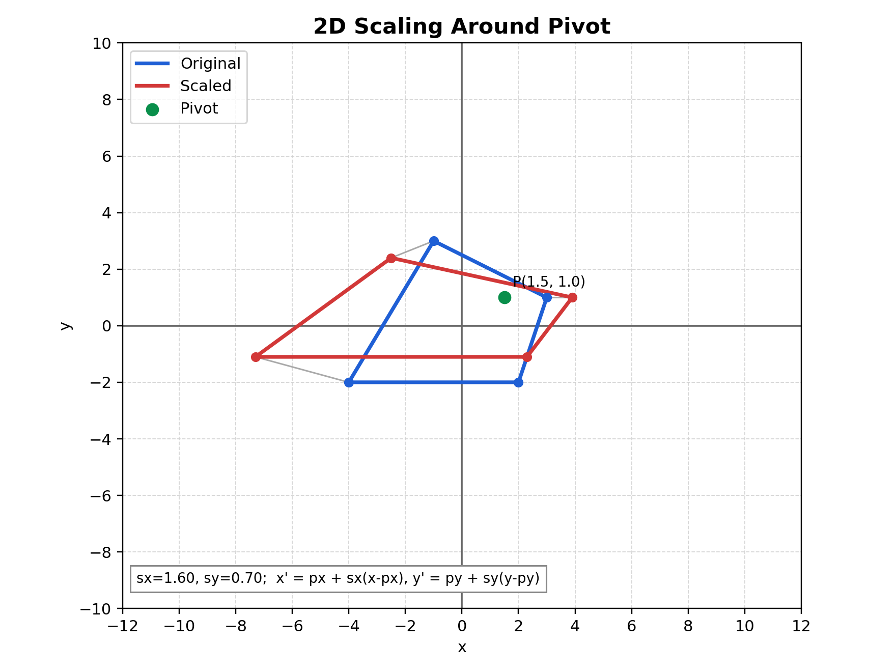
Figure: Scaling graph on Cartesian plane

Figure description: blue is original, red is scaled, and the green marker is the pivot that remains fixed.

How to Verify in Code
In tutorials/lineDrawing/06_2d_scaling.py:
- Click a pivot and verify pivot marker stays fixed.
- For sx = sy, shape keeps similarity.
- For sx != sy, shape gets stretched differently per axis.

Common Mistakes
- Using origin matrix when pivot scaling is required.
- Forgetting translation terms px*(1-sx), py*(1-sy).
- Letting sx or sy become 0 unintentionally (collapses shape).

Quick Practice
- Set sx = sy = 2 around origin and measure one edge ratio.
- Move pivot and repeat to see same ratio but different position.
- Use sx = 2 and sy = 0.5 and describe anisotropic scaling.

2D Rotation Note (Theory + Exact Matrix)

Relevant Files
- Main demo: tutorials/lineDrawing/07_2d_rotation.py
- Foundational guide: tutorials/teaching_guides/04_triangle_rotation_guide.md
- Composition demo: tutorials/lineDrawing/10_composing_transformations_.py

Theoretical Base
Rotation preserves distances and angles while changing orientation around a center.

About origin:
- x' = x*cos(theta) - y*sin(theta)
- y' = x*sin(theta) + y*cos(theta)

About pivot p = (px, py):
- x' = cos(theta)*(x-px) - sin(theta)*(y-py) + px
- y' = sin(theta)*(x-px) + cos(theta)*(y-py) + py

Exact Matrix Forms

About origin (2x2)

```text
| cos(theta) -sin(theta) |
| sin(theta) cos(theta) |

### About origin (3x3 homogeneous)

```text
| cos(theta) -sin(theta) 0 |
| sin(theta) cos(theta) 0 |
| 0 0 1 |

About arbitrary pivot p = (px, py)

```text
R_p = T(px, py) * R(theta) * T(-px, -py)

Expanded exact 3x3 matrix:

```text
| cos(theta) -sin(theta) px - px*cos(theta) + py*sin(theta) |
| sin(theta) cos(theta) py - px*sin(theta) - py*cos(theta) |
| 0 0 1 |

Composition Rule (Non-Origin Workflow)
For a non-origin pivot:
- Translate by T(-px, -py)
- Rotate by R(theta)
- Translate back by T(px, py)

Parameter Meaning
- theta: rotation angle
- p = (px, py): pivot

Convention:
- Positive theta is counterclockwise in Cartesian space.

Worked Example
Rotate P = (3, 1) about origin by theta = 90 deg:
- cos(90 deg) = 0
- sin(90 deg) = 1

Then:
- x' = 3*0 - 1*1 = -1
- y' = 3*1 + 1*0 = 3

Result: P' = (-1, 3)

Cartesian Plane Graph
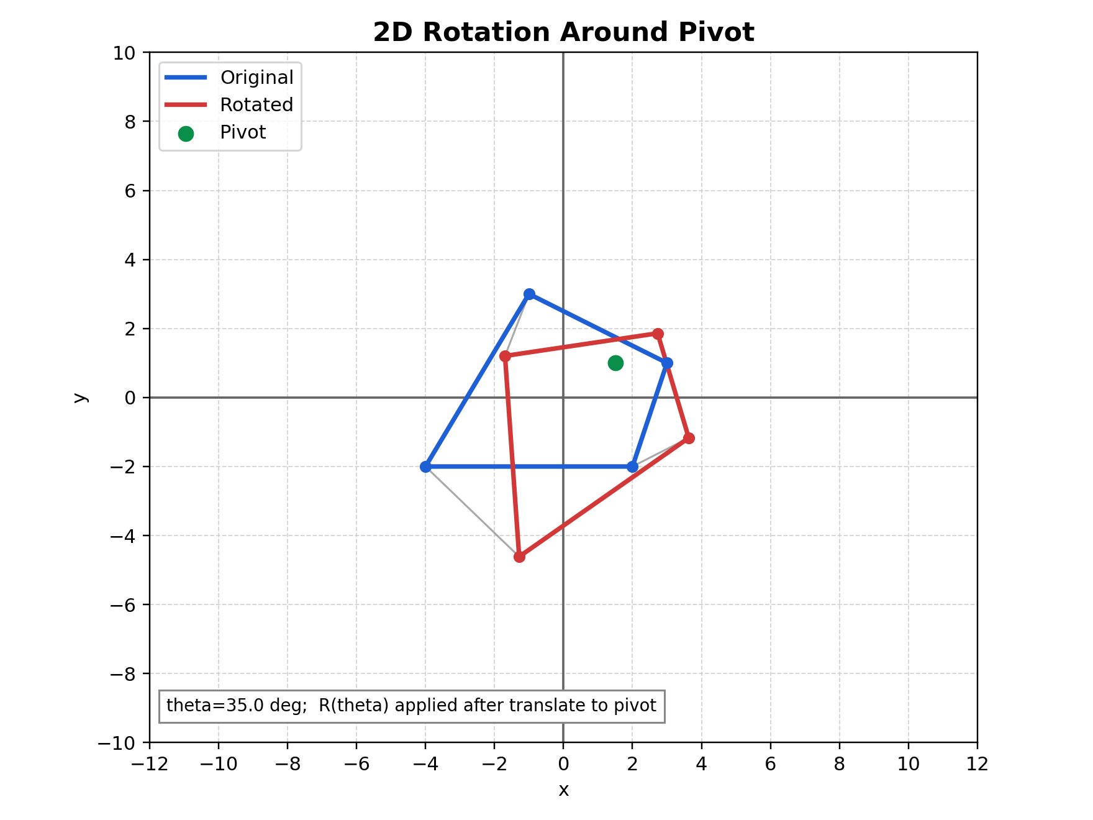
Figure: Rotation graph on Cartesian plane

Figure description: blue is original, red is rotated, and the green point is the pivot used in translate-rotate-translate composition.

How to Verify in Code
In tutorials/lineDrawing/07_2d_rotation.py:
- Set angle = 0 -> transformed shape overlaps original.
- Set angle = 180 -> each point maps to opposite side around pivot.
- Move pivot and confirm pivot remains fixed while others rotate.

Common Mistakes
- Using degrees directly in sin/cos without converting to radians.
- Rotating already rotated coordinates repeatedly (drift accumulation).
- Forgetting order: translate to pivot first, then rotate, then translate back.

Quick Practice
- Compare outputs for 90, 180, and 270 degrees.
- Rotate around origin and around a clicked pivot; explain difference.
- Verify R(theta) * R(-theta) gives identity transform.

2D Reflection Note (Theory + Exact Matrix)

Relevant Files
- Main demo: tutorials/lineDrawing/08_2d_reflection.py
- Java references: tutorials/2Dtrasformations/java_notes/reflection.java, tutorials/2Dtrasformations/java_notes/reflectionXY.java
- Composition demo: tutorials/lineDrawing/10_composing_transformations_.py

Theoretical Base
Reflection is an isometry: it preserves distances but reverses orientation.

If a line L is the mirror axis, reflected points keep equal perpendicular distance to L on opposite sides.

Exact Matrix Forms (Homogeneous 3x3)

Reflection about X-axis
- Equation: x' = x, y' = -y

```text
| 1 0 0 |
| 0 -1 0 |
| 0 0 1 |

### Reflection about Y-axis
- Equation: x' = -x, y' = y

```text
| -1 0 0 |
| 0 1 0 |
| 0 0 1 |

Reflection about Origin
- Equation: x' = -x, y' = -y

```text
| -1 0 0 |
| 0 -1 0 |
| 0 0 1 |

### Reflection about line y = x
- Equation: x' = y, y' = x

```text
| 0 1 0 |
| 1 0 0 |
| 0 0 1 |

Reflection about line y = -x
- Equation: x' = -y, y' = -x

```text
| 0 -1 0 |
| -1 0 0 |
| 0 0 1 |

## Non-Origin Reflection Rule
For reflection about a line that does not pass through origin, shift first:

```text
M_non_origin = T(px, py) * M_reflect_origin_line * T(-px, -py)

This is the same principle used in composing transformations.

Worked Example
Reflect P = (6, -2) about line y = x:

- x' = y = -2
- y' = x = 6

Result: P' = (-2, 6)

Cartesian Plane Graph
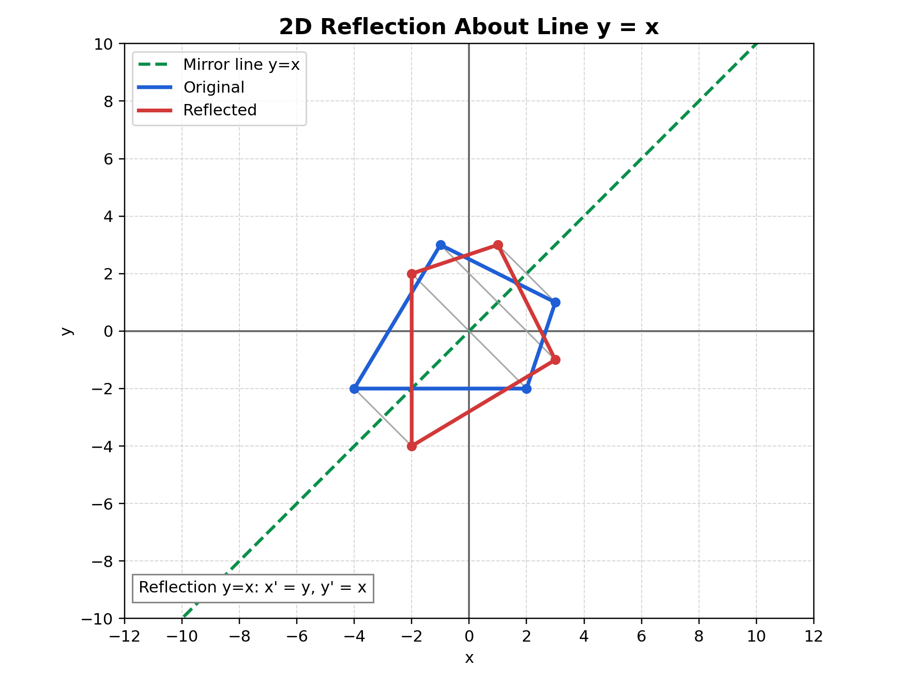
Figure: Reflection graph on Cartesian plane

Figure description: dashed green line is y=x mirror axis, blue is original, and red is reflected geometry.

How to Verify in Code
In tutorials/lineDrawing/08_2d_reflection.py:
- Switch modes 1..5 and inspect matrix HUD.
- For same mode, applying reflection twice should return original points.
- Distances to mirror line remain equal before and after reflection.

Common Mistakes
- Confusing y = x with y = -x matrix.
- Treating origin reflection as only one-axis reflection.
- Forgetting orientation flips under reflection.

Quick Practice
- Reflect a point twice about Y-axis and verify identity.
- Compare reflection about origin with rotation by 180 degrees.
- Explain why reflection keeps edge lengths unchanged.

2D Shearing Note (Theory + Exact Matrix)

Relevant Files
- Main demo: tutorials/lineDrawing/09_2d_shearing.py
- Java references: tutorials/2Dtrasformations/java_notes/shearing.java, tutorials/2Dtrasformations/java_notes/shearingY.java
- Composition demo: tutorials/lineDrawing/10_composing_transformations_.py

Theoretical Base
Shear shifts one coordinate by an amount proportional to the other coordinate.

Unlike rotation/reflection, shear is not distance-preserving and usually changes angles.

Exact Matrix Forms

X-shear
- Equation: x' = x + shx*y, y' = y

```text
| 1 shx 0 |
| 0 1 0 |
| 0 0 1 |

### Y-shear
- Equation: x' = x, y' = y + shy*x

```text
| 1 0 0 |
| shy 1 0 |
| 0 0 1 |

Combined shear (both X and Y simultaneously)

```text
| 1 shx 0 |
| shy 1 0 |
| 0 0 1 |

This gives:
- x' = x + shx*y
- y' = shy*x + y

## Non-Origin Shear Rule
For shearing around a pivot p = (px, py):

```text
H_p = T(px, py) * H * T(-px, -py)

This is required in composed transformations if operations should behave around a local center.

Parameter Meaning
- shx: x shear factor
- shy: y shear factor

Interpretation:
- Positive and negative values tilt in opposite directions.
- Larger absolute value gives stronger slant.

Worked Example
Apply X-shear with shx = 0.5 to P = (8, 6):

- x' = 8 + 0.5*6 = 11
- y' = 6

Result: P' = (11, 6)

Apply Y-shear with shy = -0.25 to same point:

- x' = 8
- y' = 6 + (-0.25)*8 = 4

Result: P' = (8, 4)

Cartesian Plane Graph
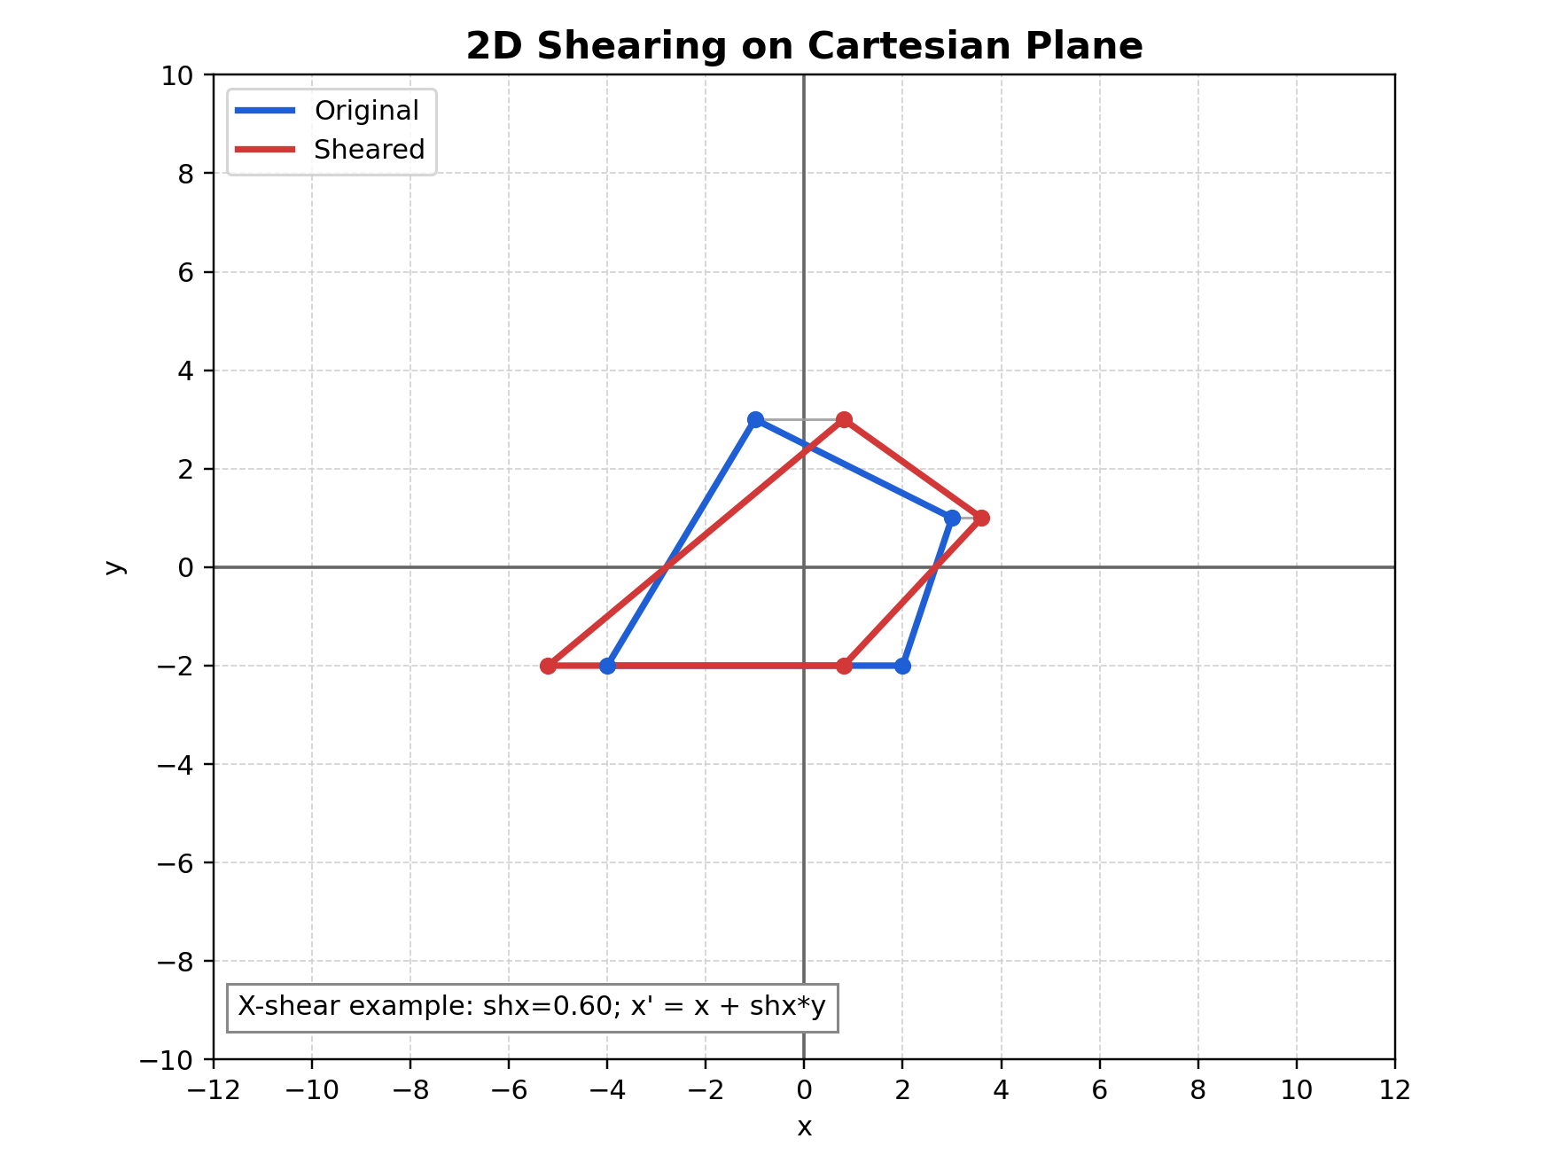
Figure: Shearing graph on Cartesian plane

Figure description: example shown for X-shear where y stays unchanged while x shifts proportionally to y.

How to Verify in Code
In tutorials/lineDrawing/09_2d_shearing.py:
- Set factor to 0 and confirm identity transform.
- In X-shear mode only x changes with y dependence.
- In Y-shear mode only y changes with x dependence.

Common Mistakes
- Confusing shear with rotation.
- Using wrong formula for selected mode.
- Forgetting that shearing changes angles and usually area.

Quick Practice
- Compare sh = 0.5 and sh = -0.5 in both modes.
- Predict one vertex movement before checking on GUI.
- Use both shx and shy in the composition GUI and inspect matrix effects.

Composing Transformations in 2D (Detailed Note)

Relevant Files
- Composition GUI: tutorials/lineDrawing/10_composing_transformations_.py
- Translation GUI: tutorials/lineDrawing/05_2d_translation.py
- Scaling GUI: tutorials/lineDrawing/06_2d_scaling.py
- Rotation GUI: tutorials/lineDrawing/07_2d_rotation.py
- Reflection GUI: tutorials/lineDrawing/08_2d_reflection.py
- Shearing GUI: tutorials/lineDrawing/09_2d_shearing.py

Why Composition Matters
In real graphics tasks, we rarely apply only one transform.
We usually need chains like:
- reflect, then scale
- shear, then rotate
- transform around an arbitrary pivot (not origin)
- then place object in world space

Matrix composition lets us do this as one matrix multiply per point:

P' = M_total * P

Core Non-Origin Rule
For any local transform M_local around pivot p = (px, py):

M_around_pivot = T(px, py) * M_local * T(-px, -py)

This is the exact "move to origin -> transform -> move back" rule.

If we also want final world translation (tx, ty):

M_total = T(tx, ty) * T(px, py) * M_local * T(-px, -py)

Exact Building Matrices

Translation
T(tx, ty)

| 1 0 tx |
| 0 1 ty |
| 0 0 1 |

Scaling
S(sx, sy)

| sx 0 0 |
| 0 sy 0 |
| 0 0 1 |

Rotation
R(theta)

| cos(theta) -sin(theta) 0 |
| sin(theta) cos(theta) 0 |
| 0 0 1 |

Shear (combined)
H(shx, shy)

| 1 shx 0 |
| shy 1 0 |
| 0 0 1 |

Reflection examples
Ref_x:
| 1 0 0 |
| 0 -1 0 |
| 0 0 1 |

Ref_y:
| -1 0 0 |
| 0 1 0 |
| 0 0 1 |

Ref_origin:
| -1 0 0 |
| 0 -1 0 |
| 0 0 1 |

Ref_y_eq_x:
| 0 1 0 |
| 1 0 0 |
| 0 0 1 |

Ref_y_eq_neg_x:
| 0 -1 0 |
| -1 0 0 |
| 0 0 1 |

Order of Multiplication (Critical)
Matrix multiplication is not commutative:

A * B != B * A

So order changes output.

In 10_composing_transformations_.py, local order is:
- Ref -> Scale -> Shear -> Rotate

With column vectors, this is implemented as:

M_local = R * H * S * Ref

Then wrapped around pivot and world translation:

M_total = T(tx, ty) * T(px, py) * M_local * T(-px, -py)

Worked Numeric Example
Let:
- P = (4, 1)
- pivot p = (2, 2)
- theta = 90 deg
- sx = 1, sy = 1
- shx = 0, shy = 0
- reflection = none
- tx = 3, ty = -1

Because scale/shear/reflection are identity here, local matrix is only rotation.

Step 1: move to origin relative to pivot
- P_local = (4-2, 1-2) = (2, -1)

Step 2: rotate 90 deg around origin
- (x, y) -> (-y, x)
- P_rot = (1, 2)

Step 3: move back from pivot
- P_back = (1+2, 2+2) = (3, 4)

Step 4: world translation
- P' = (3+3, 4-1) = (6, 3)

Final result: (6, 3)

Cartesian Plane Graph
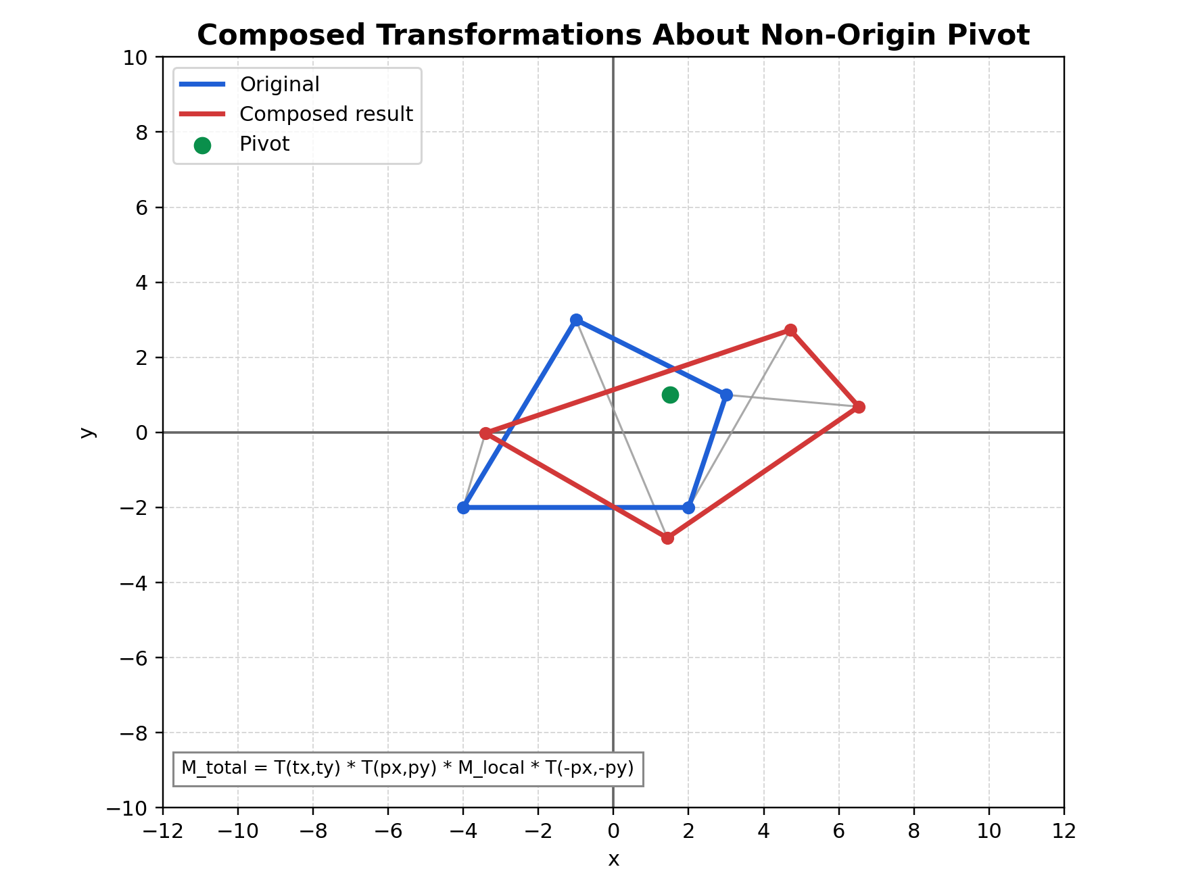
Figure: Composed transformations graph on Cartesian plane

Figure description: composed output around non-origin pivot using local transform chain and final world translation.

Practical Interpretation
- T(-pivot): build local object space around pivot.
- M_local: shape-changing operations in local space.
- T(+pivot): return to world-relative position.
- T(tx, ty): place final transformed object.

Common Mistakes
- Applying transforms in intended verbal order but wrong matrix order.
- Forgetting to convert to pivot-local coordinates.
- Mixing row-vector and column-vector conventions.
- Using degrees in trig functions without radians conversion.

Validation Checklist
- Set all transforms identity and verify M_total is identity.
- Change only tx, ty and verify pure translation.
- Change only angle and verify pivot stays fixed.
- Turn on reflection and verify mirror behavior before other effects.
- Set shx/shy and verify slant appears as expected.

Suggested Exercises
- Swap local order to S * R and compare with R * S.
- Add a UI key to toggle order and observe geometric differences.
- Reproduce one transformed vertex by manual calculation and compare with HUD.

