2D Scaling Note

Relevant Files
- Main demo: tutorials/lineDrawing/06_2d_scaling.py
- Composition demo: tutorials/lineDrawing/10_composing_transformations_.py
- Java reference: tutorials/2Dtrasformations/java_notes/scaling.java

Theoretical Base
Scaling changes size by multiplying coordinates by scale factors.

About origin:
- x' = sx * x
- y' = sy * y

About pivot p = (px, py):
- x' = px + sx * (x - px)
- y' = py + sy * (y - py)

Important properties:
- Uniform scaling if sx = sy.
- Non-uniform scaling if sx != sy.
- Negative scale flips orientation across one axis.

Exact Matrix Forms

About origin (2x2)

| sx 0 |
| 0 sy |

### About origin (3x3 homogeneous)

| sx 0 0 |
| 0 sy 0 |
| 0 0 1 |

About arbitrary pivot p = (px, py)

S_p = T(px, py) * S * T(-px, -py)

Expanded exact 3x3 matrix:

| sx 0 px*(1-sx) |
| 0 sy py*(1-sy) |
| 0 0 1 |

Composition Rule (Non-Origin Workflow)
When scaling around a point not at origin:
- Translate to origin: T(-px, -py)
- Scale at origin: S(sx, sy)
- Translate back: T(px, py)

Parameter Meaning
- sx: x-axis scale factor
- sy: y-axis scale factor
- p = (px, py): fixed point of scaling

Interpretation:
- sx > 1 or sy > 1 -> enlargement
- 0 < sx < 1 or 0 < sy < 1 -> reduction
- sx < 0 or sy < 0 -> reflection combined with scaling

Worked Example
Scale P = (40, 10) about pivot (20, -10) with sx = 1.5, sy = 0.5:

- x' = 20 + 1.5*(40 - 20) = 50
- y' = -10 + 0.5*(10 - (-10)) = 0

Result: P' = (50, 0)

Cartesian Plane Graph
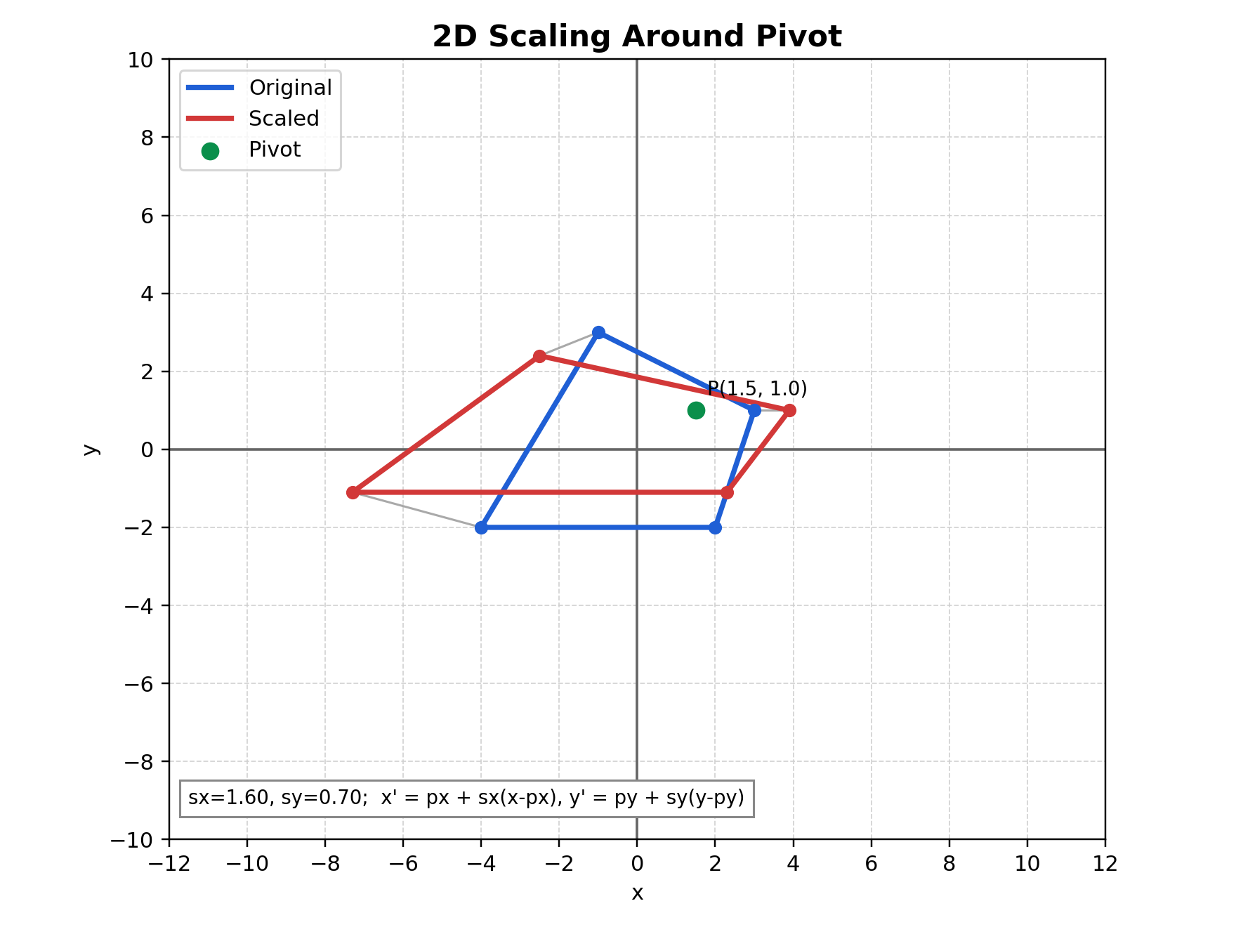
Figure: Scaling graph on Cartesian plane

Figure description: blue is original, red is scaled, and the green marker is the pivot that remains fixed.

How to Verify in Code
In tutorials/lineDrawing/06_2d_scaling.py:
- Click a pivot and verify pivot marker stays fixed.
- For sx = sy, shape keeps similarity.
- For sx != sy, shape gets stretched differently per axis.

Common Mistakes
- Using origin matrix when pivot scaling is required.
- Forgetting translation terms px*(1-sx), py*(1-sy).
- Letting sx or sy become 0 unintentionally (collapses shape).

Quick Practice
- Set sx = sy = 2 around origin and measure one edge ratio.
- Move pivot and repeat to see same ratio but different position.
- Use sx = 2 and sy = 0.5 and describe anisotropic scaling.

