2D Rotation Note (Theory + Exact Matrix)
Detailed theory, exact matrices, and Cartesian graph
Generated on 2026-04-18

2D Rotation Note

Relevant Files
- Main demo: tutorials/lineDrawing/07_2d_rotation.py
- Foundational guide: tutorials/teaching_guides/04_triangle_rotation_guide.md
- Composition demo: tutorials/lineDrawing/10_composing_transformations_.py

Theoretical Base
Rotation preserves distances and angles while changing orientation around a center.

About origin:
- x' = x*cos(theta) - y*sin(theta)
- y' = x*sin(theta) + y*cos(theta)

About pivot p = (px, py):
- x' = cos(theta)*(x-px) - sin(theta)*(y-py) + px
- y' = sin(theta)*(x-px) + cos(theta)*(y-py) + py

Exact Matrix Forms

About origin (2x2)

| cos(theta) -sin(theta) |
| sin(theta) cos(theta) |

About origin (3x3 homogeneous)

| cos(theta) -sin(theta) 0 |
| sin(theta) cos(theta) 0 |
| 0 0 1 |

About arbitrary pivot p = (px, py)

R_p = T(px, py) * R(theta) * T(-px, -py)

Expanded exact 3x3 matrix:

| cos(theta) -sin(theta) px - px*cos(theta) + py*sin(theta) |
| sin(theta) cos(theta) py - px*sin(theta) - py*cos(theta) |
| 0 0 1 |

Composition Rule (Non-Origin Workflow)
For a non-origin pivot:
- Translate by T(-px, -py)
- Rotate by R(theta)
- Translate back by T(px, py)

Parameter Meaning
- theta: rotation angle
- p = (px, py): pivot

Convention:
- Positive theta is counterclockwise in Cartesian space.

Worked Example
Rotate P = (3, 1) about origin by theta = 90 deg:
- cos(90 deg) = 0
- sin(90 deg) = 1

Then:
- x' = 3*0 - 1*1 = -1
- y' = 3*1 + 1*0 = 3

Result: P' = (-1, 3)

Cartesian Plane Graph
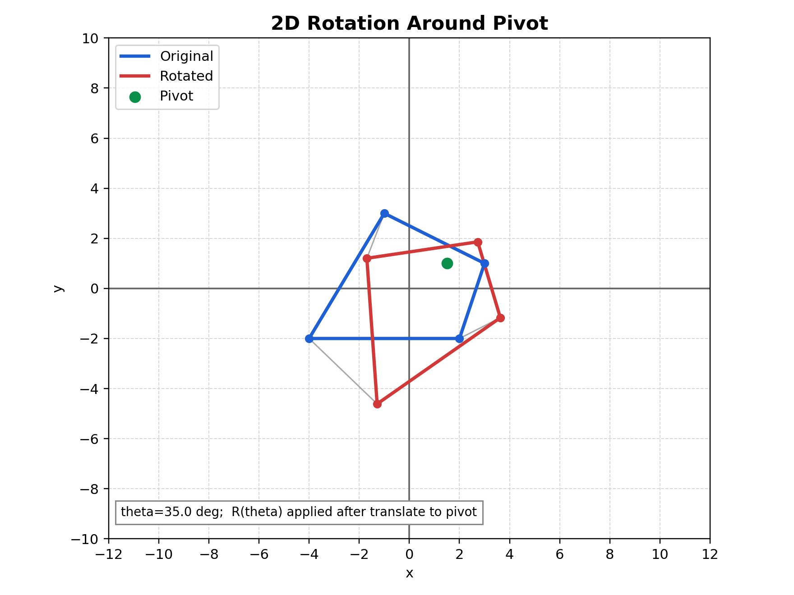
Figure: Rotation graph on Cartesian plane

Figure description: blue is original, red is rotated, and the green point is the pivot used in translate-rotate-translate composition.

How to Verify in Code
In tutorials/lineDrawing/07_2d_rotation.py:
- Set angle = 0 -> transformed shape overlaps original.
- Set angle = 180 -> each point maps to opposite side around pivot.
- Move pivot and confirm pivot remains fixed while others rotate.

Common Mistakes
- Using degrees directly in sin/cos without converting to radians.
- Rotating already rotated coordinates repeatedly (drift accumulation).
- Forgetting order: translate to pivot first, then rotate, then translate back.

Quick Practice
- Compare outputs for 90, 180, and 270 degrees.
- Rotate around origin and around a clicked pivot; explain difference.
- Verify R(theta) * R(-theta) gives identity transform.

