2D Reflection Note

Relevant Files
- Main demo: tutorials/lineDrawing/08_2d_reflection.py
- Java references: tutorials/2Dtrasformations/java_notes/reflection.java, tutorials/2Dtrasformations/java_notes/reflectionXY.java
- Composition demo: tutorials/lineDrawing/10_composing_transformations_.py

Theoretical Base
Reflection is an isometry: it preserves distances but reverses orientation.

If a line L is the mirror axis, reflected points keep equal perpendicular distance to L on opposite sides.

Exact Matrix Forms (Homogeneous 3x3)

Reflection about X-axis
- Equation: x' = x, y' = -y

| 1 0 0 |
| 0 -1 0 |
| 0 0 1 |

### Reflection about Y-axis
- Equation: x' = -x, y' = y

| -1 0 0 |
| 0 1 0 |
| 0 0 1 |

Reflection about Origin
- Equation: x' = -x, y' = -y

| -1 0 0 |
| 0 -1 0 |
| 0 0 1 |

Reflection about line y = x
- Equation: x' = y, y' = x

| 0 1 0 |
| 1 0 0 |
| 0 0 1 |

Reflection about line y = -x
- Equation: x' = -y, y' = -x

| 0 -1 0 |
| -1 0 0 |
| 0 0 1 |

Non-Origin Reflection Rule
For reflection about a line that does not pass through origin, shift first:

M_non_origin = T(px, py) * M_reflect_origin_line * T(-px, -py)

This is the same principle used in composing transformations.

Worked Example
Reflect P = (6, -2) about line y = x:

- x' = y = -2
- y' = x = 6

Result: P' = (-2, 6)

Cartesian Plane Graph
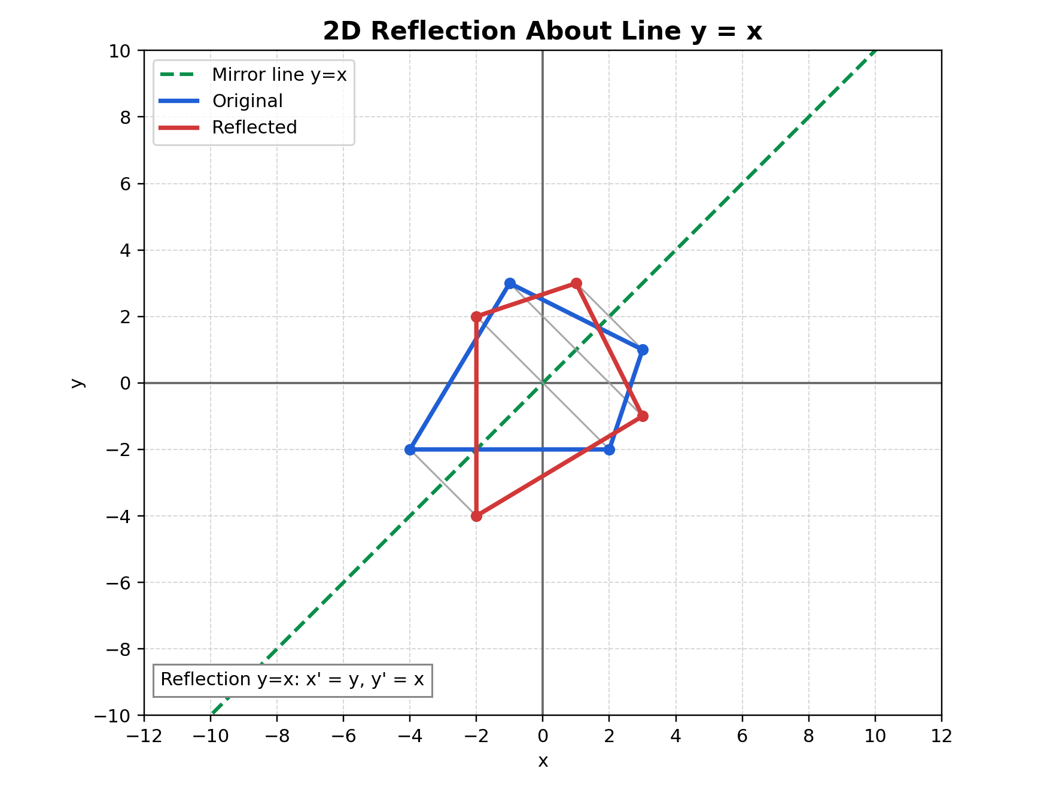
Figure: Reflection graph on Cartesian plane

Figure description: dashed green line is y=x mirror axis, blue is original, and red is reflected geometry.

How to Verify in Code
In tutorials/lineDrawing/08_2d_reflection.py:
- Switch modes 1..5 and inspect matrix HUD.
- For same mode, applying reflection twice should return original points.
- Distances to mirror line remain equal before and after reflection.

Common Mistakes
- Confusing y = x with y = -x matrix.
- Treating origin reflection as only one-axis reflection.
- Forgetting orientation flips under reflection.

Quick Practice
- Reflect a point twice about Y-axis and verify identity.
- Compare reflection about origin with rotation by 180 degrees.
- Explain why reflection keeps edge lengths unchanged.

