Composing Transformations in 2D

Relevant Files
- Composition GUI: tutorials/lineDrawing/10_composing_transformations_.py
- Translation GUI: tutorials/lineDrawing/05_2d_translation.py
- Scaling GUI: tutorials/lineDrawing/06_2d_scaling.py
- Rotation GUI: tutorials/lineDrawing/07_2d_rotation.py
- Reflection GUI: tutorials/lineDrawing/08_2d_reflection.py
- Shearing GUI: tutorials/lineDrawing/09_2d_shearing.py

Why Composition Matters
In real graphics tasks, we rarely apply only one transform.
We usually need chains like:
- reflect, then scale
- shear, then rotate
- transform around an arbitrary pivot (not origin)
- then place object in world space

Matrix composition lets us do this as one matrix multiply per point:

P' = M_total * P

Core Non-Origin Rule
For any local transform M_local around pivot p = (px, py):

M_around_pivot = T(px, py) * M_local * T(-px, -py)

This is the exact "move to origin -> transform -> move back" rule.

If we also want final world translation (tx, ty):

M_total = T(tx, ty) * T(px, py) * M_local * T(-px, -py)

Exact Building Matrices

Translation
T(tx, ty)

| 1 0 tx |
| 0 1 ty |
| 0 0 1 |

Scaling
S(sx, sy)

| sx 0 0 |
| 0 sy 0 |
| 0 0 1 |

Rotation
R(theta)

| cos(theta) -sin(theta) 0 |
| sin(theta) cos(theta) 0 |
| 0 0 1 |

Shear (combined)
H(shx, shy)

| 1 shx 0 |
| shy 1 0 |
| 0 0 1 |

Reflection examples
Ref_x:
| 1 0 0 |
| 0 -1 0 |
| 0 0 1 |

Ref_y:
| -1 0 0 |
| 0 1 0 |
| 0 0 1 |

Ref_origin:
| -1 0 0 |
| 0 -1 0 |
| 0 0 1 |

Ref_y_eq_x:
| 0 1 0 |
| 1 0 0 |
| 0 0 1 |

Ref_y_eq_neg_x:
| 0 -1 0 |
| -1 0 0 |
| 0 0 1 |

Order of Multiplication (Critical)
Matrix multiplication is not commutative:

A * B != B * A

So order changes output.

In 10_composing_transformations_.py, local order is:
- Ref -> Scale -> Shear -> Rotate

With column vectors, this is implemented as:

M_local = R * H * S * Ref

Then wrapped around pivot and world translation:

M_total = T(tx, ty) * T(px, py) * M_local * T(-px, -py)

Worked Numeric Example
Let:
- P = (4, 1)
- pivot p = (2, 2)
- theta = 90 deg
- sx = 1, sy = 1
- shx = 0, shy = 0
- reflection = none
- tx = 3, ty = -1

Because scale/shear/reflection are identity here, local matrix is only rotation.

Step 1: move to origin relative to pivot
- P_local = (4-2, 1-2) = (2, -1)

Step 2: rotate 90 deg around origin
- (x, y) -> (-y, x)
- P_rot = (1, 2)

Step 3: move back from pivot
- P_back = (1+2, 2+2) = (3, 4)

Step 4: world translation
- P' = (3+3, 4-1) = (6, 3)

Final result: (6, 3)

Cartesian Plane Graph
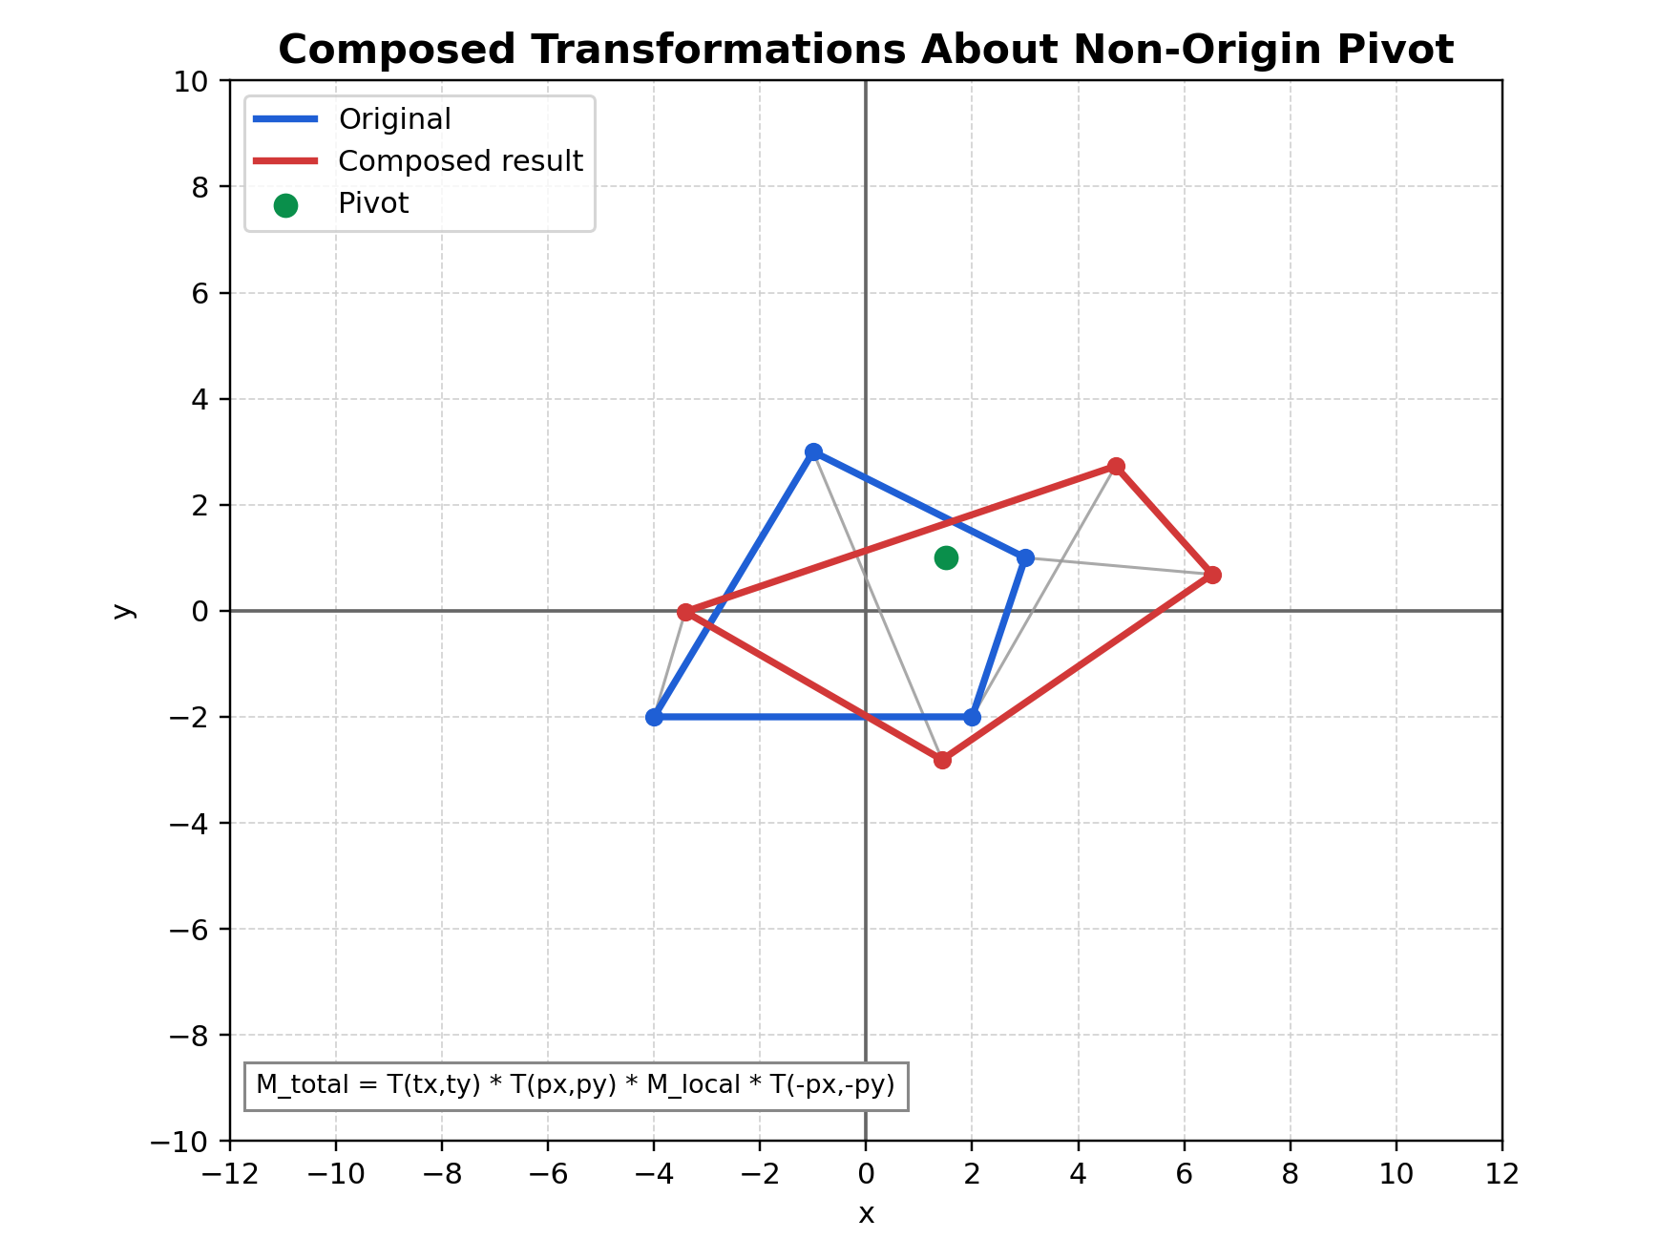
Figure: Composed transformations graph on Cartesian plane

Figure description: composed output around non-origin pivot using local transform chain and final world translation.

Practical Interpretation
- T(-pivot): build local object space around pivot.
- M_local: shape-changing operations in local space.
- T(+pivot): return to world-relative position.
- T(tx, ty): place final transformed object.

Common Mistakes
- Applying transforms in intended verbal order but wrong matrix order.
- Forgetting to convert to pivot-local coordinates.
- Mixing row-vector and column-vector conventions.
- Using degrees in trig functions without radians conversion.

Validation Checklist
- Set all transforms identity and verify M_total is identity.
- Change only tx, ty and verify pure translation.
- Change only angle and verify pivot stays fixed.
- Turn on reflection and verify mirror behavior before other effects.
- Set shx/shy and verify slant appears as expected.

Suggested Exercises
- Swap local order to S * R and compare with R * S.
- Add a UI key to toggle order and observe geometric differences.
- Reproduce one transformed vertex by manual calculation and compare with HUD.

