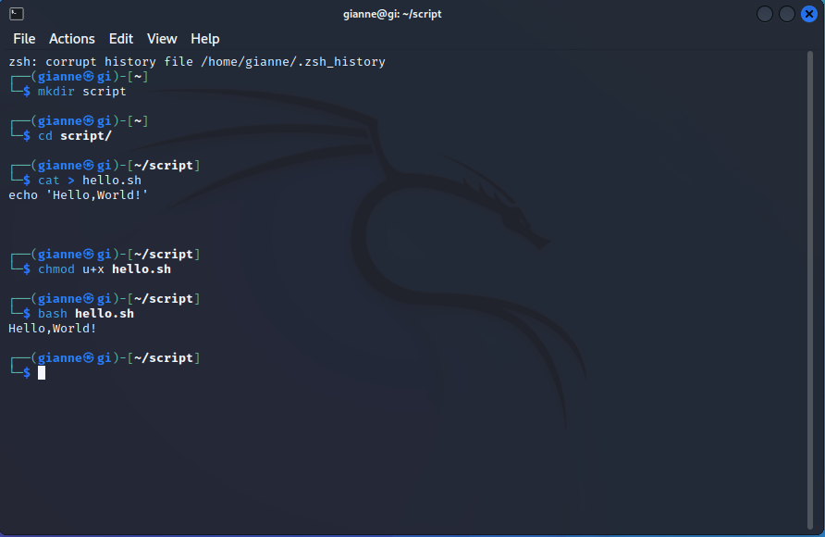**Activity 6 – Shell Scripting**